Assignment 1 – Screenshots

- Executing dotnet run command
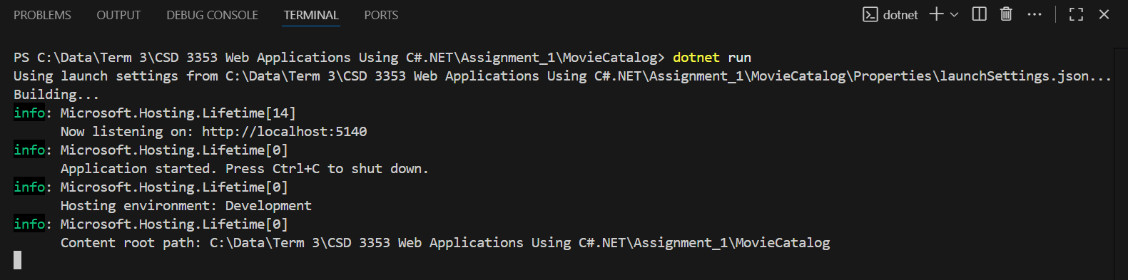

- Entering the website http://localhost:5140/

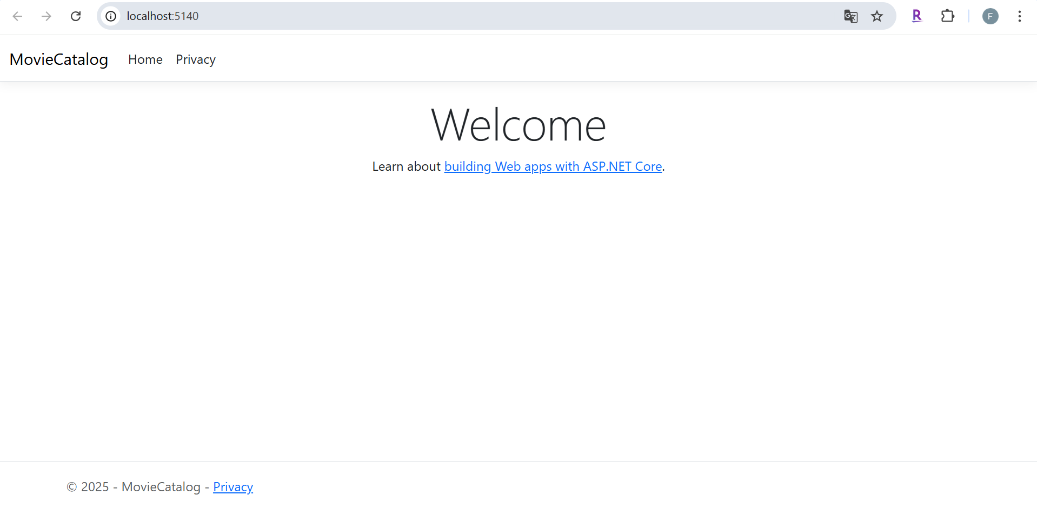

- By adding the text “/Movies” to the link to access the movie catalog home page. Direct link: http://localhost:5140/Movies . Click the Add New Movie button.

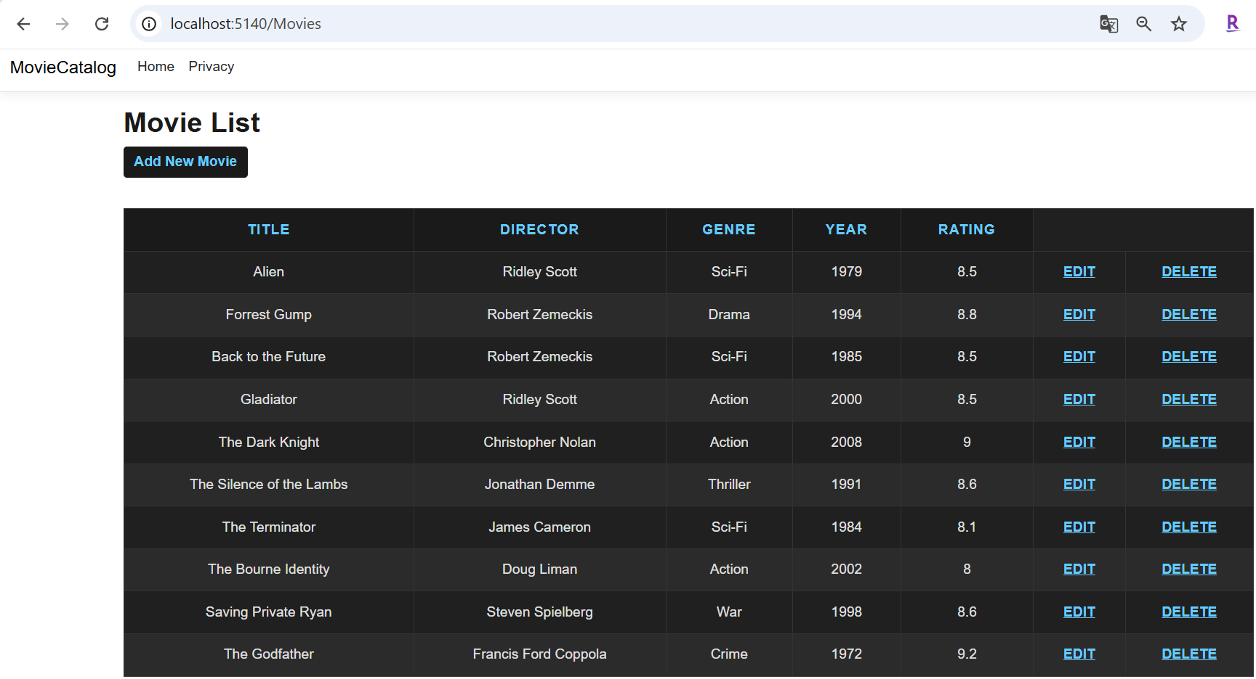

- Adding a Movie

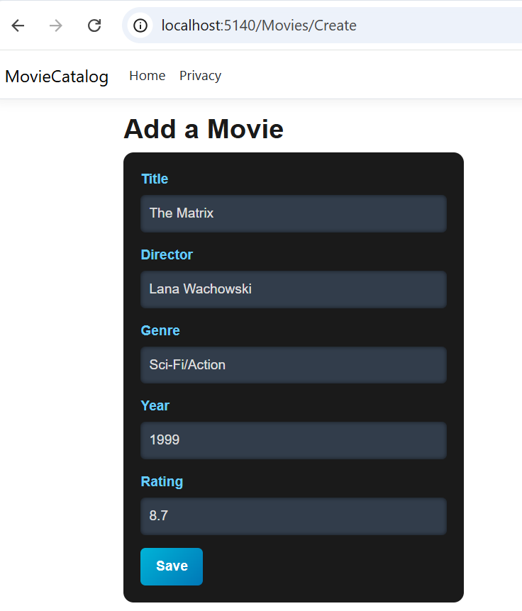

- Displaying and testing the validation functionality. The Year and Rating fields are optional.

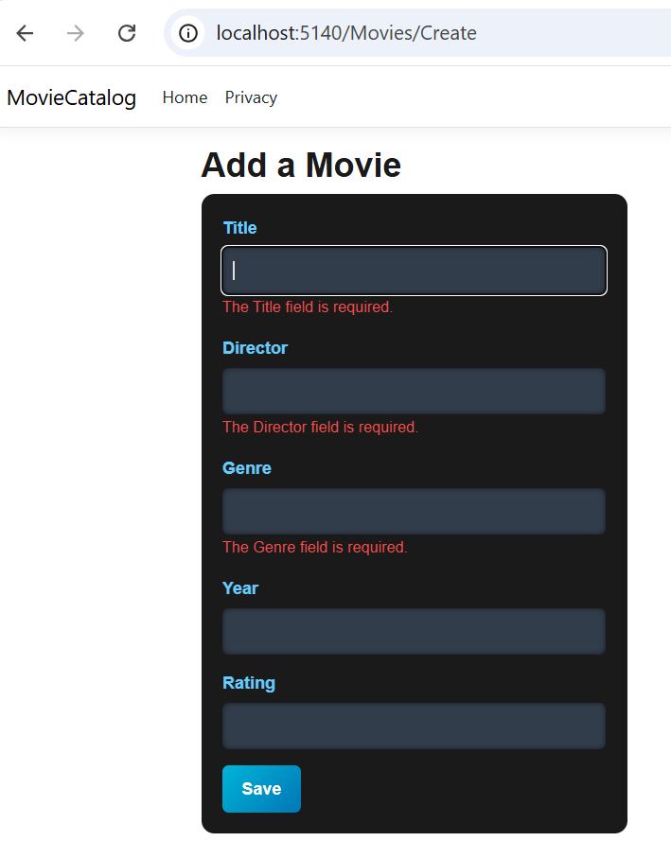

- Displaying the movie “The Matrix” added to the Movie catalog

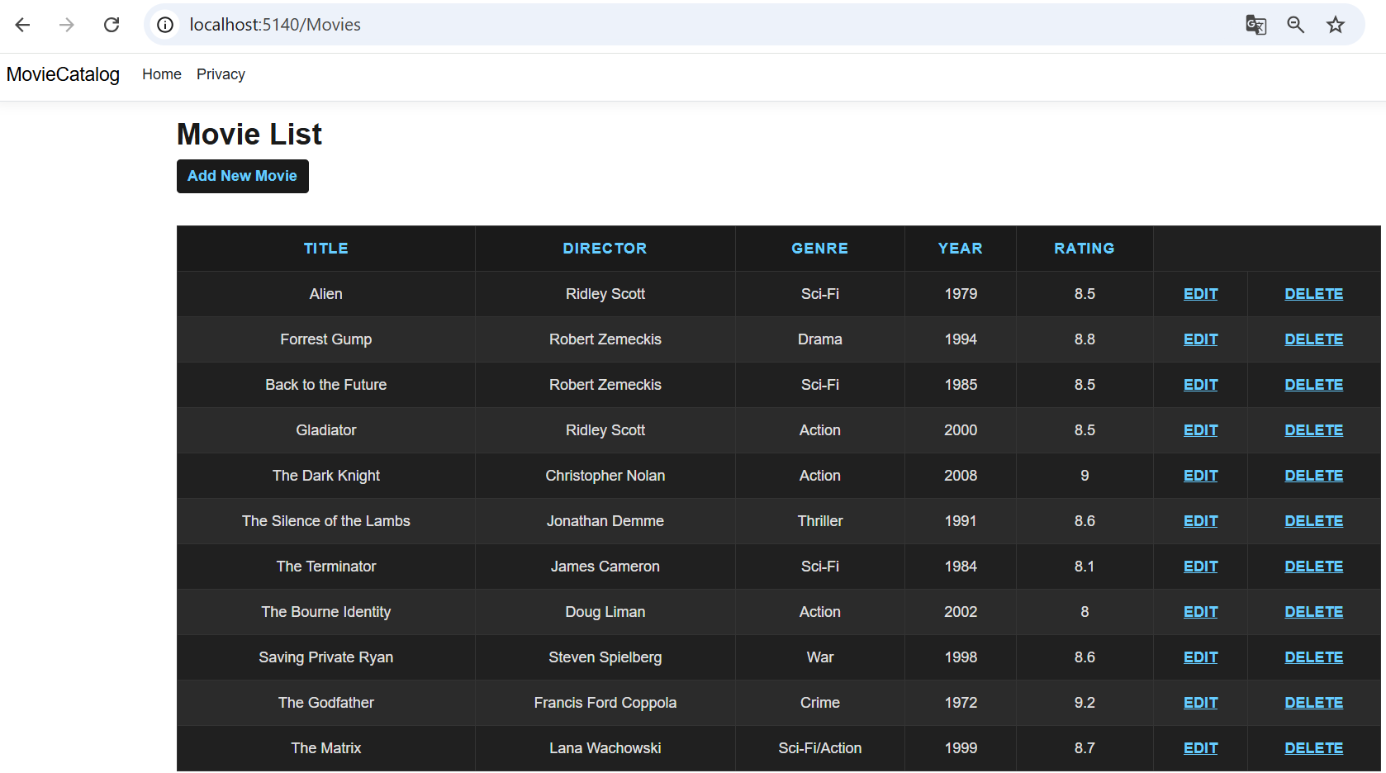

- Editing the movie “The Matrix”

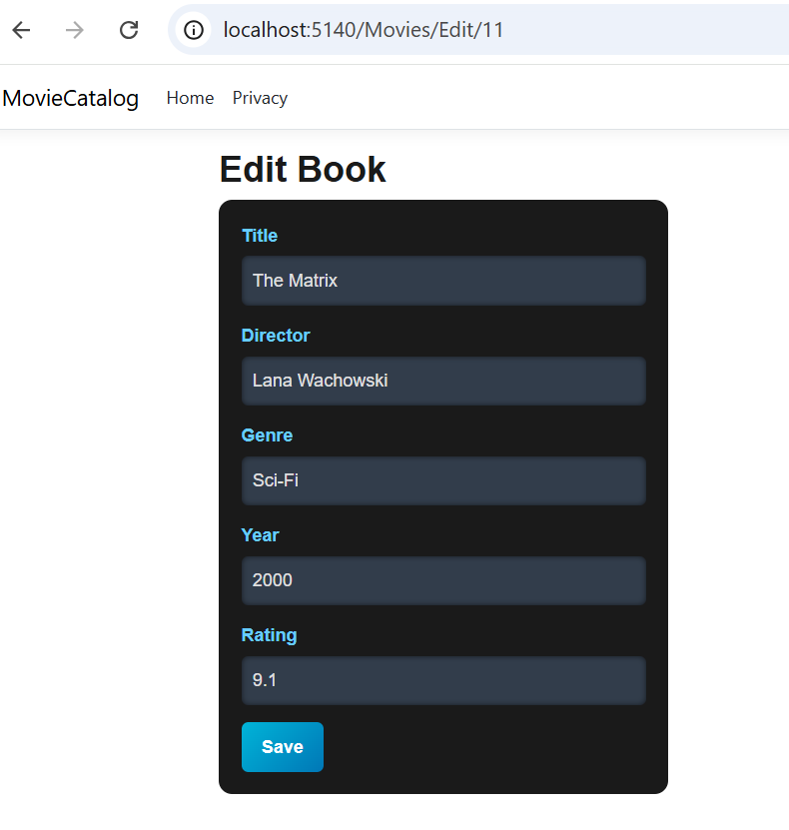

- Displaying Movie List after editing the movie “The Matrix” in the Movie catalog

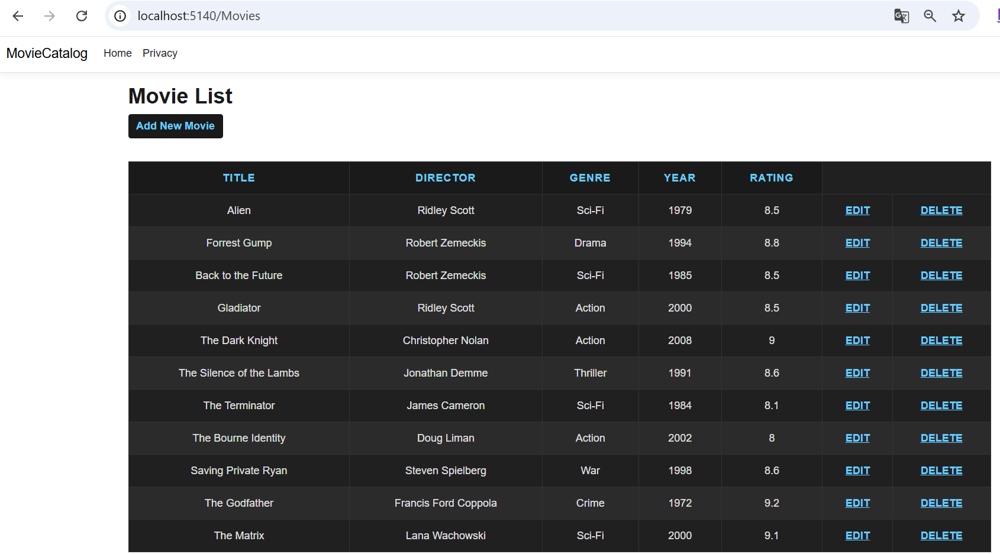

- Deleting the movie “The Matrix”

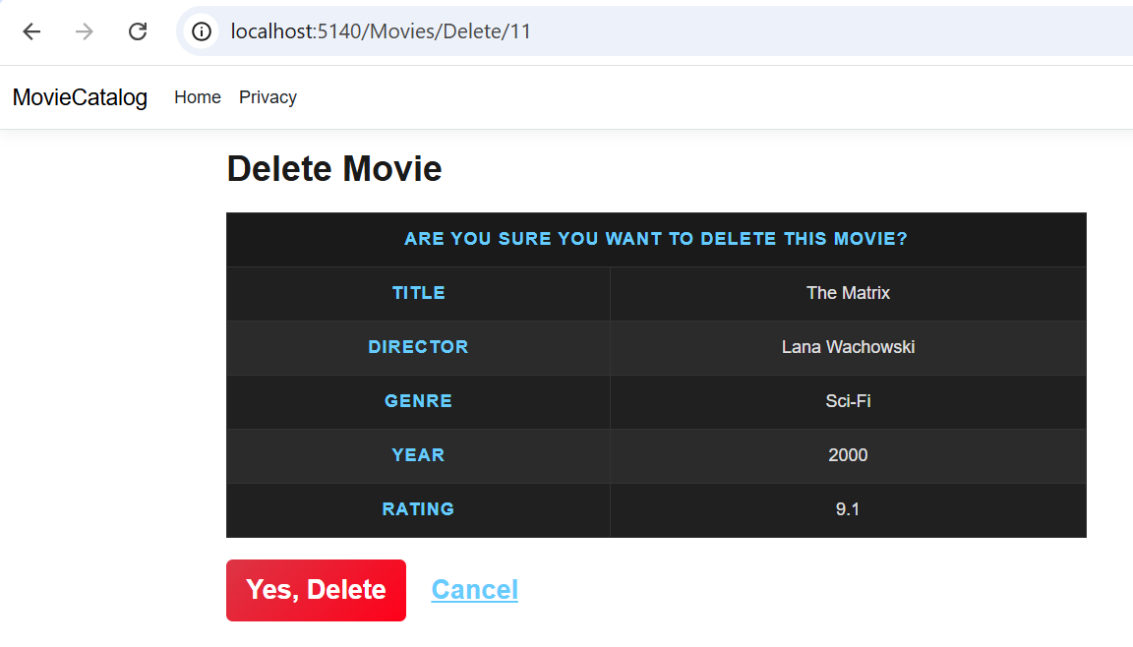

- Displaying Movie catalog after deleting the movie “The Matrix”

