Cell Growth Analysis

Neslihan Oztas

Table of contents

Exploratory Data Analysis (EDA) 2

Regression Modelling 3

Regression Model: Growth ~ Passage 3

Variance Adjustment 4

Variance Adjustment Using Residuals 4

ANOVA with Categorical Passage 5

Interaction: Treatment * Passage 6

Additive Model (No Interaction) 6

Univariable Model: Growth ~ Treatment 6

Linear Mixed Models (LMM) 6

Model: Growth~Treatment with Random Intercept for Passage 6

LMM with Treatment * Passage (Full Model) 6

Model Comparison with Maximum Likelihood 7

Visualization: Growth by Treatment & Passage 8

LMM Using lme4::lmer 8

Visualizing Random Intercepts with Fixed Slopes 9

Random Slopes: Mixed Model 9

## Exploratory Data Analysis (EDA)

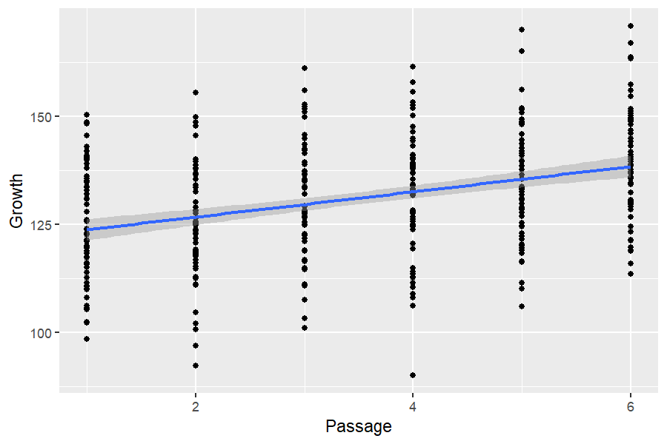

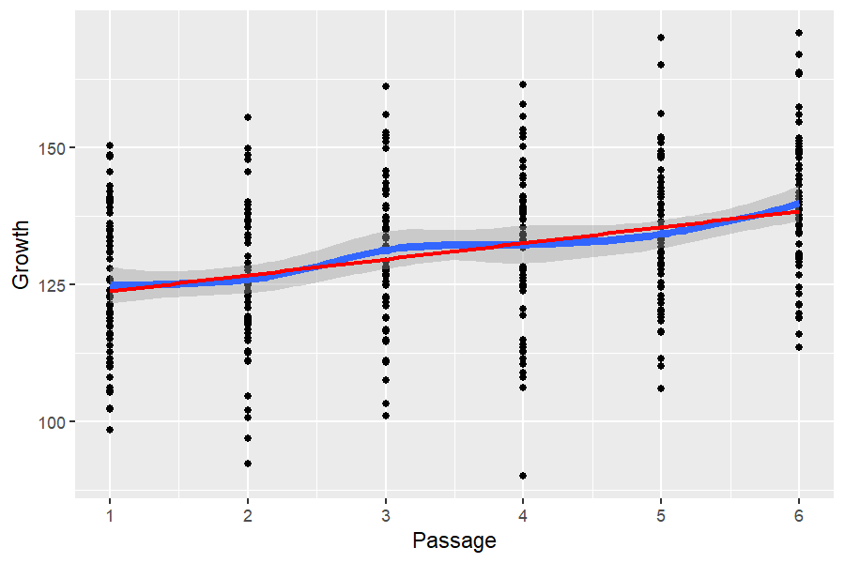

Shows rawdata trends using scatter plots. Adds regression lines (lm) to visualize trends. Growth appears to increase with Passage. A linear trend is visible, supporting the idea that passage influences cell growth.

## Regression Modelling

This takes 2 steps, building the model and computing p-values.

### Regression Model: Growth ~ Passage

Call:  
lm(formula = Growth ~ Passage, data = rawdata)  
  
Coefficients:  
(Intercept) Passage   
 120.834 2.927

# A tibble: 2 × 5  
 term estimate std.error statistic p.value  
 <chr> <dbl> <dbl> <dbl> <dbl>  
1 (Intercept) 121. 1.63 74.2 1.77e-219  
2 Passage 2.93 0.418 7.00 1.26e- 11

<br>

Analysis of Variance Table  
  
Response: Growth  
 Df Sum Sq Mean Sq F value Pr(>F)   
Passage 1 8996 8996.2 49.022 1.257e-11 ***  
Residuals 358 65698 183.5   
---  
Signif. codes: 0 '***' 0.001 '**' 0.01 '*' 0.05 '.' 0.1 ' ' 1

[1] 1.257266e-11 NA

# A tibble: 2 × 6  
 term df sumsq meansq statistic p.value  
 <chr> <int> <dbl> <dbl> <dbl> <dbl>  
1 Passage 1 8996. 8996. 49.0 1.26e-11  
2 Residuals 358 65698. 184. NA NA

**Intercept (120.834)**: Growth when Passage = 0. **Passage Coefficient (2.927)**: Each additional passage increases Growth by ~2.93 units. **Highly Significant (p = 1.26e-11)**: Passage strongly affects Growth (p < 0.001).

## Variance Adjustment

### Variance Adjustment Using Residuals

#To take out the variance due to Passage effects, we can use the residuals and shift them to the original mean:

# A tibble: 1 × 2  
 Growth growthAdj   
 <chr> <chr>   
1 131.1 ± 14.4 131.1 ± 13.5

<br>

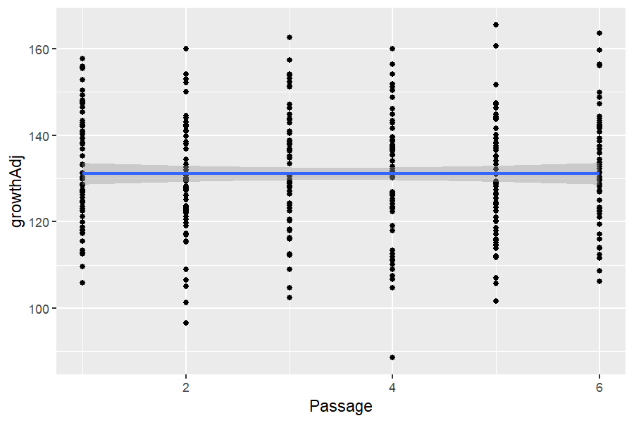

<br>

# A tibble: 2 × 6  
 term df sumsq meansq statistic p.value  
 <chr> <int> <dbl> <dbl> <dbl> <dbl>  
1 Passage 1 4.85e-26 4.85e-26 2.64e-28 1.00  
2 Residuals 358 6.57e+ 4 1.84e+ 2 NA NA

Removes Passage effects using residuals (good approach for standardization). Adjusted growth (growthAdj) no longer depends on Passage (confirmed by ANOVA). ANOVA results (p = 1.00) indicate Passage is no longer significant after adjustment.

### ANOVA with Categorical Passage

Call:  
lm(formula = Growth ~ Passage_F, data = rawdata)  
  
Coefficients:  
(Intercept) Passage_F2 Passage_F3 Passage_F4 Passage_F5 Passage_F6   
 125.440 -1.467 5.824 6.801 8.156 14.520

# A tibble: 6 × 5  
 term estimate std.error statistic p.value  
 <chr> <dbl> <dbl> <dbl> <dbl>  
1 (Intercept) 125. 1.74 71.9 2.20e-213  
2 Passage_F2 -1.47 2.47 -0.595 5.52e- 1  
3 Passage_F3 5.82 2.47 2.36 1.87e- 2  
4 Passage_F4 6.80 2.47 2.76 6.11e- 3  
5 Passage_F5 8.16 2.47 3.31 1.04e- 3  
6 Passage_F6 14.5 2.47 5.89 9.03e- 9

<br>

Analysis of Variance Table  
  
Response: Growth  
 Df Sum Sq Mean Sq F value Pr(>F)   
Passage_F 5 10134 2026.71 11.113 5.852e-10 ***  
Residuals 354 64561 182.38   
---  
Signif. codes: 0 '***' 0.001 '**' 0.01 '*' 0.05 '.' 0.1 ' ' 1

[1] 5.851856e-10 NA

# A tibble: 2 × 6  
 term df sumsq meansq statistic p.value  
 <chr> <int> <dbl> <dbl> <dbl> <dbl>  
1 Passage_F 5 10134. 2027. 11.1 5.85e-10  
2 Residuals 354 64561. 182. NA NA

The intercept value of **125.440** represents the mean Growth at **Passage_F1**, which serves as the reference level. Each coefficient for the other Passage_F levels indicates how much Growth differs compared to this baseline. For example, the coefficient for **Passage_F6** is **14.52**, meaning that at Passage 6, Growth is estimated to be **14.52 units higher** than at Passage 1. This difference is **highly significant** with a p-value of **9.03e-9**, suggesting that Growth increases significantly at higher passage numbers.

### Interaction: Treatment * Passage

Anova Table (Type III tests)  
  
Response: Growth  
 Sum Sq Df F value Pr(>F)   
(Intercept) 285160 1 2448.5613 < 2.2e-16 ***  
Passage 2723 1 23.3855 1.981e-06 ***  
Treatment 5635 2 24.1924 1.419e-10 ***  
Passage:Treatment 335 2 1.4376 0.2389   
Residuals 41227 354   
---  
Signif. codes: 0 '***' 0.001 '**' 0.01 '*' 0.05 '.' 0.1 ' ' 1

Passage effect is significant (p = 1.98e-6) → Supports previous results. Treatment effect is also highly significant (p = 1.42e-10) → Suggests Treatment impacts Growth. Passage × Treatment interaction is **NOT significant** (p = 0.2389). This means the effect of Passage on Growth does **NOT** depend on Treatment.

### Additive Model (No Interaction)

[1] 7.051564e-17 4.006053e-36 NA

# A tibble: 3 × 5  
 term sumsq df statistic p.value  
 <chr> <dbl> <dbl> <dbl> <dbl>  
1 Passage 8996. 1 77.1 7.05e-17  
2 Treatment 24137. 2 103. 4.01e-36  
3 Residuals 41562. 356 NA NA

Passage remains significant (p = 7.05e-17). Treatment remains significant (p = 4.01e-36). This model is better than the interaction model because Treatment and Passage independently affect Growth.

### Univariable Model: Growth ~ Treatment

[1] 5.549803e-31 NA

Treatment alone has a strong, significant effect on growth

## Linear Mixed Models (LMM)

### Model: Growth~Treatment with Random Intercept for Passage

Analysis of Deviance Table (Type II tests)  
  
Response: Growth  
 Chisq Df Pr(>Chisq)   
Treatment 210.17 2 < 2.2e-16 ***  
---  
Signif. codes: 0 '***' 0.001 '**' 0.01 '*' 0.05 '.' 0.1 ' ' 1

Treatment significantly affects Growth (**p < 0.001**). Passage is modeled as a random effect to account for baseline differences.

### LMM with Treatment * Passage (Full Model)

Analysis of Deviance Table (Type III tests)  
  
Response: Growth  
 Chisq Df Pr(>Chisq)   
(Intercept) 1666.2294 1 < 2.2e-16 ***  
Treatment 49.1952 2 2.077e-11 ***  
Passage 15.9137 1 6.630e-05 ***  
Treatment:Passage 2.9233 2 0.2319   
---  
Signif. codes: 0 '***' 0.001 '**' 0.01 '*' 0.05 '.' 0.1 ' ' 1

**Treatment** and **Passage** both have significant effects on Growth. The **interaction** between Treatment and Passage is **not significant.** This means their effects are **independent and additive.** The interaction model is **more complex**, but does **not improve the fit** over the simpler additive model.

### Model Comparison with Maximum Likelihood

Analysis of Deviance Table (Type III tests)  
  
Response: Growth  
 Chisq Df Pr(>Chisq)   
(Intercept) 2056.1734 1 < 2.2e-16 ***  
Treatment 49.7574 2 1.568e-11 ***  
Passage 19.6379 1 9.359e-06 ***  
Treatment:Passage 2.9567 2 0.228   
---  
Signif. codes: 0 '***' 0.001 '**' 0.01 '*' 0.05 '.' 0.1 ' ' 1

Use ML when comparing models (e.g., with or without interaction). Passage and Treatment affect Growth independently. No significant interaction, meaning Passage effects do not depend on Treatment.

## Visualization: Growth by Treatment & Passage

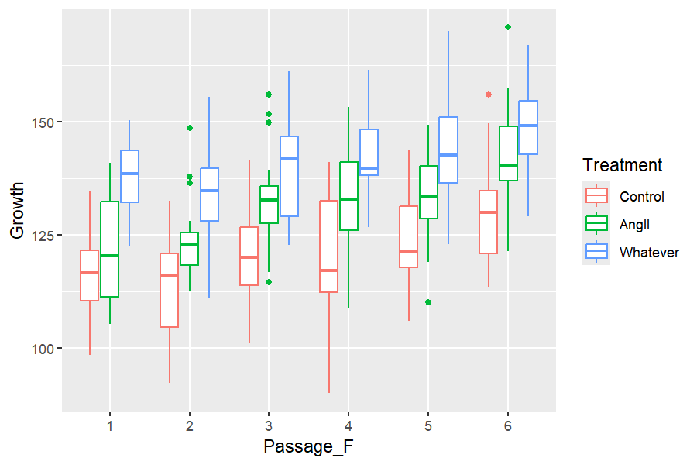

Growth increases with Passage. Treatment groups show consistent differences across passages. Some passages (e.g., 3, 5, 6) show higher variability.

### LMM Using lme4::lmer

Analysis of Deviance Table (Type II Wald chisquare tests)  
  
Response: Growth  
 Chisq Df Pr(>Chisq)   
Treatment 210.17 2 < 2.2e-16 ***  
---  
Signif. codes: 0 '***' 0.001 '**' 0.01 '*' 0.05 '.' 0.1 ' ' 1

# Fixed Effects  
  
Parameter | Coefficient | SE | 95% CI | t(355) | p  
------------------------------------------------------------------------------  
(Intercept) | 120.92 | 2.50 | [116.00, 125.85] | 48.30 | < .001  
Treatment [AngII] | 10.41 | 1.38 | [ 7.69, 13.13] | 7.52 | < .001  
Treatment [Whatever] | 20.05 | 1.38 | [ 17.33, 22.77] | 14.49 | < .001  
  
# Random Effects: Passage_F  
  
Parameter | Coefficient | SE | 95% CI  
-----------------------------------------------------  
(Intercept) [1] | -5.32 | 1.34 | [-7.95, -2.69]  
(Intercept) [2] | -6.70 | 1.34 | [-9.34, -4.07]  
(Intercept) [3] | 0.17 | 1.34 | [-2.46, 2.81]  
(Intercept) [4] | 1.10 | 1.34 | [-1.54, 3.73]  
(Intercept) [5] | 2.37 | 1.34 | [-0.26, 5.01]  
(Intercept) [6] | 8.38 | 1.34 | [ 5.74, 11.01]

“Whatever” treatment increases growth the most, followed by “AngII”. Random effects show substantial variability between passages. Fixed effects are highly significant.

### Visualizing Random Intercepts with Fixed Slopes

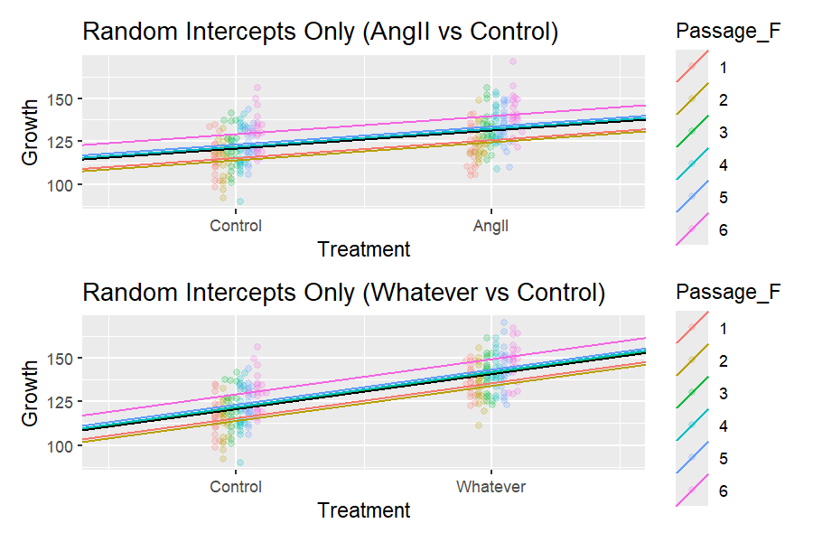

Each line represents a Passage_F group. They start at different intercepts (heights), but the treatment slopes are the same. This assumes all groups respond equally to treatment — which might be too simple.

### Random Slopes: Mixed Model

Now we extend the model to also include **random slopes**. This allows both the **intercept** and the **treatment effect** to vary for each passage.

Model: lme4::lmer(Growth ~ Treatment + (1 + Treatment | Passage_F), data = rawdata, REML = FALSE)

Analysis of Deviance Table (Type II Wald chisquare tests)  
  
Response: Growth  
 Chisq Df Pr(>Chisq)   
Treatment 202.85 2 < 2.2e-16 ***  
---  
Signif. codes: 0 '***' 0.001 '**' 0.01 '*' 0.05 '.' 0.1 ' ' 1

# Fixed Effects  
  
Parameter | Coefficient | SE | 95% CI | t(350) | p  
------------------------------------------------------------------------------  
(Intercept) | 120.92 | 2.26 | [116.48, 125.37] | 53.50 | < .001  
Treatment [AngII] | 10.41 | 1.48 | [ 7.50, 13.31] | 7.05 | < .001  
Treatment [Whatever] | 20.05 | 1.43 | [ 17.25, 22.86] | 14.06 | < .001  
  
# Random Effects: Passage_F  
  
Parameter | Coefficient | SE | 95% CI  
-----------------------------------------------------------  
(Intercept) [1] | -5.37 | 1.27 | [-7.87, -2.88]  
(Intercept) [2] | -6.34 | 1.27 | [-8.84, -3.85]  
(Intercept) [3] | 0.35 | 1.27 | [-2.15, 2.84]  
(Intercept) [4] | 1.10 | 1.27 | [-1.39, 3.60]  
(Intercept) [5] | 2.22 | 1.27 | [-0.28, 4.72]  
(Intercept) [6] | 8.05 | 1.27 | [ 5.55, 10.55]  
TreatmentAngII [1] | -1.42 | 0.34 | [-2.08, -0.76]  
TreatmentAngII [2] | -1.68 | 0.34 | [-2.34, -1.02]  
TreatmentAngII [3] | 0.09 | 0.34 | [-0.57, 0.75]  
TreatmentAngII [4] | 0.29 | 0.34 | [-0.37, 0.95]  
TreatmentAngII [5] | 0.59 | 0.34 | [-0.07, 1.25]  
TreatmentAngII [6] | 2.13 | 0.34 | [ 1.47, 2.79]  
TreatmentWhatever [1] | 1.00 | 0.24 | [ 0.54, 1.47]  
TreatmentWhatever [2] | 1.19 | 0.24 | [ 0.72, 1.65]  
TreatmentWhatever [3] | -0.06 | 0.24 | [-0.53, 0.40]  
TreatmentWhatever [4] | -0.21 | 0.24 | [-0.67, 0.26]  
TreatmentWhatever [5] | -0.42 | 0.24 | [-0.88, 0.05]  
TreatmentWhatever [6] | -1.51 | 0.24 | [-1.97, -1.04]

#### Visualizing Random Slopes by Passage

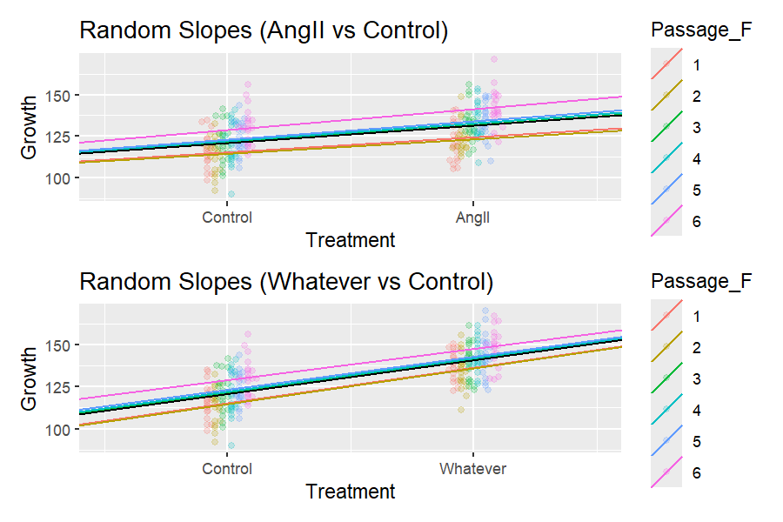

Now both intercepts and slopes vary across passages. Some passages react more strongly or weakly to treatment. This model reflects **real biological variability** much better than the intercept-only version.