NShare
A-Level Computer Science Project
Noah Torrance
Table of Contents
Analysis of the Problem 4
Problem Identification 5
Computational Approach 5
Application 5
Storage 5
Amenability 5
Post 5
Fax 5
Email 6
File Transfer Protocol 6
Stakeholders 7
Company Owner 7
Business Manager 7
Business Employee 7
Personal User 7
Research the Problem 8
Program Name 8
Features of Existing Solutions 8
OneDrive 9
MediaFire 10
MEGA 11
Discord 12
Findings 13
Primary Features 13
File Management 13
File Sharing 13
Accounts 13
Secondary Features 14
Encryption 14
User Discovery 14
Moderation 14
Previewing 14
Editing 14
Email Confirmation 15
Limitations 15
Specify the Proposed Solution 16
Requirements 16
Webserver 16
Fileserver 16
Database 16
Operating System 16
Client Device 16
User Management 16
Success Criteria 17
Design of the Solution 18
Decompose the Problem 19
Wireframe 20
Signup System 21
Login System 21
Upload System 21
Friend System 22
Describe the Solution 23
Usability Features 23
Data Structures 23
Sessions and Cookies 23
Key Variables 24
Users 24
Files 24
Links 24
Database 25
users 25
reports 25
files 25
Algorithms 27
Signup System 27
Describe the Approach to Testing 28
Final Product Testing 28
Registration 28
Login 28
File uploads 28
File share 28
Developing the Solution 29
Iterative Development Process 30
Testing to Inform Development 33
Evaluation 36
Testing to Inform Evaluation 37
Success of the Solution 38
Describe the Final Product 39
Maintenance and Development 40

Chapter 1
Analysis of the Problem

Problem Identification
I frequently copy files between devices and share them with friends, which I would typically do via a USB stick or email. This is something I see people doing often, so I want to make a program that makes this process easier.

Computational Approach

Application

A web-based application makes sense here because it would make the service available on mobile and desktop devices that will more than likely already have a modern web browser capable of running such an application. Using the same website on devices with different screen sizes is made possible with responsive web design. CSS and HTML events can react to different screen sizes and adjust the size of elements in response.

Storage

Storing files requires hardware. Storing a lot of files can be expensive and complicated, especially if multiple people need access to it at once. In Software as a Service (SaaS), companies who can afford to buy expensive storage hardware allow customers to use part of it to store their own files for a lower price compared to storing files locally. SaaS often provides the service through subscription models.

Not every user is going to use all of their storage space allotted to them. This problem can be solved with storage virtualisation. For example, if someone pays the company every year for a terabyte of storage, the server does not have to immediately partition 1TB of space on it’s hard drive for them. Instead, the user’s files would reside in a pool alongside everyone else’s files.

Data can automatically be compressed (by the client or server) as it is uploaded, and decompressed as it is downloaded to save space on the server and decrease transfer time.

Amenability
I will compare the process of sending a document to a recipient using different file sharing methods. I will also explain the pros, cons, and risks associated with each method.

Post
To transfer a document via the post, you need a envelope and stamp. You must take the prepared document to a post box or post office to send the document. The sender looses access to the document as it is physically sent to the recipient. The mail takes at least a day to send because it has to be collected, sorted, and delivered. At any stage, the mail could be delayed, lost, or damaged, though it is the only way to send the original physical document. Additionally, sending and receiving mail does not need an internet connection.

Fax
To transfer a document via fax, you need a fax machine, and a landline connection. You must scan or send the document to the fax machine, then dial in the number of another one. The document is sent without losing the original physical or digital copy. The speed is slow because it is being sent across phone lines, but the speed was acceptable for the time.

Email
To transfer a document via email, you need a device capable of sending emails, and an internet connection. You must attach the digital document to the email and send it to the chosen address. The speed is limited by the bandwidth of the provided internet connection and network cables.

File Transfer Protocol
The File Transfer Protocol (FTP) and Secure File Transfer Protocol (SFTP) are protocols that provides access to files over a network. After the FTP server is configured on the client device, it can mount to a users computer like any other storage drive, allowing the user to upload and download files from a remote location. This method is limited by the size of the server’s disks and network’s bandwidth.
To transfer a document, you log onto the server with the required credentials and upload the document to the server. Then the recipient can log onto the server from their device and download the document.
FTP is not encrypted, meaning any data sent to or from the server is vulnerable to a man-in-the-middle attack. If the document is in any way confidential, a secure protocol such as SFTP should be used instead.
This method is more advanced than sending an email. I believe a web-based solution would be accessible to more users, as well as being more mobile-friendly.

Stakeholders

Company Owner
The company owner is who I am writing the program for. They will own the final product, and it will become their company’s responsibility to maintain it when I have finished development. Their company will operate the servers that it runs on, as well as dealing with support and selling advertising space.

Business Manager
The business manager will use the program to share training materials to other employees. Sending documents like this is easier than emailing them. Employees can simply open the program to view and download the latest training materials, as well as previous ones.
An important feature for the business manager is encryption. Without encryption, confidential data such as sales reports and business plans that reside on the fileserver would be at risk of getting hacked by a competitor.

Business Employee
The business employee will use the program to share business documents within the business and with their customers because sending documents like this would cost less compared to post and fax.
They want to be able to access their files remotely so they can access and update important files while they are away from the office.

Personal User
The personal user will use the program to store media like photos and music. They can use it to share photos between friends. If encryption is used, the program because it is more secure than social media due to its encryption.

Research the Problem

Program Name
Before I go any further, the program needs a name. I kept it simple, taking the first letter of my name (N) and combining it with the main feature of my program (sharing) to create “NShare”.

Features of Existing Solutions
On the next few pages, I will research existing solutions of file hosting and sharing services to identify the appropriate features to incorporate into my own solution. The services I will be looking at are OneDrive, MediaFire, MEGA, and Discord.

OneDrive
Microsoft’s OneDrive is a file hosting service that allows users to store, share and synchronize work or school files. It integrates with the Microsoft Office suite allowing multiple users to edit and work on files at the same time. It is provided as part of a Microsoft 365 subscription.
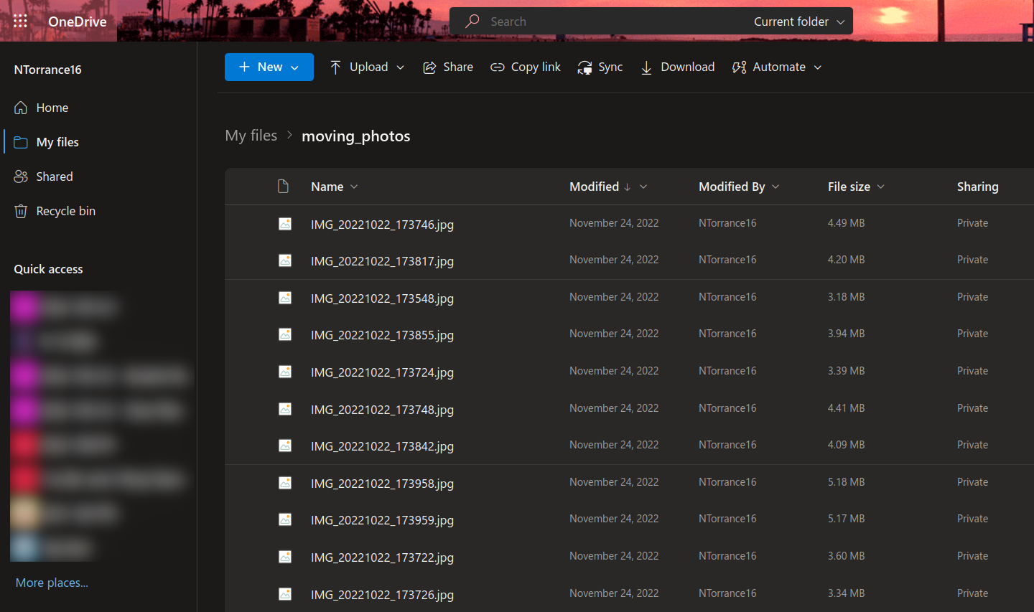
The OneDrive file manager.
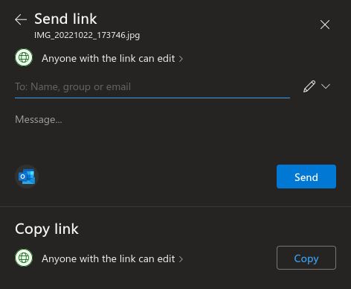Generating a file link.

OneDrive features a powerful sharing tool that allows users to share one or more files with specific people by setting different permissions.
Above the file list is a folder path that shows the user’s current location.

MediaFire
MediaFire is a web-based file synchronisation and cloud storage service. It provides a simple way to share files by generating a link to the file which anyone can use. The link takes you to a page with information about the file, such as the size, date of upload, and the IP address it was uploaded from.
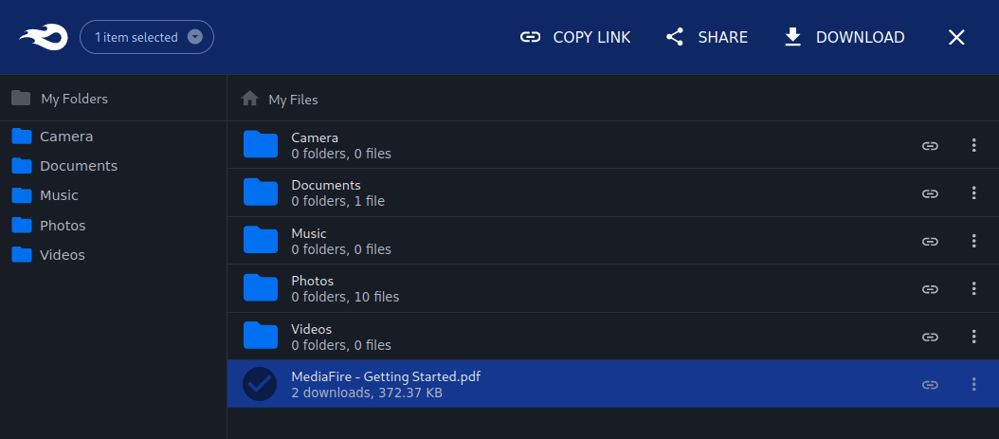
The MediaFire file manager.
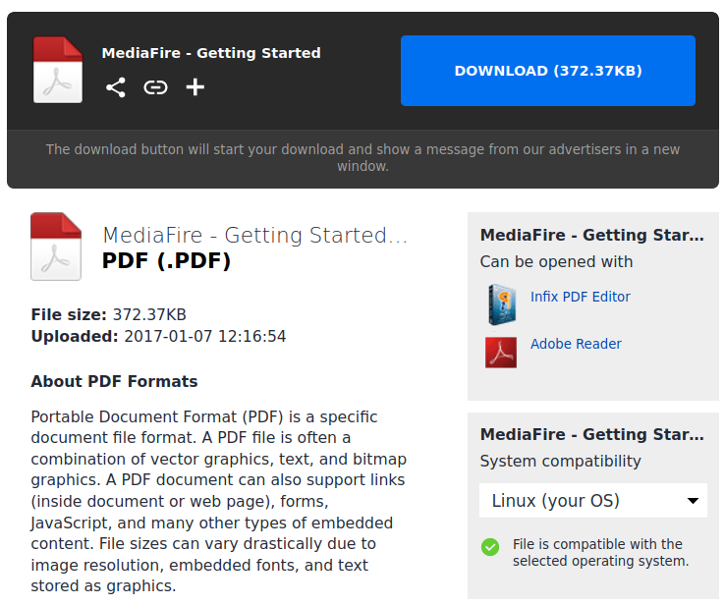Downloading a PDF document.

The file manager includes large and easy to use buttons that copy a link, share, and download selected files. They only appear when files are selected, replacing the upload button.
The folder list on the left serves as a quick way to navigate through folders.

MEGA
MEGA is a web-based cloud storage and file hosting service. It features end-to-end encryption to keep files secure as they transfer between the client and server. Even MEGA themselves cannot see the files because all encryption and decryption takes place on the user’s devices.
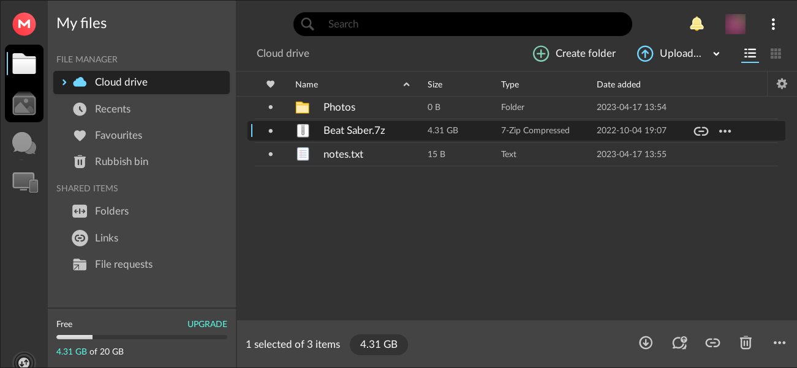
The MEGA file manager.
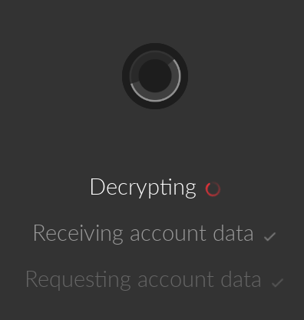Decrypting the user’s files.

MEGA has a well designed file manager with a good colour scheme. It makes good use of available screen space by showing detailed file information.
All data is end-to-end encrypted which makes their service more secure.
They offer an above average 50GB of free storage space to new users.

Discord
Discord is a social platform that allows for text messaging, voice calls, video calls, and basic file hosting. Users can create groups of multiple users which are known as “servers”. A useful feature is the ability to generate links that let other people join a server. Links can have an expiry date and a maximum amount of uses.
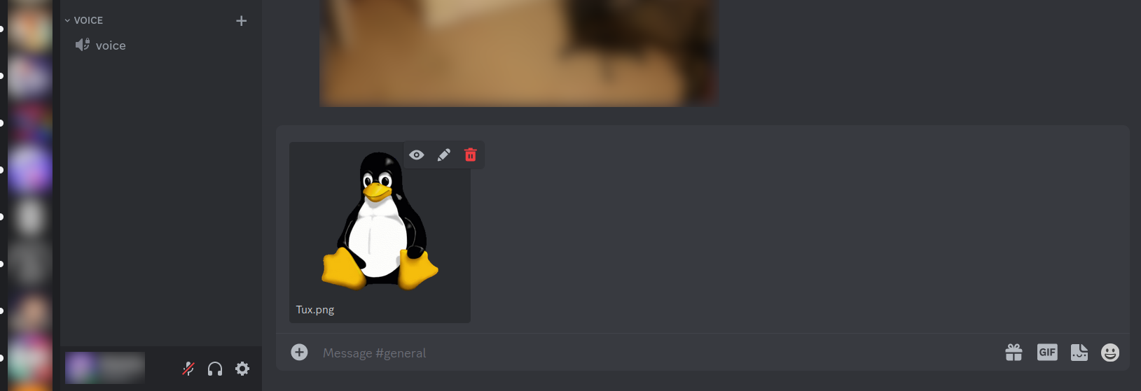
Uploding a PNG to a Discord server.
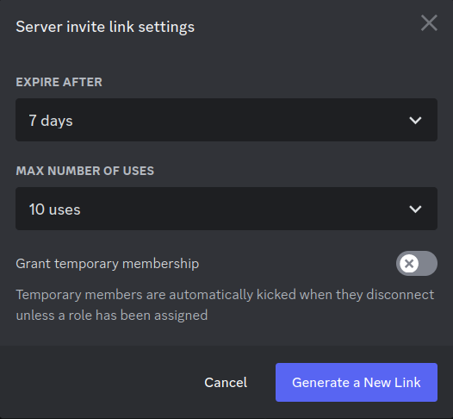Generating a server invite link.

Discord features a modern interface with an excellent colour scheme.
The link sharing feature is simple, but effective.

Findings
The various file managers have some common elements in their layouts. File information, such as the type, size, and modification date, are often included alongside the file. This makes the interface more useful, and files easier to differentiate. All four services allowed the user to share files via a link. Sending a link to others is simple, especially in Discord which include means to send messages to other users.
In all cases, I have found a range of subscription tiers with varying upload limits depending on the cost. These tiers are typically suited to personal users, professional users, and business owners. In a realistic environment, NShare would need to use a similar subscription model to cover server costs.

Primary Features

File Management
- Upload button to upload files to the server.
- Download button to download files from the server.
- Delete button to delete files on the server.
- Total file size limit to stop the total size of files going above allocated storage space.
A primary component of NShare will be the file manager, where the user will interact with their files. This needs to look nice and be easy to use. The file manager would have features similar to one in a desktop environment. For example, the user could select multiple files to act on them in one go. Users will also be able to create folders to organise their files. Acting on the folder should effect everything in the folder.

File Sharing
- Share button to share files with other users.
- Link button to copy the link of a file.
- Link settings to choose who can use the link.
Another core part of NShare will be file sharing, where the user can grant other users access to some or all of their files, and vice versa, allowing for convenient file sharing between users. I could implement link sharing from OneDrive and Discord and allow the user to to set an optional expiry date. Additionally, The link could be set to expire immediately after the first use for sharing more private files.

Accounts
- Create account form to register accounts and use the service.
- Account settings to update personal information.
- Delete account form to delete personal information and files.
Before you can upload and share files, you would need an account. Accounts would be created by providing information such as an email address, username, and password. The password should be hashed and stored in a database along with the other information.

Secondary Features

Encryption
- File encryption to improve privacy.
Without encryption, anyone with access to the server would be able to view the name and contents of every file from every user. For security and privacy reasons, it is important to encrypt the files such that it can only be decrypted by the owner and those the owner has shared the files with. Like MEGA, this can be achieved by using end-to-end encryption. However, file encryption is a difficult thing to implement correctly because modern encryption methods are very complex. Therefore, it will be a secondary feature.

User Discovery
- Account search tool to find other users.
- Add friend button to add user to friends list.
- Remove friend to remove user from friends list.
Using a search tool, the user will be able to be able to find other users and send them a friend request. When the user accepts the request, both users will have easier access to each other’s files.

Moderation
- File report form to report files that break the terms of service.
- Account ban form to ban accounts that upload files that break the terms of service.
There are numerous ways a bad actor could use file sharing services. Whether they upload illegal content or steal other user’s data, it is important to have an administration system where users who abuse the service can be reported and banned by a moderator if need be.
If a user shares illegal content to another person, that person should have the ability to report the file where it would be investigated by a moderator. The moderator should be able to respond in several ways. For example, they could dele the file, ban the account that uploaded the file, or ignore the report if it turns out to be false.

Previewing
- File preview button to preview the contents of a file.
While NShare is primarily a file hosting service, it would be useful to preview files before downloading them. Text, image, video, and audio files would be streamed from the server and embedded in the page.

Editing
- File edit button to edit the contents of a file.
As well as previewing text files, the user might also be able to modify them. The modified file would then replace the old one.

Email Confirmation
- Email confirmation to reduce fraud.
To ensure that accounts are created with a legitimate email address, a confirmation email could be sent to the user on signup.
Disposable email addresses are used to create multiple accounts under one person for online services that require an email address. In the case of file sharing services, disposable email addresses could be used to abuse the free storage given to new accounts.
When a user attempts to create an account with a disposable email address, NShare should be able to check if the address is from a disposable email provider. Additionally, a confirmation email should be sent to the user. They would be required to enter the code from the email into the signup form to confirm they own the address.

Limitations
This will be a web-based application, which means the user will need a computer with a web browser, as well as an internet connection to use the service. The user should have basic IT skills including knowledge on files and directories, website navigation, and subscription models. Because of this, people who are too young or too old to have regularly used a computer would not be able to use NShare without some trouble.
As I will be developing my program on a test server, there will be limited amounts of disk space, memory, and processing power. Less disk space means less files can be uploaded to the server. Less memory and processing power means less users can interact with the server at the same time. This is fine for development purposes, but the program would need to be hosted on a bigger server for a real deployment.

Specify the Proposed Solution

Requirements

Webserver
NShare is a cloud service which will be accessed through a website. I will be using an Apache webserver to host the website. Additionally, I will use PHP which runs server-side scripts that send and receive data from a database to create dynamic web pages.

Fileserver
Many users will be uploading and sharing their files on the service, which means a massive amount of storage space would be required. If the company decided to buy their own servers then they should use magnetic storage to host the user’s files. This is because magnetic storage is cheaper than solid state.
In most cases, hard disk drives are less reliable than solid state drives, but that downside negligible because most users will not be using NShare as frequently as they would their own local storage. An operating system on secondary storage constantly reads and writes to the drive, whereas the server’s drives would only be in use when the users are modifying files.
If the amount of data is too large to fit on the company’s servers or the storage cost is too high, servers rented at a data centre could be used instead. One downside is the lessened control the company has over the user’s data. Additionally, the company would have less or no control over resource allocation, user data, and network speed which could negatively affect the user experience.

Database
A database is a large data structure that organises data into rows in tables. I will need a database server for the long-term storage of user data. For this, I will use MariaDB which is based on MySQL.

Operating System
The servers that host the website and files should be secure and stable. NShare should be ran on Linux distribution that meets this criteria, such as Debian, Ubuntu, or CentOS.

Client Device
NShare is designed to run on modern web browsers such as Google Chrome and Mozilla Firefox. Most computers and smartphones already include a web browser, therefore NShare will be widely available and easy to access.

User Management
To allow multiple users to use NShare, user management systems will be required. Users will be able to create and edit their own accounts and moderators will enforce the terms of service by responding to ban reports. Users will also be able to delete their accounts, which is necessary due to the General Data Protection Regulation which gives user’s the right to delete their personal data held by organisations.

Success Criteria
These are essential features that all stakeholders want:
- Create an account
- Manage account settings
- Delete account
- Login and logout
- Upload files
- Download files
- Delete files
- Share files via a link
- Manage link settings
- Adjustable storage space limit for subscription tiers
These are non-essential features that only some stakeholders want:
- File encryption
- File reporting
- Ban and unban accounts
- Search for other users
- Add and remove users to a friends list
- Preview files
- Edit files
- Email verification

Chapter 2
Design of the Solution

Decompose the Problem
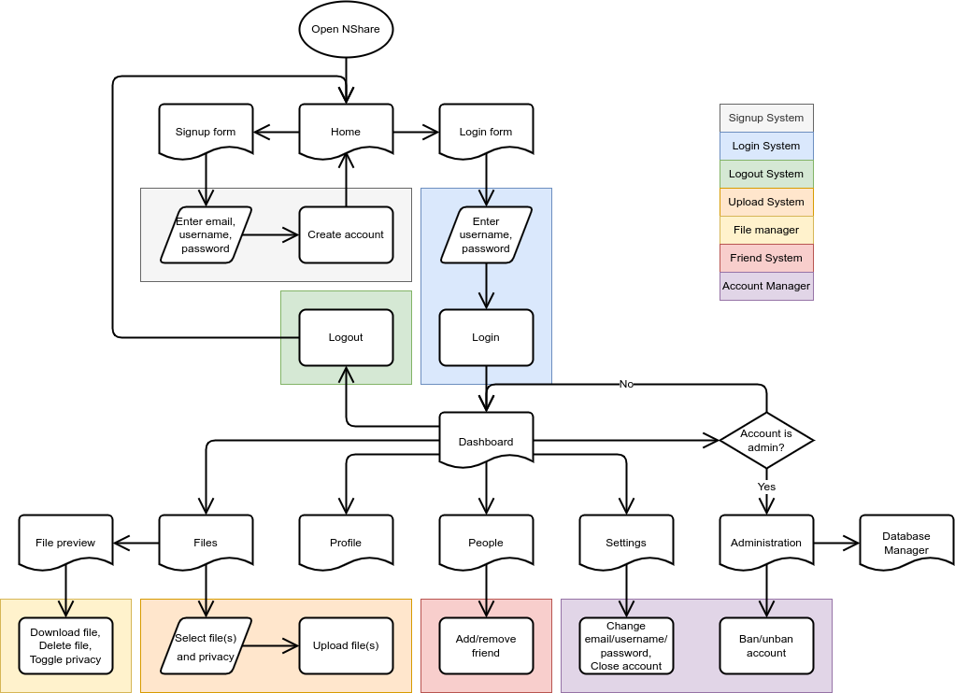
Taking all of the primary (and some secondary) features into consideration, this flowchart shows how the user interacts with the website, alongside a broad overview of the processes that can happen on each page. I will use data flow diagrams to show how user input will be processed for each of these processes.

Wireframe
I have created a website wireframe of the file manager which is the design I will work towards.
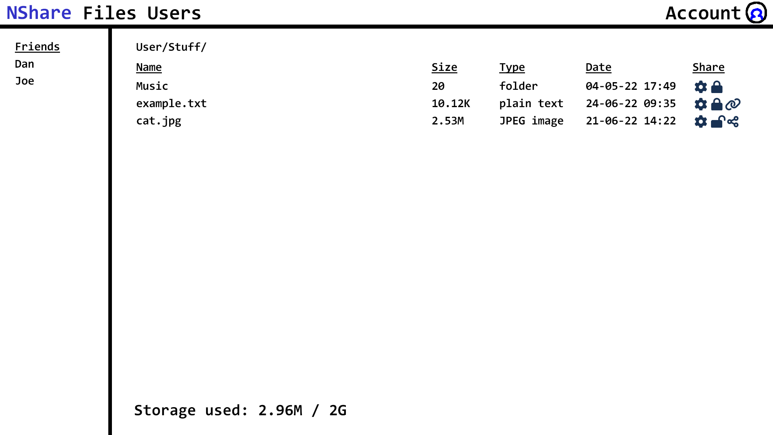
Above every page there will be a navigation bar containing links to frequently accessed pages, such as the home page, file manager, and account settings. The right window contains a file and folder lists file information and sharing options. To save space, I have used icons which will open sharing and link settings similar to OneDrive. There is a file path to show where the user is, and a storage counter which states their used and remaining storage space. The left window contains a convenient friends list where files shared with the user can be accessed.

Signup System
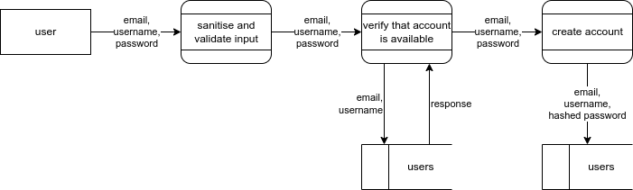
The signup system will create accounts. It will take an email, username, and password; verify that there are no existing accounts with the same email and username; and insert a new user entry into the database.

Login System
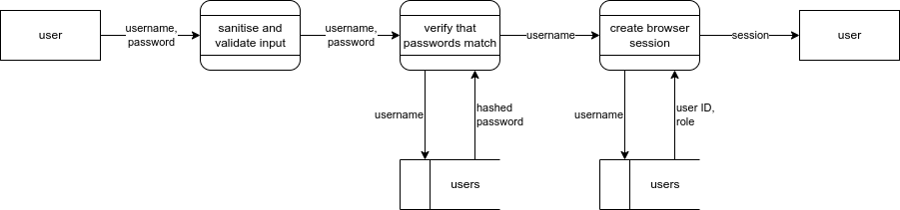
The login system will let users log into the website. It will take an email or username, and a password; verify that the password matches their one in the database; and create a browser session with their data, which logs them in. Simple sentence link together

Upload System
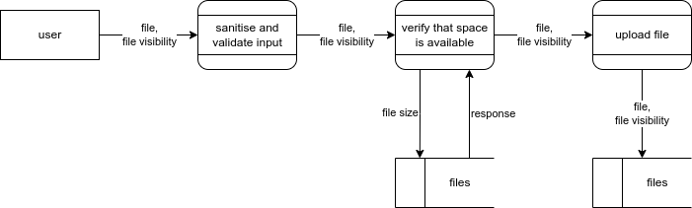
The job of the upload system will to handle the uploading of files onto the server. It will take a file along with some additional data, like the visibility (who can see the file), the upload date, etc; verify that there is enough space on the server and in the user’s quota; and send the file to the server.

The size of newly uploaded files is added to a total. When the total reaches the user’s assigned storage capacity the program should prevent them from uploading more files until old ones are deleted or more storage space is purchased.

Friend System
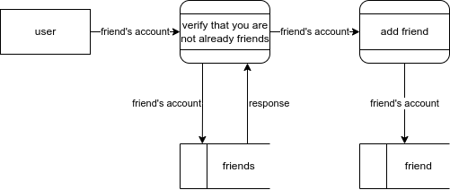
The friend system will add and remove accounts from the user’s friends list. To add a friend, it will take the account of the desired friend and verify that they are not friends already before adding them, and vice versa for removing a friend.

Describe the Solution

Usability Features
I will ensure that the website is responsive, so that it can work on both desktop and mobile devices. The elements will be able to dynamically resize and reposition themselves in response to different screen sizes. This will make it easier to use on mobile devices, allowing business employees to access important files from anywhere.
The website should contain an easy to use navigation menu. This is where the main sections of the website will be. The overall layout of the various pages should only be as complex as they need to be.
I will make sure to use a legible font family with an appropriate size and style to ensure that text is easy to read, especially for users with visual impairments.
I could make the website more accessible to users with disabilities. I could include alt title tags for icons and images I use in the interface. I could also make it possible to navigate the website with a keyboard.
Finally, the website should load quickly and run well without stutters, because users are less likely to stay on a website if it takes too long to load. This should not be a problem over the course of my project’s life cycle, but pages might become more complex during future maintenance and development.

Data Structures
For short-term storage that is only needed for as long as the user is on the website, sessions can be used. These are variables and arrays that are stored server-side. When the user closes their browser, they loose their session data.
For long-term storage that needs to persist after a user has ended their browser session, cookies can be used. These are like sessions, except they are stored client-side and persist after a session ends. Cookies can contain a variable or array, as well as their expiration date. Because cookies are client-side, they should not be used to store account information because that would be unsecure and impractical.
For long-term storage of account information, a database should be used. This is a large data structure that organises data into rows in tables.

Sessions and Cookies
There are a few session variables used to store the user's session data. Their account information, such as their user ID, username, and role is used to create a browser session. NShare uses this information to verify that the user has the correct credentials to access their account and certain areas of NShare.
When the browser is closed the session would be lost, meaning the user would need to sign in again. This could be solved with cookies. The user could store a cookie that contains a unique key that is linked to their account. If NShare recognises the key, the user’s data could be loaded without entering their credentials. A security risk with this method is that a bad actor could extract the key from the user’s browser. Then they would have access to the user’s account until the cookie expires.

Key Variables

Users
Variable | Type | Purpose | Validation | Justification
username | string | Account identification | Must be unique | If more than one account shares the same username, the login system would break
password | string | Account verification | Must be at least 8 characters long  Must be a mix of letters, numbers, and symbols | Password must be secure because it protects the user’s files and personal information
email | string | Account verification and alerts | Must be unique  Must be a valid email address | If more than one account shares the same email, the login and alert system would break

Files
Variable | Type | Purpose | Validation | Justification
filename | string | File identification | Must be unique | If more than one file shares the same filename, the file system would break
size | integer | Monitoring used storage | Must not exceed total file size limit | The user cannot use more storage than what their plan allows
visibility | boolean | File visibility

Links
Variable | Type | Purpose | Validation | Justification
link | string | File link | Must be unique and random | If more than one link shares the same URL, the link would break

Database
The nshare database is made up of five tables. Each table has a primary key that gives each record a unique number so that it can be referenced in other tables. A primary key in another table is called a foreign key. The main table is users which has a foreign key in bans, friends, and files. Lastly, files has a foreign key in links.
I will explain some of the fields in these tables, most of them are self-explanatory so I will not explain those.

users
The role field represents the user’s access level. 0 is for everyone, the default for new accounts. Everyone has access to the file manager and account explorer. 1 is for moderators. They can view account reports/appeals and ban/unban accounts. 2 is for administrators. They can view and edit the database directly.
The visibility field represents how visible the user’s account is. 0 is private. The user’s account will not show up in the account explorer. 1 is public, the default for new accounts. The user’s account will show up in the account explorer. This means that other users can find, view, and send a friend request to them.

reports
The action field represents what the user is requesting to do. 0 is a ban request. The user has found an illegal file and has chosen to report it. The file and the account that uploaded it will be investigated by a moderator. 1 is an unban request. The user’s account has been banned but they believe that the ban was undeserved.

files
The visibility field represents how visible the file is. 0 is private, the default for new files. Only the file’s owner can view it, unless someone follows an active link to it. 1 is public. Everyone can view the file.

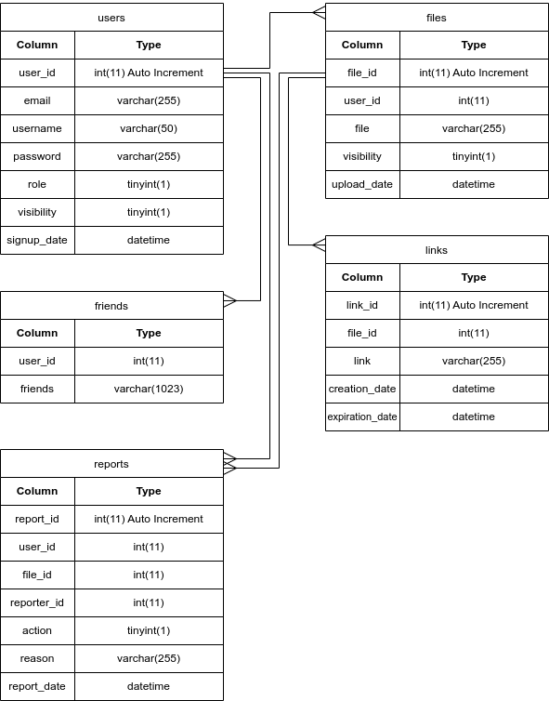

Algorithms

Signup System
create_account(email, username, password) {
# validate_email() returns false if the email is invalid, e.g. missing @
if(validate_email(email) == false) {
return false
}
if(username.length > 50) {
return false
}
if(password.length < 8) {
return false
}

# check for duplicate email or username in database
# if row_count is greater than 0, an account already exists
if(sql_command("SELECT * FROM users WHERE email = " + email + " OR username = " + username + ";").row_count > 0) {
return false
}

# password is hashed for security
password = hash(password)
# valid account data is inserted into the database
sql_command("INSERT INTO users (email, username, password) VALUES (" + email + ", " + username + ", " + password + ");")

return true
}

Describe the Approach to Testing
When I add or change a feature of the website or server, I will run a test. Each test will contain an ID, the elements being tested, the type of elements, the pages those elements are on, inputs the user makes, the expected result, the actual result, and its status, which can be a pass, fail, or partial pass. If the test is successful, I will commit the change and move on.

Final Product Testing

Registration
- Navigate to the Create Account form at user/signup.php or admin/index.php.
- Input a valid email address, username, and password.
- If at user/signup.php, solve the CAPTCHA. If at admin/index.php, select a role, either Member or Admin.
- Submit the form by clicking Create.

Login
- Navigate to any page while not logged in.
- Click on Login in the header to bring up the Login form.
- Input a username or email, and password.
- Submit the form by clicking Login.

File uploads
- Navigate to the file manager at files/index.php.
- Click Upload to bring up the Upload form.
- Select the visibility, either Private or Public.
- Click Browse to bring up the system’s upload dialogue.
- Select one or more files to upload.
- Confirm the selection and the form will submit automatically.

File share
- Navigate to the file manager at files/index.php.
- Set the file’s visibility to public by clicking on the button under Visibility.
- Click on the file to open it.
- Copy it’s URL and send it to the recipient.
- As long as the file’s visibility is set to public, the recipient can open the link and download the file.

Chapter 3
Developing the Solution

Iterative Development Process
For the front-end, I knew that I would need to use several programming languages, those being HTML, CSS, and JavaScript. The first part of development was creating a basic website that I could build from. For convenience, I decided to use W3.CSS, which is a modern responsive CSS framework. This way, I could create UI elements that work well together on many display sizes.
The website stores and fetches user data to and from a database. I chose to use PHP for this task, which can execute SQL commands and display the output on the website. The first system I programmed was the signup system. This was where users can input an email address, username, and password to create an account. To execute SQL commands in PHP, I used PDO, an API that supports many databases. I am using a MariaDB database which is based of MySQL.
Security was a priority, so implemented the PHP password_hash function. This uses the bcrypt algorithm to hash and salt passwords before they are stored in the database. All SQL queries are prepared, meaning their inputs are escaped which prevents SQL injection and XSS attacks.
Once the account system was in place, I started development of the file manager. When a user creates an account, an associated directory is made on the server named with their unique username. The user can choose a file which is sent via POST to the server. It is then moved to their directory. To view and manage these files, I created a script that would read files in the users directory and display them in a list. The user can click on a file to download it.
As a quick way to share files, I created a public folder that anyone can access. This is similar to the way you could share files with a team in Microsoft Teams. At the moment, every account has access to the public folder. The stakeholders require a way of sharing files between specific people so I need a better solution for sharing files.
Now that files can be uploaded, they needed a way to be deleted. I simply added a delete button next to each file. The button spawns a popup (modal) that the user must confirm before deleting the file. This will help avoid accidental deletion.
If a user types in a value that the database cannot take, the program crashes. I started validating the input in JavaScript before sending it to the server. I realised that a user could bypass JavaScript because it is processed locally, so I added validation in the PHP scripts to ensure that it cannot crash. I will continue to validate all inputs in the future.
I needed to prevent users from accessing a restricted page. For example, a user could type in the URL of the settings page to access it without logging in. To fix this, I simply checked their role. If they do not have a role, they must not be logged in. If they have a role therefore, they must be logged in. Additionally, access to administrator pages is restricted to admin roles only.
To help the user better understand what the program is doing, I added a notification system that can display a message on the bottom of the screen. On completion or failure of a JavaScript script or PHP script, it returns a message which states what it did. This way, the user can clearly see if and why the program failed to execute.
I added the ability for users to change their password. I did this for a few reasons: The user should be able to make their password more complex to increase security, and if their password is compromised, they need a way to change it. I also made it possible to change other details, such as their email and username.
In a similar vein, users can now close their account which deletes all information about them, as well as their files. Users have a right to remove their information from the service, if they so choose.
To save time and space, I took some common PHP functions and moved them to a separate file. When I need a function, going to the previous page for example, I can simply include the code and call the function instead of redefining it. This also has the advantage that changing the function will change it everywhere it is included.
I have added a basic file viewer to the file manager. Before, when clicking on a file, it would just download it. Clicking on a text, image, video, or audio file opens a new page that displays the file along with additional metadata. Additionally, text files can be edited and saved.
The current file manager doesn’t make good use of space. I have redesigned the file manager to fit more files on screen. I also added a sidebar which will list folders, or something else. The sidebar doesn’t collapse which makes the file manager unusable on mobile. I will add this function later because personal users want to use NShare on their phones.
I created a profile page where a user can see their account information, such as their name and role. By changing the ID in the URL, the user can also see profiles of other users. I should add a proper way of finding specific users in the future.
Until now, only the user who uploaded a file can access it. Now, the user can set it’s privacy from private to public and any user with it’s URL can access it. This is a more private way of sharing files. Instead of incrementing the file ID, I could randomize it. This would make finding files through brute-force much harder.
The file manager now uses a table to display files. Similar to desktop file managers, file details are shown in columns. These columns show the file’s name, size, modification date, and privacy.
Previously when a user creates an account, an associated directory is made on the server named with their username. Instead, the directory now uses their user ID because a username with special characters could potentially break something in the filesystem. Not only are IDs unique, they also cannot change, making them the logical choice.
During my research, I found that there is typically a range of subscription tiers with varying upload limits depending on the cost. For the time being, I have implemented a 5 gigabyte file limit. I will make this adjustable in the future.
Currently, when a file is uploaded it’s metadata is stored in the server. The file manager selects this data from the database and displays it on the page. Because of this system, I am not sure how to represent folders in the database. Before I implement folders, I want to simplify this process. Instead of reading metadata from the database, I could read it directly from the files instead.
I decided to add a CAPTCHA to the signup page to potentially prevent bots from creating accounts. I went with hCaptcha because it’s free and was relatively easy to set up.
Another feature I needed to add was moderation. Administrators can now ban a user who breaks the terms of service. The terms of service has not been established yet, but that does not matter at this stage. The only thing a banned user can do is download their files. After a week, their account is deleted. If the ban was in error, their account can be unbanned.
Changing a files privacy, or any other setting, requires a page reload to show what happened. This is because PHP can only modify a page server-side, before it is sent to the client. JavaScript however, can modify the page client-side. Using JavaScript, I can trigger an XML request which sends a GET request to a PHP script on the server. This technique is known as AJAX, which will allow the user to change options without reloading the page. Currently, only the privacy toggle uses AJAX. Moving forward, I will try to use it in more processes for a smoother user experience.
I have added a user browser that displays a list of every account. Users can find and friend other users, the goal being to make it easy for friends to find each other and share files. Adding a search bar would be very useful for locating known accounts, but this has not been added yet. The list also has no pagination, meaning the list extends well below the screen. I must add search and pagination later on.
To ensure that accounts are created with a legitimate email address, I have implemented a disposable email checker to the signup page. When a disposable email address is used, a library checks if the address is from a known disposable email service. This is not perfect because there could be a service that is not on the library’s blacklist, but it is better than nothing.
For convenience, the user can now select multiple files by clicking on checkboxes next to the filename. There is also a checkbox in the header that can select and deselect all files. At the moment, the user can delete the selected files. I will add support for downloading later.
I have added a friends list next to the user browser. In the future, this is where permissions would be managed on an account level. For example, an account could have permission to download files, but not to modify or upload them.
I have updated the notification system. They now have a progress bar which shows when the notification will expire. The border and progress bar turns red when a script fails, making it clear to the user when something goes wrong.
Until now, I have used the page header code in multiple files. I have moved this code, and other common elements, into their own files. Now, I simply include these files where they are needed. This makes the code much easier to maintain because changing the common elements will change it everywhere they are included.
Accounts in the user browser are supposed to be sorted alphanumerically. Letters are sorted correctly, but numbers are not. 10 comes before 2 because the first digit in 10 is 1, which is less than 2. I fixed this by sorting accounts alphanumerically, then by length.
The file manager now darkens the screen and displays a loading spinner to communicate to the user that a file is uploading.

Testing to Inform Development
Video evidence: https://2-12.co.uk/~ntorrance
ID | Element | Type | Input | Expected | Actual | Status
1 | admin page, ban form | text box | enter username | User should not be banned more than once | User is not banned more than once | pass
2 | admin page, unban form | text box | enter username | User should be unbanned | User is unbanned | pass
3 | banned page, profile links | link | click | Profile page should open | Profile page is opened | pass
4 | folder page, privacy button | button | click | Privacy of file should toggle | Privacy of file is toggled | pass
5 | settings page, pagination | button | click | Current page should be highlighted | Current page is highlighted | pass
6 | folder page, upload button | button | click | File chooser should open and selected file should upload | File chooser opens and selected file is uploaded | pass
7 | any page, invalid link | link | click | Invalid link should open 404 page | Invalid link opens 404 page | pass
8 | 404 page, back button | button | click | Previous page should open | Previous page is opened | pass
9 | any page | document | NA | All pages should use a dark or light theme depending on browser settings | Dark or light theme is used on all pages except 404 page | partial
10 | any page | link | click | URL should not show “html” or “php” file extension | URL does not show “html” or “php” file extension | pass
11 | settings page, email form | text box | enter email, enter new temporary email | New temporary email should be rejected | New temporary email is rejected | pass
12 | settings page, email form | text box | enter email, enter new temporary email | New temporary email should be rejected | New temporary email is accepted because it was not on the blacklist | fail
13 | user browser page, add friend button | button | click | New friend’s ID should be added to user’s friends list | New friend’s ID is added to user’s friends list | pass
14 | user browser page, add friend button | button | click | New friend’s ID should be added to user’s friends list | New friend’s ID is added to user’s riends list | pass
15 | signup page, signup form | text box | enter email, enter username, enter password, solve CAPTCHA | Record is added to friends table when account is created | Record is not added to friends table | fail
16 | signup page, signup form | text box | enter email, enter username, enter password, solve CAPTCHA | Record is added to friends table when account is created | Record is added to friends table | pass
17 | user browser page, add friend button | button | click | New friend’s ID should be added to user’s friends list and vice versa | New friend’s ID is added to user’s friends list except it can be added multiple times | partial
18 | user browser page, add friend button | button | click | New friend’s ID should be added once to user’s friends list and vice versa | New friend’s ID is added once to user’s friends list | pass
19 | signup page, signup form | text box | enter temporary email, enter username, enter password, solve CAPTCHA | Temporary email should be rejected | Temporary email is rejected | pass
20 | folder page, files list | checkbox, button | click | Selected files should be deleted | Selected files are deleted | pass
21 | folder page, files list | checkbox | click | All files should be selected | All files are selected | pass
22 | folder page, files list | checkbox, button | click | Delete button should be disabled when no files are selected | Delete button is disabled when no files are selected | pass
23 | user browser page, friends list | NA | NA | Friends should be displayed in friends list | Friends are displayed in friends list | pass
24 | user browser page, remove friend button | button | click | Friend’s ID should be removed from user’s friends list and vice versa | Friend’s ID is removed from user’s friends list | pass
25 | settings page, password form | text box | enter password, enter new password | User’s assigned directory should change when their username changes | User’s assigned directory changes | pass
26 | settings page, admin signup form | text box | enter email, enter username, enter password, choose role | Account is created | Account is not created because the account creator script expects a solved CAPTCHA | fail
27 | settings page, admin signup form | text box | enter email, enter username, enter password, choose role | Account should be created | Account is created | pass
28 | any page, notification | notification | NA | Notifications should appear when the message variable is set | Notifications appear | pass
29 | file page, public file not owned by user | NA | NA | File should be displayed | File is not displayed | fail

Chapter 4
Evaluation

Testing to Inform Evaluation

Success of the Solution

Describe the Final Product

Maintenance and Development

