NShare
A-Level Computer Science Project
Noah Torrance
Table of Contents
Computational Approach 3
Amenability 3
Post 3
Fax 3
Email 3
File Communication Protocols 3
Storage 3
Application 4
Stakeholders 5
Company Owner 5
Business Owner 5
Business Manager 5
Personal User 5
Research 6
MEGA 6
MediaFire 6
Primary Features 7
File Management 7
Accounts 7
User Discovery 7
File Sharing 7
Secondary Features 8
Encryption 8
Moderation 8
Previewing 8
Editing 8
Email Confirmation 8
Requirements 9
Webserver 9
Fileserver 9
Operating System 9
Client Device 9
Decomposition 10
Data Structures 11
Sessions and Cookies 11
Database 12
users 12
reports 12
files 12
Success Criteria 14
Test Results 15

Computational Approach

Amenability
I will compare the process of sending a document to a recipient using different file sharing methods. I will also explain the pros, cons, and risks associated with each method.

Post
To transfer a document via the post, you need a envelope and stamp. You must take the prepared document to a post box or post office to send the document. The sender looses access to the document as it is physically sent to the recipient. The mail takes at least a day to send because it has to be collected, sorted, and delivered. At any stage, the mail could be delayed, lost, or damaged, though it is the only way to send the original physical document. Additionally, sending and receiving mail does not need an internet connection.

Fax
To transfer a document via fax, you need a fax machine, and a landline connection. You must scan or send the document to the fax machine, then dial in the number of another one. The document is sent without losing the original physical or digital copy. The speed is slow because it is being sent across phone lines, but the speed was acceptable for the time.

Email
To transfer a document via email, you need a device capable of sending emails, and an internet connection. You must attach the digital document to the email and send it to the chosen address. The speed is limited by the bandwidth of the provided internet connection and network cables.

File Communication Protocols
This method involves a fileserver that supports one or more file communication protocols, such as File Transfer Protocol (FTP), Network File System (NFS), and so on. In this case, the server acts like a regular storage drive where you can upload or create files and directories. This makes file sharing more convenient compared to email, as well as providing an external drive for files. This method is limited by the size of the server’s disks and network’s bandwidth.
To transfer a document, you log onto the server with the required credentials and upload the document to the server. Then the recipient can log onto the server and download the document.
Some protocols are not encrypted, such as FTP, meaning any data sent to or from the FTP server is vulnerable to a man-in-the-middle attack. If the document is in any way confidential, a secure protocol like SFTP should be used instead.

Storage

Storing files requires hardware. Storing a lot of files can be expensive and complicated, especially if multiple people need access to it at once. In Software as a Service (SaaS), companies who can afford to buy expensive storage hardware allow customers to use part of it to store their own files for a lower price compared to storing files locally. SaaS often provides the service through subscription models.

Not every user is going to use all of their storage space allotted to them. This problem can be solved with storage virtualisation. For example, if someone pays the company every year for a terabyte of storage, the server doesn’t have to immediately partition 1 TB of space on it’s hard drive. Instead, the user’s files would reside in a pool alongside everyone else’s files. This way, no unused space is wasted.

The size of newly uploaded files is added to a virtual total. When the total reaches their storage capacity the program would prevent them from uploading until old files are deleted or more storage space is purchased.

Application

A web-based application makes sense here because it would make the service available on mobile and desktop devices that will more than likely already have a modern web browser capable of running such an application. Using the same website on desktop and mobile is made possible with responsive design. Here, CSS can be used to react to different screen sizes and adjust the size of elements accordingly.

Stakeholders

Company Owner
The company owner is who I am writing the program for. They will own the final product. NShare will become their responsibility when I have finished developing it. Their company will operate the servers that NShare runs on, as well as dealing with support and selling advertising space.
The company owner wants an online cloud storage program with the ability to share files between users.

Business Owner
The business owner and their employees will use NShare to share business documents within the business and with their customers because sending documents like this would cost less compared to post and fax.
The business owner

Business Manager
The business manager will use NShare to share training materials to other employees. Sending documents like this is easier than emailing them. Employees can simply open NShare to view and download the latest training materials, as well as previous ones.

Personal User
The personal user will use NShare to store media like photos and music. They can use it to share photos between friends, especially if they are private, because NShare is more secure than social media due to its encryption.

Research

MEGA
MEGA is a web-based cloud storage and file hosting service. It features end-to-end encryption to keep files secure as they transfer between the client and server. Even MEGA themselves cannot see the files because they do not hold the encryption keys needed to decrypt them.

MediaFire
MediaFire is a web-based file synchronisation and cloud storage service. It provides a convenient way to share files by generating a link to the file which anyone can use to download it. It gives information about the file, such as the size, date of upload, and the IP address it was uploaded from.

Primary Features

File Management
The primary component of NShare is the file manager, where the user views and interacts with their files. There will be a priority on making this as convenient as possible. For example, the user will be able to select multiple files and delete them in one go. Users can also create folders to organise their files. Acting on the folder should effect everything in the folder.

Accounts
Before you can upload files, you need an account. Accounts can be created by providing some basic information, such as an email address, username, and password.

User Discovery
Using a search tool, the user can find other users and send them a friend request. When the user accepts the request, both users will be able to share files. Both users will be added to each other’s friends list so they can easily find one another.

File Sharing
The user can grant their friends access to some or all of their files, and vice versa, allowing for convenient file sharing between users. The user can also create a link to a file with an optional expiry date. The link can be set to expire immediately after the first use for more secure files.

Secondary Features

Encryption
Without encryption, anyone with access to the server would be able to view the name and contents of every file from every user. For security and privacy reasons, it is important to encrypt the files such that it can only be decrypted by the owner and those the owner has shared the files with.

Moderation
There are numerous ways a bad actor could use file sharing services. Whether they upload illegal content or steal other user’s data, it is important to have an administration system where users who abuse the service can be reported and banned by a moderator if need be.
If a user shares illegal content to another person, that person can choose to report the file and it will be investigated by a moderator. The moderator can do one of three things: delete the file, ban the account that uploaded the file, or ignore the report.

Previewing
While NShare is primarily a file hosting service, files can be previewed before downloading them. Text, image, video, and audio files are streamed from the server and embedded in the page.

Editing
Text files can be modified in a basic editor. They can then be saved, overwriting the old file.

Email Confirmation
To ensure that accounts are created with a legitimate email address a confirmation email is sent to the user on signup.
Disposable email addresses are used to create multiple accounts under one person for online services that require an email address. In the case of NShare, disposable email addresses could be used to abuse the free storage given to new accounts.
Before the email is sent the server will check if the address is from a disposable email provider. Once the email address has been validated a confirmation email is sent to the user. They must enter the code from the email into the signup form to confirm their account.

Requirements

Webserver
NShare is a cloud service which is accessed through a website. It has been developed on an Apache webserver, but there is no reason why it can’t also run on Nginx. The files themselves should be kept on a dedicated fileservers that are either owned by the company or rented at a data centre.

Fileserver
Many users will be uploading and sharing their files on the service which means a massive amount of storage space would be required. If the company decided to buy their own servers then they should use magnetic storage to host the user’s files. This is because magnetic storage is cheaper than solid state.
In most cases hard disk drives are less reliable than solid state drives, but that downside is made up for the fact that most users will not be using NShare as frequently as they would their own local storage. An operating system on secondary storage constantly reads and writes to the drive, whereas the server’s drives would only be in use when the users are modifying files.
If the amount of data is too large to fit on the company’s servers or the storage cost is too high, servers rented at a data centre could be used instead. One downside is the lessened control the company has over the user’s data. Additionally, the company would have less or no control over resource allocation, user data, and network speed which could negatively affect the user experience.

Operating System
The servers that host the system should be secure and stable. They should be running a distribution that meets this criteria such as Debian, CentOS, or RHEL.

Client Device
NShare is designed to run on modern web browsers such as Google Chrome and Mozilla Firefox. Most computers and smartphones already include a web browser, therefore NShare will be widely available and easy to access.

Decomposition

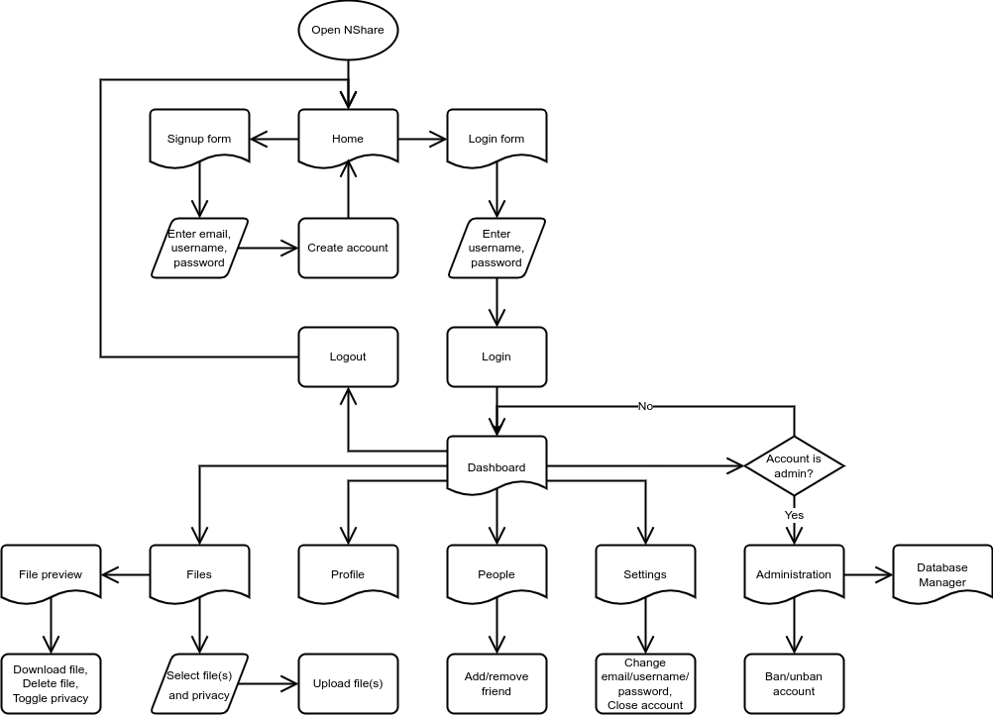
Taking all of the primary (and some secondary) features into consideration, this is how my website will be laid out, alongside a broad overview of the processes that can happen on each page.

Data Structures
To store user data, three methods can be used:
For short-term storage that is only needed for as long as the user is on the website, sessions can be used. These are variables and arrays that are stored server-side. When the user closes their browser, they loose their session data.
For long-term storage that needs to persist after a user has ended their browser session, cookies can be used. These are like sessions, except they are stored client-side and persist after a session ends. Cookies can contain a variable or array, as well as their expiration date. Because cookies are client-side, they should not be used to store account information because that would be unsecure and impractical.
For long-term storage of account information, a database should be used. This is a large data structure that contains many cells of user data organised into rows in tables.

Sessions and Cookies
There are many session variables used to store the users session data. Information such as their user ID, username, and role is used to verify that the user has the correct credentials to access their account and certain areas of NShare.
When the browser is closed the session would be lost, meaning the user would need to sign in again. This could be solved with cookies. The user could store a cookie that contains a unique key that is linked to their account. If NShare recognises the key, the user’s data could be loaded without entering their credentials. A security risk with this method is that a bad actor could extract the key from the user’s browser. Then they would have access to the user’s account until the cookie expires.

Database
The nshare database is made up of five tables. Each table has a primary key that gives each row a unique number so that it can be referenced in other tables. A primary key in another table is called a foreign key. The main table is users which has a foreign key in bans, friends, and files. Lastly, files has a foreign key in links.
I will explain some of the columns in these tables, most of them are self-explanatory so I won’t explain those.

users
The role column represents the user’s access level. 0 is for everyone, the default for new accounts. Everyone has access to the file manager and account explorer. 1 is for moderators. They can view account reports/appeals and ban/unban accounts. 2 is for administrators. They can view and edit the database directly.
The visibility column represents how visible the user’s account is. 0 is private. The user’s account will not show up in the account explorer. 1 is public, the default for new accounts. The user’s account will show up in the account explorer. This means that other users can find, view, and send a friend request to them.

reports
The action column represents what the user is requesting to do. 0 is a ban request. The user has found an illegal file and has chosen to report it. The file and the account that uploaded it will be investigated by a moderator. 1 is an unban request. The user’s account has been banned but they believe that the ban was undeserved.

files
The visibility column represents how visible the file is. 0 is private, the default for new files. Only the file’s owner can view it, unless someone follows an active link to it. 1 is public. Everyone can view the file.
users
Column | Type
user_id | int(11) Auto Increment
email | varchar(255)
username | varchar(50)
password | varchar(255)
role | tinyint(1)
visibility | tinyint(1)
signup_date | datetime
friends
Column | Type
friend_id | int(11) Auto Increment
user_id | int(11)
friends | varchar(1023)
reports
Column | Type
report_id | int(11) Auto Increment
user_id | int(11)
file_id | int(11)
reporter_id | int(11)
action | tinyint(1)
reason | varchar(255)
report_date | datetime
banner_id | int(11) NULL
ban_date | datetime NULL
files
Column | Type
file_id | int(11) Auto Increment
user_id | int(11)
filename | varchar(255)
size | bigint(15)
visibility | tinyint(1)
upload_date | datetime

links
Column | Type
link_id | int(11) Auto Increment
file_id | int(11)
link | varchar(255)
creation_date | datetime
expiration_date | datetime

Success Criteria

Test Results
ID | Description | Evidence | Type | Expected | Actual | Date
1 | Account not banned if user already banned | Video |  | False | False | 2022????
2 | Account unbanned when unban button clicked | Video |  | True | True | 2022????
3 | Profile page opened when user link clicked | Video |  | True | True | 2022????
4 | Privacy of file is toggled when privacy button clicked | Video |  | True | True | 2022????
5 | Current page is highlighted | Video |  | True | True | 2022????
6 | Files upload when opened | Video |  | True | True | 2022????
7 | Previous page opens when back button clicked | Video |  | True | True | 2022????
8 | Website uses light or dark theme theme specified by the browser | Video |  | True | True | 20220713
9 | Page file extension is hidden by default | Video |  | True | True | 20220713
10 | Email address not changed if email address is disposable | Video |  | False | False | 20220713
11 | Email address not changed if email address is disposable | Video |  | False | True | 20220713
12 | Friend’s account ID is added to user’s friends list | Video |  | True | True | 20220714
13 | Row is added to friends table when account is created | Video |  | True | False | 20220714
14 | Row is added to friends table when account is created | Video |  | True | True | 20220714
15 | Friend’s account ID is added to user’s friends list and vice versa | Video |  | True | True | 20220714
16 | Account not created if email address is disposable | Video |  | False | False | 20220714
17 | Selected files are deleted when delete button clicked | Video |  | True | True | 20220715
18 | All files are selected when master checkbox clicked | Video |  | True | True | 20220715
19 | Delete button is disabled if no files are selected | Video |  | True | True | 20220715
20 | Friends are displayed in friends list and can be removed | Video |  | True | True | 20220715
21 | Friend’s account ID is added once to user’s friends list and vice versa | Video |  | True | False | 20220715
22 | Friend’s account ID is added once to user’s friends list and vice versa | Video |  | True | True | 20220715
23 | User directory name changes when username changes | Video |  | True | True | 20220720
24 | Account created without completing CAPTCHA if created with admin account creator | Video |  | True | False | 20221005
25 | Account created without completing CAPTCHA if created with admin account creator | Video |  | True | True | 20221005
26 | New notifications are used | Video |  | True | True | 20221005

