
Collaborative Development (5CS024)
Sprint 2 Individual Report
VroomNepal Vehicle Rental System
Field | Details
Student ID | 2505470
Student Name | Sandesh Thapa
Section | G-4
Module Leader | Arvind Nepal
Lecturer | Arvind Nepal
Tutor | Sandhya Tiwari
Submitted On | 5/26/2026
Project Role | Developer
Biratnagar International College / University of Wolverhampton

Acknowledgement
I want to express gratitude to the module team, lecturer and tutor for guidance in this Collaborative Development module. These workshop sessions and feedback enabled me to get insight on how project planning, project implementation evidence, and reflective writing can be linked in one project report.
Thanks to my team of others who supported me during Sprint 2. Coordination was needed with the VroomNepal system between front end pages, back end API routes, updates on the database and screenshot evidence. Discussions were regular so when one feature affected another, such as booking status and confirming payments and updating the vendor dashboard, we did not have any confusion.
Sandesh Thapa
2505470
G-4

Contents
Acknowledgement 2
Contents 3
1. Project Overview and Sprint 2 Scope 4
1.1 Project Purpose and User Roles 4
1.2 Sprint 2 Contribution 4
1.3 System Architecture and Tools 4
1.4 Requirement Coverage 5
2. Implementation Evidence Portfolio 7
2.1 Landing Page and Vehicle Discovery 7
2.2 Authentication and Account Recovery 8
2.3 Booking Workflow 9
2.4 Payment Workflow 10
2.5 Dashboards and Vendor Operations 11
2.6 Backend, Database and Version Control Evidence 14
3. Collaboration and Professional Development 16
3.1 Communication and File Sharing 16
3.2 Sprint Planning, Issues and Deadlines 16
3.3 Continuing Personal Development 17
4. Testing and Quality Checks 18
4.1 Manual Testing, Limitations and Future Work 18
5. Sprint Retrospective 20
6. Self-Appraisal 21
7. Conclusion 22
8. References 23

1. Project Overview and Sprint 2 Scope

1.1 Project Purpose and User Roles
VroomNepal is a vehicle rental web application which has been developed to facilitate the full rental process. Customers are able to explore the vehicles, book a rental period, build a booking, make payments and see which of their rentals are active. Vehicles can be published by vendors and booking requests can be handled and verification documents submitted. Admins can view system records like as user, booking, vehicle, payment and vendor documents.
Sprint 2 was primarily focused on treating the system as a unified product instead of a bunch of static pages. Back-end API endpoints were connected to the front-end screens and the database schema developed to capture important actions as actual records.
The challenge for the project is that a rental service can only rely on fixed car data. All these elements must play a part in one another when it comes to a real rental flow: account identity, vehicle ownership, date availability or payment status and dashboard feedback. This led to making these parts talk to each other in the backend and database as opposed to being standalone interface pages, which is what Sprint 2 set about doing.
The system has been organized along three lines of user responsibilities as well. Customers primarily need a smooth customer experience from checking out to payment. The control of their own fleet and booking requests is required by vendors. Admins want more visibility & control. This divide introduced Role Management to be one of the critical technical issues for the sprint.

1.2 Sprint 2 Contribution
So my Sprint 2 task was on the application flow to get to account access, through to making a booking. This encompassed authentication, password recovery, vehicle listing APIs, booking validation, payment handling, eSewa integration, notifications, and updating records and the database for the various documents.
Most changes were found to have impact on more than one layer of the system. If a user books a booking from the front end end, the booking controller will check this booking and save it, then show it on the customer's dashboard and update it via the payment module. This gave extra weight to the need to do more than testing to see if a page displayed correctly during integration testing.
- Connected login, signup and protected pages with JWT based authentication.
- Added OTP based forgot password and reset password behaviour.
- Implemented booking checks for dates, availability, ownership and status updates.
- Integrated payment records and eSewa verification before confirming bookings.
- Improved vendor features including vehicle publishing and document verification.
- Updated the MySQL schema, seed data and README setup instructions.

1.3 System Architecture and Tools
The architecture is based on a route-controller-model. The route files contain the definition of the URL endpoints, validation rules, controller files the main business logic and the model files database operations. This separation maintained the project understandable because the project didn't become a large file containing booking logic, payment logic, user logic and vendor document logic.
Since the static frontend pages are served also by the Express server, the demonstration could be accomplished locally with ease. When the server starts, it loads the frontend folder, mounts each API route and connects to the MySQL database. Also, the database set up code looks for crucial tables and columns, minimizing set up issues when this project is deployed on another machine.

Layer | Tools Used | Use in VroomNepal
Frontend | HTML, CSS, JavaScript | Landing page, vehicle listing, booking screen, payment pages and dashboards.
Backend | Node.js and Express.js | REST API routes for authentication, vehicles, bookings, payments, users, notifications and vendor documents.
Database | MySQL with mysql2 | Relational storage for users, cars, bookings, payments, password OTPs, notifications and vendor documents.
Security | JWT, bcryptjs, express-validator | Token based access, hashed passwords, role restriction and request validation.
Payment | eSewa test API, crypto, axios | Wallet payment initiation, HMAC signature creation and server side transaction verification.
Email | Nodemailer | OTP email support for password recovery when mail credentials are configured.

1.4 Requirement Coverage
Requirement Area | Sprint 2 Work Completed | Main Evidence
Account access | Registration, login, JWT token storage, role checks and current user endpoint. | authRoutes.js, authController.js, middleware/auth.js
Account recovery | Forgot password, OTP generation, OTP verification and reset password token. | authController.js, password_otps table, forgotPassword.html, resetPassword.html
Vehicle catalogue | Vehicle listing, filtering by availability/vendor, create/update/delete vehicle records. | carRoutes.js, carController.js, models/Car.js, vehicleListing.html
Booking | Booking creation, date validation, overlap prevention, cancellation and vendor/admin status updates. | bookingRoutes.js, bookingController.js, models/Booking.js, vehicles.html
Payment | Direct payment validation, eSewa initiation, callback verification and booking confirmation. | paymentController.js, esewaController.js, payment.html, payment_Ewallet.html
Vendor workflow | Vendor dashboard, add vehicle form, booking management and document submission. | dashboard_vendor.html, addvehicle_vendor.html, booking_vendor.html, document_vendor.html
Notifications | Booking, payment and document review notifications for customers and vendors. | notificationController.js, models/Notification.js
Database setup | Schema, relationships, indexes, seed admin and seed vehicle records. | config/schema.sql, config/db.js

2. Implementation Evidence Portfolio
This section presents the main implementation evidence. The screenshots are arranged by user flow so the reader can understand how the application works from first visit to backend proof.

2.1 Landing Page and Vehicle Discovery
The knowledge and goals of the project are clearly defined (as can be seen in figures 1 to 3) and a discovery path is being formed. The landing page introduces the brand, browse by need section clusters vehicles for user objectives and the action listings page presents definite rental choices. That's important, because the initial part of the customer journey should engage a user and get them to the right type of vehicle without the user ever clicking on any booking form.
This applies to the backend work as well as the vehicle is not simply written down as plain text in a report. Vehicle information with names, price, image and availability are used in the Application. This creates a nice validation example for the database 'seed' data and the /api/cars endpoint.
The landing page tells about the VroomNepal brand and leads to the available rentals. Vehicle discovery screens lend themselves to browsing by need followed by viewing those listings which are active and presented in a gallery format.
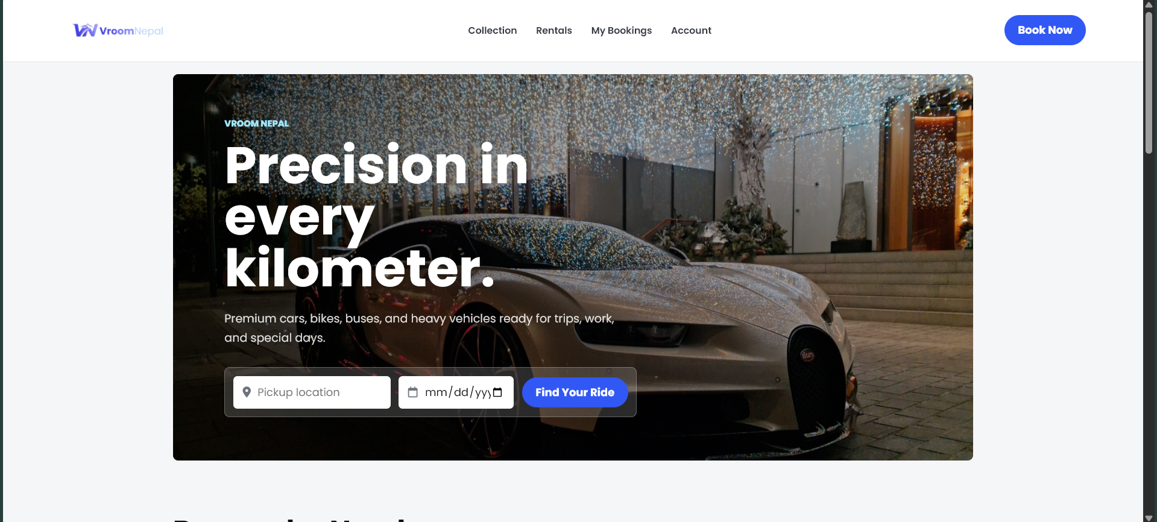
Figure 1: VroomNepal landing page
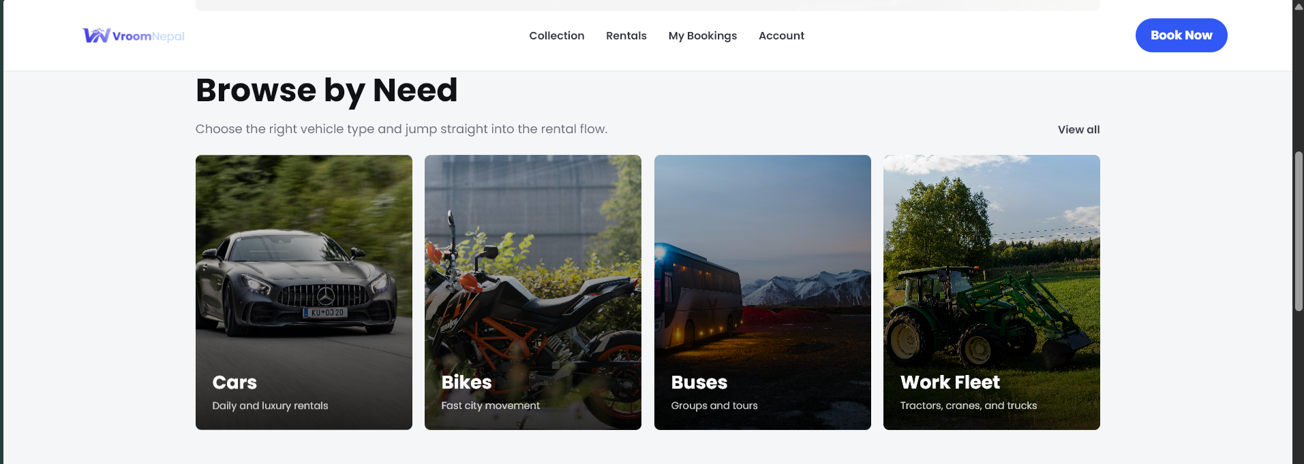
Figure 2: Browse by need section on the landing page
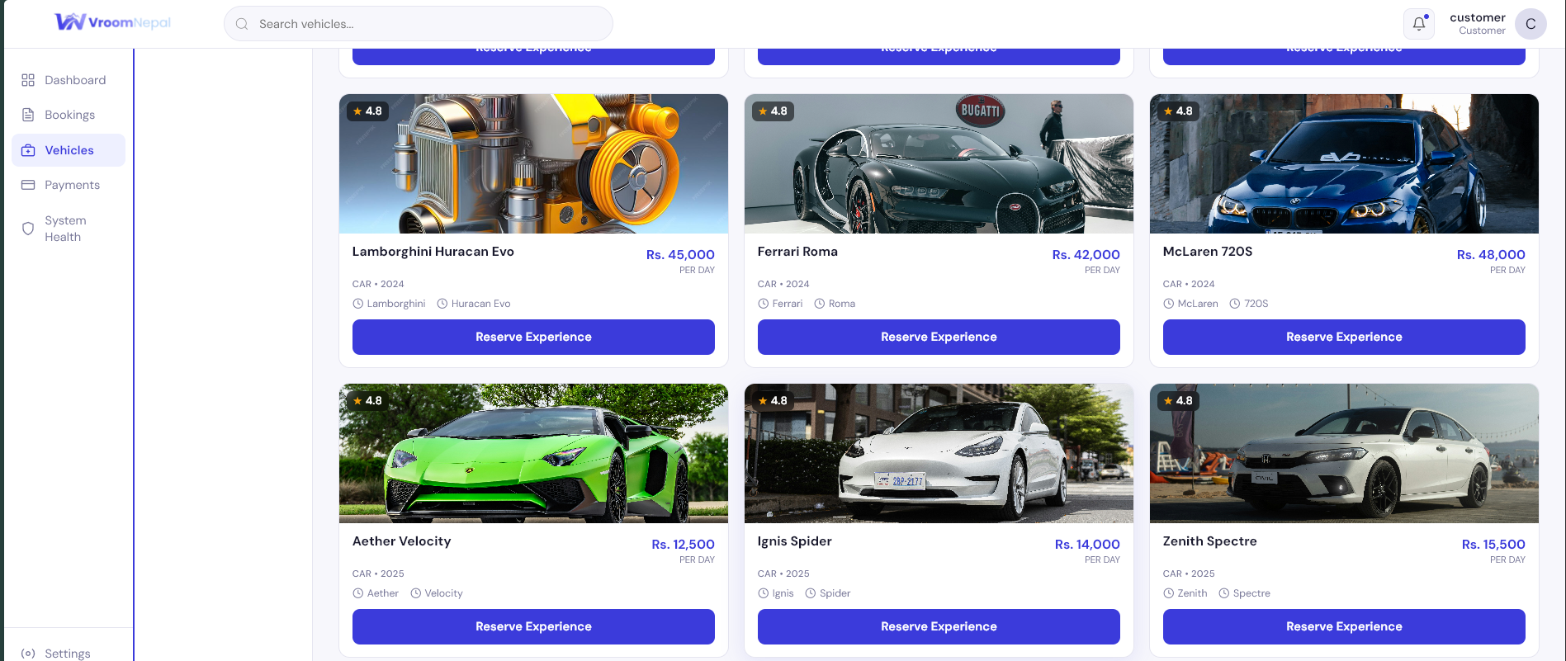
Figure 3: Active vehicle listings page

2.2 Authentication and Account Recovery
Figures 4 and 5 depict two significant flows that are security related. The login page is a role based login access, and forgot password page is designed to facilitate logging in to the account even if they forget the password, which does not reveal the password. It's backend with BCryptjs for password hashing, JWT - session validation and identity middleware, to prevent incomplete/invalid inputs.
Because in a rental system, personal account information and history is stored, the OTP recovery flow was included. In case the user forgets a password there must be a controlled recovery process. The implementation keeps the OTP documentation with the status of expiry and used, and of course, this is better than accepting a password reset request without verifying it.
Role aware login / sign up pages control authentication. The backend validates an email or phone credential, compares passwords (which are stored as a hash) and returns a JWT token. The account recovery uses OTP record (with expiry) before entering a new password.
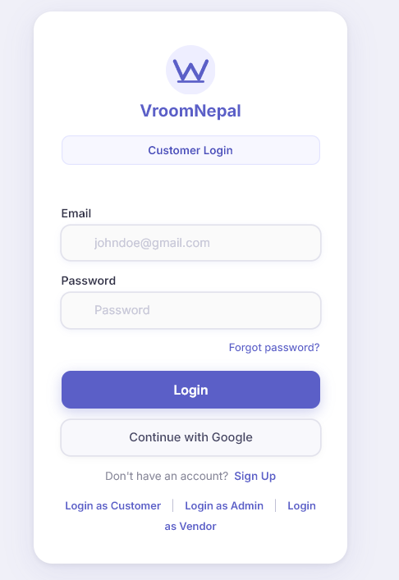
Figure 4: Customer login screen
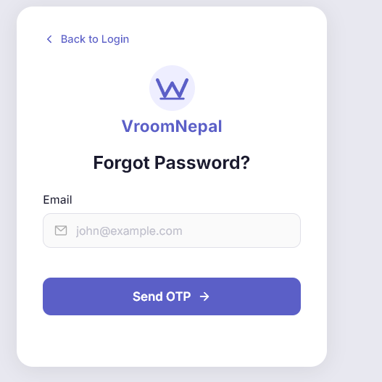
Figure 5: Forgot password page for OTP recovery

2.3 Booking Workflow
Figure 6 needs to be shown because it is the main customer process for the project. The price summary and the vehicle chosen for the rental is displayed prior to the booking being established. Behind the scenes, the controller will verify if the customer has the proper login credentials and role, and if the date range is considered valid and that the selected vehicle hasn't already been reserved for the dates selected.
The total price computation also empowers the project to be more realistic. The model determines the base rental fee and charges for service fees and insurance. This translates to a final amount that has been determined in the backend as opposed to manual typing in the frontend reducing the chances of inconsistencies between booking and payment.
The selected vehicle is sent to the booking page and the customer is able to select dates, times, and shows the cost of renting accompanied by a backend booking. Bookings can't be done in the past, the return date is checked for validity and it won't allow overlapping bookings with the same car.
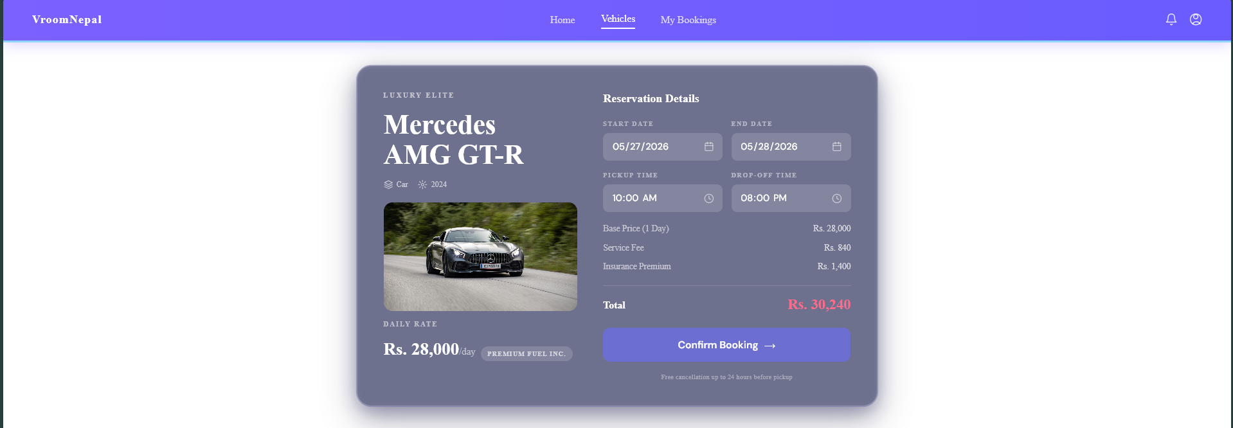
Figure 6: Vehicle booking page with price summary

2.4 Payment Workflow
Refer to figure 7 and figure 8 for the status of payment following the creation of the booking. This phase is significant due to the fact that until a successful payment is made, the booking should not be considered confirmed. Payment records are maintained in the back end and the payment information is verified during direct payment and changed to the booking status on payment completion.
The project works with eSewa by providing a transaction UUID and the signed message, to be verified when processing the payment request. The verification step ensures that the system is basing itself on the fact that only frontend redirection is trusted. After confirming payment, the Payment status is updated and the Booking is confirmed and notifcations can be created to related users.
Once payment is done in the payment module, the booking journey is complete. Direct card and bank style payments are validated by backend while transaction request is initiated with eSewa signed payment and verified prior to confirmation of booking status.
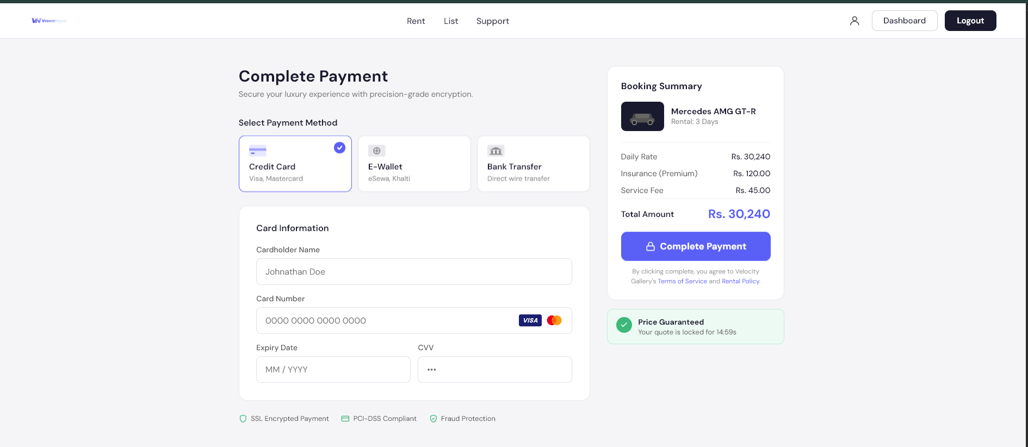
Figure 7: Complete payment page
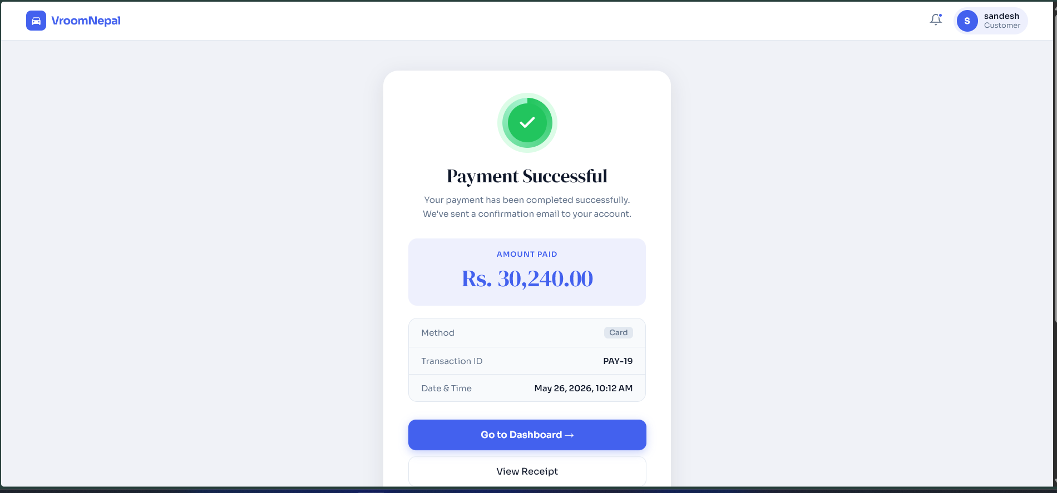
Figure 8: Payment success receipt

2.5 Dashboards and Vendor Operations
Tailoring the same project to multiple users' roles is as depicted in figures 9 through 14. The Customer's Dashboard is geared towards bookings and spending, and the Vendor's Dashboard is geared towards fleet, bookings, earnings and verification documents. This difference is significant as a vender should never regard the system as the purchaser does.
Database design is also related to the vendor document evidence. With the document type, stored with all of the documents from the vendor, its status, reason for rejection and the date of review. This provides the project with a realistic verification workflow and sets the system up for future improvements for admin review.
The dashboards display the outcomes of activity where a database was used. Activity and expenditure can be viewed by customers and vehicle publishing and documents status, bookings and earnings can be viewed by vendors.
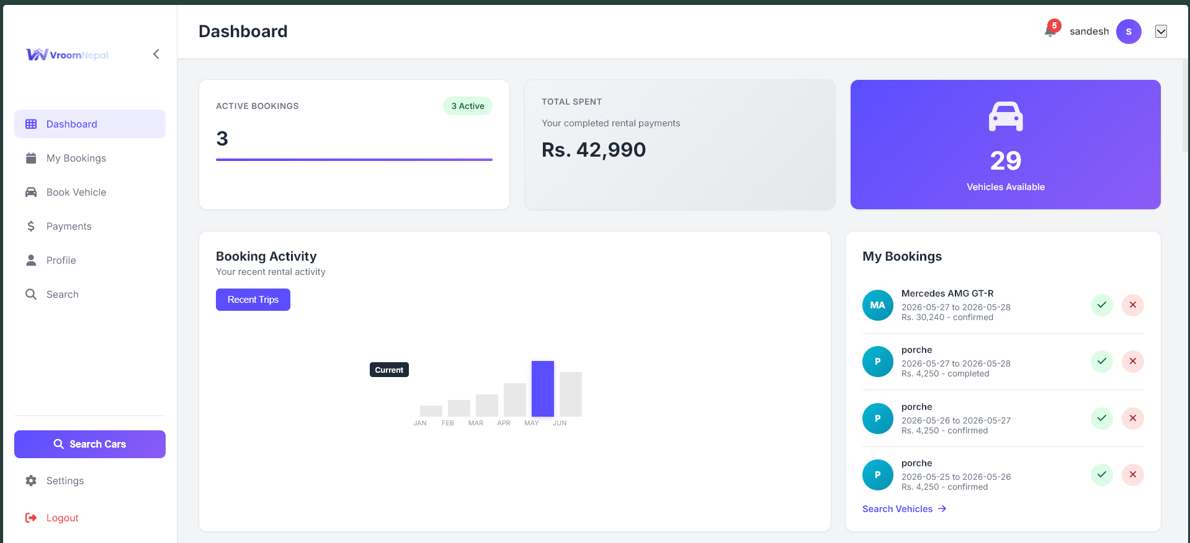
Figure 9: Customer dashboard with booking activity
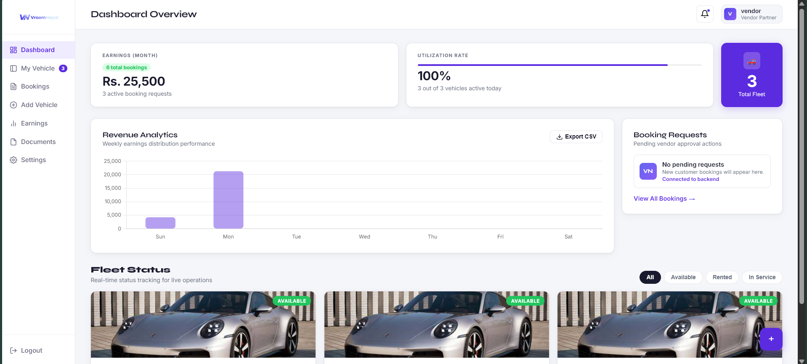
Figure 10: Dashboard overview with fleet and verification status
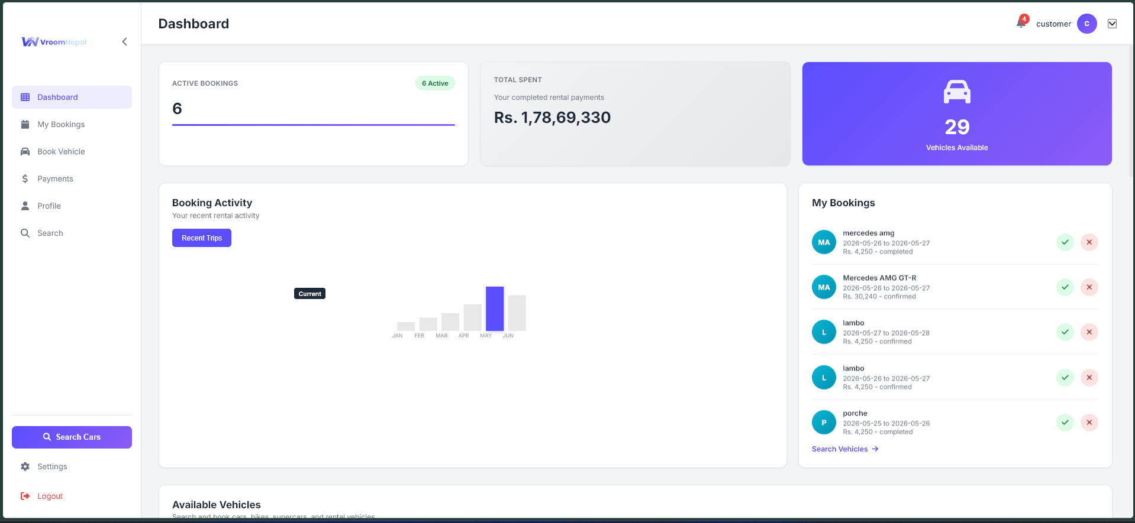
Figure 11: Dashboard booking and revenue view
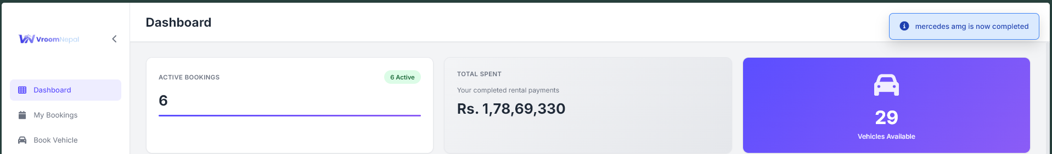
Figure 12: Dashboard header and live state evidence
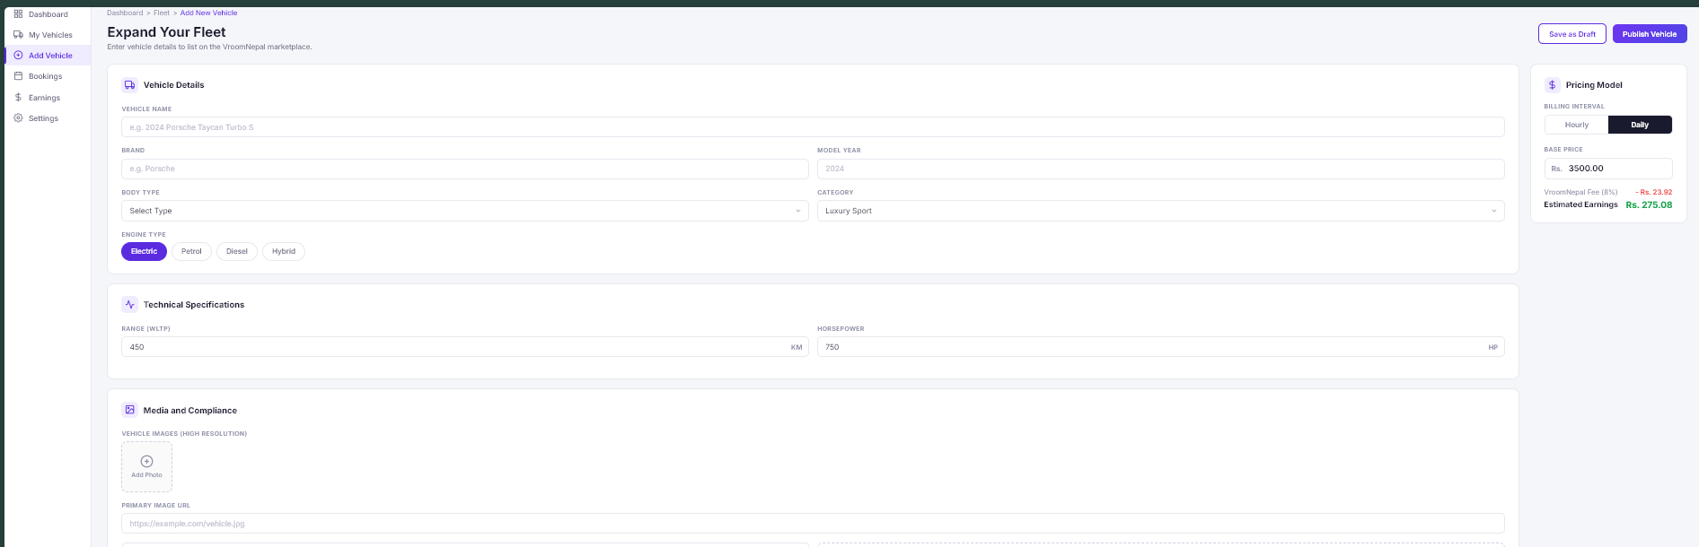
Figure 13: Add vehicle form for vendor fleet publishing
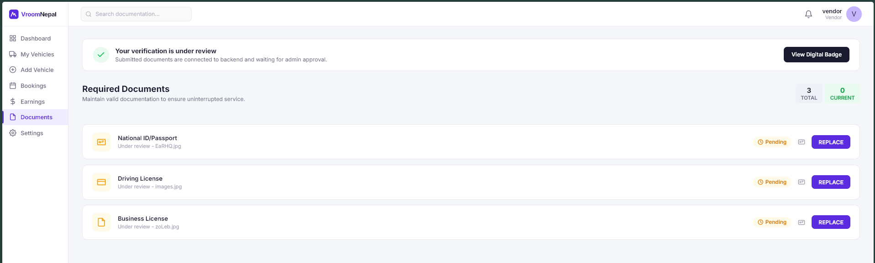
Figure 14: Vendor required documents page

2.6 Backend, Database and Version Control Evidence
Actual technical evidence is presented in figures 15 through 18. As represented in the folder structure, backend is clearly divided into controllers, routes, models, middleware and configuration files. The relational design is supported by the database screen as mentioned above with the tables Users, Cars, Bookings, Payment, password-OTP, Notifications and vendor documents etc.
It's essential in a collaborative effort that is shown through the GitHub screenshots that the work has been tracked over time. The commit history and the organization of the repository indicate this process progressed past the point of just the visual design of the final user interface, implying Sprint 2 was spent working on implementation, testing and documenting and not just design.
Backend is divided into routes, controllers, models, middleware and configuration files. All main business records are housed in the MySQL database; and GitHub is used to store versions of the work completed in Sprint 2.The mers can view booking activity, spending, the vendors can view fleets activity, bookings, earnings, vehicle publishing and document status.
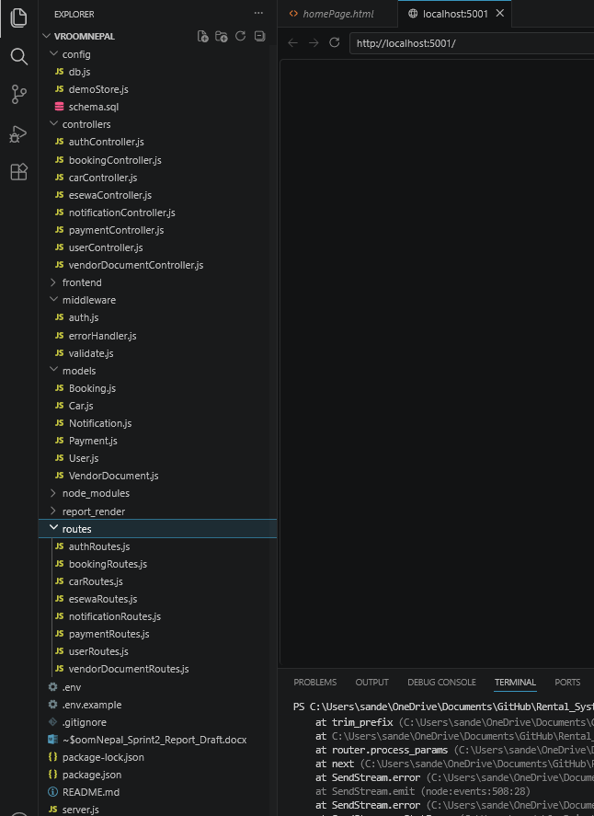
Figure 15: Project folder structure in the code editor
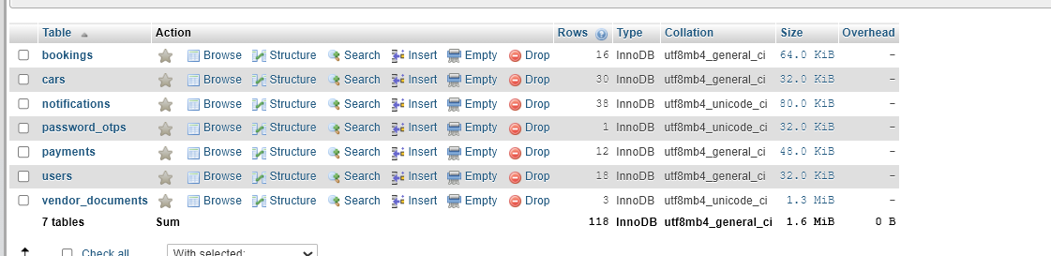
Figure 16: MySQL database tables for VroomNepal
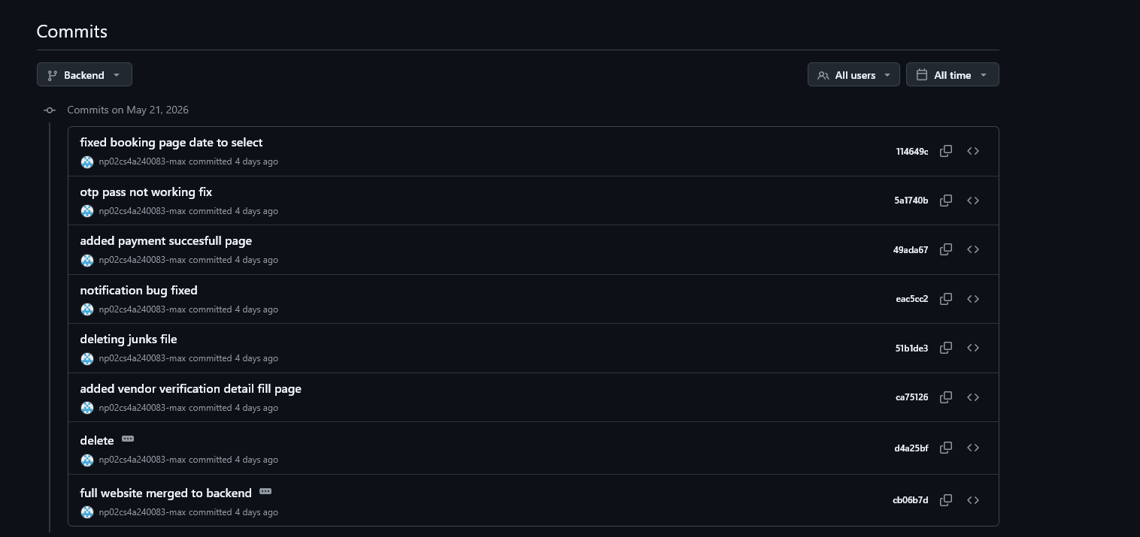
Figure 17: GitHub commit history evidence
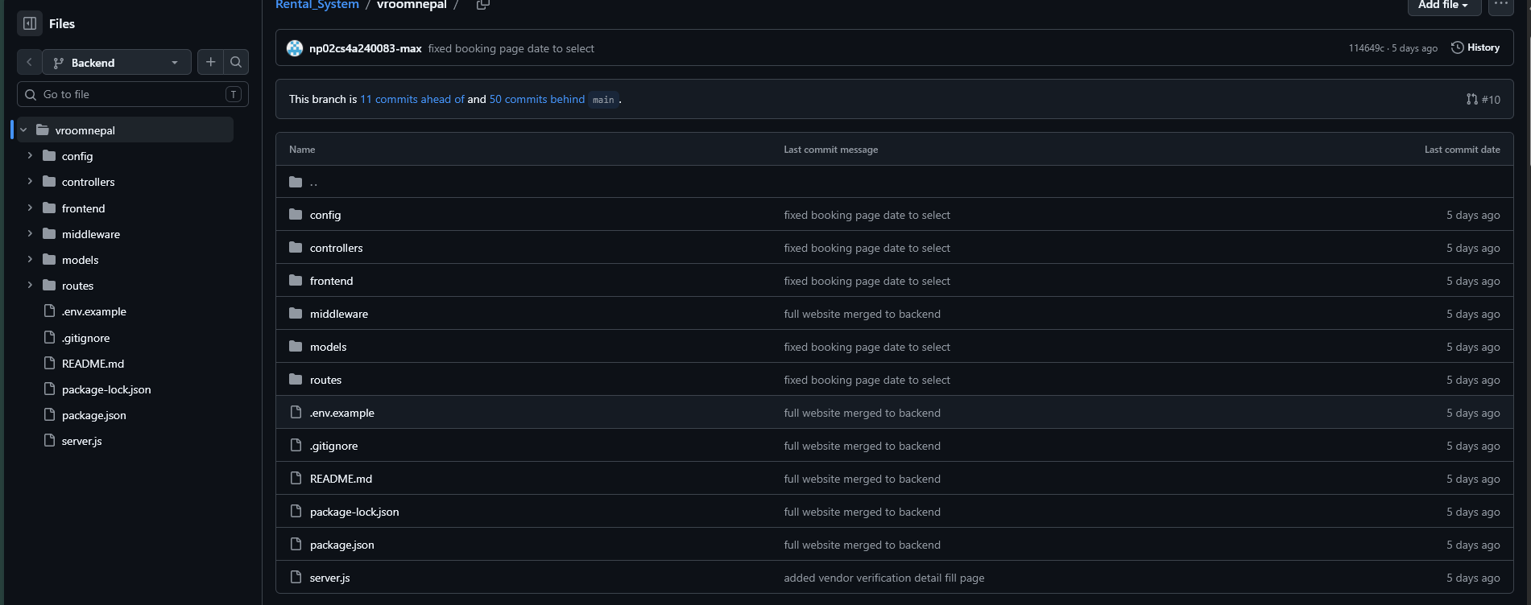
Figure 18: GitHub repository structure evidence

3. Collaboration and Professional Development

3.1 Communication and File Sharing
Development was done by the team on regular communication, discussing blockers and confirming evidence to collect. This was crucial since the project had important aspects tied together, such as having status changes trigger on the payments page affecting the booked state, booking events creating notifications and vendor documents showing on the dashboard.
This communication was particularly appreciated when working out what and what not to add to the report as screenshots and code evidence. The evidence was organized following the same flow of the application, discovery, login, booking, payment, dashboard, backend, database and version control, so as not to include random screenshots.
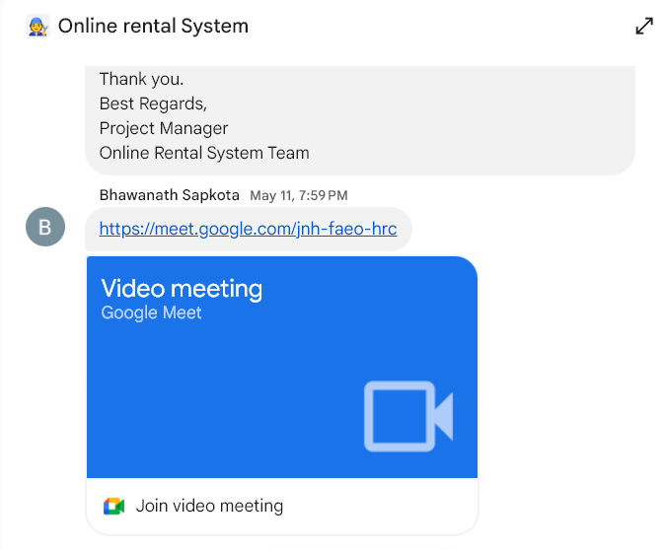
Figure 19: Team communication evidence

3.2 Sprint Planning, Issues and Deadlines
S Sprint planning done by dividing work into smaller implementation areas. Authentication and database setup were considered as basic tasks which were followed by the tasks of vehicle listing, booking and payment, dashboard and documentation work. Route validation, role check, payment state handling and other implementation concerns have been addressed and not left till the end since they are not trivial.
Large goals were broken down into smaller work using the task board. An example of this would be payment integration, which required booking creation, payment record creation, status updates and evidence on the success-page. This allowed one to have better control on the sprint and helped team see if work was missing when presenting or thinking about preparing it for submission.
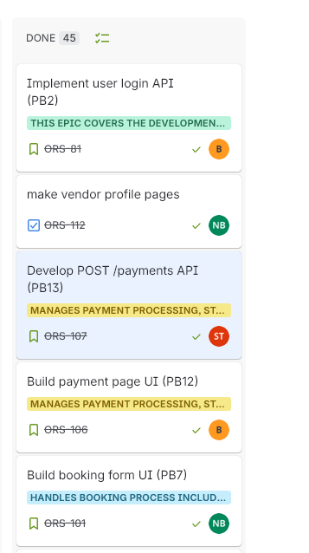
Figure 20: Sprint task board and issue tracking evidence

3.3 Continuing Personal Development
After Sprint 2, I definitely got more confident when it comes to backend development, since I was using routes, controllers, models and middleware as interrelated components of a single application. Another aspect in which I started being careful is the validation and ownership checks, particularly in cases where customer, vendor and admin users may have different permissions.
One of the best take aways was the eSewa payment feature. It made me cognizant to the fact that a payment should not be trusted only from the front side. The backend needs to sign the request, validate the callback data, validate the transaction, and finally, update the booking and notification records.4. Testing and Quality Checks

4. Testing and Quality Checks
Testing was carried out manually through the frontend pages and backend API behaviour. The main aim was to confirm that each user flow worked with real database records and that users could not access actions outside their role.

4.1 Manual Testing, Limitations and Future Work
Manual testing was suitable for this sprint because the main risk was whether the full user journey worked across multiple pages. I tested the flow by moving through the application as different roles rather than only checking individual functions. This helped confirm that the customer, vendor and admin responsibilities were separated properly.
The most important edge cases were invalid login details, missing booking fields, past dates, return dates before pickup dates, payment attempts on invalid bookings and vendor access to vehicles that do not belong to the logged-in vendor. These checks helped identify where validation and role restrictions were needed.
Test Area | What Was Checked | Outcome
Registration and login | Created users with different roles, checked login with email/phone and confirmed protected pages require a token. | Passed after JWT and role checks were connected.
Password recovery | Requested OTP, verified OTP and reset password through the recovery pages. | Passed with password_otps records and reset token.
Vehicle listing | Loaded vehicles from /api/cars and checked the listing/gallery pages. | Passed with seeded vehicles and vendor-created records.
Booking | Selected a vehicle, dates and times, then created a booking. | Passed with pending booking and price summary.
Booking validation | Checked invalid dates, past dates and unavailable/overlapping bookings. | Validation prevents unsafe booking states.
Payment | Tested payment page and payment success flow. | Payment updates booking status after successful completion.
Vendor features | Checked add vehicle, booking management and document pages. | Vendor flow works with role restricted access.
Database | Reviewed users, cars, bookings, payments, notifications and vendor document tables. | Tables and relationships support the main features.
The largest concentrated changes of quality that were done in Sprint 2 were the input validation checks, route active checks, unique phone number checks and role based access control, and improved database relationships. These changes lowered frequent runtime errors and enhanced the security of the application when observing.
The implementation is fair given the time per submission in Sprint 2 but refinements need to be done in the future. Testing if required for authentication, booking conflicts, payment verification, vendor documents should be automated. A development of Admin dashboard may also be made where document approvals, payment check and user management would be done from a single consistent interface.
It could also be better to have a formal migration process that would enable the database workflow to be improved. Currently schema setup and schema compatibility is done in the SQL file and database setup code. Working for the project demonstration but versioned migrations per future sprint would be beneficial to have an equal database structure per team member..

5. Sprint Retrospective
What went well?
- The project became a connected rental system instead of separate static pages.
- Authentication, booking, payment and dashboard features were linked to backend records.
- The vendor flow became stronger with vehicle publishing and document verification.
- The database schema was improved with useful relationships, indexes and seed data.
What did not go well?
- Payment verification required extra time because success and failure states had to be handled carefully.
- Some screenshots and evidence needed to be collected after implementation, which made report preparation slower.
- Keeping localStorage data and backend records consistent during testing required repeated checking.
What should improve next?
- Add automated tests for authentication, booking conflicts, payments and role restrictions.
- Use a proper migration process for future database changes.
- Improve admin review screens for vendor documents and payment monitoring.
- Hold shorter code reviews before merging large feature changes.

6. Self-Appraisal
Field | Details |  | Field | Details
Student Number | 2505470 |  | Name | Sandesh Thapa
Project | VroomNepal Vehicle Rental System |  | Date | 5/26/2026
Role | Developer |  | Team | G-4 Project Team
Sprint | 2 |  | Module | 5CS024
Objective |  | Evidence Provided |  | Student Evaluation
Planning |  | Reviewed Sprint 1 progress and identified Sprint 2 priorities for account access, booking, payment, vendor flow and database updates. |  | 9
Authentication |  | Implemented JWT based access, role checks, login, signup and current user behaviour. |  | 9
Password recovery |  | Built OTP based forgot password and reset password workflow. |  | 8
Booking |  | Implemented booking creation, date validation, overlap checks, cancellation and status updates. |  | 9
Payment |  | Connected direct payment records and eSewa initiation/verification before booking confirmation. |  | 9
Vendor workflow |  | Supported vendor dashboard, add vehicle, booking management and document verification evidence. |  | 8
Database |  | Updated MySQL schema with users, cars, bookings, payments, password_otps, notifications and vendor_documents. |  | 9
Documentation |  | Prepared report evidence, screenshots, setup notes, endpoint explanation and reflection. |  | 9
Teamwork |  | Used communication, task tracking and GitHub evidence to keep Sprint 2 work organised. |  | 9

7. Conclusion
Sprint 2 brought VroomNepal towards full-fledged vehicle rental platform. The most outstanding progress was the link-up between customer, vendor and admin workflows using backend of node.js and express with MySQL database. Customers can see the vehicles, book them and pay, and vendors can monitor the vehicles and upload documents for verification.
Generally, there is evidence of implementation and reflection. The screenshots show the visible system, and the requirement table, testing table and written explanation reveal how the logic for the backend of the system and the bespoke database records support the functionality of the frontend. That's because it's customary for a technical report to gain marks, not just for the screenshots, but for what the screenshots demonstrate.
The project was also enhanced in terms of technical quality. The addition of JWT authentication, bcrypt password hashing, routes validation, role restriction, eSewa verification and database constraints and notification records made the application more realistic. The screenshots and project evidence demonstrate that the Sprint 2 was not code work only, but was a practical move towards a working rental system.

Link
Presentation:
Github:
Video group presentation:

8. References
Express.js, n.d. Express routing documentation. Available at: https://expressjs.com/en/guide/routing.html
Node.js, n.d. Node.js documentation. Available at: https://nodejs.org/en/docs
MySQL, n.d. MySQL Reference Manual. Available at: https://dev.mysql.com/doc/
JSON Web Tokens, n.d. Introduction to JSON Web Tokens. Available at: https://jwt.io/introduction
Nodemailer, n.d. Nodemailer documentation. Available at: https://nodemailer.com/
eSewa, n.d. eSewa developer resources. Available at: https://developer.esewa.com.np/
GitHub Docs, n.d. GitHub documentation. Available at: https://docs.github.com/

