Herald College, Kathmandu


Concepts and Technologies of AI
5CS037

Analysis of the Human Development Index (HDI):
Data - Driven Exploration of Global
and Regional Development Patterns.

Student Name: Ansuya Silwal
Student ID: 2505504
Course: BCS
Level:5
Date : 10th January 2026
Table of Contents
Introduction: 3
2. Problem 1A: 3
One-Year HDI Investigation (2022): 3
Strategies and Approaches: 3
Key Findings and Analysis 4
3 Problem 1B: 4
HDI Trend Analysis (2020–2022): 4
Methods and Techniques 4
Important Findings and Interpretation: 5
4. Problem 2 – Advanced HDI Exploration (South Asia): 5
Techniques and Methods: 5
Important Findings and Interpretation: 5
Problem 3: 6
Comparative Regional Analysis: The Middle East, vs. Southern Asia: 6
Methods and Approaches: 6
Important Findings and Analysis: 6
6. Conclusion: 6
Limitations and Recommendations: 7
7. References: 7

Introduction:

The HDI is a set of indicators developed by the United Nations Development Programme (UNDP) whish is used for the comparing and contrasting overall level of improvement across countries. It is comprised of three main elements of human well-being, academic success, , medical care and good quality of life. HDI provides a better understanding of development outcomes compared to income-based indicators, therefore, HDI is an essential instrument that can be used by international organizations, teachers, and governments to determine the situation and focus on the areas that require improvements. This paper presents an exploratory data analysis (EDA) and statistical interpretation of Human Development Index data on 1990 2022 with a particular focus on 202022. The objectives are to make comparisons of development results between South Asia and the Middle East, explore the annual patterns of HDI, analyze the time patterns, and conduct an advanced regional analysis focusing on the South Asian region. The report addresses Problems 1A and 1B, 2 and 3 in line with the instructions in the assignment.
2. Problem 1A:
One-Year HDI Investigation (2022):
Strategies and Approaches:
The research filtered the items that corresponded to the latest year, 2022, to determine every separate year that was used as data. The last option was carefully examined and researched. The preliminaries steps in the exploration process were a review of sample records, analysis of data structure, and confirmation of column names and data types. The data was cleaned in a systematic process that ensured quality of the data. This included identifying the missing values, transforming the text numeric columns into the relevant numerical formats, deleting the redundant records, and correcting the inconsistent names of countries. The important measures such as GNI per capita and HDI had missing data which were addressed by row-wise deletion because the imputation of these measures would distort the development comparison. This is the average graph of 2020 to 2022AD.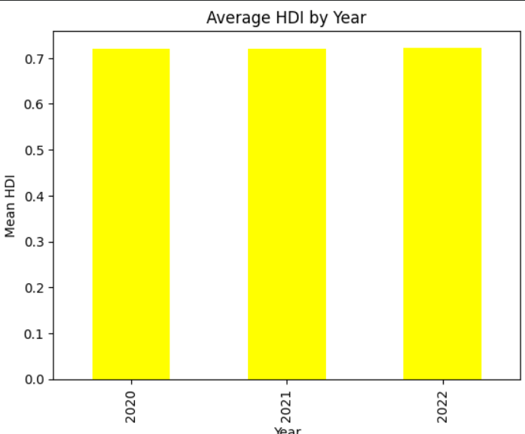And here is the graph of scattered plot of HDI in the basis of gr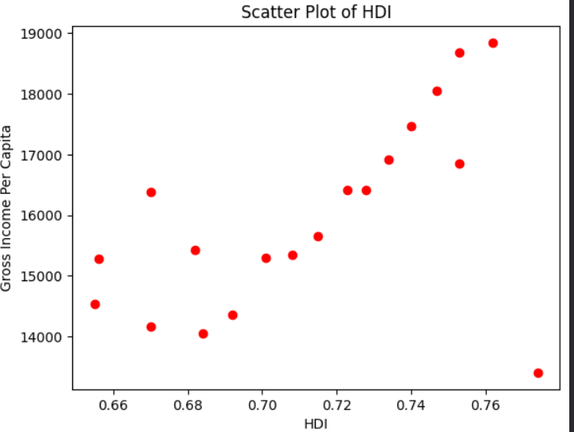

Key Findings and Analysis
Descriptive statistics offered in the mean, median, and standard deviation of the HDI in 2022 shed light on the distribution of human development across the world. The themes of the study were the highest and the least developed countries in terms of HDI rating. Whenever the HDI rating of a given country exceeded 0.800, then the country was regarded to have an extraordinarily high human development. Further ranking of these countries was based on gross national income per capita which put into focus the interdependence between income and development within the higher levels of HDI. All the countries using the UNDP-defined standards were classified as Low, Medium, High, and Very High Human Development in a new column called HDI Category. The findings indicate significant global disparities and the necessity of equal spending of money on healthcare and education.

3 Problem 1B:
HDI Trend Analysis (2020–2022):
Methods and Techniques
The data of 2020, 2021, and 2022 were separated and stored separately to conduct the trend analysis over the subsequent three years. We searched inconsistent or missing information in the significant variables such as country, year and HDI. Additional data cleaning processes were type conversion, the removal of duplicates, and standardization of the names of countries.
Important Findings and Interpretation:
The line charts presenting HDI trends of specific countries state that most countries were slowly getting better during the three years. Other countries on the contrary experienced decline or stagnation. Box plots were able to see how the distribution of the HDI changed over time, whereas bar charts of the average HDI by region could demonstrate regional inequalities that were sustained. Though money does not fully explain the observed variation, a scatter diagram comparing the relationship between HDI and GNI per capita indicated a positive relationship, which implies that income is useful in human growth. The findings suggest that the COVID-19 pandemic has reduced the HDI progress in many countries or even undone these achievements because of health complications, lack of access to education, and economic declines . Here is the graph from year 2020 to 2022AD.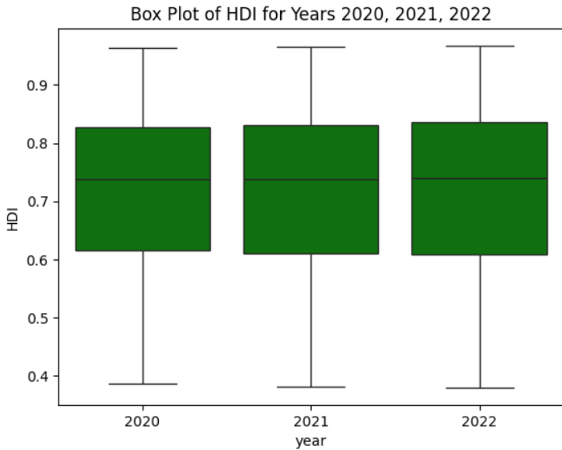

4. Problem 2 – Advanced HDI Exploration (South Asia):

Techniques and Methods:
This section targeted Pakistan, Bhutan, India, Bangladesh, Nepal, Sri Lanka and Afghanistan. In order to capture equalized contribution of development, a geographical subset was employed in calculating a Composite Development Score of the Life Expectancy Index and GNI per Capita Index. To detect the outliers, the 1.5 × IQR rule was applied and to examine relationships between the HDI and the specific development indices, Pearson correlation analysis was employed

Important Findings and Interpretation:
The Composite Score rankings were found to have differences when compared to the HDI rankings, indicating that the contribution made by the health and income dimensions on development varied among the South Asian countries. The outlier analysis was used to identify countries with unusual high or low incomes relative to the HDI. The findings of the correlation indicated the significance of health in human development as it showed that life expectancy was more correlated with HDI than income.
Problem 3:
Comparative Regional Analysis: The Middle East vs. Southern Asia:

Methods and Approaches:
The analysis of comparison was done using the data of South Asia and the Near East during the years 2020 to 2022. In both, descriptive statistics, correlation, and outlier detecting techniques were frequently used.

Important Findings and Analysis:
This research provides a systematic evaluation of the human development of the region and the world at large, using the Human Development Index. The findings reveal the presence of prevailing inequalities, complexity of development and significant differences between Southern Asia and eastern part of the region. The impact of the money on HDI is still significant, yet health and education are equally significant. 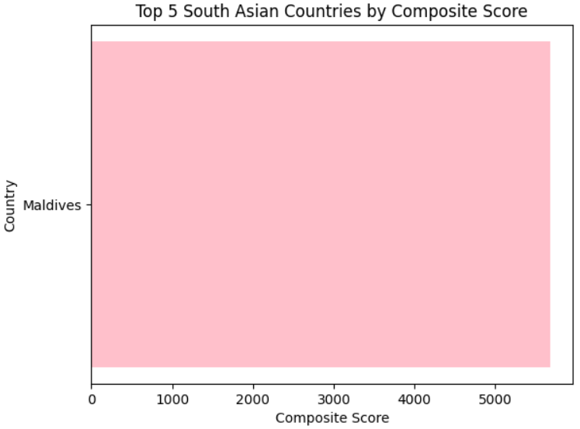
6. Conclusion:
Using the Human Development Index, this study offers an organized assessment of global and regional trends in human development. The results highlight persistent inequalities, the intricacy of development, and notable distinctions between Southern Asia and the region's eastern part. Money still has a big influence on HDI, but health and education are just as important.

Limitations and Recommendations:
The analysis is limited to the dataset's quantitative measurements and disregards qualitative elements like administration and stability of politics. Particularly in areas with high incomes but relatively low HDI ratings, managers are recommended to seek out balanced initiatives that support economic development as well as health and education.

7. References:
United Nations Development Programme. (2023). Human Development Report.
Lucas Yukiolmafuko. Human Development Index Dataset (1990–2022).

8. Appendix:
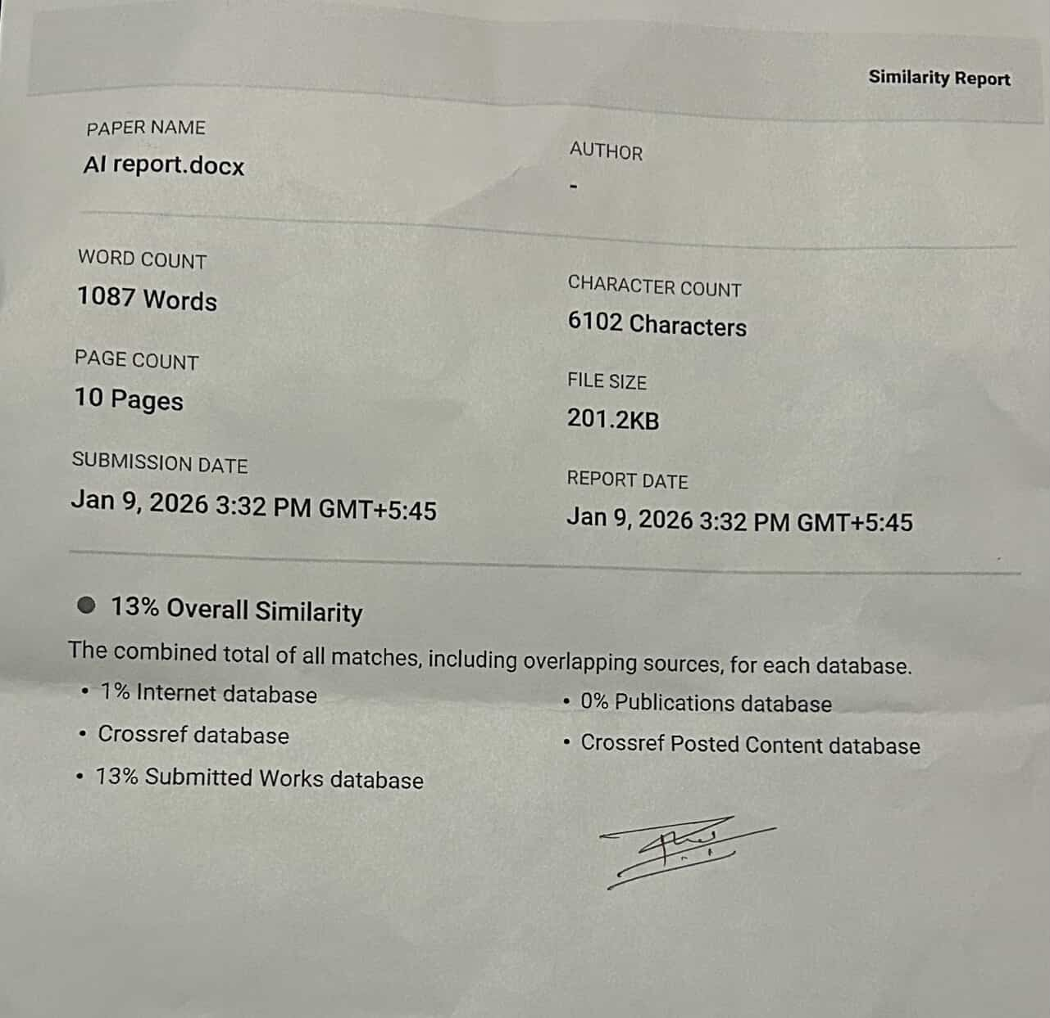

Thank You!

