# Initial view before updating bootstrap classes.

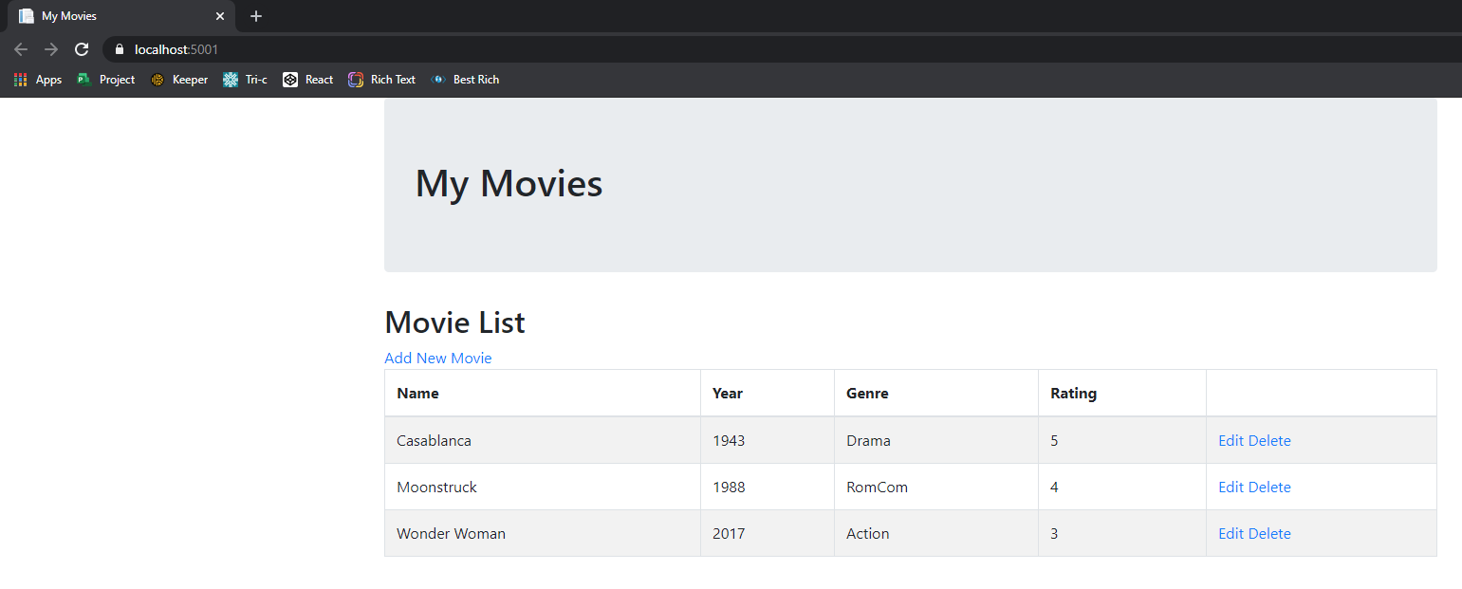

# Removed table-bordered table-striped classes.

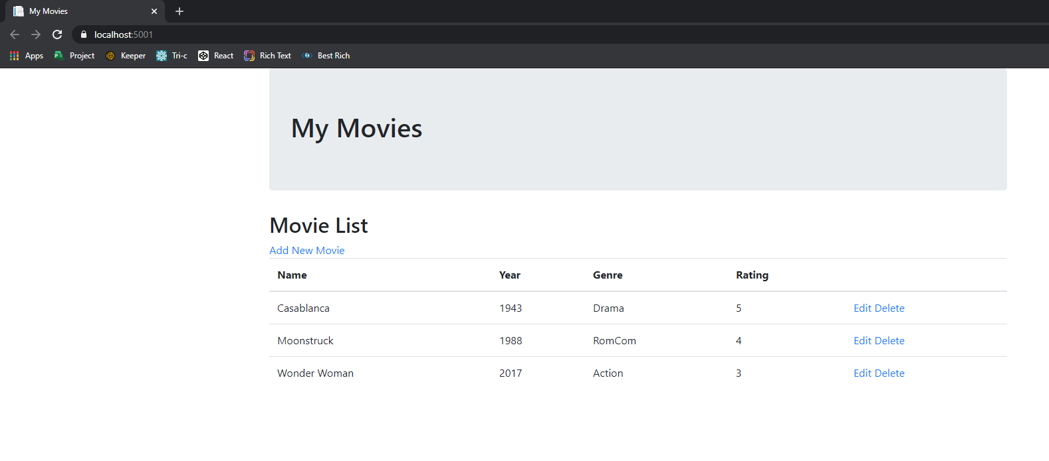

# After adding table-hover class.

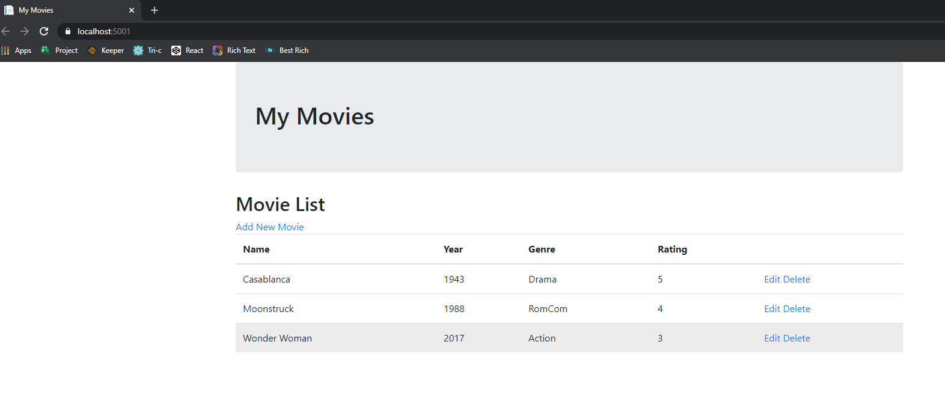

# After adding btn btn-primary classes.

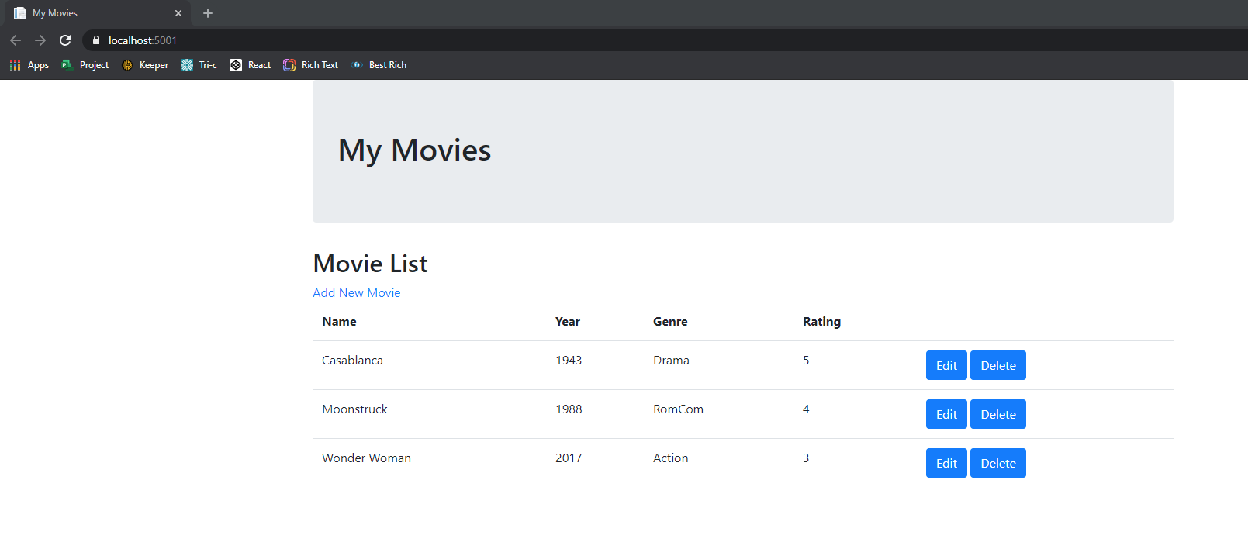

# Updated cancel button on the edit.cshtml page to use btn-outline-secondary classes

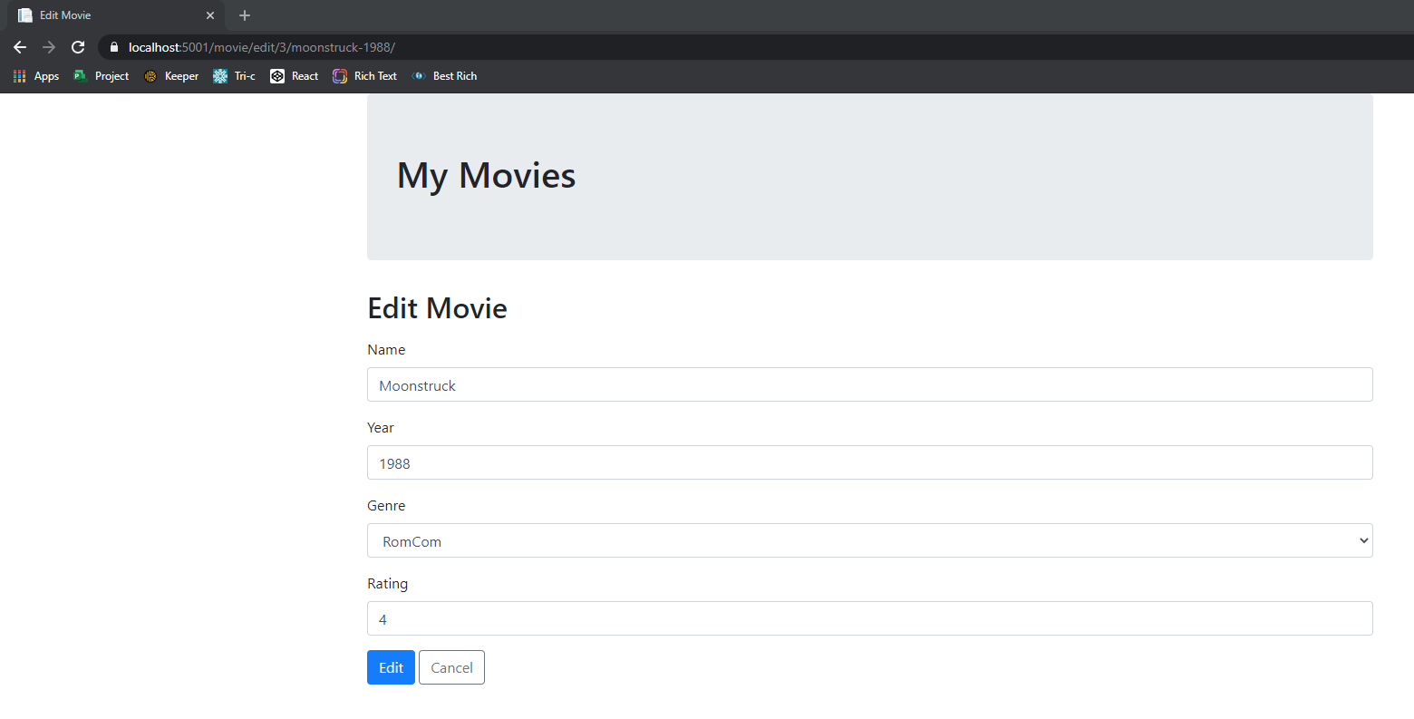

# Updated cancel button on the delete.cshtml page to use btn-outline-secondary classes

