Some General Notes on Framing the Constitution
In Friday's notes, we talked about the inadequacies of the Articles of Confederation, which became apparent shortly after the Revolution ended.
-- Lack of a stable monetary system slowed down interstate commerce. The country was awash in paper money, with all the states and the central government issuing currency to pay their debts
--Central government was unable to negotiate agreements on international trade policy. Europe took advantage of America's divisions to close its markets and flood the U.S. with European goods.
--In foreign relations, Britain refused to evacuate forts around the Great Lakes, Spain closed the Mississippi Rive and the Barbary Pirates made the Mediterranean Sea a war zone for American shipping.
All of the above added to America's woes and degraded its image abroad. This alarmed many because the government seemed unable tomaintain order and protect the property of its citizens at home. A series of domestic distrubances in the mid 1780s culinated with Shays's Rebellion in 1786-1787. When the central government was unable to put down Shays and his rebels, it became clear that the Articles must be radically changed.
Changing the Articles
By mid 1780s, national-minded James Madison and Alexander Hamilton became convinced that the Articles must be replaced with a strong central government.
1786 - Annapolis Convention : the nationalists began a campaign to revise the Articles. All states but Rhode Island agreed to meet and in May 1787, fifty-five delegates convened in Philadelphia to revise the Articles.
The delegates were national- minded as they quickly discarded the Articles and established a stronger central government. Both the Virginia Plan (favored by large states) and the New Jersey Plan (favored by small states) greatly enhanced the power of the central government.
Read more specifically about these plans and what was included in your text.
Putting the Constitution in Place
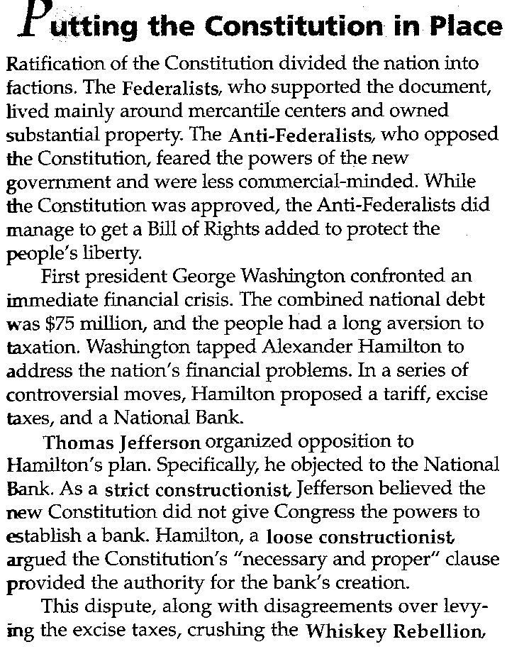
Ratification of the Constitution divided the nation into factions. The Federalists, who supported the document, lived mainly around mercantile centers and owned substantial property. The Anti-Federalists, who opposed the Constitution, feared the powers of the new government and were less commercial-minded. While the Constitution was approved, the Anti-Federalists did manage to get a Bill of Rights added to protect the people's liberty.
First President George Washington confronted an immediate financial crisis. The combined national debt was $75 million, and the people had a long version to taxation. Washington tapped Alexander Hamilton to address the nation's financial problems . In a series of controversial moves, Hamilton proposed a tariff, excise taxes, and a National Bank.
Thomas Jefferson organized opposition to Hamilton's plan. specifically, he objected ot the National Bank. As a strict constructionist, Jefferson believed the new Constitution did not give Congress the powers to establish a bank. Hamilton, a loose constructionist, argued the Constitution's "necessary and proper" clause provided the authority for the bank's creation.
This dispute, along with disagreements over levying the excise taxes, crushing the Whiskey Rebellion, and funding the national debt, gave rise to the nation's political party system. Jefferson's Democratic Republican Party supported limiting the powers of the central government. Hamilton's Federalist party believed the government must have significant taxing and governmental authority.

Source: U.S. History Skillbook

