# Housing Price Prediction – Capstone Two

## Project Overview

This project demonstrates a complete end-to-end machine learning workflow for predicting housing sale prices. Using a dataset of ~2,900 housing records, multiple regression models were built, evaluated, and compared to select the most effective model.

**Objective:** Predict `SalePrice` using numerical and categorical housing features.

**Outcome:** A Random Forest Regressor was identified as the best-performing model based on MAPE and R² metrics.

---

## Table of Contents

1. [Dataset](#dataset)
2. [Data Preprocessing](#data-preprocessing)
3. [Exploratory Data Analysis (EDA)](#exploratory-data-analysis-eda)
4. [Models Implemented](#models-implemented)
5. [Model Evaluation](#model-evaluation)
6. [Final Model](#final-model)
7. [Visualizations](#visualizations)
8. [Usage](#usage)
9. [Future Work](#future-work)
10. [References](#references)

---

## Dataset

- Source: HousePricePrediction.xlsx
- Records: ~2,900
- Features: Mix of numerical (LotArea, HouseAge, OverallCond) and categorical (MSZoning, BldgType, Exterior1st)
- Target: `SalePrice`

**Note:** Dataset preprocessing includes handling missing values, one-hot encoding for categorical variables, and feature scaling for certain models (e.g., SVR).

---

## Data Preprocessing

- **Missing values:** Imputed using mean for numeric columns
- **Feature engineering:** Created `HouseAge` and other derived features
- **Encoding:** One-hot encoding for categorical variables
- **Scaling:** StandardScaler applied to SVR features
- **Train/Test split:** 80% train / 20% test

---

## Exploratory Data Analysis (EDA)

**Key Findings:**

- Sale prices are right-skewed with high-value outliers
- Weak linear correlations with the target variable
- Supports use of tree-based models over linear regression

📊 Visualizations included in the report:
- Distribution of Sale Prices
- Correlation Heatmap

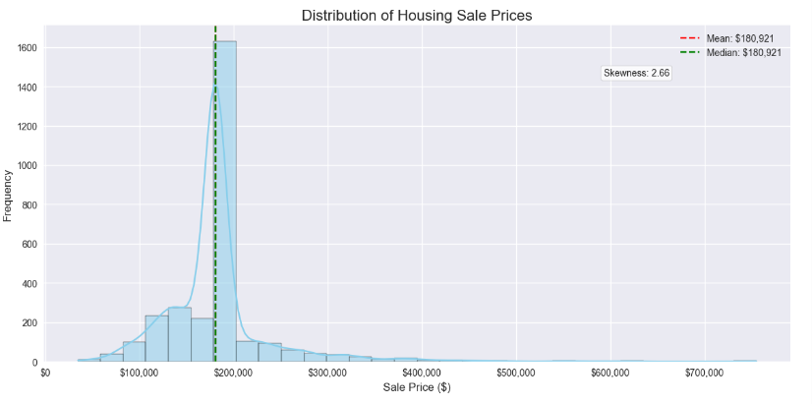
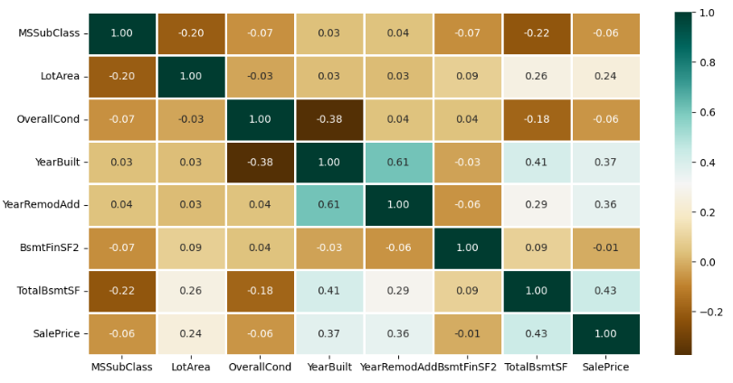

---

## Models Implemented

| Model | Description |
|-------|-------------|
| Linear Regression | Baseline linear model |
| Support Vector Regression (SVR) | Tuned with RBF kernel |
| Random Forest Regressor | Handles non-linear relationships, provides feature importance |
| Random Forest (Log-Transformed Target) | Attempts to normalize skew |
| CatBoost Regressor | Gradient boosting with native categorical handling |

---

## Model Evaluation

| Model | R² | MAPE |
|-------|----|------|
| Linear Regression | — | 20% |
| SVR | ~0.00 | ~18% |
| Random Forest | **~0.30** | ~20% |
| RF (Log) | ~0.26 | ~20% |
| CatBoost | ~0.23 | ~22% |

**Observation:** Random Forest provides the best combination of performance and interpretability.

---

## Final Model

- **Selected Model:** Random Forest Regressor
- **Reason:** Highest R², interpretable feature importance, robust performance
- **Top Features:** LotArea, HouseAge, OverallCond, MSSubClass

**Limitation:** ~70% of variance remains unexplained due to missing critical predictors.

---

## Visualizations

- **Figure 1:** Distribution of Sale Prices (skewed, high-value outliers)
- **Figure 2:** Correlation heatmap (weak linear relationships)
- **Figure 3:** Actual vs Predicted prices (Random Forest)
- **Figure 4:** Feature importance (Random Forest)

> Figures are referenced in the final report PDF using APA/IEEE-compliant captions.

---

## Usage

To run this project:

1. Clone the repository:

```bash
git clone https://github.com/npandey472/CapstoneTwoProject.git
cd CapstoneTwoProject
Install required packages:

bash
pip install -r requirements.txt
Run Jupyter Notebooks:

bash
jupyter notebook
Access results:

Capstone_Final_Report.pdf → Final report with figures and analysis

model_metrics.csv → All model evaluation metrics

Future Work
Include additional features like neighborhood data, total rooms, and quality metrics

Test Gradient Boosting (XGBoost, LightGBM)

Deploy model as a web application or API for predictions

References
Scikit-learn documentation: https://scikit-learn.org

Kaggle Housing Price dataset

Géron, A. (2019). Hands-On Machine Learning with Scikit-Learn, Keras & TensorFlow.

APA/IEEE Style Guidelines for Figures and References

Repository Structure:

markdown
CapstoneTwoProject/
│
├── notebooks/
│ ├── data_preprocessing.ipynb
│ ├── eda.ipynb
│ ├── model_building.ipynb
│
├── Capstone_Final_Report.pdf
├── model_metrics.csv
├── README.md
├── requirements.txt
└── figures/
├── figure1_distribution.png
├── figure2_correlation.png
├── figure3_rf_predictions.png
└── figure4_rf_feature_importance.png
GitHub Repository:
https://github.com/npandey472/CapstoneTwoProject

