TP4 - Sphere under internal pressure

Resume :

The main goal is to compare different finite element formulation for the mechanical benchmark of a sphere under internal pressure. Depending of the finite element, we will observe volumetric locking due to plastic deformations. Small and finite deformations will be used to compare also the difference.

Description of the problem

Geometry

The internal radius is and the external radius is . For symmetries raisons, only one-eigth of the sphere is modelled.

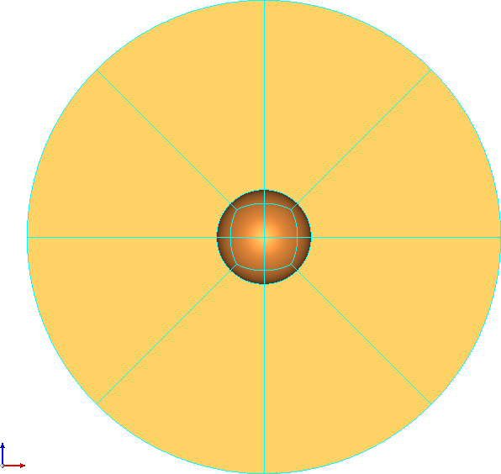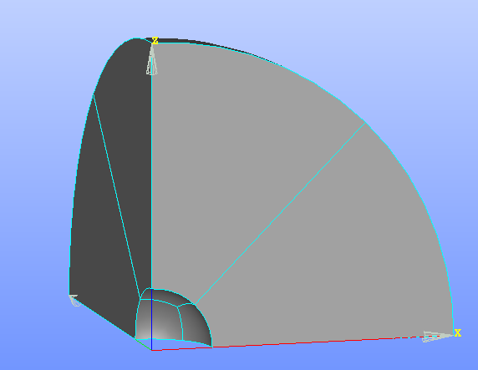

Boundary conditions and load

Symmetries :
Three faces are blocked in their orthogonal direction

Pressure load :
A pressure is applied on his internal surface with a magnitude from 0 to .

Material properties
The material is linear elastic with perfect plasticity.

- Young modulus
- Poisson’s ration
- Initial yield stress :
- Isotropic hardening modulus :

Analytical solution
The analytical solution for elasticity or perfect plasticity in small deformations is given in [E.A. de Souza Neto, D. Peric, D.R. Owen, Computational Methods for Plasticity: Theory and Applications, 2011 ].

Plasticity in small deformations

We begin with the scripts TP4.comm and TP4.export which contain a complete working example. For this first test, linear Lagrange finite elements are used. The pressure applied is of 150 MPa. You can begin by read the script and the different commands, then run it in the current directory with “/opt/public/code_aster/bin/run_aster TP4.export”
A result file named “result.med” is generated. You can renamed it to compare the different formulations with for example “cp result.med result_sdef_H8.rmed“.

A sign of volumetric locking is that the trace of stress tensor present strong oscillations. The following finite formulation will be used (and the name of mesh to use in TP4.export file)
Finite element | Name in code_aster | mesh
Linear Lagrange | 3D | sphere_H8.med
Quadratic Lagrange | 3D | sphere_H20.med
BiQuadratic Lagrange | 3D | sphere_H27.med
Quadratic under-integrated Lagrange | 3D_SI | sphere_H20.med
Three fields mixed method | 3D_INCO_UPG | sphere_H20.med
HHO | 3D_HHO / LINEAIRE | sphere_T4.med
The code_aster’s name has to be used in AFFE_MODELE/MODELISATION. For HHO, you have also to specify FORMULATION=’LINEAIRE’ or ‘QUADRATIQUE’. Moreover, the mesh have to converted to support HHO element with:

mesh = CREA_MAILLAGE(MAILLAGE=mesh0, MODI_HHO=_F(TOUT="OUI",),)

Post-processing

To visualise MED file, open AsterStudy module in salome_meca, then in Operations you can post-process your result with Post-process an external MED Results file.

Different fields can be visualised
- SIEF_ELGA: stress at the quadrature points
- SIEQ_ELFA: equivalent stress at quadrature points like von Mises stress (=VMIS), trace of the stress tensor (=TRISIG)
- VARI_ELGA_NOMME: constitutive-law’s variable at quadrature point like equivalent plastic deformations (=EPSPEQ)
- DEPL: displacement field at nodes

Q1: Have you some volumetric locking for linear Lagrange element ?
Q2: And for quadratic and bi-quatratic Lagrange elements ?
Q3: For comparison, you can note for each formulation, the total computation time present in mess.txt at the end of STAT_NON_LINE. Temps CPU consommé dans le calcul : 1 min 4 s

Correction for biquadratic Lagrange and HHO elements are given in TP4_SDEF.comm and in TP4_SDEF_HHO.export.

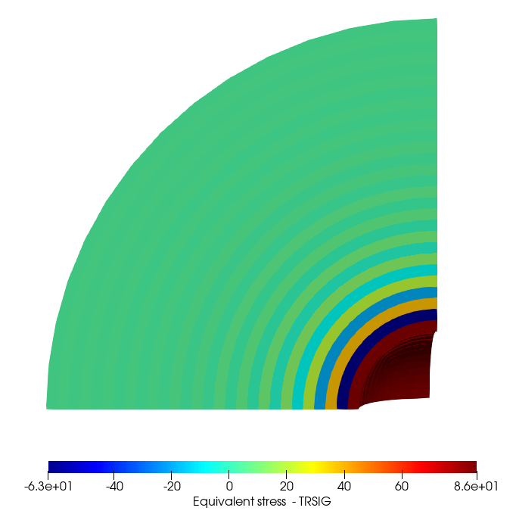Figure 1.4-1: Trace of the stress tensor for linear Lagrange element.

Plasticity in finite deformations

The difference with small deformations is that we use finite deformation within a logarithmic framework. You have to modify two parameters in the script:
- The pressure applied is now of 480 MPa: AFFE_CHAR_MECA/PRES_REP/PRES=480.
- The deformation is logarithmic: STAT_NON_LINE/COMPORTEMENT/DEFORMATION='GDEF_LOG'

The resolution is longer since we have added a second nonlinearity with a nonlinear measure of deformations. You can compare as previously the different formulations.

Q4: Which formulation does not present volumetric-locking ?
Q5: Which formulation seems optimal in terms of locking and computation times ?
Q6: What is the disadvantages of this formulation ?
Q7: For HHO formulations, have you a difference between linear and quadratic formulations ?
Q8: For HHO formulations, test small and large value of the stabilization coefficient ? Which impact has it compare to small deformations ? DEFI_MATERIAU/HHO/COEF_STAB

Correction for UPG and HHO elements are given in TP4_FDEF_UPG.comm and in TP4_FDEF_HHO.export.
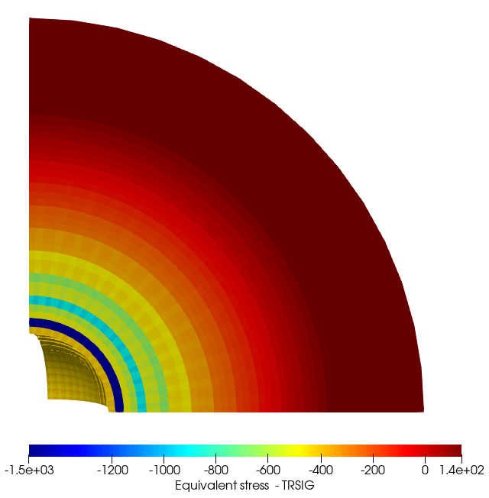Figure 2-1: Trace of stress tensor in finite deformation for quadratic Lagrange element

