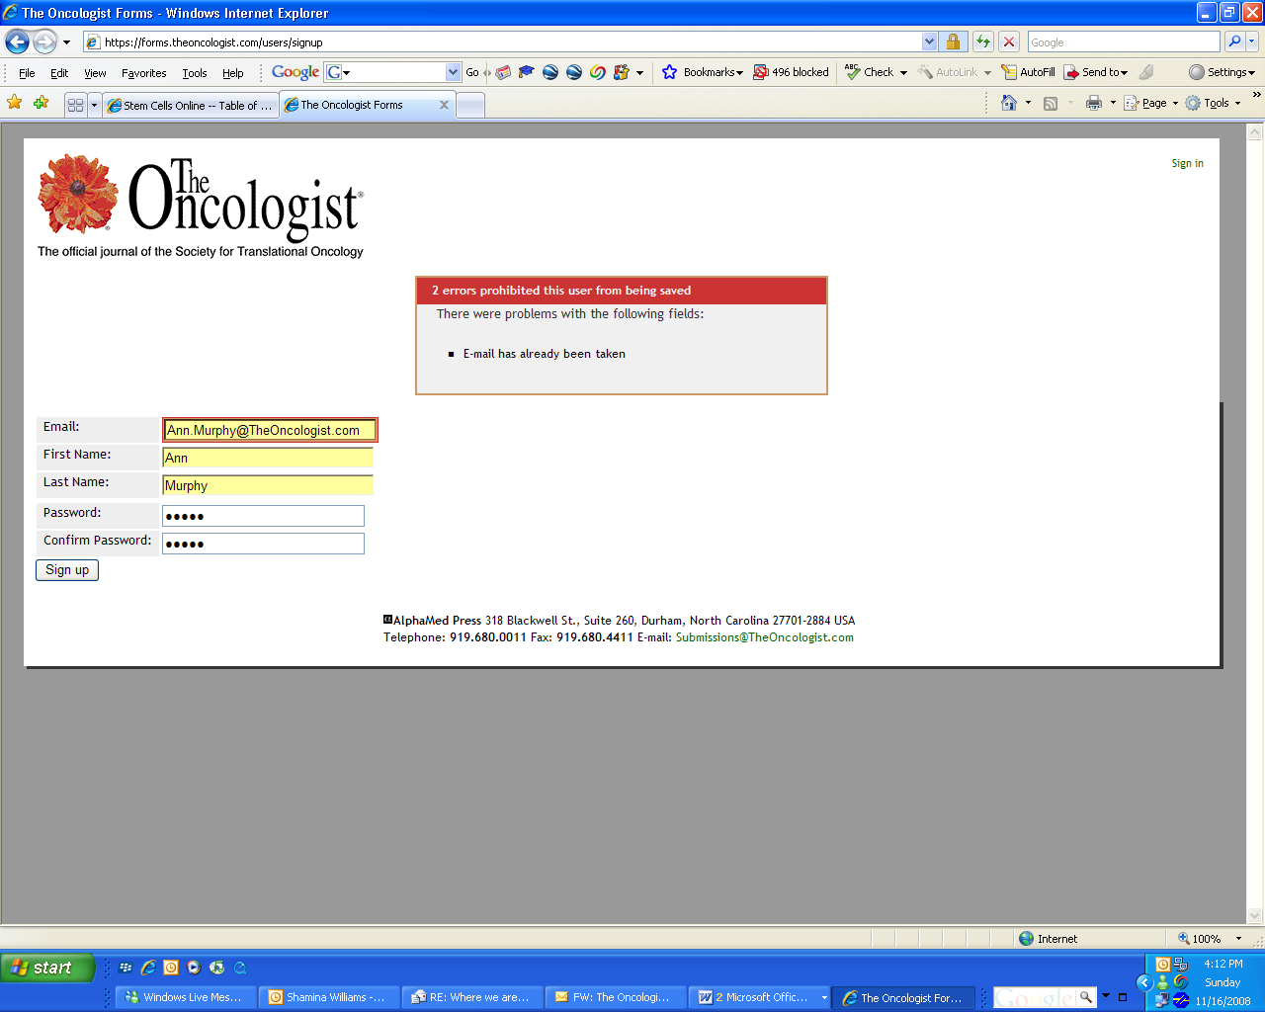

But when I tried to sign in using exactly the same, here’s what it says: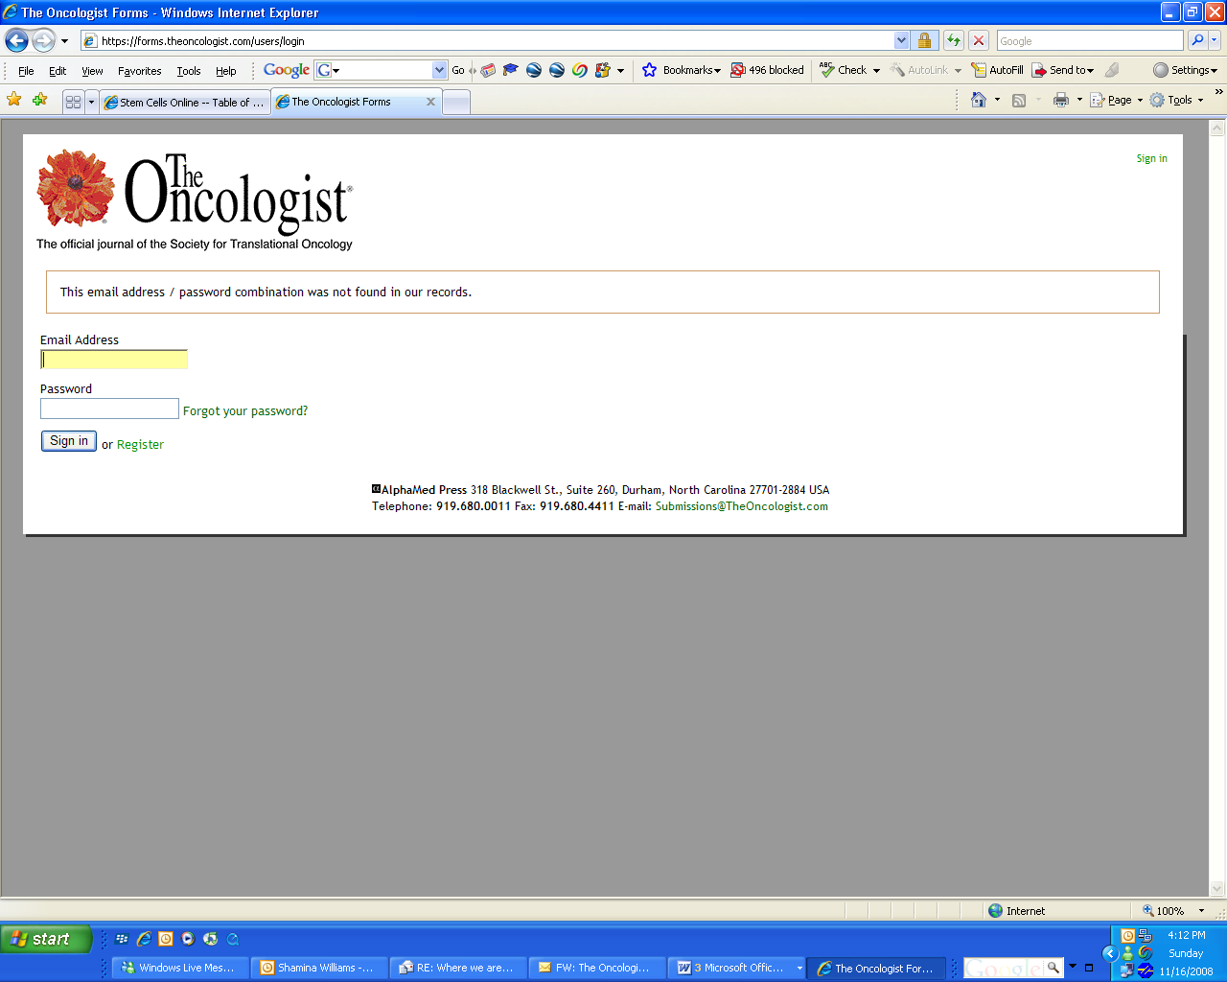

When I hit the back button, the web page could not be found

