**Java Notification Client**

Contents

General: 1

Running the program 1

Screens in the UI 1

Login Screen: 1

Search Results Screen: 2

Main Screen 2

Installation 3

Notification Service 3

## General:

* The UI is created using JavaFx 2 (JDK 7)
* The backend notification service (<http://fakezapposnotificationservice.npatta01.cloudbees.net/>) is written using the Play framework
* Applications is composed of several maven modules

## Running the program

Double click the jar file “DesktopNotificationClient.jar"

## Screens in the UI

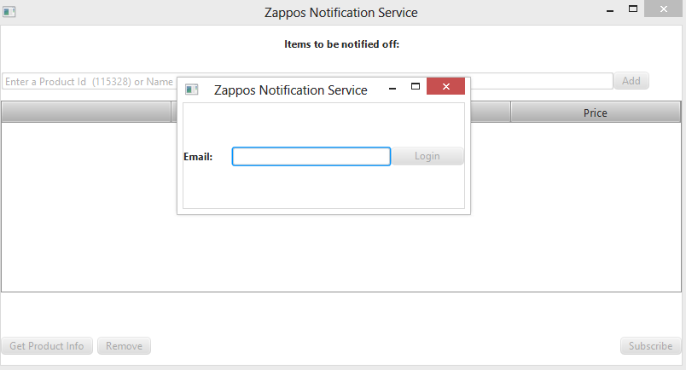

### Login Screen:

Enter email. If you are an **existing** user, your subscription list will be shown, else you will automatically register as a new user

### Search Results Screen:

If product query, has multiple style the below window will be shown asking to select specific styles.

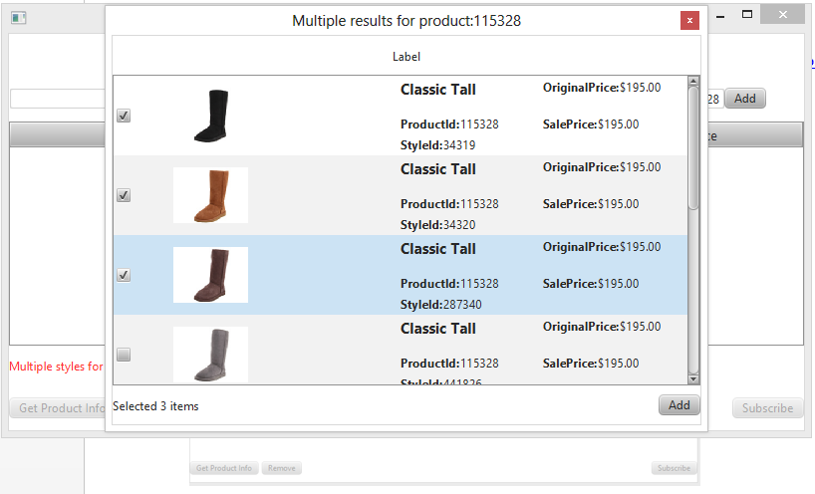

Click on the checkbox to add to list. Double click on a cell to be taken to the product page

### Main Screen

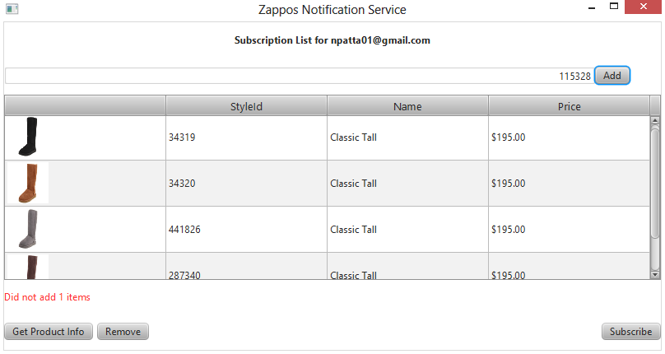

Click on subscribe, to update the subscription list

## Installation

Requires JavaFx/JDK7 to be installed and in the path  
Requires maven to be installed and in path  
Optional: running NotificationService requires play 2.1+ to be installed

* Change into the directory ZapposNotification
  + Directory should only contain a’pom.xml file
* Run ‘mvn install’
  + Program is composed of 4 modules
  + If successful, below is the result

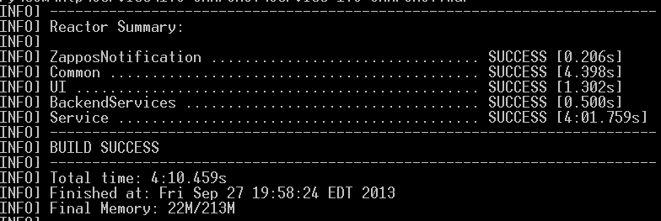

If the Service Module fails, that’s okay.

To create an executable jar:  
- navigate to the UI module  
- run mvn clean jfx:jar  
- result will be in target/jfx/app  
-click " UI-1.0-SNAPSHOT-jfx.jar"

## Notification Service

A backend service that I wrote to wrap around the ZapposApi. Users can ask the api for product information given a styleid, productid, product name. User’s can register/unregister to be notified for certain items .  
The server is deployed at <http://fakezapposnotificationservice.npatta01.cloudbees.net/>

Every 12 hours, a job is fired to check the price of registered items.  
Emails are send using SendGrid: from “**notification@npatta01-zappos.com** “

*Note: no default routes are defined.

Below are possible options to get info from the service

1. Get info on product id **115328**

[/api/Product?product_id=115328](http://fakezapposnotificationservice.npatta01.cloudbees.net/api/Product?product_id=115328)

1. Get info on product with name **“classic tall black”**

[/api/Product?product_name=classic%20tall%20black](http://fakezapposnotificationservice.npatta01.cloudbees.net/api/Product?product_name=classic%20tall%20black)

1. Get info on product with style id “**1788226**”

[/api/Product?style_id=1788226](http://fakezapposnotificationservice.npatta01.cloudbees.net/api/Product?style_id=1788226)

1. Unregister user “npatta01@gmail.com”

[/api/User/unregister?email=npatta01@gmail.com](http://fakezapposnotificationservice.npatta01.cloudbees.net/api/User/unregister?email=npatta01@gmail.com)

1. Register user

[/api/User/register?email=npatta01@gmail.com](http://fakezapposnotificationservice.npatta01.cloudbees.net/api/User/register?email=npatta01@gmail.com)

1. Verify User with email [npatta01@gmail.com](mailto:npatta01@gmail.com) and verification code 9708a56b-9566-40c9-8e6a-604a3b24274f

[/api/User/verify?email=npatta01@gmail.com&verificationCode=9708a56b-9566-40c9-8e6a-604a3b24274f](http://fakezapposnotificationservice.npatta01.cloudbees.net/api/User/verify?email=npatta01@gmail.com&verificationCode=9708a56b-9566-40c9-8e6a-604a3b24274f)

1. Notify to be subscribed for email [npatta01@gmail.com](mailto:npatta01@gmail.com) and items [2123605,1788226\

Post a json request to [/api/User/notify](http://fakezapposnotificationservice.npatta01.cloudbees.net/api/User/register?email=npatta01@gmail.com)

With a body such as

{"emailAddress":"npatta01@gmail.com", "products":[2123605, 1788226]}

1. Force Notification Job

To force a price check, submit a post request to

<http://fakezapposnotificationservice.npatta01.cloudbees.net/startJob>