File Management & Synchronization
Powered by:
Pratik S. Desai
Nikhil Bendre
CPSC 852 Project

Contents

1. Introduction 3
2. overview 4
2.1. Client 4
2.2. Server 4
3. Motivation & Objective: 5
4. Technical Specifications 6
5. Installation Guide 7
5.1. Downloading and Installing the SDK: 7
5.2. Adding Android Platforms and other Components: 7
5.3. Creating an AVD: 7
6. Implementation Details 8
6.1 Server 8
6.2 Android Device Client: 8
8. Testing 12
9. Conclusions 13

Introduction
File management and synchronization has played an important role in mobile devices ever since the use of smart phones increased. Smart phones allow users to store data (files) on the mobile device. Users have lots of files ranging from simple text to video files stored on the mobile device. As Android is a smartphone operating system, it has various applications which can read, play and write to different files. Also users have the need to synchronize data stored on their device, with other computers at work or home. Our project deals with file management and synchronization with a host machine. The project involves building an Android mobile application which allows user to manage and synchronize files with the host machine. The user has the freedom to send/receive only a single file or the user can synchronize the entire folder.

overview
Android mobile application acts as a client, it connects to the server which is a Linux Machine. We use TCP connection to send data between client and server. The application can send and receive files of any format. The synchronization takes place on the basis of “last modified” timestamps.

2.1. Client
Mobile application is built on Android 2.2 (FROYO) using Python and the Scripting Layer for Android (SL4A) package. The client side application is responsible for making requests for downloading and uploading files from and to the server respectively.

2.2. Server
A python script running on a Linux host is the server. It sends the list of files to be uploaded and downloaded to and from Android device.

3. Motivation & Objective:
The most important motivation of this project has been the application development on Android OS. The use of python with Scripting Layer for Android (SL4A) on Android platform was also exciting and has been a great success.

The objectives of this project are:
- To understand and use the Android platform.
- To design and write network applications for Android OS.

4. Technical Specifications
S. No | Component | Specifications.
1. | Client | Platform: Android Platform 2.2 (FROYO) using android SDK.  Language Used: Python (v 2.6.2) using SL4A  Connection to Server: TCP/IP connection
2. | Server | Server Configuration: Linux Machine  Language used: Python (v 2.7)  Connection to Client: TCP/IP connection

5. Installation Guide

5.1. Downloading and Installing the SDK:
The Android SDK can be downloaded from http://developer.android.com/sdk/index.html.The Android SDK archive should be unpacked to any location on the machine. By default, the SDK files are unpacked into a directory named android-sdk-<machine-platform>.

5.2. Adding Android Platforms and other Components:
Android SDK and AVD Manager can be used to install or update the individual SDK components. The Android SDK and AVD Manager tool is included by default in Android 1.6 and later SDK packages.
The SDK and AVD Manager can be launched in one of the following ways:
Execute the android tool command with no options. The <sdk>/tools directory should be change and run the command: $ android

5.3. Creating an AVD:
To use the emulator, an Android Virtual Device (AVD) must be created. The following command can be executed from the directory in SDK package:
$ android create avd –target 2 –name 852_avd
Complete Reference on Installation Guide: http://developer.android.com/sdk/installing.html

6. Implementation Details
The server is responsible for creating a list of files to be synced and the client (on the Android device) initiates the file transfers.

6.1 Server
- The server (or the host) gets a list of files present in specified directory, their modified timestamps and stores these values in a hash table.
- The host then opens the .file_stats file (if present) in the specified directory.
- .file_stats contains the names of files in the directory and their respective modified timestamps at the last sync operation.
- The host updates the hash table by appending the “last modified time” entry from .file_stats to the corresponding file name, if present in the hash table.
- If there is no entry in .file_stats, it appends the file creation time. The extra file (deleted after last sync operation) entries in .file_stats are ignored.
- The client then sends its own file hash table to the server.
- The server compares the two hash tables and creates a list of files to be uploaded to the android device and the list of files to be downloaded from the device.
- The list of files is created by comparing the difference between the timestamps for each file from both the host's and client's hash table. The one with the larger difference is considered as most recent.
- The list also includes the files to be uploaded or downloaded which are only present in either of the host or android device.
- The host then sends the final list to the client.
- The host first sends all the files to be uploaded, then downloads all the files needed.
- Finally the hash table is recalculated and written to .file_stats

6.2 Android Device Client:
- The client creates a hash table in the same way the host does, and transfers it to the host.
- The host sends back a list of files to be sent to the device and a list of files to be downloaded from the client.
- The client starts receiving files from the host.
- After all the files are received, it sends out the files required by the host.
- Finally it recalculates the hash table of files present and writes it to its .file_stats.
7. Snapshots
This command sends Python script files to the Android Device.
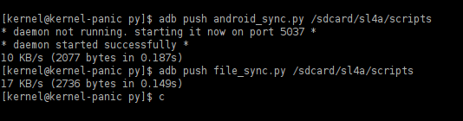
List of files on the host and the AVD before sync operation
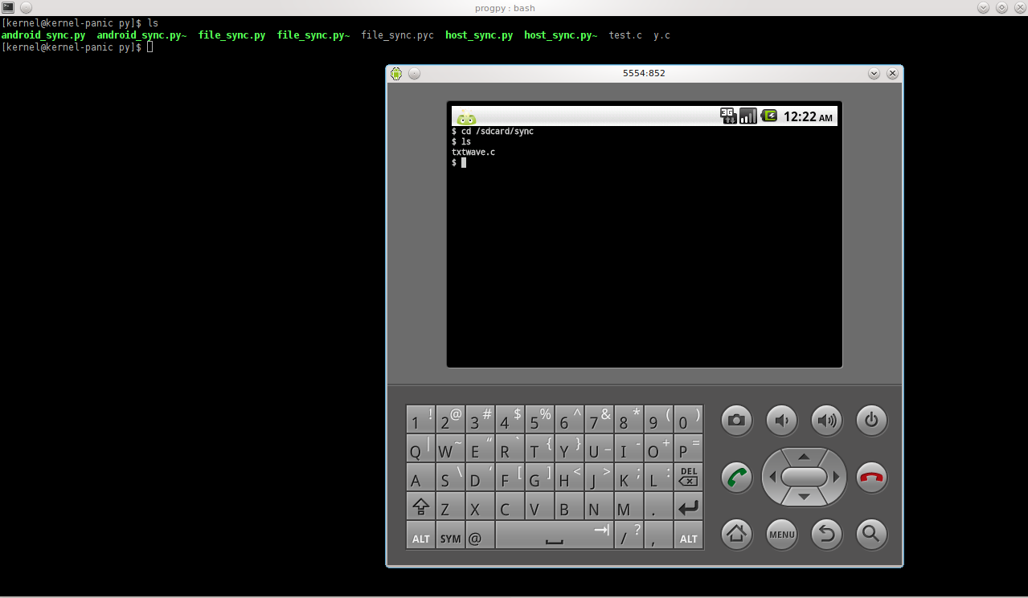
The sync process 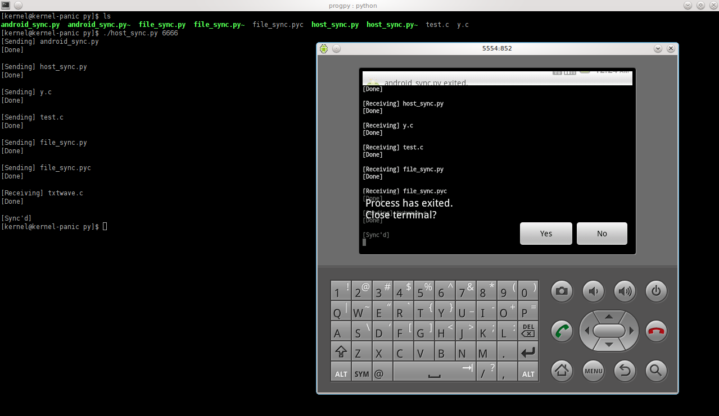
Syncing again does not do any transfer as both the host and client are synced.
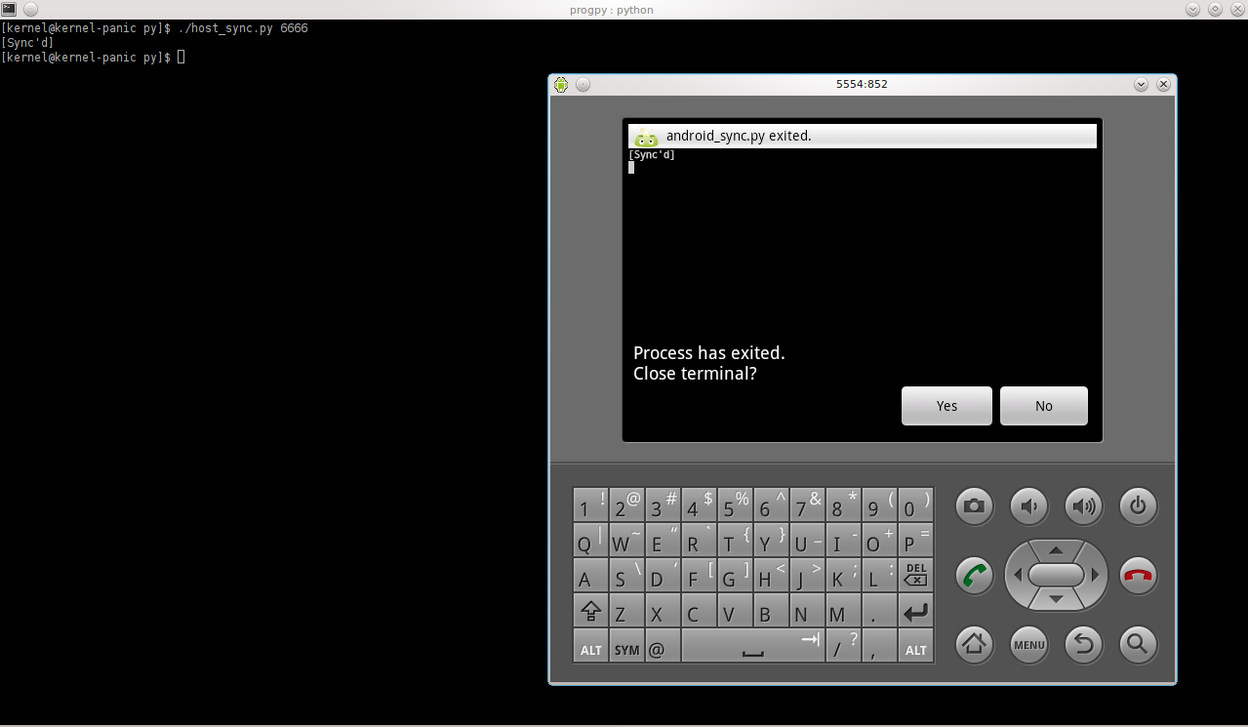
The file contents of host and client after the sync operation.
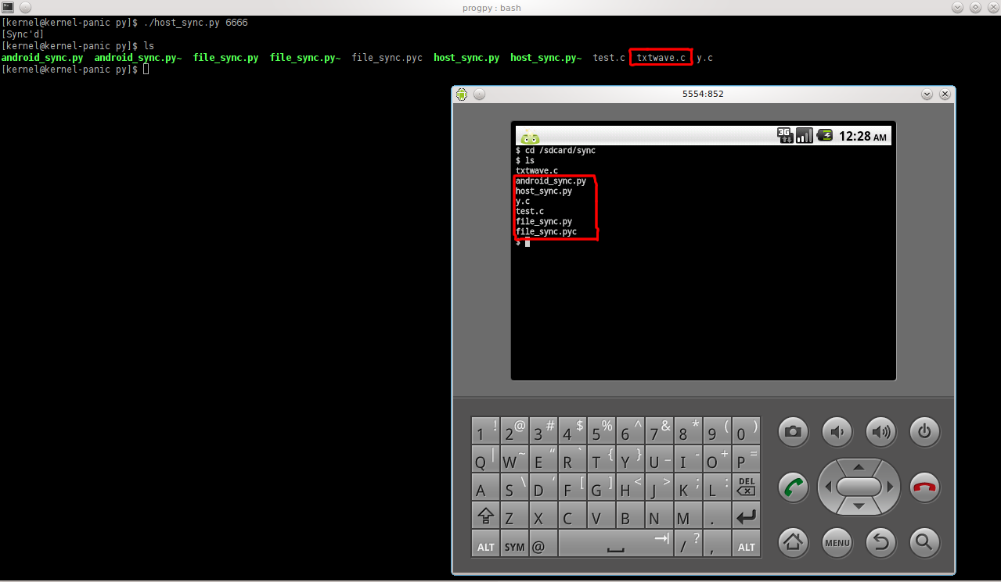

8. Testing

- Suppose, the client does not contain any files and the server contains one or more files then synchronize will update the client with all the hosts content.
- If the .file_stats file does not exist, in either of the host or the client, then only the modified timestamps are taken from the files in the directory.
- If client crashes while sending data, the timeout in the server expires and server closes down successfully, and vice-versa.
- The bandwidth obtained for a large file (46MB) transfer from Android device to host was about 937.7 Kbps over a wireless network (54 Mbps).

9. Conclusions
We have successfully implemented the “File Management & Synchronization” project on Android.
Future work for this project will include designing a GUI. We can also enhance this “Synchronization” to include sub folders. Also it can be made compatible with IPv6.

