Assumptions of ANOVA

Hypothesis

* Null hypothesis: Average age is the same across all categories.
* Alternative hypothesis: Average age varies across categories

ANOVA of age

Average age

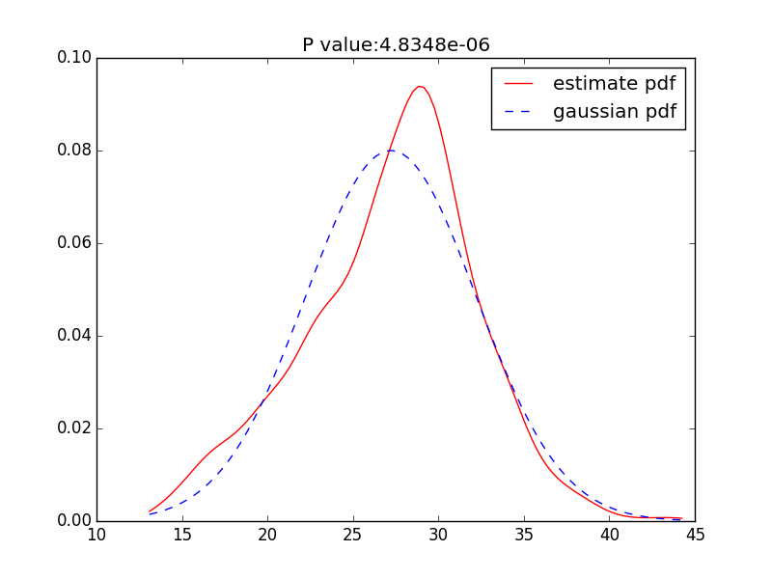

1. Average age components

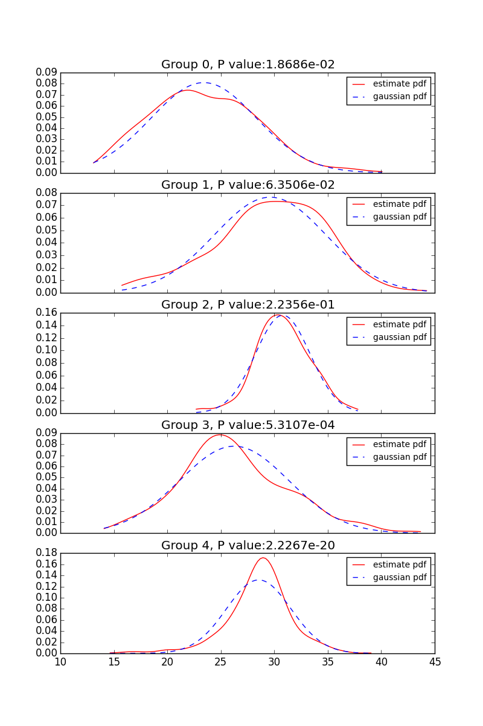

|  |  |  |  |  |  |  |  |  |
| --- | --- | --- | --- | --- | --- | --- | --- | --- |
|  | 1 | 2 | 3 | 4 | 5 | Max | Min | Ratio |
| Variance | 24.19 | 27.13 | 6.48 | 25.93 | 9.10 |  |  |  |
| Std. Dev | 4.92 | 5.21 | 2.55 | 5.09 | 3.02 | 5.21 | 2.55 | 2.04 |

Max and Min standard deviation ratio is 2.04. Although not strictly, it satisfies the thumb rule that the ratio should be less than 2.

Other columns

1. Number of members

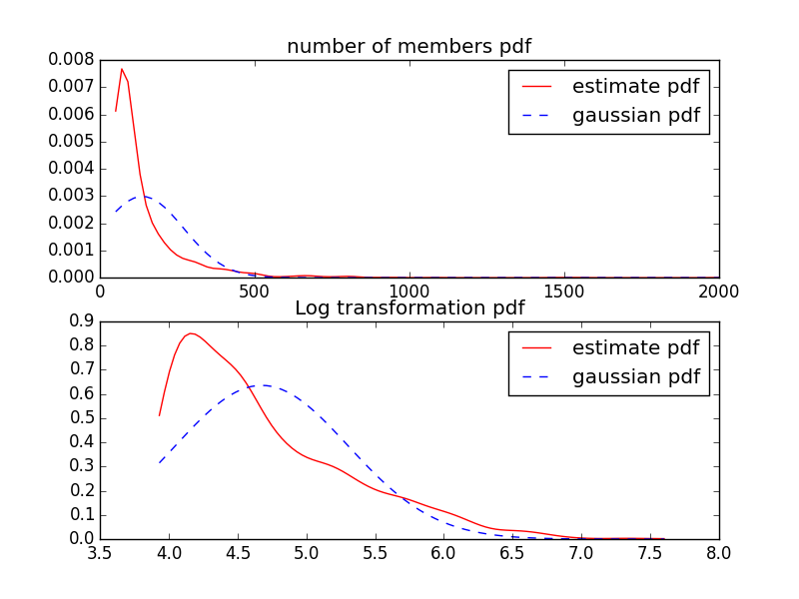

1. Number of messages

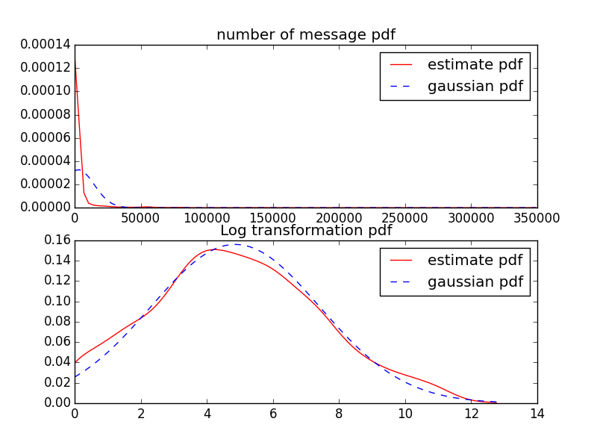

|  |  |  |  |  |  |  |  |  |
| --- | --- | --- | --- | --- | --- | --- | --- | --- |
|  | 1 | 2 | 3 | 4 | 5 | Max | Min | Ratio |
| Variance | 8.98 | 7.72 | 5.90 | 5.58 | 4.17 |  |  |  |
| Std. Dev | 3.00 | 2.78 | 2.43 | 2.36 | 2.04 | 3.00 | 2.04 | 1.47 |

1. Number of conversations

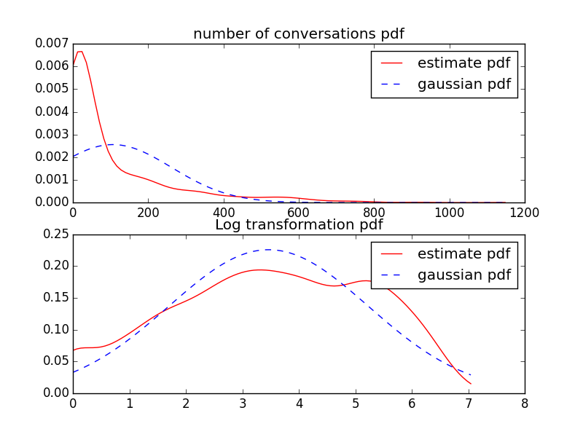

ANOVA for non-Gaussian

1,

One-way ANOVA is considered a “robust” test against the normality assumption. When used directly for non-Gaussian data, only produce a small effect on the Type I error rate

Non-parametric methods.

**Kruskal–Wallis H test**

**Mann–Whitney U test (when only two groups for testing)**

**Friedman test**

**Kendall's W test (normalization of Friedman test)**