***Systems modelling predicts chronic inflammation and genomic instability prevent effective mitochondrial regulation during biological ageing.***

Alvaro Martinez Guimera1, Juel Rasmussen2, Daryl Shanley1

1. Institute for Cell and Molecular Biosciences (ICaMB), Ageing Research Laboratories, Campus for Ageing and Vitality, Newcastle University, United Kingdom

2. Faculty of Health and Medical Sciences, University of Copenhagen, Copenhagen, Denmark

1. Parameter estimation

The parameter estimation procedure was done sequentially for each model input. This means that after estimating a set of parameters using the available data for a given treatment, these were fixed and would not be re-estimated in subsequent parameter estimations for the other treatments. The first parameter estimation procedure was carried out using data for PJ34 treatment in order to estimate the parameters involved in NAD synthesis and utilisation (transitions V9 to V11 in supplementary table 4). For the calibration of the model response to PARP1 inhibition, time course data for the NAD key observable was obtained from Bai et al. (2011) where C2C12 myotubes were treated with 1µM PJ34. The data spanned 24hrs through 5 timepoint measurements. No data was found for PGC1α or AMPK-P for this treatment on C2C12 myotubes. The simulation of PARP1 inhibition in the model requires the initial abundance of the ‘PARP1’ model variable be changed from 1 to 0. The parameter estimation procedure produced a close fit between the model simulation and the experimental data from [Bai et al. (2011)](#_ENREF_1" \o "Bai, 2011 #1), as shown in Figure S1.

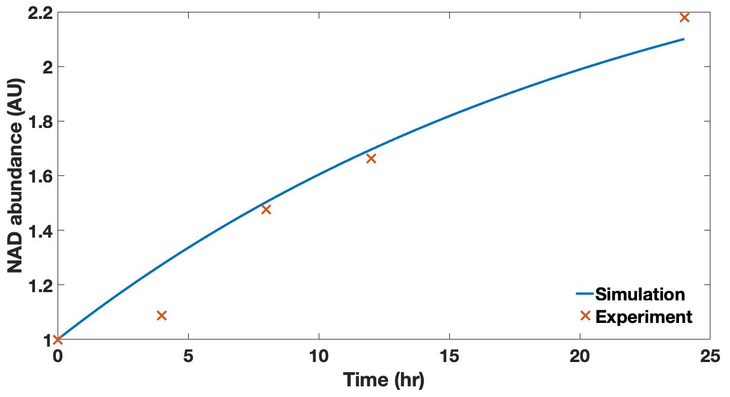***Figure S1.*** *Model calibration results for NAD in response to 1µM PJ34 treatment. Experimental data* *from C2C12 myotubes was obtained from [Bai et al. (2011)](#_ENREF_1" \o "Bai, 2011 #1) .*

The second parameter estimation estimated all the remaining model parameters except those modelling the NR treatment input (transition V26 in supplementary table 4) and the glucose treatment input (transitions V19 to V23 in supplementary table 4). For the calibration of the model response to AICAR treatment, time course data was found for the three key observables of the model: NAD, deacetylated PGC1α and PhosphoThr172 AMPK (henceforth AMPK-P). The time course for the latter observable was obtained from Egawa et al. (2014) and spanned 24 hrs through five timepoint measurements. The time courses for the first two key observables was obtained from Canto et al. (2009) and spanned 12 hrs through five timepoint measurements. The time course for all three observables was in C2C12 myotubes in response to 0.5mM AICAR treatment.

The simulation of an AICAR treatment in the model requires the initial abundance of the ‘AICAR’ model variable be changed from 0 to 1. The execution of a parameter estimation procedure calibrated the parameter set to a close fit with the experimental data as seen in Figures S2 and S3 below.

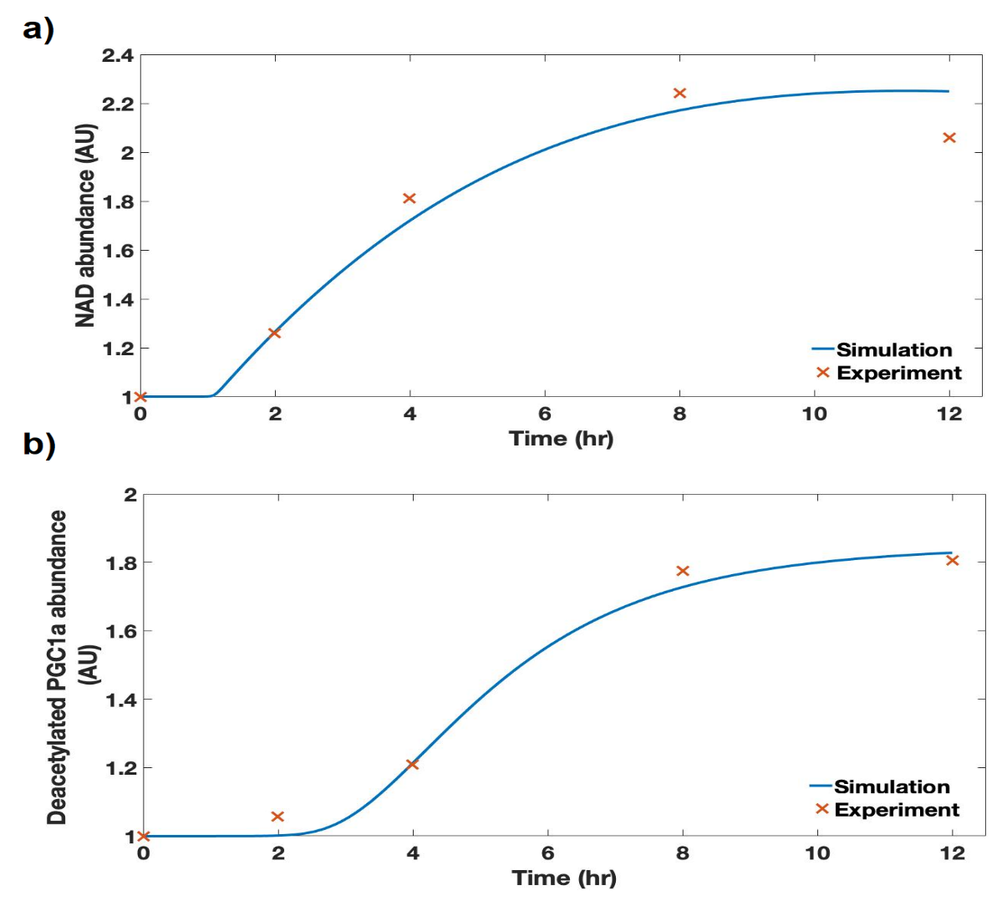***Figure S2.*** *Model calibration results for* ***a)*** *NAD and* ***b)*** *deacetylated PGC1α in response to 0.5mM AICAR treatment. Experimental data from C2C12 myotubes was obtained from [Canto et al. (2009)](#_ENREF_2" \o "Canto, 2009 #3).*

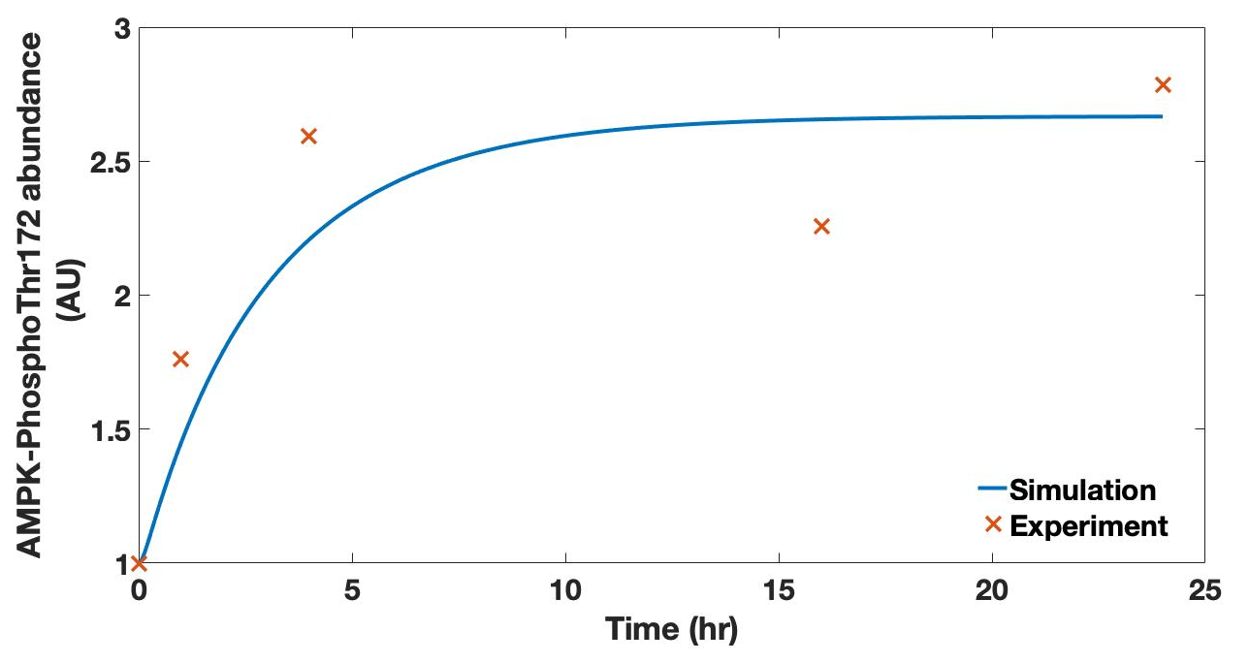***Figure S3.*** *Model calibration results for PhosphoThr172 AMPK in response to 0.5mM AICAR treatment. Experimental data from C2C12 myotubes was obtained from [Egawa et al. (2014)](#_ENREF_5" \o "Egawa, 2014 #7).*

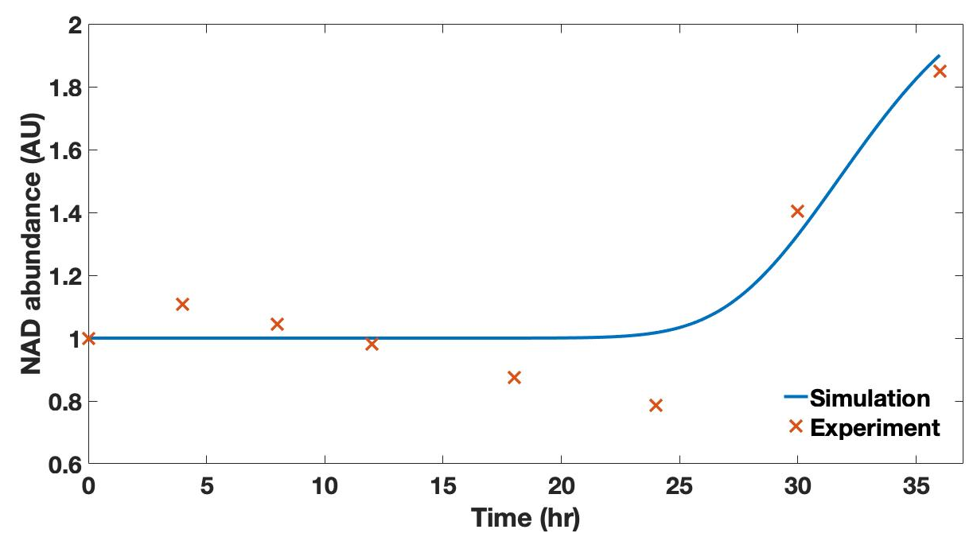For the calibration of the model response to glucose restriction, time course data for the NAD key observable was obtained from Canto et al. (2010) where C2C12 myotubes cultured under 25mM glucose medium were switched to 5mM glucose medium. The data spanned 36hrs through 8 timepoint measurements. No data was found for PGC1α or AMPK-P for this treatment on C2C12 myotubes. The simulation of glucose restriction in the model requires the rate constant of the ‘Glucose influx’ reaction to be changed to a value of 5 a.u from a value of 25 a.u. A subsequent parameter estimation procedure for parameters involved in transitions V19 to V23 (see supplementary table 4) resulted in a close fit between the model simulation and the experimental data from Canto et al. (2010) as shown in Figure S4.

***Figure S4.*** *Model calibration results for NAD in response to a 25mM to 5mM glucose restriction protocol. Experimental data from C2C12 myotubes was obtained from [Canto et al. (2010)](#_ENREF_4" \o "Canto, 2010 #4).*

The last parameter estimation was done for the calibration of the model response to NR supplementation for the parameters in transition V26 (see supplementary table 4). Dose-response data for the NAD key observable was obtained from Canto et al. (2012) where C2C12 myotubes were treated with 6 different doses of NR spanning a 20-fold range and NAD measurements taken at the 24hr timepoint. Dose-response data was used in the calibration of this model input in the absence of any time-course data retrieved from the literature. Because the data was not in a time course format, the parameter estimation was performed manually to produce a visually-assessed good fit, which is shown in Figure S5. No data was found for PGC1α or AMPK-P for this treatment on C2C12 myotubes.

The simulation of NR supplementation in the model requires the initial abundance of the ‘NR-NMN’ model variable be changed from 0 to the numerical value of the dose being simulated in µM units. Hence, if experimental data for a 200µM NR supplementation is used, the initial abundance of the ‘NR-NMN’ model variable should be set to 200a.u.

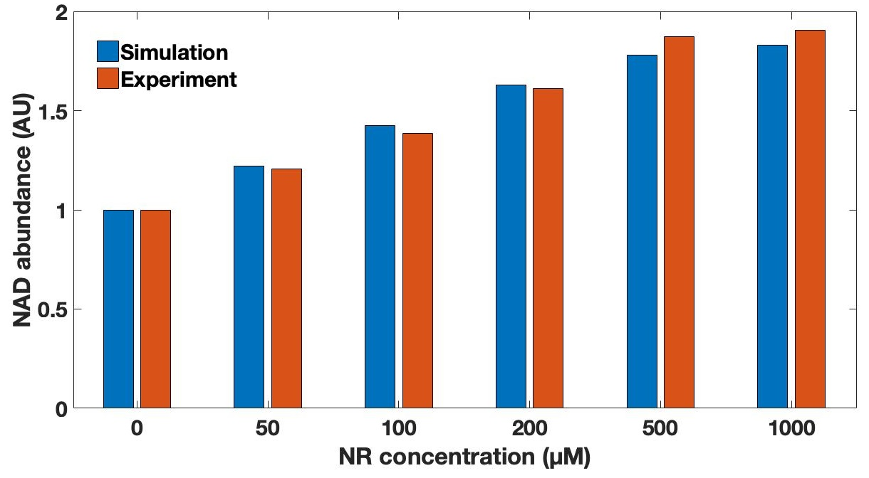

***Figure S5.*** *Model calibration results for NAD levels at the 24hr timepoint in response to different doses of NR supplementation. Experimental data from C2C12 myotubes was obtained from [Canto et al. (2012)](#_ENREF_3" \o "Canto, 2012 #5).*

1. Model validation
   1. Validation of AICAR treatment

A time course dataset from Park et al. (2011) on the abundance of PhosphoThr172 AMPK in C2C12 myotubes treated with 2mM AICAR was used to validate model behaviour to the AICAR stimulus. Since the model had been calibrated to a dataset involving 0.5mM AICAR treatment, the ‘AICAR’ parameter denoting the presence of AICAR had to be raised four-fold from a value of 1 to a value of 4. The simulation of the model under these conditions resulted in a fit to the validation data shown in Figure S6.

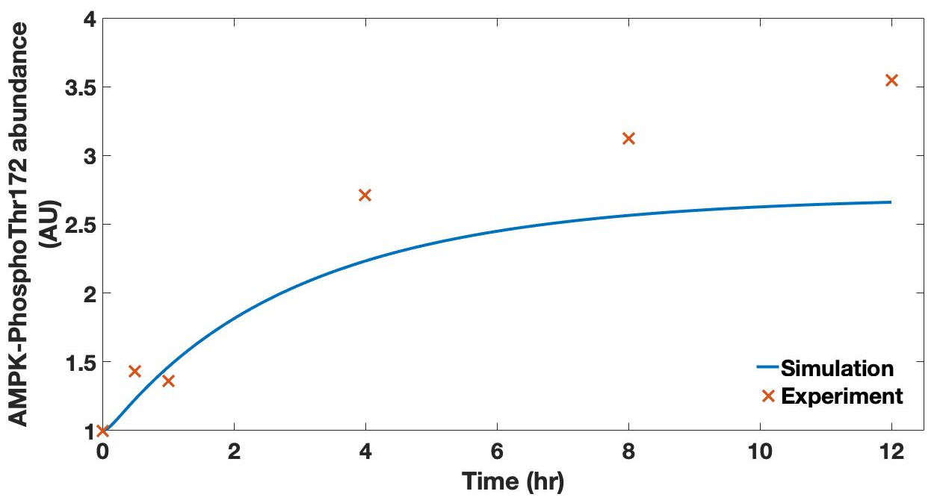

***Figure S6.*** *Model validation results for PhosphoThr172 AMPK levels in response to 2mM AICAR treatment. Experimental data from C2C12 myotubes was obtained from [Park et al. (2011)](#_ENREF_17" \o "Park, 2011 #12).*

The validation results shown in Figure S6 suggest that the model starts underestimating the magnitude of AMPK phosphorylation to a 2mM AICAR treatment after 4 hours and the degree of this underestimation increases gradually up to 12 hrs post-treatment. It should be worth noting, however, that it is the difference from the mean experimental measurement what is being examined. The experimental error bars in the original data correspond to the standard error of the mean for three experimental repeats. If these were converted into standard deviations and plotted alongside the mean measurements then the model simulation would seem closer to the experimental data than displayed in Figure S6.

In addition, another time course dataset for the response of AMPK-P to 2mM AICAR treatment in C2C12 myotubes was obtained from the literature (Ouchi et al., 2005). In this case, the model simulation fits the data very closely (Figure S7).

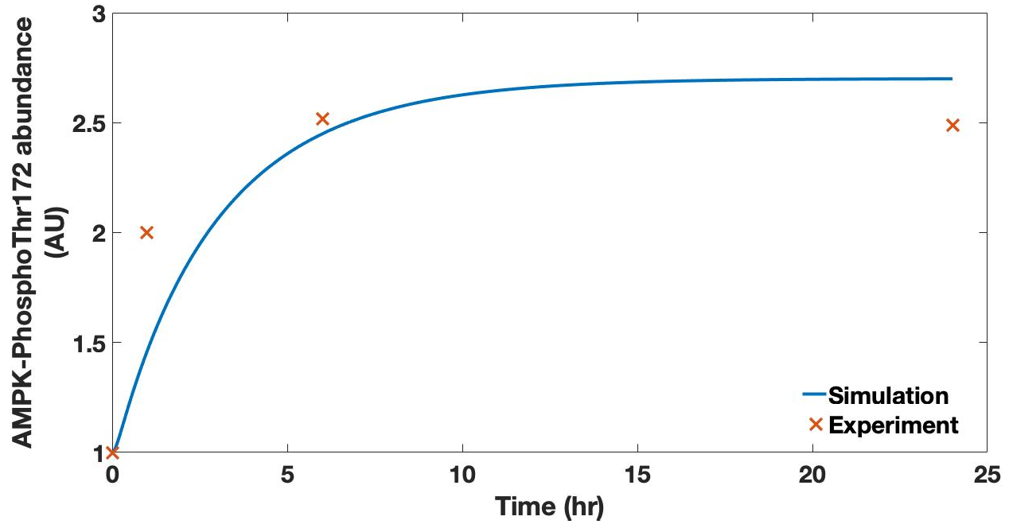

***Figure S7.*** *Model validation results for PhosphoThr172 AMPK levels in response to 2mM AICAR treatment. Experimental data from C2C12 myotubes was obtained from [Ouchi et al. (2005)](#_ENREF_15" \o "Ouchi, 2005 #11).*

Data by Egawa et al. (2014) shows a dose response curve where treating C2C12 myotubes with 2mM AICAR will not result in a difference in PhosphoThr172 AMPK levels at the 24hr timepoint compared to treatment with 0.5mM AICAR. The dose response also shows that treating cells with 0.1mM AICAR will not result in a change from the basal levels of AMPK phosphorylation, with the responsiveness threshold lying somewhere between 0.1 and 0.5mM AICAR. Such a response threshold and the saturation effect is faithfully captured by model simulations as displayed in Figure S8. The slight overestimation of the abundance of AMPK-P at the 24hr timepoint seen in Figure S8 is confirmed by further data from Hall et al. (2018), where C2C12 myotubes where treated with 0.5mM AICAR (see Figure S9).

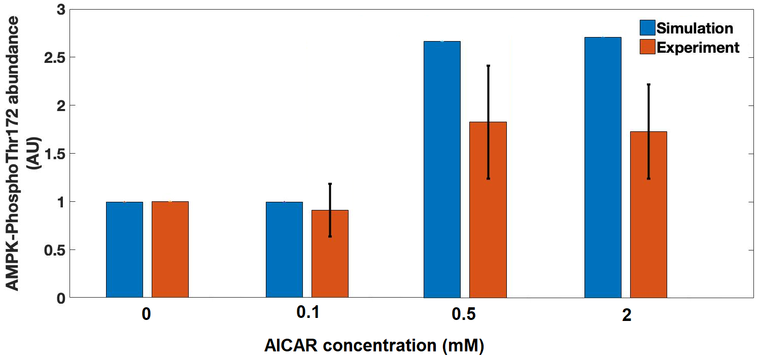

***Figure S8.*** *Model validation results for PhosphoThr172 AMPK levels at the 24hr timepoint in response to increasing doses of AICAR treatment. Experimental data from C2C12 myotubes was obtained from [Egawa et al. (2014)](#_ENREF_5" \o "Egawa, 2014 #7). Error bars show standard deviation.*

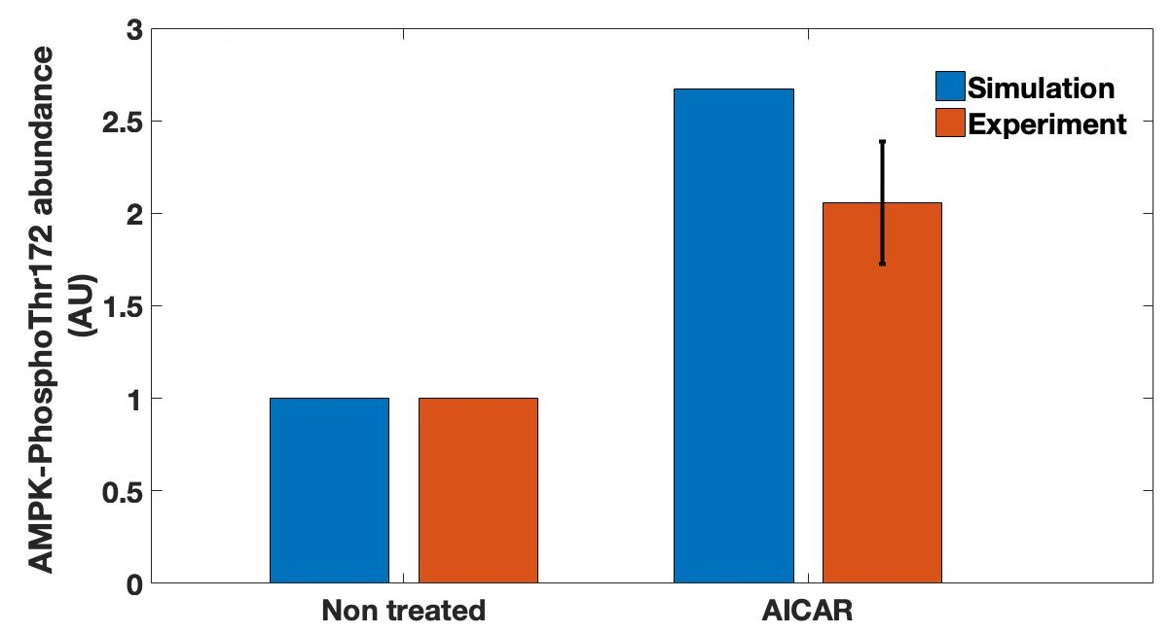

***Figure S9.*** *Model validation results for PhosphoThr172 AMPK levels at the 24hr timepoint in response to 0.5mM AICAR treatment. Experimental data from C2C12 myotubes was obtained from [Hall et al. (2018)](#_ENREF_11" \o "Hall, 2018 #8). Error bars show standard deviation*

Data from Canto et al. (2009) that had not been used to calibrate the model were also used for validation. This included changes in NAD and deacetylated PGC1α levels in response to 0.5mM AICAR treatment (Figures S10 and S12 respectively). The validation shown in Figure S10 seems to suggest that at early timepoints (~4hrs) the model might be underestimating slightly the amount of NAD by roughly 0.6 fold. This does not seem a substantial mismatch when considering that the spread of the experimental data in the form of standard deviations would diminish the distance between the experimental data points and the model simulation.

Further data on C2C12 myotubes treated with 0.5mM AICAR from Fulco et al. (2008) show a good match between the NAD levels predicted by the model and those measured experimentally at the 24hr timepoint (Figure S11). In the case of deacetylated PGC1α, Figure S12 also shows a close accordance between simulation and experiment.

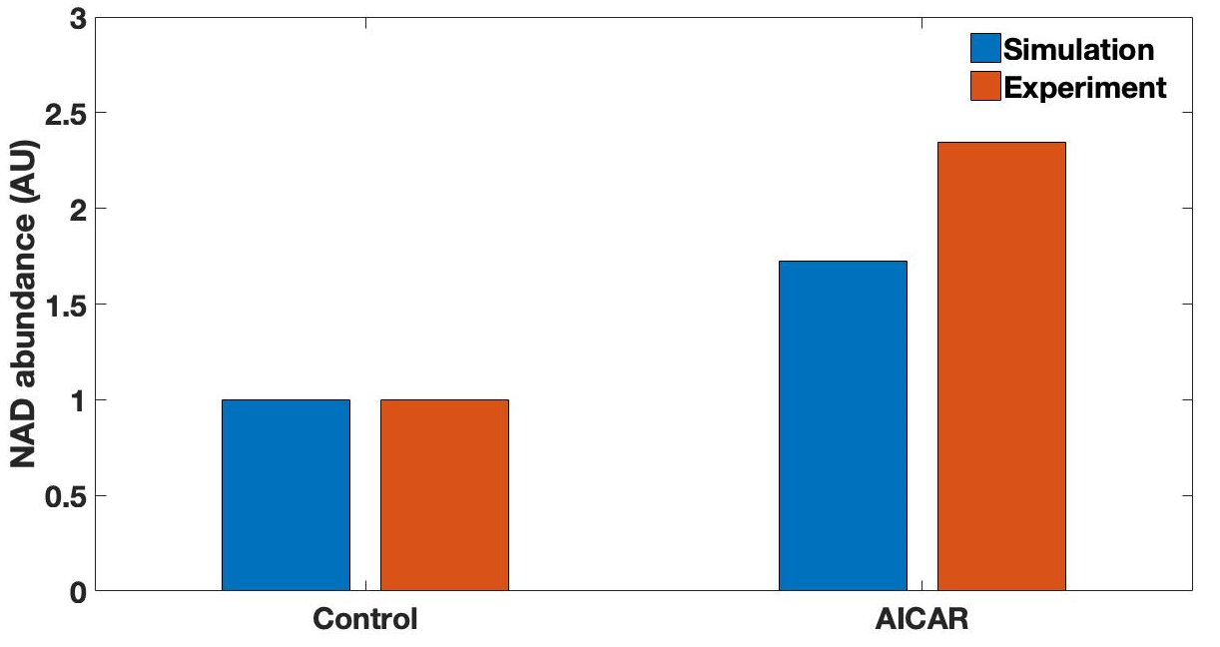

***Figure S10.*** *Model validation results for NAD levels at the 4hr timepoint in response to 0.5mM AICAR treatment on C2C12 myotubes. Experimental data was obtained from [Canto et al. (2009)](#_ENREF_2" \o "Canto, 2009 #3).*

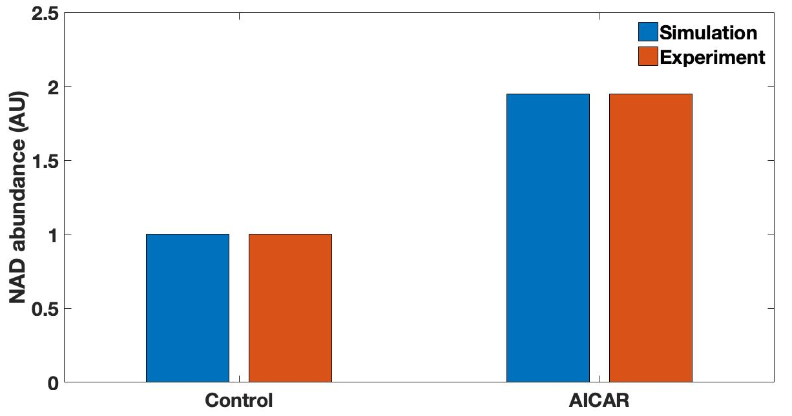

***Figure S11.*** *Model validation results for NAD levels at the 24hr timepoint in response to 0.5mM AICAR treatment on C2C12 myotubes. Experimental data was obtained from [Fulco et al. (2008)](#_ENREF_9" \o "Fulco, 2008 #18). Note that the original data corresponds to measurements of the NAD+/NADH ratio and so thus this data is used under the assumption that NADH levels do not significantly change after treatment with AICAR.*

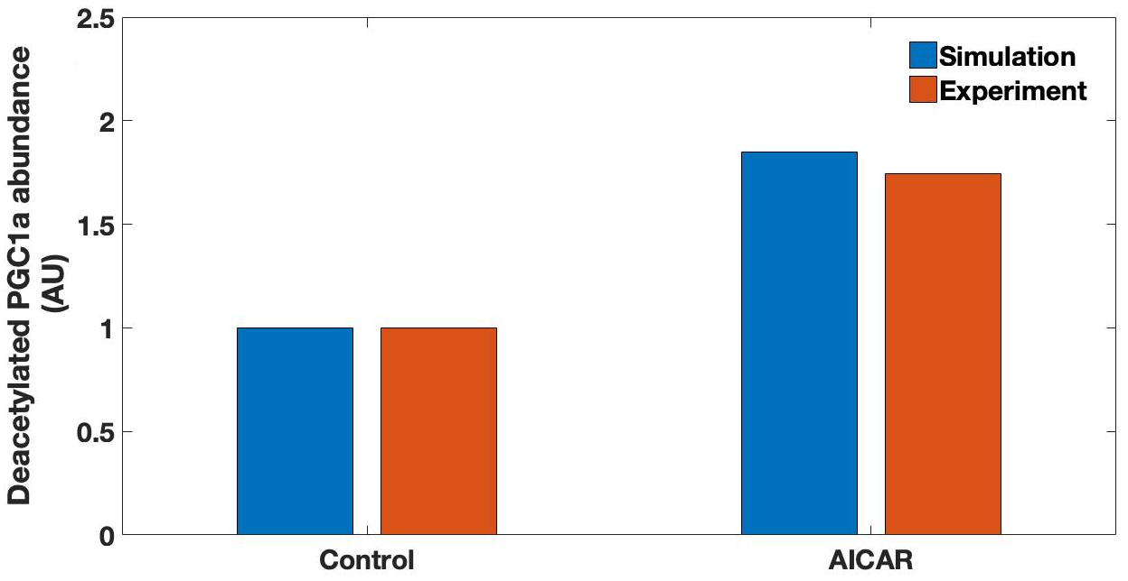

***Figure S12.*** *Model validation results for deacetylated PGC1α levels at the 12hr timepoint in response to 0.5mM AICAR treatment on C2C12 myotubes. Experimental data was obtained from [Canto et al. (2009)](#_ENREF_2" \o "Canto, 2009 #3).*

* 1. Validation of the model response to glucose restriction

The first dataset used to validate glucose restriction was extracted from Park et al. (2012) and consists of the exposure of C2C12 myotubes to a 2mM AICAR treatment under low glucose (5mM) and high glucose (25mM) regimes. The correspondence of the model simulations with their data is shown in Figure S13.

It is important to note that because the model was constructed so that the basal state corresponds to high glucose conditions, the original experimental data was normalised to the condition of high glucose. This is because the model calibration dataset was derived from treatments involving standard C2C12 myotube cell culture conditions which involves the use of a high-glucose (25mM) medium. From this basal state, it can be appreciated that the data by Park et al. (2012) also indicates that the model slightly over-estimates the quantity of phosphorylated AMPK 24hr after treatment with AICAR.

The culture of the C2C12 myotubes under low glucose conditions results in a degree of AMPK phosphorylation that is substantially underestimated by the model at the 24hr timepoint. However, when an AICAR stimulus is added to the steady state stabilised by a low glucose level, the model simulation produces a close match to the experimental data (Figure S13). This suggests that the AICAR stimulus is strong enough to make the system reach the same steady state despite starting from a lower basal level of AMPK activation from the low glucose conditions.

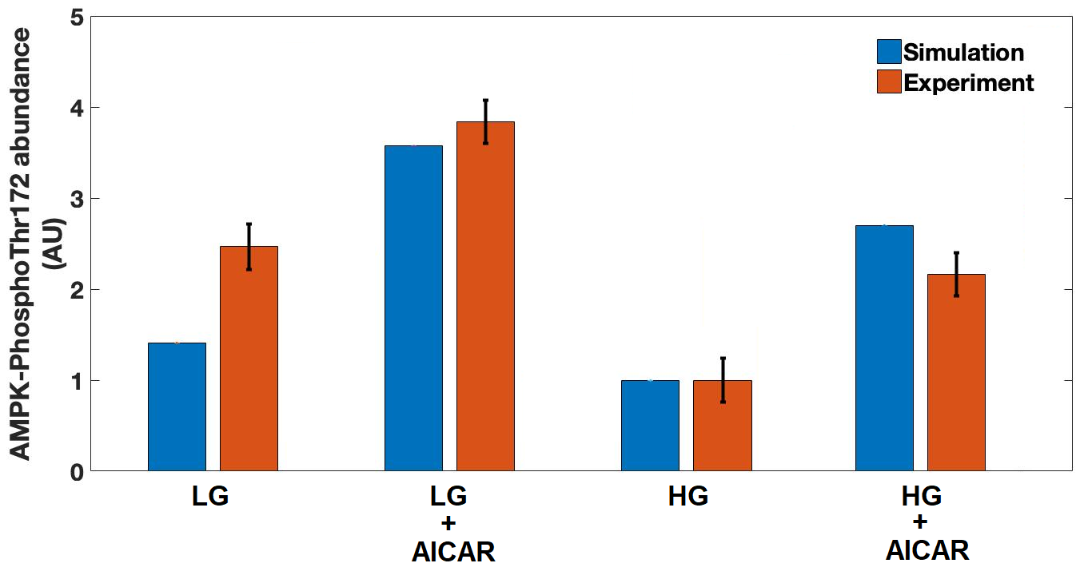***Figure S13.*** *Model validation results for PhosphoThr172 AMPK levels at the 24hr timepoint in response to 2mM AICAR treatment on C2C12 myotubes cultured under different glucose conditions. Experimental data was obtained from* *Park et al. (2012)**. Error bars show standard deviation. LG=Low glucose (5mM), HG= High glucose (25mM).*

Two datasets belonging to Gerhart-Hines et al. (2007) and [Fulco et al. (2008)](#_ENREF_9" \o "Fulco, 2008 #18), displayed in Figure S14 and Figure S15 respectively, suppose a strong challenge to the model. The data of both publications suggest that changes in NAD levels can be seen as soon as 12hrs after the glucose restriction protocol was initiated. This is in contrast to the data by Canto et al. (2009)– whose data was used to calibrate the model response to a glucose restriction protocol – which reports the first statistically significant change in NAD levels to occur at the 36hr timepoint (See Figure S4).

Considering all three studies were performed on the same cell type, the adjusting of the model to meet one or another set of data is a judgement call. Because time course data is richer in constraining the models’ parameter values and because time course data on other cell lines (Yang et al., 2015) correspond with the time scale reported by Canto et al. (2009), the model was not modified in the light of the data presented in Figures S13 and S14. However, this validation data serve as a warning to bear in mind in future that the simulated model response to glucose restriction may be too slow.

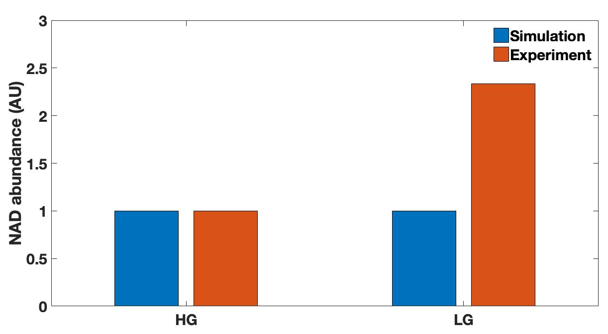

***Figure S14.*** *Model validation results for NAD levels in C2C12 myotubes cultured for 12hrs under different glucose conditions. Experimental data was obtained from [Gerhart-Hines et al. (2007)](#_ENREF_10" \o "Gerhart-Hines, 2007 #19). LG=Low glucose (5mM), HG= High glucose (25mM).*

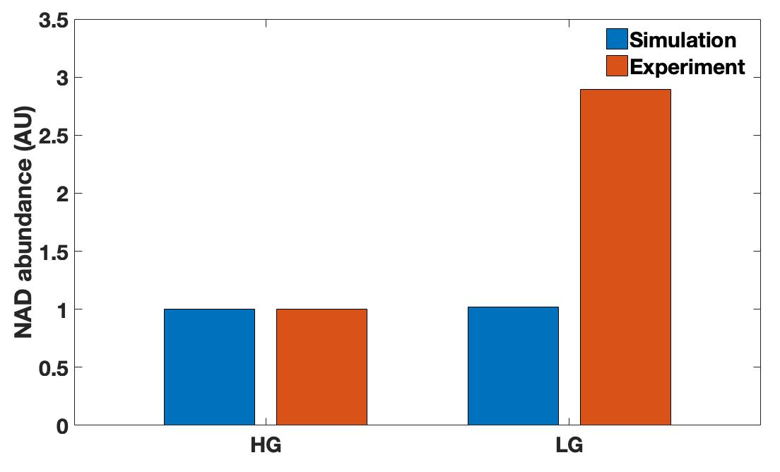

***Figure S15.*** *Model validation results for NAD levels in C2C12 myotubes cultured for 24hrs under different glucose conditions. Experimental data was obtained from [Fulco et al. (2008)](#_ENREF_9" \o "Fulco, 2008 #18). LG=Low glucose (5mM), HG= High glucose (25mM). Note that the original data corresponds to measurements of the NAD+/NADH ratio and so thus this data is used under the assumption that NADH levels do not significantly change after treatment with AICAR.*

* 1. Validation of model response to NR supplementation

The validation of the model behaviour to an NR input was carried out using the dataset from Canto et al. (2012) where NAD content in C2C12 myotubes was measured 24 hours after treatment with 0.5mM NR. Model simulations are in close agreement with the data reported by the authors (see Figure S16). This was also the case for the experimental data obtained from [Ryu et al. (2016)](#_ENREF_18" \o "Ryu, 2016 #14), where NAD levels where measured 12hrs post-treatment with 1mM NR (see Figure S17). Interestingly, NAD measurements performed Fletcher et al. (2017) on primary mouse muscle fibres after supplementation with 0.5mM NR were also consistent with model simulations (Figure S18).

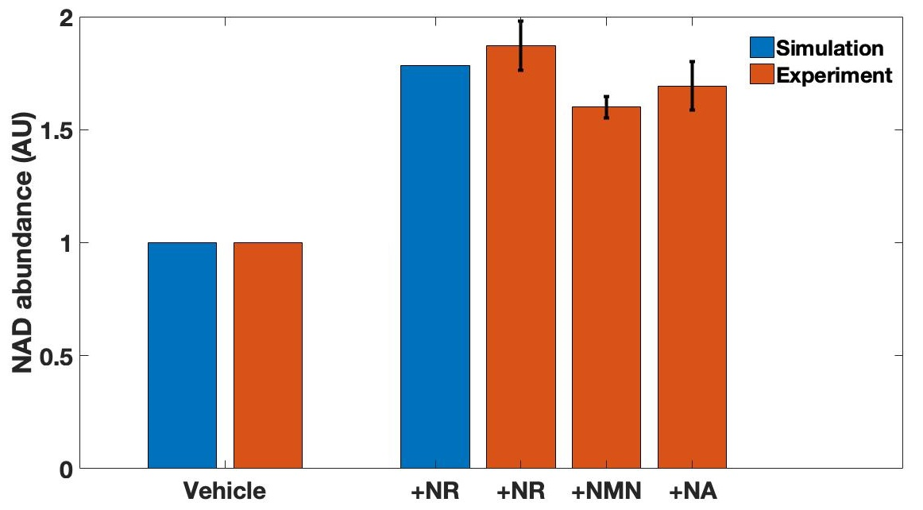

***Figure S16.*** *Model validation results for NAD levels at the 24hr timepoint in response to 0.5mM NAD precursor supplementation. Experimental data from C2C12 myotubes was obtained from [Canto et al. (2012)](#_ENREF_3" \o "Canto, 2012 #5). Error bars show standard deviation.*

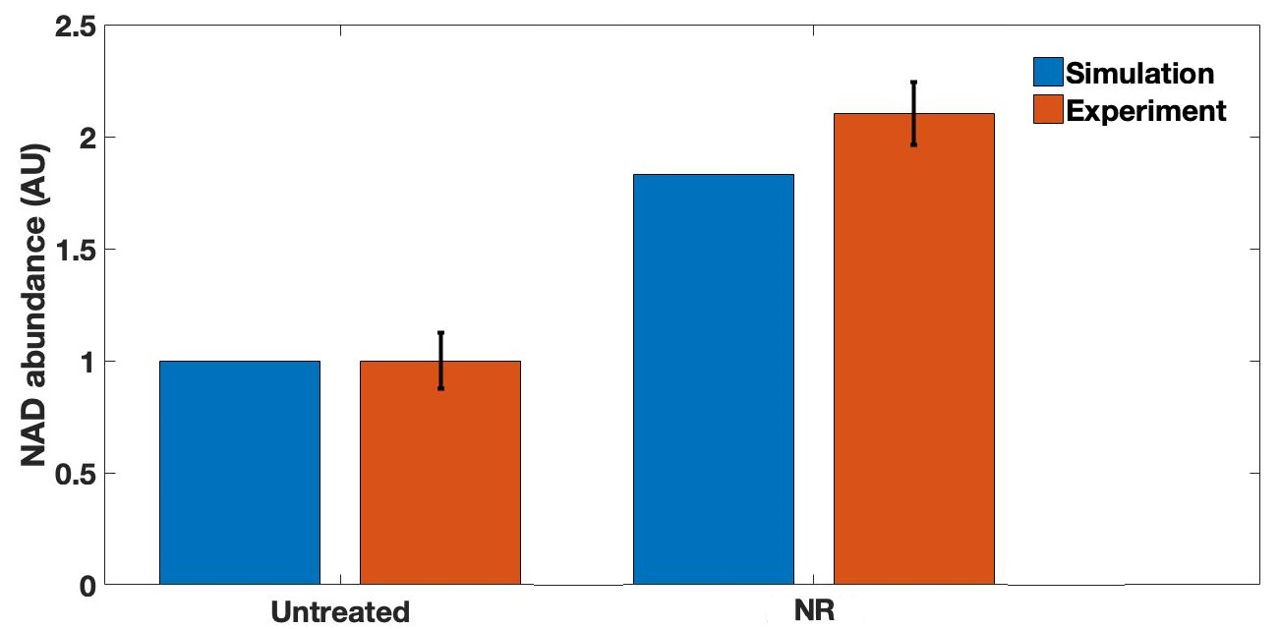

***Figure S17.*** *Model validation results for NAD levels at the 12hr timepoint in response to 1mM NR supplementation. Experimental data from C2C12 myotubes was obtained from [Ryu et al. (2016)](#_ENREF_18" \o "Ryu, 2016 #14). Error bars show standard deviation.*

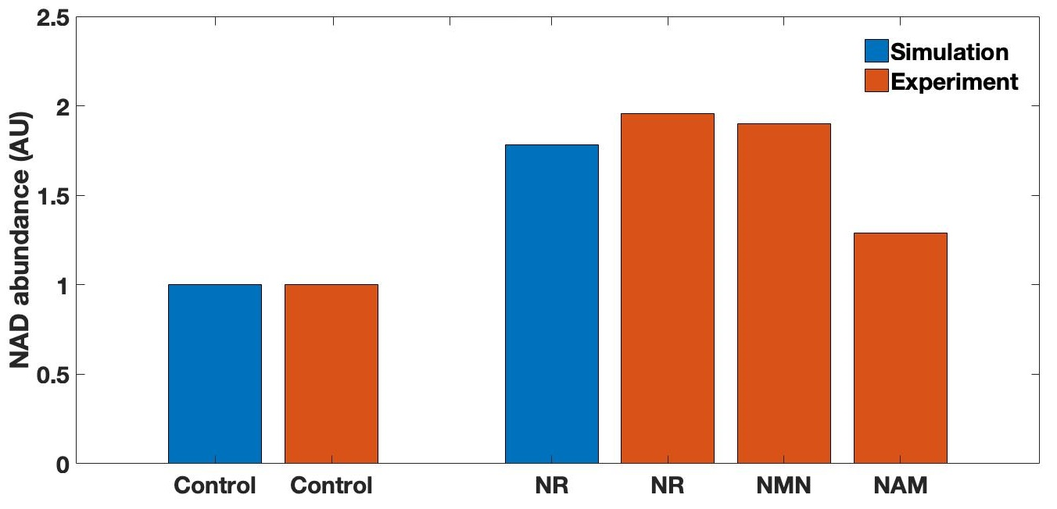

***Figure S18.*** *Model validation results for NAD levels at the 24hr timepoint in response to 0.5mM NAD precursor supplementation. Experimental data from mouse skeletal muscle was obtained from [Fletcher et al. (2017)](#_ENREF_8" \o "Fletcher, 2017 #21).*

It is worth noticing that the data from Canto et al. (2012) shown in Figure S16 reports that the changes in NAD 24hrs after NR supplementation are similar to the changes seen when the same concentration of other NAD precursors such as NMN or NA are supplemented. This is also suggested by the data from Fletcher et al. (2017) shown in Figure S18. This suggests that the model could be used to also approximate the response of the regulatory network to NAD supplementation through these alternative precursors. To test this, a time course of NAD changes in response to 200µM NMN supplementation was obtained from Hsu and Burkholder (2016) and tested against a model simulation involving 200µM of NR.

As shown in Figure S19, the dynamics of NAD simulated by the model do not produce a close match to the experimental data. The obvious conclusion is that the model cannot simulate NR or NMN supplementation interchangeably. However, it is also noticeable that the model reaches the same NAD abundance as indicated by the experimental data after 24 hrs. This is indicative of the limitations of validating model behaviour using single timepoint measurements, where the model might give a good fit to the steady state but not to the transition dynamics. This is the reason why, ideally, time course data provide the most thorough validation to the model behaviour when it is available.

Indeed, it seems biologically plausible that an NAD plateau might be reached 4 hours after NR supplementation when considering changes in NAD synthesis consequentially arise from the substrate-limited constitutive synthesis rates that increase after such supplementation. In the case of the validation of the NR input, however, the model output is in close accordance with experimental data for both the 12hr timepoint (Figure S17) and the 24hr timepoint (Figure S18).

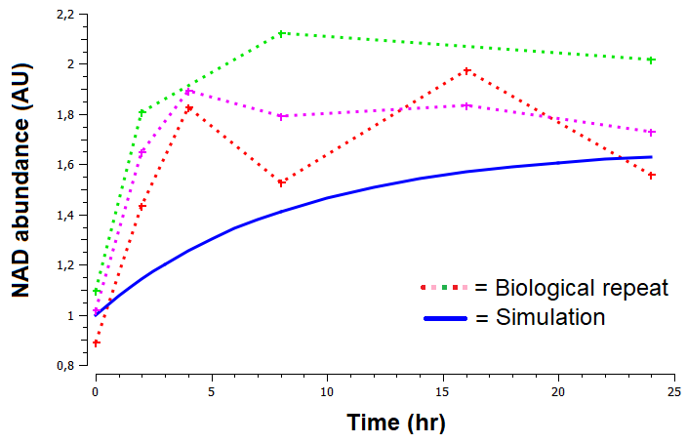

***Figure S19.*** *Model validation results for changes in NAD levels in response to 200µM NMN supplementation. Experimental data from C2C12 myotubes was obtained from [Hsu and Burkholder (2016)](#_ENREF_13" \o "Hsu, 2016 #9).*

The structure of the model implies that the supplementation with NAD precursors would not result in any changes in the phosphorylation state of AMPK, since this molecule lies upstream of NAD in the signalling pathway. Data by Higashida et al. (2013) confirms this, where C2C12 cells were treated with10mM nicotinamide and no change was observed in AMPK phosphorylation (See Figure S20).

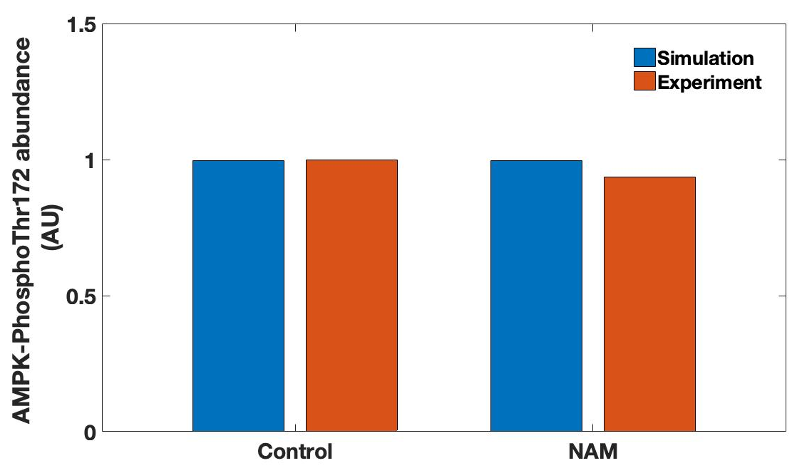 ***Figure 20.*** *Model validation results for changes in Phospho-Thr172 AMPK levels in response to 10mM nicotinamide (NAM) supplementation. Experimental data from C2C12 myotubes was obtained from [Higashida et al. (2013)](#_ENREF_12" \o "Higashida, 2013 #20).*

* 1. Validation of model response to changes in PARP1 activity

The last model input to be validated involves changes in PARP1 activity as a reflection of the genomic stability of the cell. The first validation exercise for this model input utilised data from [Fakouri et al. (2017)](#_ENREF_6" \o "Fakouri, 2017 #10). The authors present data for changes in the AMPK-PGC1α-NAD-SIRT1 axis as a result of the knockout of the Rev1 protein. Rev1 is involved in DNA repair and the authors report that its knockout in MEF cells result in a number of changes including: an increase in total AMPK but a >50% decrease in PhosphoThr172 AMPK levels, the halving of SIRT1 levels, a reduction in total PGC1α levels and an ~2.6 fold increase in PARP1 levels. When these changes are introduced into the model, the resulting steady state NAD levels predicted by the model matches very closely with the experimentally measured levels of NAD in Rev1 knockout MEF cells (Figure S21). The new steady state of NAD abundance in Rev1 knockout MEF cells is driven almost exclusively by the increase in PARP1 activity.

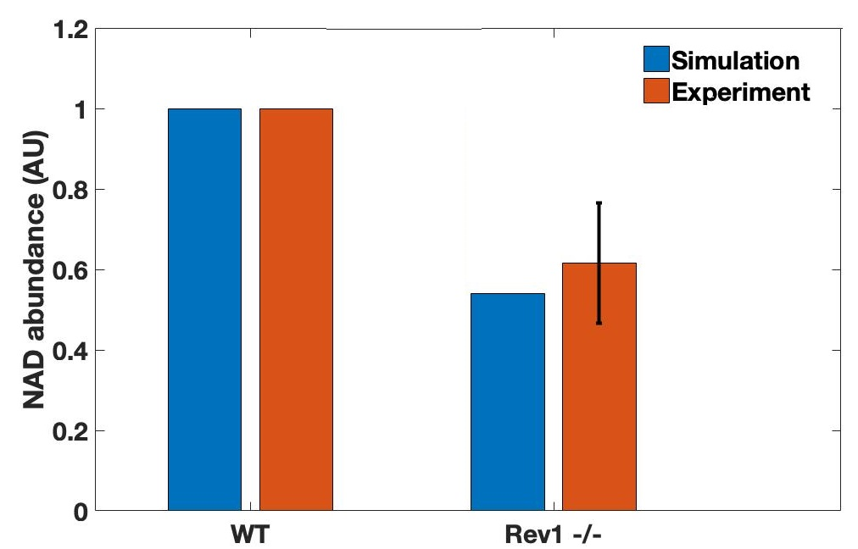

***Figure S21.*** *Model validation results for changes in NAD levels in Rev1 knockout MEF cells. Experimental data was obtained from [Fakouri et al. (2017)](#_ENREF_6" \o "Fakouri, 2017 #10). Error bars show standard deviation.*

Although the authors did not measure changes in PGC1α deacetylation in the Rev1 -/- cells, it could be predicted that as a result of a lower basal level of NAD then there would be a lower basal level of deacetylated PGC1a. This is because NAD levels are substrate-limiting for this SIRT1-catalysed reaction. A similar effect on PGC1α would therefore be expected if SIRT1 levels were substantially reduced. Higashida et al. (2013) performed a point-mutation (H355A) in SIRT1 to disrupt its activity in C2C12 myotubes and measured a two-fold increase in acetylated PGC1α. This can be interpreted as a two-fold decrease in deacetylated PGC1α, which was not captured by the model (Figure S22).

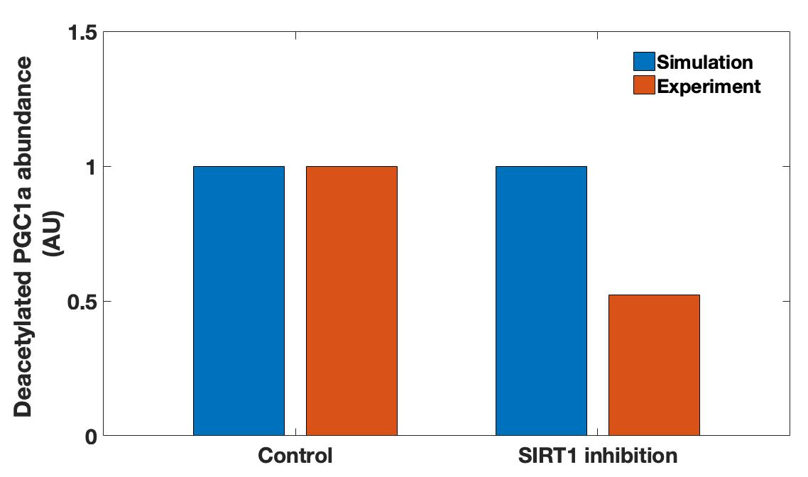  
***Figure S22.*** *Model validation results for changes in deacetylated PGC1α levels in C2C12 cells with mutated SIRT1 (H355A). Experimental data was obtained from [Higashida et al. (2013)](#_ENREF_12" \o "Higashida, 2013 #20).*

Figure S22 indicates that the basal levels of deacetylated PGC1αin the model seem to be independent of SIRT1 levels. This means that the SIRT1-independendent deacetylation reaction in the model has a rate that is too high relative to the basal deacetylation activity performed by SIRT1 under basal conditions. The problem is that the SIRT1-dependent basal deacetylation of SIRT1 depends on parameters that have been calibrated to data involving an induced increase in PGC1α deacetylation. Therefore, the parameters that capture the induced deacetylation by SIRT1 do not capture its basal deacetylation.

In order to fit the data in Figure S22 regarding the contribution of SIRT1 to the basal deacetylation of PGC1α but continue to have a good fit to treatment-induced increases in deacetylation, the function modelling the SIRT1-independent basal PGC1α deacetylation reaction in the model was altered. Originally the rate (*r*) of this reaction was modelled by a mass action function:

(i)

where *k* had a value of 1 and PGC1αP corresponds to the abundance of phosphorylated PGC1α.

This mass action function was altered to the following function:

(ii)

Where *v* denotes a constant flux, *c* denotes the contribution of SIRT1 activity to the basal deacetylation rate and SIRT1 corresponds to the abundance of SIRT1.

The adoption of such a new function still retains the SIRT1-independent deacetylation component within parameter *v* since if SIRT1 was mutated and assigned a value of 0, the parameter *v* within the equation would still provide a basal rate of transition. The numerical values for both *v* and *c* correspond to 0.5. This is because the basal level of PGC1α-P molecules is 1 and since the value of *k* in the original mass action function (i) is also 1 then it means the basal rate of this reaction was 1. This is a reaction rate value that is desirable to be conserved since all of the model calibrations and validations have been based on it.

In the new function for this reaction, we know SIRT1 to have a constant value of 1 within simulations. We also know *c* to be 0.5 since Figure 23 indicates that the removal of SIRT1 activity from the system results in a halving of basal deacetylated PGC1α (assuming no change in the acetylation rate for this molecule). This results in a rate value for the SIRT1-dependent component of the equation of 0.5 (0.5·1). Since we desire to maintain the overall basal rate of PGC1α deacetylation at 1, then *v* must also be 0.5.

The use of this custom-function as a “patch” in the model reproduces the data from Higashida et al. (2013) [Data not shown] and does not change the output simulation of the model for any of the conditions the model has been validated against.

Further data to validate the effect of changes in PARP1 activity on the pathways’ components was found for primary rat neurons in the publication by [Fang et al. (2016)](#_ENREF_7" \o "Fang, 2016 #22). The authors knocked down the ATM protein involved in DNA damage which resulted in a 3.2 fold increase in PARP1 activity. The authors measured changes in NAD and deacetylated PGC1α in both control primary neurons and ATM knockdown (ATM-KD) primary neurons at rest or treated with NR supplementation. The measured changes in these two molecules were compared to those simulated by the model to result after a 3.22 fold increase in PARP1 activity.

Figure S23 shows the comparison of the NAD data from Fang et al. (2016) to the model simulations whilst Figure S24 shows the comparison of the simulated and measured changes in PGC1α deacetylation.

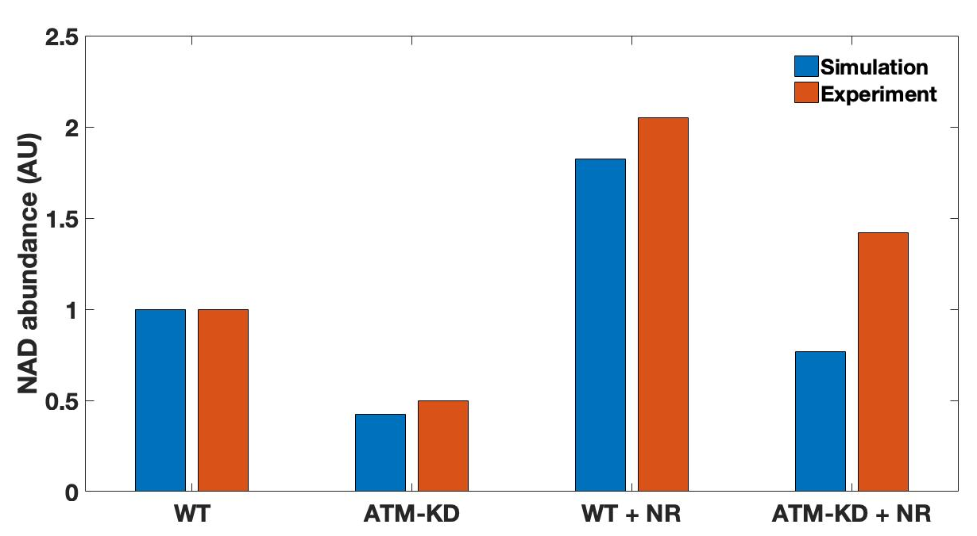

***Figure S23.*** *Model validation results for changes in NAD levels in primary rat neurons. WT=Wildtype, ATM-KD= ATM-knockdown, NR=0.5mM Nicotinamide Riboside. Experimental data was obtained from [Fang et al. (2016)](#_ENREF_7" \o "Fang, 2016 #22).*

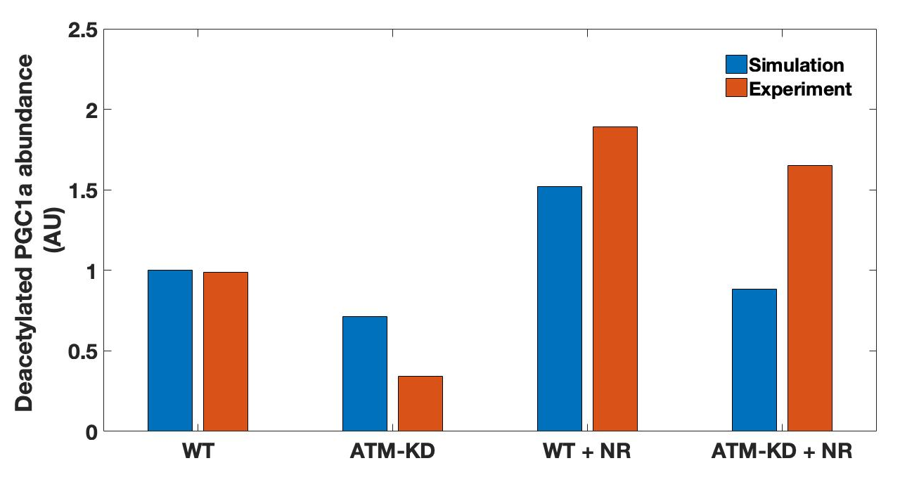

***Figure S24.*** *Model validation results for changes in deacetylated* PGC1α *levels in primary rat neurons. WT=Wildtype, ATM-KD= ATM-knockdown, NR=0.5mM Nicotinamide Riboside. Experimental data was obtained from [Fang et al. (2016)](#_ENREF_7" \o "Fang, 2016 #22).*

Both Figure S23 and Figure S24 indicate that model simulations are in close accordance with experimental data when it comes to the supplementation with NR. This is re-assuring since the experimental data comes from primary rat neurons instead of the C2C12 cell line the model has been calibrated to. This hints at the cross-applicability of the developed model. In a similar manner to Figure S21, Figure S23 also indicates that the model successfully predicts the levels of NAD arising from the increase in PARP1 activity in ATM knockout cells. However, even though the NAD levels in ATM-KD cells are simulated to a good level of accuracy, this is not the case for deacetylated PGC1α levels (Figure S24).

This means that a drop in NAD levels is not transmitted well as a change in the rate of PGC1α deacetylation. Of course, it could be argued that the mismatch between experiment and simulation could arise from the model being calibrated to a different cell type. However, a more than three fold increase in PARP1 activity would be expected to result in a bit more than a ~30% reduction in PGC1α deacetylation.

The analysis derived from Figure S22 involving SIRT1 inhibition suggests that SIRT1 contributes about 50% of the basal rate of PGC1α deacetylation. However, Figure S24 suggests that this percentage contribution does not allow for a big enough sensitivity of PGC1α to the changes in NAD levels that occur as a result of increased PARP1 activity. This could mean that an increase in PARP1 activity is linked to an increase in the rate of PGC1α acetylation as well as an decrease in the rate of PGC1α deacetylation. It could also mean that changes in PGC1α deacetylation could be happening independently of PARP1 activity.

However, the model could still be made to be closer to the experimental data by re-examining the rationale that lead to the use of function (ii) from the data presented in Figure S22. The value of 0.5 for *c* in function (ii) reflects the data in Figure S22 in that if SIRT1 activity is knocked-out, the reaction will occur at half the rate, resulting in a halving of deacetylated PGC1α levels. However, this assumes that 100% of the SIRT1 proteins are knocked-out. The experimental data presented in Figure S22 involves the adenoviral transfection of a mutated form of SIRT1 into a C2C12 cell culture which is then all lysed into a pool of lysate. That means the experimental data comes from a pool of cells, some of which will still have SIRT1 activity. This is since gene transfection in cell culture in never 100% efficient. Data by Jackson et al. (2013) reports a maximal adenoviral transduction efficiency of 65% in C2C12 cells.

The parameters for *v* and *c* in function (*ii*) currently assume 100% efficiency of gene transduction since they are based on SIRT1 acquiring a value of 0 when knocked down. However, experimental data from Higashida et al. (2013) suggests there is still some residual SIRT1 activity contributing to basal PGC1α deacetylation in SIRT1 (H355A) cells. This is suggested by the observation that nicotinamide supplementation (a SIRT1 inhibitor) results in ~27% more PGC1a acetylation than the knockout of SIRT1 activity in the original data by *Higashida et al. (2013)*, suggesting there is still a pool of active SIRT1 in SIRT1 H355A cells.

Under the assumption that the transfection efficiency for the experimental data in Figure S22 was 70%, the contribution *c* of SIRT1 to the basal deacetylation of PGC1α can be increased to 75%, thus increasing the sensitivity of PGC1α deacetylation to changes in NAD levels through SIRT1. The values of *v* and *c* in function (ii) are now thus 0.25 and 0.75 respectively and SIRT1 knockout is simulated as a change in SIRT1 abundance from 1 to 0.3 (70% knockout). This change keeps the model in line with the experimental data presented in Figure S22 and results in deacetylated PGC1α levels being reduced to 56% percent of their basal value as a result of a 3.22 fold increase in PARP1 activity. The model simulation is thus much closer to the experimental measurements made in ATM knockout cells shown in Figure S24.

The issue remains, however, that the model is unable to fit the experimental measurements made on ATM knockout cells treated with 0.5mM NR for both NAD levels (Figure S23) and deacetylated PGC1α levels (Figure S24). The issue in both cases is that an NR treatment in the model is unable to restore the system past basal wildtype levels, whilst the experimental data suggests treatment with NR elevates both molecules well above their basal abundance in a wildtype phenotype.

PARP1 activity is assumed to remain constant in the simulation. However, as DNA damage is resolved it would be expected that PARP1 activity would decrease. Since NAD provides a substrate for the PARylation of DNA to prime its repair, it would be expected that an increase in NAD would mean a faster resolving of DNA damage which frees more of the NAD pool. This could be why NR supplementation increases both NAD and PGC1a levels over 1 a.u in Figures S23 and S24. The model could be expanded to account for this.

The validation dataset used for changes in SIRT1 and PARP1 activity has led a to single change to the model. This involved the assignation of function (ii) to model the basal rate of PGC1α deacetylation. The updating of models with the acquisition of new data is a natural part of the systems biology cycle. These changes were deliberately designed to minimise changes to the rest of the model. Nonetheless, the altered model was re-validated against all the data presented and it was confirmed that the performance of model simulations against the data did not change for any of the datasets used. This being with the additional benefit of now being in a much closer accordance with the validation data of Figures S22-S24.



***Figure S25****. PARP1 levels measured in WT and Rev1 -/- MEF cells.* *Error bars correspond to SEM. *=p<0.05.*



***Figure S26.*** *Measured changes in phosphoThr172-AMPK levels as a result of AICAR treatments in WT and Rev1 -/- MEF cells. AIC=0.5mM AICAR treatment. NR= preconditioning of cells with 0.5mM Nicotinamide Riboside for 24hrs. PJ34 = preconditioning of cells with 1µM PJ34 treatment for 24hrs. The timepoint for AICAR measurement is 12hrs post-treatment initiation. Ctrl = Control (no AICAR treatment). WT = wildtype. Error bars correspond to SEM. *=p<0.05.*

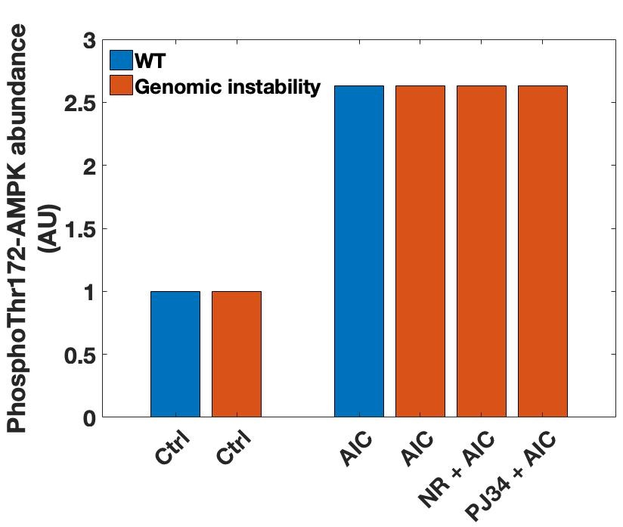

***Figure S27.*** *Model simulation of changes in phosphoThr172-AMPK levels as a result of AICAR treatments. AIC=0.5mM AICAR treatment. NR= preconditioning of cells with 0.5mM Nicotinamide Riboside for 24hrs. PJ34 = preconditioning of cells with 1µM PJ34 treatment for 24hrs. The timepoint for AICAR measurement is 12hrs post-treatment initiation. ‘Genomic instability’ refers to an increase in basal PARP1 activity of 2.5 fold. Ctrl = Control (no AICAR treatment). WT = wildtype.*

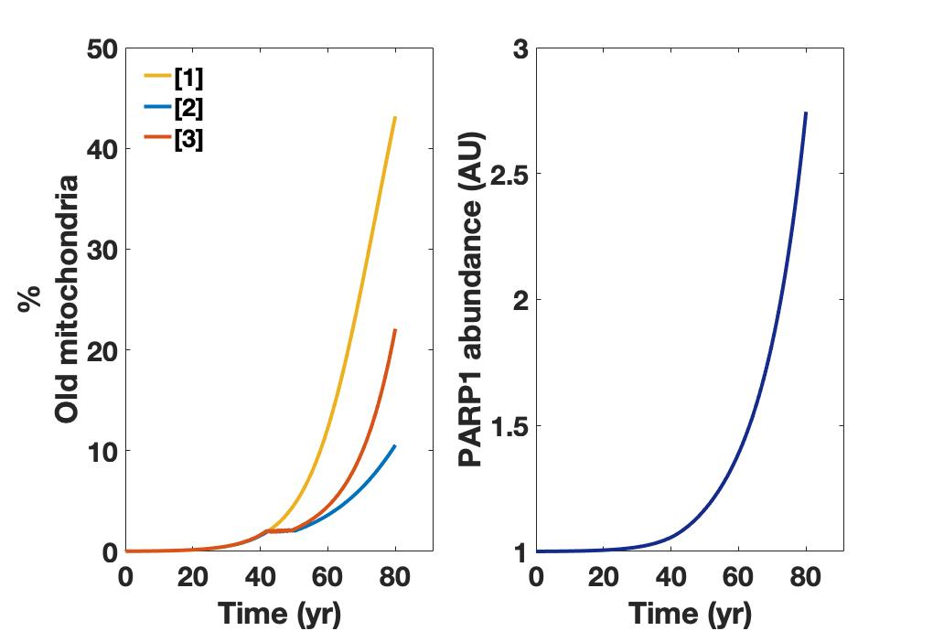

***Figure S28.*** *Accumulation of dysfunctional mitochondria over 80 years simulated by [1] mitochondrial module alone; [2] mitochondrial module coupled to the AMPK-NAD-PGC1α-SIRT1 signalling axis with a fixed PARP1 level of 1 a.u;* *[3] mitochondrial module coupled to the AMPK-NAD-PGC1α-SIRT1 signalling axis with age-related changes in PARP1 levels as shown on the right panel.*

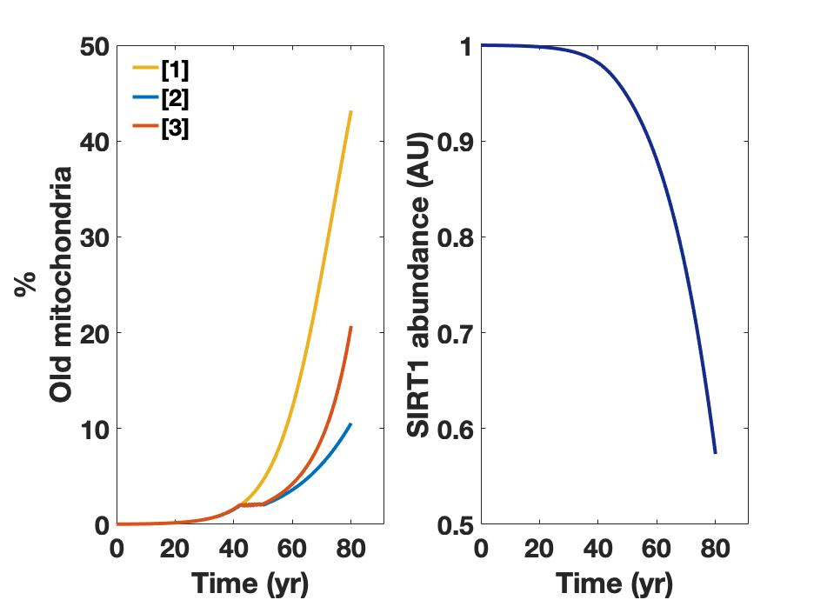

***Figure S29.*** *Accumulation of dysfunctional mitochondria over 80 years simulated by [1] mitochondrial module alone; [2] mitochondrial module coupled to the AMPK-NAD-PGC1α-SIRT1 signalling axis with a fixed PARP1 level of 1 a.u;* *[3] mitochondrial module coupled to the AMPK-NAD-PGC1α-SIRT1 signalling axis with age-related changes in SIRT1 levels as shown on the right panel.*

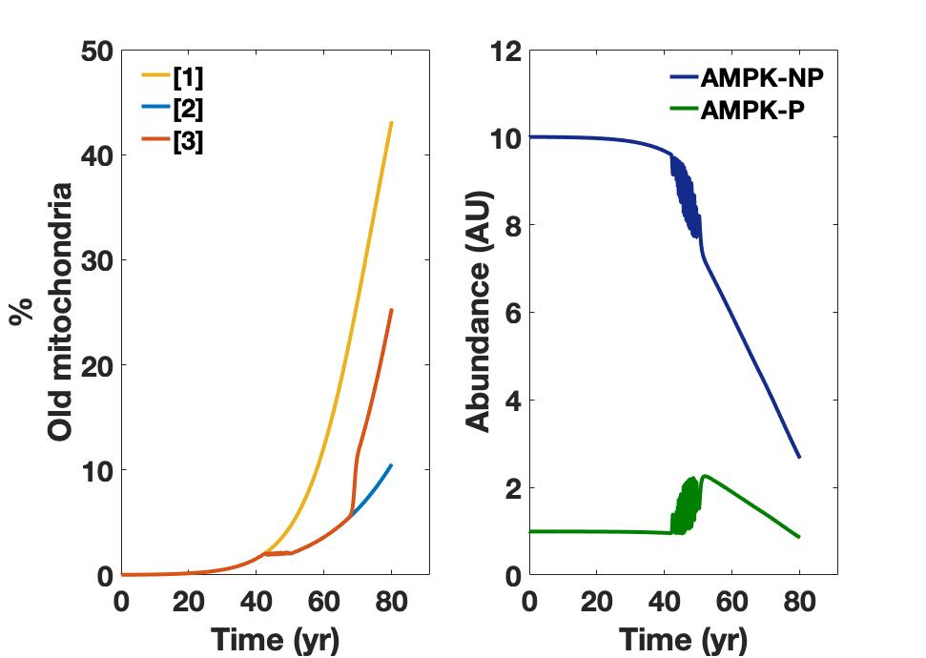

***Figure S30.*** *Accumulation of dysfunctional mitochondria over 80 years simulated by [1] mitochondrial module alone; [2] mitochondrial module coupled to the AMPK-NAD-PGC1α-SIRT1 signalling axis with a fixed PARP1 level of 1 a.u;* *[3] mitochondrial module coupled to the AMPK-NAD-PGC1α-SIRT1 signalling axis with age-related changes in total AMPK levels as shown on the right panel. AMPK-P = PhosphoThr172-AMPK, AMPK-NP = Non-phosphorylated AMPK.*

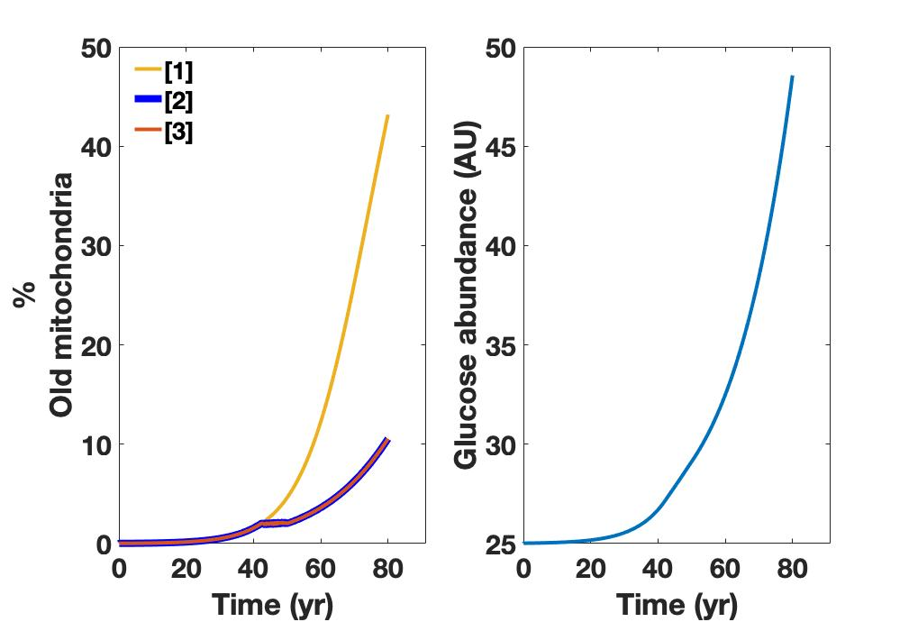

***Figure S31.*** *Accumulation of dysfunctional mitochondria over 80 years simulated by [1] mitochondrial module alone; [2] mitochondrial module coupled to the AMPK-NAD-PGC1α-SIRT1 signalling axis with a fixed PARP1 level of 1 a.u;* *[3] mitochondrial module coupled to the AMPK-NAD-PGC1α-SIRT1 signalling axis with age-related changes in glucose levels as shown on the right panel.*

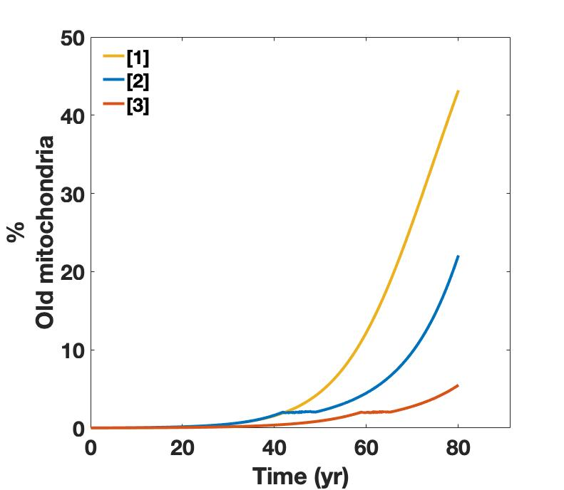

***Figure S32.*** *Accumulation of dysfunctional mitochondria over 80 years simulated by [1] mitochondrial module alone; [2] mitochondrial module coupled to the AMPK-NAD-PGC1α-SIRT1 signalling axis with a fixed PARP1 level of 1 a.u;* *[3] mitochondrial module coupled to the AMPK-NAD-PGC1α-SIRT1 signalling axis with NR value fixed to 100 to model a life-long cellular supplementation of 0.1mM Nicotinamide Riboside.*

**Supplementary tables**

|  |  |  |  |
| --- | --- | --- | --- |
| **Input** | **AMPK -P** | **NAD** | **PGC1a-Deacet** |
| **PARP1 activity** |  | *✔✔* | *✔✔* |
| **AICAR stimulation** | *✔✔✔✔✔* | *✔✔* | *✔* |
| **Glucose restriction** | *✔* | *✔✔* |  |
| **NAD supplementation** | *✔* | *✔✔✔✔✔* | *✔* |

***Supplementary Table 1.*** *Breadth and depth of current model validation. ‘Tick’ represents the use of experimental data from a given peer-reviewed scientific journal to check accordance with model simulations.*

|  |  |  |  |
| --- | --- | --- | --- |
| **Input** | **AMPK -P** | **NAD** | **PGC1a-Deacet** |
| **PARP1 activity** |  | *Fakouri et al. (2017)*  *Fang et al. (2016)* | *Higashida et al. (2013)*  *Fang et al. (2016)* |
| **AICAR stimulation** | *Park et al. (2011)*  *Ouchi et al. (2005)*  *Egawa et al. (2014)*  *Hall et al. (2018)*  *Park et al. (2012)* | *Canto et al. (2009)*  *Fulco et al. (2008)* | *Canto et al. (2009)* |
| **Glucose restriction** | *Park et al. (2012)* | *Gerhart-Hines et al. (2007)*  *Fulco et al. (2008)* |  |
| **NAD supplementation** | *Higashida et al. (2013)* | *Canto et al. (2012)*  *Ryu et al. (2016)*  *Fletcher et al. (2017)*  *Hsu and Burkholder (2016)*  *Fang et al. (2016)* | *Fang et al. (2016)* |

***Supplementary Table 2.*** *Publications used to source the data for each model validation exercise.*

**Supplementary Table 3.** Ordinary differential equations for the AMPK-NAD-PGC1a-SIRT1 model. Note that equation elements highlighted in red are introduced as part of the age-related changes to species and are absent otherwise. Elements in dark blue are introduced as part of the coupling between the mitochondrial module and the AMPK-NAD-PGC1α-SIRT1 model.

|  |  |
| --- | --- |
| **Variable** | **Equation** |
|  |  |
|  |  |
|  |  |
|  |  |
|  |  |
|  |  |
| **ǂ** |  |
| **¥** |  |
| **ɫ** |  |
|  |  |
|  |  |
| **ɸ** |  |
|  |  |
|  |  |
|  | **else constant** |
|  | **else constant** |

**ǂ** Dummy species that introduces a delay in NAD increase by AMPK-P.  
**¥** Dummy species that introduces a delay in PGC1a deacetylation by SIRT1.  
**ɫ** Dummy species that introduces a delay in AMPK phosphorylation by AICAR treatment.  
**ɸ** Dummy species that introduces a delay in AMPK dephosphorylation by glucose.

**Supplementary Table 4.** Ordinary differential equations for the AMPK-NAD-PGC1a-SIRT1 model.

|  |  |  |
| --- | --- | --- |
| **Transition** | **Description** | **Equation** |
|  | AMPK basal phosphorylation |  |
|  | AMPK basal dephosphorylation |  |
|  | PGC1a basal phosphorylation |  |
|  | PGC1a basal dephosphorylation |  |
|  | PGC1a induced deacetylation |  |
|  | PGC1a basal acetylation |  |
|  | Delay Reaction –  NAD increase by AMPK-P |  |
|  | Dummy Reaction –  Removal of Delay1**ǂ** |  |
|  | NAD synthesis |  |
|  | NAD utilisation |  |
|  | NAD utilisation by PARP1 |  |
|  | NAD increase by AMPK-P |  |
|  | Delay Reaction –  SIRT1-induced PGC1a deacetylation |  |
|  | Dummy Reaction –  Removal of Delay3 **ɫ** |  |
|  | AICAR-induced phosphorylation of AMPK |  |
|  | Delay Reaction –  AICAR-induced phosphorylation of AMPK |  |
|  | PGC1a basal deacetylation |  |
|  | Dummy Reaction –  Removal of Delay2**¥** |  |
|  | Glucose-induced AMPK dephosphorylation |  |
|  | Glucose influx |  |
|  | Glucose utilisation |  |
|  | Delay Reaction –  Glucose-induced AMPK dephosphorylation |  |
|  | Dummy Reaction –  Removal of Delay4 **ɸ** |  |
|  | NAD negative regulation |  |
|  | Dummy Reaction –  NegReg removal |  |
|  | NR-NMN supplementation |  |

**ǂ** Dummy species that introduces a delay in NAD increase by AMPK-P.  
**¥** Dummy species that introduces a delay in PGC1a deacetylation by SIRT1.  
**ɫ** Dummy species that introduces a delay in AMPK phosphorylation by AICAR treatment.  
**ɸ** Dummy species that introduces a delay in AMPK dephosphorylation by glucose.

**SupplementaryTable 5.** Kinetic parameters for the AMPK-NAD-PGC1a-SIRT1 model.

|  |  |  |
| --- | --- | --- |
| **Rate Constant** | **Value** | **Reaction** |
|  | 1 | AMPK basal phosphorylation |
|  | 5 | AMPK basal dephosphorylation |
|  | 1 | PGC1a basal phosphorylation |
|  | 10 | PGC1a basal dephosphorylation |
|  | 1.913 | PGC1a induced deacetylation |
|  | 1 | PGC1a basal acetylation |
|  | 10 | Delay Reaction – NAD increase by AMPK-P |
|  | 10 | Dummy Reaction - Removal of Delay1 |
|  | 0.12 | NAD synthesis |
|  | 0.045 | NAD utilisation |
|  | 0.075 | NAD utilization by PARP1 |
| | | | 1.45 | 0.32 | 100 **ʄ** | NAD increase by AMPK-P |
| | | | 3 | 0.01 | 30  **ʄ** | Delay Reaction –  SIRT1-induced PGC1a deacetylation |
|  | 0.29 | Dummy Reaction –  Removal of Delay3 |
|  | 3.99 | AICAR-induced phosphorylation of AMPK |
| | | | 0.67 | 0.17 | 9.24  **ʄ** | Delay Reaction –  AICAR induced phosphorylation of AMPK |
|  | 0.25 | PGC1a basal deacetylation |
|  | 0.57 | Dummy Reaction – Removal of Delay2 |
|  | 5 | Glucose-induced AMPK dephosphorylation |
|  | 25 | Glucose influx |
|  | 1 | Glucose utilisation |
| | | | 5.36 | 0.10 | 15.04  **ʄ** | Delay Reaction –  Glucose-induced AMPK dephosphorylation |
|  | 0.1 | Dummy Reaction – Removal of Delay4 |
|  | 0.061 | NAD negative regulation |
|  | 0.1 | Dummy Reaction – NegReg removal |
| | | | 100 | 0.11 | 1.5  **ʄ** | NR-NMN supplementation |

**ʄ** = Hill function *K*, *V* and *h* parameters, respectively.

**SupplementaryTable 6.**  Species initial abundances for the AMPK-NAD-PGC1a-SIRT1 model.

|  |  |
| --- | --- |
| **Variable** | **Initial abundance (AU)** |
|  | 10 |
|  | 1 |
|  | 10 |
|  | 1 |
|  | 1 |
|  | 1 |
| **ǂ** | 1 |
| **¥** | 0 |
| **ɫ** | 0 |
|  | 0 |
|  | 25 |
| **ɸ** | 1 |
|  | 0 |
|  | 0 |
|  | 1 (constant) |
|  | 1 (constant) |

**ǂ** Dummy species that introduces a delay in NAD increase by AMPK-P.  
**¥** Dummy species that introduces a delay in PGC1a deacetylation by SIRT1.  
**ɫ** Dummy species that introduces a delay in AMPK phosphorylation by AICAR treatment.  
**ɸ** Dummy species that introduces a delay in AMPK dephosphorylation by glucose.

**Supplementary Table 7.** Ordinary differential equations in the mitochondrial module.

|  |  |
| --- | --- |
| **Variable** | **Equation** |
|  |  |
|  |  |
| **ʡ** |  |
|  |  |
|  |  |

**ʡ** Dummy species that introduces a delay in mitophagy.

**Supplementary Table 8.** Ordinary differential equations in the mitochondrial module.

|  |  |  |
| --- | --- | --- |
| **Transition** | **Description** | **Equation** |
|  | Damage propagation |  |
|  | Delay Reaction –  Mitophagy |  |
|  | Dummy Reaction –  Removal of Delay5 **ʡ** |  |
|  | Mitochondrial dysfunction |  |
|  | Mitogenesis |  |
|  | Mitophagy of new mitochondria |  |
|  | Mitophagy of old mitochondria |  |
|  | Mitochondrial stress signal |  |
|  | Dummy Reaction –  Mitochondrial stress signal removal |  |
|  | Age-related increase in PARP1 |  |
|  | Age-related decrease in SIRT1 | ·SIRT1 |
|  | Age-related decrease in AMPK | ·AMPK·AMPKP |
|  | Age-related increase in glucose |  |

**ʡ** Dummy species that introduces a delay in mitophagy.

**SupplementaryTable 9.** Kinetic parameters in the mitochondrial module.

|  |  |  |
| --- | --- | --- |
| **Rate Constant** | **Value** | **Transition** |
|  |  | Damage propagation |
|  | 0.1 | Delay Reaction - Mitophagy |
|  | 0.1 | Dummy Reaction – Delay5 removal  **ʡ** |
|  |  | Mitochondrial dysfunction |
|  | 100 | Mitogenesis |
|  | 1 | Mitophagy of new mitochondria |
|  |  | Mitophagy of old mitochondria |
|  | 2 | 0.1 | 20 | *K*, *V* and *h* parameters (respectively) for the hill function modelling the production of the mitochondrial stress signal by old mitochondria |
|  | 0.1 | Dummy Reaction – Removal of mitochondrial stress signal |
|  |  | Age-related increase in PARP1 |
|  |  | Age-related decrease in SIRT1 |
|  |  | Age-related decrease in AMPK |
|  | 7 | Age-related increase in glucose |

**ʡ** Dummy species that introduces a delay in mitophagy.

**SupplementaryTable 10.**  Species initial abundances in the mitochondrial module.

|  |  |
| --- | --- |
| **Variable** | **Initial abundance (AU)** |
|  | 0.002518 |
|  | 0 |
|  | 1 |
|  | 100 |
|  | 1 |

**ʡ** Dummy species that introduces a delay in mitophagy.

**References**

BAI, P., CANTO, C., OUDART, H., BRUNYANSZKI, A., CEN, Y., THOMAS, C., YAMAMOTO, H., HUBER, A., KISS, B., HOUTKOOPER, R. H., SCHOONJANS, K., SCHREIBER, V., SAUVE, A. A., MENISSIER-DE MURCIA, J. & AUWERX, J. 2011. PARP-1 inhibition increases mitochondrial metabolism through SIRT1 activation. *Cell Metab,* 13**,** 461-468.

CANTO, C., GERHART-HINES, Z., FEIGE, J. N., LAGOUGE, M., NORIEGA, L., MILNE, J. C., ELLIOTT, P. J., PUIGSERVER, P. & AUWERX, J. 2009. AMPK regulates energy expenditure by modulating NAD+ metabolism and SIRT1 activity. *Nature,* 458**,** 1056-60.

CANTO, C., HOUTKOOPER, R. H., PIRINEN, E., YOUN, D. Y., OOSTERVEER, M. H., CEN, Y., FERNANDEZ-MARCOS, P. J., YAMAMOTO, H., ANDREUX, P. A., CETTOUR-ROSE, P., GADEMANN, K., RINSCH, C., SCHOONJANS, K., SAUVE, A. A. & AUWERX, J. 2012. The NAD(+) precursor nicotinamide riboside enhances oxidative metabolism and protects against high-fat diet-induced obesity. *Cell Metab,* 15**,** 838-47.

CANTO, C., JIANG, L. Q., DESHMUKH, A. S., MATAKI, C., COSTE, A., LAGOUGE, M., ZIERATH, J. R. & AUWERX, J. 2010. Interdependence of AMPK and SIRT1 for metabolic adaptation to fasting and exercise in skeletal muscle. *Cell Metab,* 11**,** 213-9.

EGAWA, T., OHNO, Y., GOTO, A., IKUTA, A., SUZUKI, M., OHIRA, T., YOKOYAMA, S., SUGIURA, T., OHIRA, Y., YOSHIOKA, T. & GOTO, K. 2014. AICAR-induced activation of AMPK negatively regulates myotube hypertrophy through the HSP72-mediated pathway in C2C12 skeletal muscle cells. *Am J Physiol Endocrinol Metab,* 306**,** E344-54.

FAKOURI, N. B., DURHUUS, J. A., REGNELL, C. E., ANGLEYS, M., DESLER, C., HASAN-OLIVE, M. M., MARTIN-PARDILLOS, A., TSAALBI-SHTYLIK, A., THOMSEN, K., LAURITZEN, M., BOHR, V. A., DE WIND, N., BERGERSEN, L. H. & RASMUSSEN, L. J. 2017. Rev1 contributes to proper mitochondrial function via the PARP-NAD(+)-SIRT1-PGC1alpha axis. *Sci Rep,* 7**,** 12480.

FANG, E. F., KASSAHUN, H., CROTEAU, D. L., SCHEIBYE-KNUDSEN, M., MAROSI, K., LU, H., SHAMANNA, R. A., KALYANASUNDARAM, S., BOLLINENI, R. C., WILSON, M. A., ISER, W. B., WOLLMAN, B. N., MOREVATI, M., LI, J., KERR, J. S., LU, Q., WALTZ, T. B., TIAN, J., SINCLAIR, D. A., MATTSON, M. P., NILSEN, H. & BOHR, V. A. 2016. NAD(+) Replenishment Improves Lifespan and Healthspan in Ataxia Telangiectasia Models via Mitophagy and DNA Repair. *Cell Metab,* 24**,** 566-581.

FLETCHER, R. S., RATAJCZAK, J., DOIG, C. L., OAKEY, L. A., CALLINGHAM, R., DA SILVA XAVIER, G., GARTEN, A., ELHASSAN, Y. S., REDPATH, P., MIGAUD, M. E., PHILP, A., BRENNER, C., CANTO, C. & LAVERY, G. G. 2017. Nicotinamide riboside kinases display redundancy in mediating nicotinamide mononucleotide and nicotinamide riboside metabolism in skeletal muscle cells. *Mol Metab,* 6**,** 819-832.

FULCO, M., CEN, Y., ZHAO, P., HOFFMAN, E. P., MCBURNEY, M. W., SAUVE, A. A. & SARTORELLI, V. 2008. Glucose restriction inhibits skeletal myoblast differentiation by activating SIRT1 through AMPK-mediated regulation of Nampt. *Dev Cell,* 14**,** 661-73.

GERHART-HINES, Z., RODGERS, J. T., BARE, O., LERIN, C., KIM, S. H., MOSTOSLAVSKY, R., ALT, F. W., WU, Z. & PUIGSERVER, P. 2007. Metabolic control of muscle mitochondrial function and fatty acid oxidation through SIRT1/PGC-1alpha. *EMBO J,* 26**,** 1913-23.

HALL, D. T., GRISS, T., MA, J. F., SANCHEZ, B. J., SADEK, J., TREMBLAY, A. M. K., MUBAID, S., OMER, A., FORD, R. J., BEDARD, N., PAUSE, A., WING, S. S., DI MARCO, S., STEINBERG, G. R., JONES, R. G. & GALLOUZI, I. E. 2018. The AMPK agonist 5-aminoimidazole-4-carboxamide ribonucleotide (AICAR), but not metformin, prevents inflammation-associated cachectic muscle wasting. *EMBO Mol Med,* 10.

HIGASHIDA, K., KIM, S. H., JUNG, S. R., ASAKA, M., HOLLOSZY, J. O. & HAN, D. H. 2013. Effects of resveratrol and SIRT1 on PGC-1alpha activity and mitochondrial biogenesis: a reevaluation. *PLoS Biol,* 11**,** e1001603.

HSU, C. G. & BURKHOLDER, T. J. 2016. Independent AMP and NAD signaling regulates C2C12 differentiation and metabolic adaptation. *J Physiol Biochem,* 72**,** 689-697.

JACKSON, M. F., HOVERSTEN, K. E., POWERS, J. M., TROBRIDGE, G. D. & RODGERS, B. D. 2013. Genetic manipulation of myoblasts and a novel primary myosatellite cell culture system: comparing and optimizing approaches. *FEBS J,* 280**,** 827-39.

OUCHI, N., SHIBATA, R. & WALSH, K. 2005. AMP-activated protein kinase signaling stimulates VEGF expression and angiogenesis in skeletal muscle. *Circ Res,* 96**,** 838-46.

PARK, C.-S., KIM, J.-H., OH, Y.-K., KIM, K., CHOI, C.-W., CHO, E.-S., JEONG, Y.-D. & PARK, S.-K. 2012. *AICAR (5-aminoimidazole-4-carboxamide-1-?-D-ribonucleoside) Decreases Protein Synthesis in C2C12 Myotubes Cultured in High Glucose Media*.

PARK, S., SCHEFFLER, T. L. & GERRARD, D. E. 2011. Chronic high cytosolic calcium decreases AICAR-induced AMPK activity via calcium/calmodulin activated protein kinase II signaling cascade. *Cell Calcium,* 50**,** 73-83.

RYU, D., ZHANG, H., ROPELLE, E. R., SORRENTINO, V., MAZALA, D. A., MOUCHIROUD, L., MARSHALL, P. L., CAMPBELL, M. D., ALI, A. S., KNOWELS, G. M., BELLEMIN, S., IYER, S. R., WANG, X., GARIANI, K., SAUVE, A. A., CANTO, C., CONLEY, K. E., WALTER, L., LOVERING, R. M., CHIN, E. R., JASMIN, B. J., MARCINEK, D. J., MENZIES, K. J. & AUWERX, J. 2016. NAD+ repletion improves muscle function in muscular dystrophy and counters global PARylation. *Sci Transl Med,* 8**,** 361ra139.

YANG, N. C., SONG, T. Y., CHANG, Y. Z., CHEN, M. Y. & HU, M. L. 2015. Up-regulation of nicotinamide phosphoribosyltransferase and increase of NAD+ levels by glucose restriction extend replicative lifespan of human fibroblast Hs68 cells. *Biogerontology,* 16**,** 31-42.