Methods to identify safe routes to schools in residential areas

# Introduction

The goal of this project is to explore how we can identify residential zones that would be served by a major safe route to school.

The outputs should provide evidence in support of ‘liveable streets’, where the emphasis is on reducing car vehicle speeds and volumes, and ‘filtered permeability’, where through traffic is allowed for cycling and walking, but not driving. Evidence can be used to support improvements such as segregated or on-road cycle routes and to aid in determining where the best locations are for these routes to be built.

## Methods

Vector and raster approaches were explored, as illustrated in Figure @ref(fig:combi1).

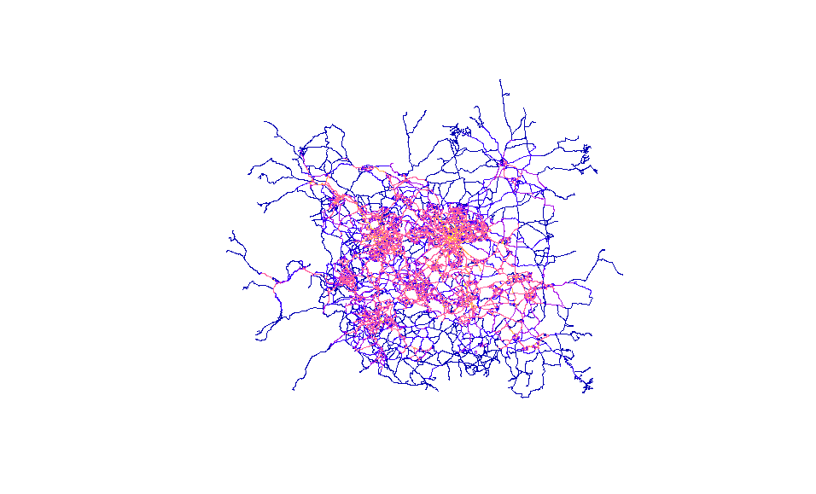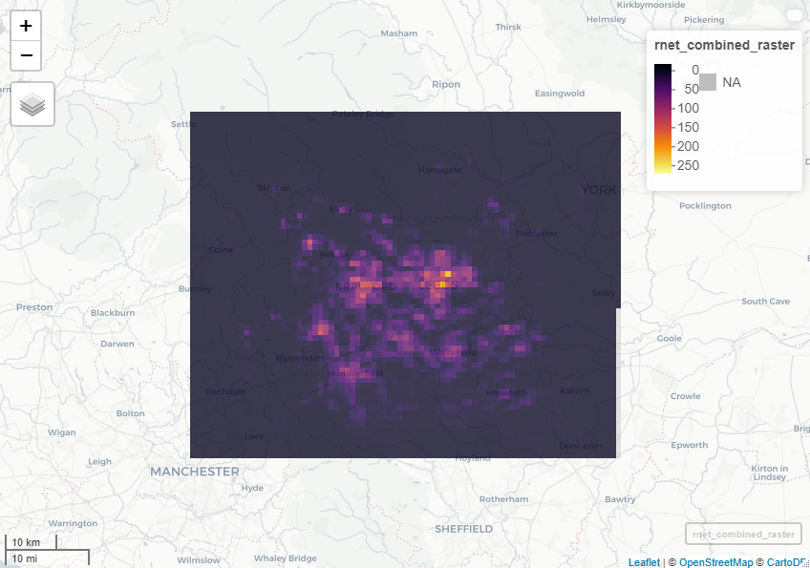

This shows the aggregation effect of rasterising the road data. At a higher resolution, we can see how individual roads are lost, but the overall picture is retained.

The raster approach may be helpful in identifying areas where several high-usage cycle routes lie close to one another, such as areas close to schools perhaps. Meanwhile, the vector approach can highlight the potential cycle routes themselves.

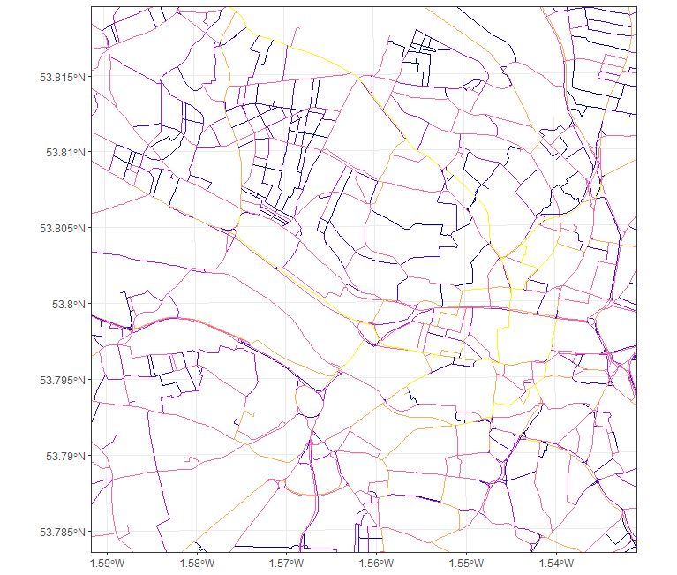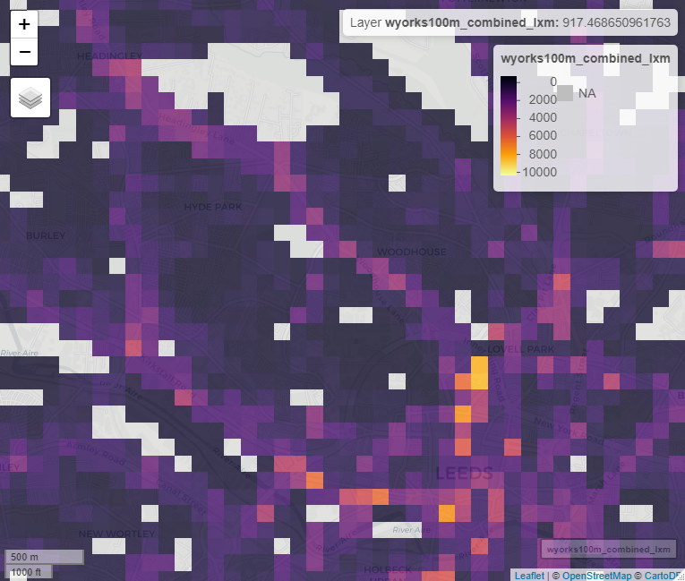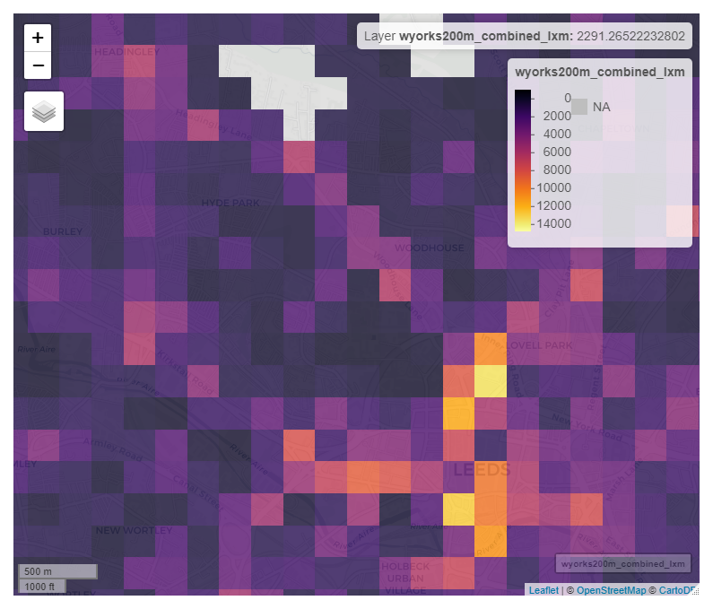

The starting point therefore is to first identify residential zones then to look at where these zones might be served by major safe routes to schools. Residential zones are defined as built-up areas with a non-zero population.

### Discussion

It is important to be aware that while these route networks can reveal a great deal about where people cycle, any given road section within the network may not necessarily be the one that is best suited to cycling or to cycle improvements. It may be there is a parallel street or off-road route that is better suited to cycling, and knowledge of local streets and conditions is vital here.

For example, the vector map of the centre of Leeds shown in Figure @ref(fig:combi2) shows a high-usage cycle route passing along Albion Street, Short Street and Lower Basinghall Street. This is a heavily used cycle corridor leading towards Leeds rail station, but with local knowledge a more appropriate cycle route for these journeys would most likely be on the nearby Park Row, which runs broadly parallel to these streets.