Instructions for post-processing ‘merge’ raster chunks created by 08a_create_rasters.Rds script

Step 1: opening and stacking, in ArcMap
- Optional: Open ArcMap and add all the ‘merge’ raster files (in 2_merge subfolder) for a given scenario. change the colour scheme to make these easier to see
    - first file: choose the file with the highest maximum number of cyclists; right click -> properties -> symbology -> change to ‘classified’ (yes to histogram) -> change colour around -> click classify and change bottom break to 0.01 -> change the colour for the bottom category to ‘no colour’
    - all other files: properties -> symbology -> classified -> import -> choose the name of the first file, such that its colour scheme gets applied automatically.

- Find the function ‘mosaic to new raster function’: see figure 1
  - load all the rasters. This can be done from the colour-modified rasters already loaded in the workspace if step 1a has been done, but for large scenarios with many rasters it may be simpler to load them all directly from where they are saved on the hard drive.
  - set output folder: ‘3_post-process/ intermediate files’
  - set file name: ‘scenarioname-combined’.tif
  - spatial reference: British National Grid
  - pixel type: 16_bit_unsigned
  - cell size: 10
  - no. Bands: 1
  - mosaic operator: some
  - (mosaic colourmap: leave on “first”, doesn’t matter)

[This may be slow, to check it is working in the background, can click Geo processing -> results -> current session ]
Figure 1
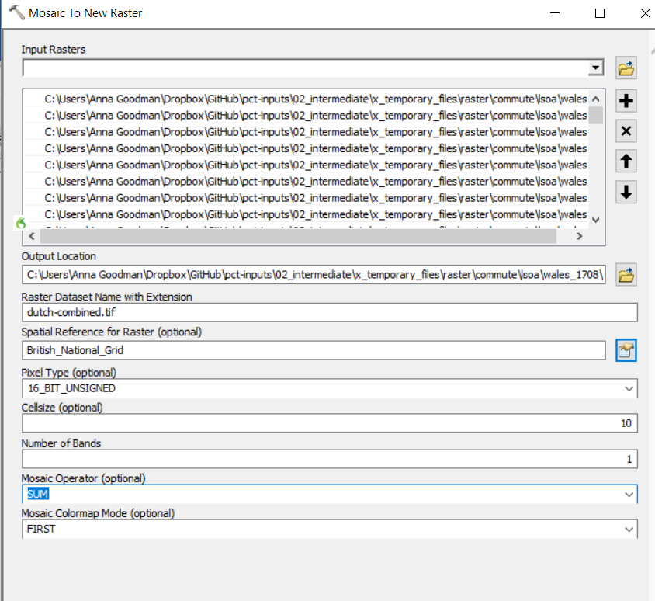

Step 2: cleaning the rasters by using neighbour values, in QGIS
- open the raster scenarioname-combined.tif
- optional: change the colours to make easier to see. Right click -> properties -> style -> render type = ‘single band pseudo-colour’ -> interpolation = discreet -> click the zero colour and change the opacity to 0.
- open function raster r.neighbors. (This will let us tidy the colours, to take the maximum value surrounding them in a 3X3 square). See Figure 2
  - Neighbourhood operation = maximum
  - neighbourhood size = 3
  - neighbours = save to file
- save the file as ‘3_post-process/ intermediate files/scenarioname-combined-clean.tif. Note that now the rasters have been extended one cell in every direction, relative to the master

Figure 2
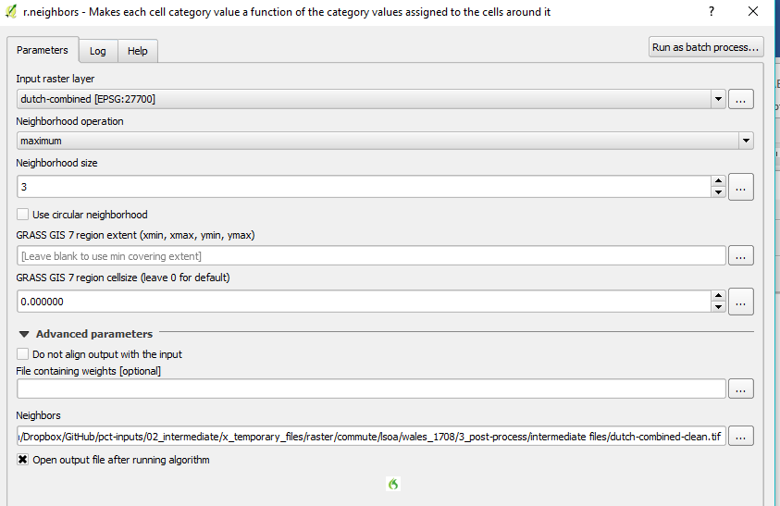

Step 3: trimming the rasters back to their original width, in QGIS
- raster on top bar -> raster calculator, and use these to remove cells from neighbors.tif that were blank in scenarioname-combined. See Figure 3
  - Syntax = "Neighbors@1" * ("scenatio-combined@1" > 0)
  - save the file as ‘3_post-process/scenarioname-10.tif.’
  - format GeoTIFF
- ALSO copy the saved file scenarioname-10.tif to file.path(path_outputs_national, purpose, geography, "ras_scenarioname_all.tif”): I.e. this is the cleaned raster ready to be shared by the data download page.
- [question: does this introduce decimal places? Avoid like this? https://gis.stackexchange.com/questions/206724/rounding-raster-values-in-qgis-raster-calculator. Or step 1 again, as that saves with 0dp?]

Figure 3
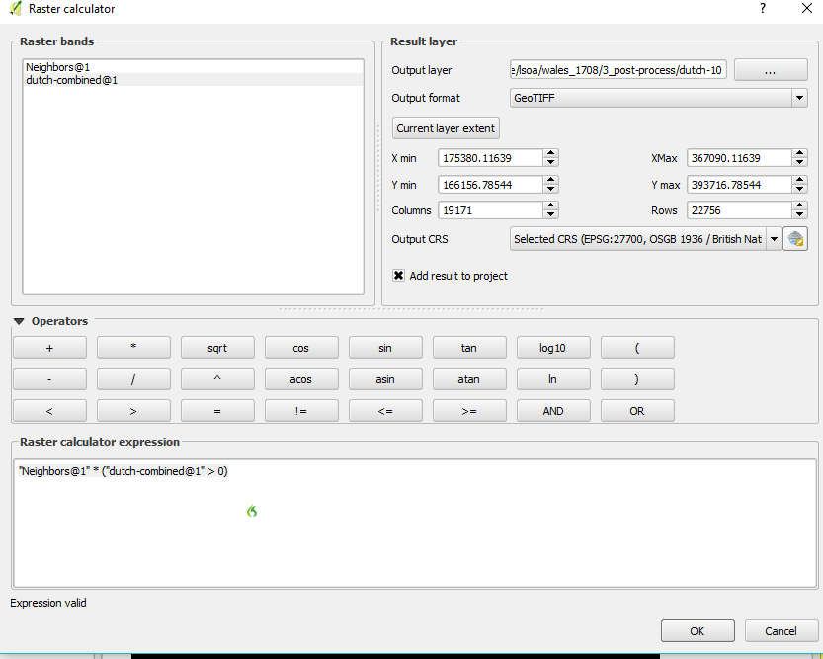
[NB if step three is not done directly after step two, you will need to open scenarioname-combined and scenarioname-combined-clean, and use scenarioname-combined-clean in place of neighbours in the syntax above]

Step 4: the sampling the rasters to make lower resolution versions, in QGIS
- Open ‘3_post-process/scenarioname-10.tif’
- Open r.resamp.stats. see Figure 4
  - aggregation method: maximum
  - cell size: 50
  - save as ‘3_post-process/scenarioname-50.tif’
- then repeat this process with 100 instead of 50
[ NB 10 is for zoom 11-19, 50 is zoom 9-10, 100 is zoom 1-8]

Figure 4
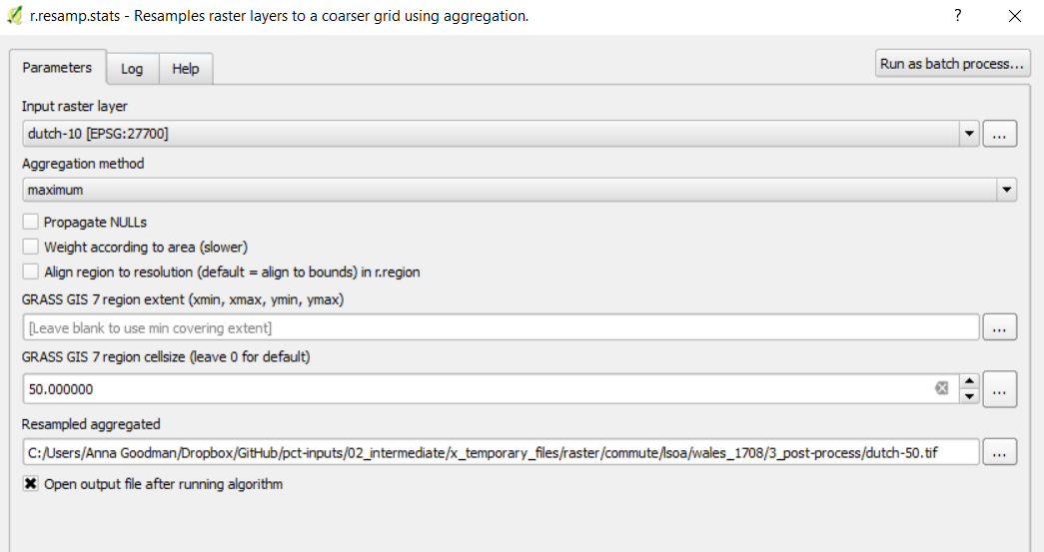

These three rasters ‘scenarioname-10.tif’, ‘scenarioname-50.tif’ and ‘scenarioname-100.tif’ are now ready to be given to Nikolai to modify the colours and turn them into tiles, using code at https://github.com/npct/pct-lsoa-vis

Alternatively, this could be done in QGIS as described in steps 5 and 6
Step 5: turning rasters into GDAL tiles, in QGIS
- Open ‘3_post-process/scenarioname-10.tif’
- Properties -> style -> render type = ‘ standard pseudo-colour’ -> max = 99999
- in style, add nine bands and set the boundaries and colours as per https://github.com/npct/pct-lsoa-vis/blob/master/generate/colour.txt.
- right click -> save as -> rendered image in ‘3_post-process/scenarioname-10-gdal.tif’

Step 6: turning GDAL files to tiles, in QGIS
- Open ‘3_post-process/scenarioname-10-gdal.tif’
- open function gdal2tiles
  - Mercator
  - resampling = average
  - zoom level: 11 (for example)
  - select folder (make one per scenario)

