??CanAI (??? Cancer Prediction Machine Learning Project)

George Karakatsoulis, Nikos Pechlivanis

Institute of Applied Biosciences, Centre for Research and Technology, Hellas

Contents

Preprocessing of the input dataset 1

Fast Unified Random Forests with randomForestSRC 4

Death time prediction 4

Experiment #1 5

Experiment #2 5

Experiment #3 6

# Preprocessing of the input dataset

1. Any numeric predictors that were stored as characters were converted to numeric.
2. *_pathogenic predictors labelled as “na” were converted to NA (Not Available)
3. *_pathogenic predictors labelled as “0” were converted to “NON-PATH”
4. Filtering out of near zero variance predictors:

**Table 1**: Zero Variance Predictors

|  |  |  |  |  |
| --- | --- | --- | --- | --- |
| predictor | freqRatio | percentUnique | zeroVar | nzv |
| p16_score | 31.66666667 | 4.964539007 | FALSE | TRUE |
| ACVR1 | 60 | 1.418439716 | FALSE | TRUE |
| AKT1 | 29.5 | 1.418439716 | FALSE | TRUE |
| ARHGAP26 | 60 | 1.418439716 | FALSE | TRUE |
| ARID2 | 19.33333333 | 1.418439716 | FALSE | TRUE |
| ARID4B | 19.33333333 | 1.418439716 | FALSE | TRUE |
| ATG2A | 29.5 | 1.418439716 | FALSE | TRUE |
| ATG7 | 19.33333333 | 1.418439716 | FALSE | TRUE |
| ATRX | 29.5 | 1.418439716 | FALSE | TRUE |
| BRAF | 29.5 | 1.418439716 | FALSE | TRUE |
| CASP8 | 60 | 1.418439716 | FALSE | TRUE |
| CD247 | 60 | 1.418439716 | FALSE | TRUE |
| CDK4 | 19.33333333 | 1.418439716 | FALSE | TRUE |
| CRTC3 | 29.5 | 1.418439716 | FALSE | TRUE |
| DNMT3A | 19.33333333 | 1.418439716 | FALSE | TRUE |
| EBF1 | 60 | 1.418439716 | FALSE | TRUE |
| EZH2 | 19.33333333 | 1.418439716 | FALSE | TRUE |
| H3F3B | 60 | 1.418439716 | FALSE | TRUE |
| HOXA13 | 29.5 | 1.418439716 | FALSE | TRUE |
| KDM4A | 29.5 | 1.418439716 | FALSE | TRUE |
| KDR | 60 | 1.418439716 | FALSE | TRUE |
| LMO2 | 19.33333333 | 1.418439716 | FALSE | TRUE |
| MET | 19.33333333 | 1.418439716 | FALSE | TRUE |
| MSH3 | 19.33333333 | 1.418439716 | FALSE | TRUE |
| NCOR2 | 29.5 | 1.418439716 | FALSE | TRUE |
| NFKB2 | 60 | 1.418439716 | FALSE | TRUE |
| NOTCH1 | 29.5 | 1.418439716 | FALSE | TRUE |
| NOTCH2 | 29.5 | 1.418439716 | FALSE | TRUE |
| NRAS | 19.33333333 | 1.418439716 | FALSE | TRUE |
| PAX3 | 19.33333333 | 1.418439716 | FALSE | TRUE |
| PHOX2B | 19.33333333 | 1.418439716 | FALSE | TRUE |
| PTPRC | 19.33333333 | 1.418439716 | FALSE | TRUE |
| RAD21 | 29.5 | 1.418439716 | FALSE | TRUE |
| RAD50 | 19.33333333 | 1.418439716 | FALSE | TRUE |
| RSPO2 | 19.33333333 | 1.418439716 | FALSE | TRUE |
| SFPQ | 19.33333333 | 1.418439716 | FALSE | TRUE |
| SLC34A2 | 60 | 1.418439716 | FALSE | TRUE |
| SMARCC1 | 60 | 1.418439716 | FALSE | TRUE |
| SRGAP3 | 29.5 | 1.418439716 | FALSE | TRUE |
| TET3 | 19.33333333 | 1.418439716 | FALSE | TRUE |
| WHSC1 | 60 | 1.418439716 | FALSE | TRUE |
| ABL1_pathogenic | 23.5 | 1.418439716 | FALSE | TRUE |
| ACVR1_pathogenic | 0 | 0.709219858 | TRUE | TRUE |
| AKT1_pathogenic | 0 | 0.709219858 | TRUE | TRUE |
| ARHGAP26_pathogenic | 0 | 0.709219858 | TRUE | TRUE |
| ARID1A_pathogenic | 0 | 0.709219858 | TRUE | TRUE |
| ARID2_pathogenic | 0 | 0.709219858 | TRUE | TRUE |
| ARID4B_pathogenic | 0 | 0.709219858 | TRUE | TRUE |
| ATG13_pathogenic | 0 | 0.709219858 | TRUE | TRUE |
| ATG2A_pathogenic | 0 | 0.709219858 | TRUE | TRUE |
| ATG7_pathogenic | 0 | 0.709219858 | TRUE | TRUE |
| ATRX_pathogenic | 0 | 0.709219858 | TRUE | TRUE |
| AXIN1_pathogenic | 0 | 0.709219858 | TRUE | TRUE |
| BAP1_pathogenic | 0 | 0.709219858 | TRUE | TRUE |
| BRAF_pathogenic | 48 | 1.418439716 | FALSE | TRUE |
| BRD4_pathogenic | 0 | 0.709219858 | TRUE | TRUE |
| CASP8_pathogenic | 0 | 0.709219858 | TRUE | TRUE |
| CD247_pathogenic | 0 | 0.709219858 | TRUE | TRUE |
| CD274_pathogenic | 0 | 0.709219858 | TRUE | TRUE |
| CD8A_pathogenic | 0 | 0.709219858 | TRUE | TRUE |
| CD8B_pathogenic | 48 | 1.418439716 | FALSE | TRUE |
| CDK4_pathogenic | 0 | 0.709219858 | TRUE | TRUE |
| CHD6_pathogenic | 0 | 0.709219858 | TRUE | TRUE |
| CHEK2_pathogenic | 48 | 1.418439716 | FALSE | TRUE |
| CRTC3_pathogenic | 0 | 0.709219858 | TRUE | TRUE |
| CTLA4_pathogenic | 0 | 0.709219858 | TRUE | TRUE |
| DNMT3A_pathogenic | 0 | 0.709219858 | TRUE | TRUE |
| EBF1_pathogenic | 0 | 0.709219858 | TRUE | TRUE |
| EP300_pathogenic | 0 | 0.709219858 | TRUE | TRUE |
| ERBB2_pathogenic | 23.5 | 1.418439716 | FALSE | TRUE |
| ERBB3_pathogenic | 48 | 1.418439716 | FALSE | TRUE |
| EZH2_pathogenic | 48 | 1.418439716 | FALSE | TRUE |
| FGFR2_pathogenic | 48 | 1.418439716 | FALSE | TRUE |
| H3F3B_pathogenic | 0 | 0.709219858 | TRUE | TRUE |
| HOXA13_pathogenic | 23.5 | 1.418439716 | FALSE | TRUE |
| JAK1_pathogenic | 48 | 1.418439716 | FALSE | TRUE |
| JAK2_pathogenic | 48 | 1.418439716 | FALSE | TRUE |
| KDM4A_pathogenic | 48 | 1.418439716 | FALSE | TRUE |
| KDR_pathogenic | 0 | 0.709219858 | TRUE | TRUE |
| KIT_pathogenic | 23.5 | 1.418439716 | FALSE | TRUE |
| KMT2C_pathogenic | 23.5 | 1.418439716 | FALSE | TRUE |
| KMT2D_pathogenic | 23.5 | 1.418439716 | FALSE | TRUE |
| LMO2_pathogenic | 0 | 0.709219858 | TRUE | TRUE |
| MAP2K2_pathogenic | 0 | 0.709219858 | TRUE | TRUE |
| MET_pathogenic | 0 | 0.709219858 | TRUE | TRUE |
| MLH1_pathogenic | 48 | 1.418439716 | FALSE | TRUE |
| MSH2_pathogenic | 48 | 1.418439716 | FALSE | TRUE |
| MSH3_pathogenic | 0 | 0.709219858 | TRUE | TRUE |
| MSH6_pathogenic | 48 | 1.418439716 | FALSE | TRUE |
| NCOR2_pathogenic | 48 | 1.418439716 | FALSE | TRUE |
| NFKB2_pathogenic | 0 | 0.709219858 | TRUE | TRUE |
| NIN_pathogenic | 0 | 0.709219858 | TRUE | TRUE |
| NOTCH1_pathogenic | 0 | 0.709219858 | TRUE | TRUE |
| NOTCH2_pathogenic | 0 | 0.709219858 | TRUE | TRUE |
| NOTCH3_pathogenic | 23.5 | 1.418439716 | FALSE | TRUE |
| NRAS_pathogenic | 0 | 0.709219858 | TRUE | TRUE |
| PALB2_pathogenic | 48 | 1.418439716 | FALSE | TRUE |
| PAX3_pathogenic | 48 | 1.418439716 | FALSE | TRUE |
| PDCD1_pathogenic | 0 | 0.709219858 | TRUE | TRUE |
| PHOX2B_pathogenic | 0 | 0.709219858 | TRUE | TRUE |
| PTCH1_pathogenic | 0 | 0.709219858 | TRUE | TRUE |
| PTPRC_pathogenic | 0 | 0.709219858 | TRUE | TRUE |
| RAD21_pathogenic | 0 | 0.709219858 | TRUE | TRUE |
| RAD50_pathogenic | 48 | 1.418439716 | FALSE | TRUE |
| RANBP2_pathogenic | 48 | 1.418439716 | FALSE | TRUE |
| RSPO2_pathogenic | 0 | 0.709219858 | TRUE | TRUE |
| SETD2_pathogenic | 0 | 0.709219858 | TRUE | TRUE |
| SFPQ_pathogenic | 0 | 0.709219858 | TRUE | TRUE |
| SLC34A2_pathogenic | 0 | 0.709219858 | TRUE | TRUE |
| SMARCC1_pathogenic | 0 | 0.709219858 | TRUE | TRUE |
| SRCAP_pathogenic | 23.5 | 1.418439716 | FALSE | TRUE |
| SRGAP3_pathogenic | 48 | 1.418439716 | FALSE | TRUE |
| TET1_pathogenic | 0 | 0.709219858 | TRUE | TRUE |
| TET2_pathogenic | 23.5 | 1.418439716 | FALSE | TRUE |
| TET3_pathogenic | 0 | 0.709219858 | TRUE | TRUE |
| TSC1_pathogenic | 0 | 0.709219858 | TRUE | TRUE |
| TSHZ3_pathogenic | 0 | 0.709219858 | TRUE | TRUE |
| WHSC1_pathogenic | 0 | 0.709219858 | TRUE | TRUE |
| ZNF521_pathogenic | 0 | 0.709219858 | TRUE | TRUE |

# Fast Unified Random Forests with randomForestSRC

Survival analysis for both prediction of death and progress time was computed with *randomForestSRC* R package and the *rfsrc* function

## Death time prediction

Analysis was conducted in four experiments:

* experiment #1: considering all predictors (as produced by previous preprocessing steps)
* experiment #2: considering only clinical (*"GroupTreatm", "AgeAccepted", "PS", "EBERPROBE_neg_pos",Smoking", "Sex", "T", "N", "CyclinD1", "ki67", "Mutation status", "Stability status"*) and *_score predictors (*"TAU_score", "ERCC1_score", "p63_score", "ECADH_score", "PADH_score", "pakt473_score", "MTOR_score", "VEGFR2_score", "VEGFA_score", "VEGFR3_score", "VEGFC_score", "PTEN_score", "COX2_score", "FASCIN_score", "p53_score", "EGFR_score", "GSK3B_score", "p4442_score"*)
* experiment #3: considering only gene NGS predictors (*"ABL1", "ARID1A", "ATG13", "AXIN1", "BAP1", "BRCA1", "BRCA2", "BRD4", "CD274", "CD8A", "CD8B", "CHD6", "CHEK2", "CTLA4", "EGFR", "EP300", "ERBB2", "ERBB3", "FGFR2", "JAK1", "JAK2", "KIT", "KMT2C", "KMT2D", "KRAS", "MAP2K2", "MLH1", "MSH2", "MSH6", "NIN", "NOTCH3", "PALB2", "PDCD1", "PIK3CA", "POLE", "PTCH1", "RANBP2", "SETD2", "SRCAP", "SYNE1", "TET1", "TET2", "TP53", "TSC1", "TSHZ3", "ZNF521"*)
* experiment #4: consideting only *_pathogenic predictors *("BRCA1_pathogenic", "BRCA2_pathogenic", "EGFR_pathogenic", "KRAS_pathogenic", "PIK3CA_pathogenic", "POLE_pathogenic", "SYNE1_pathogenic", "TP53_pathogenic"*)

### Experiment #1

* Performance error: 0.4639866
* C-index: 0.23275618
* Most important variables (Importance > .01): *"AgeAccepted", "CyclinD1", "ki67", "N", "p63_score", "MSH2", "pakt473_score" "TSC1"*

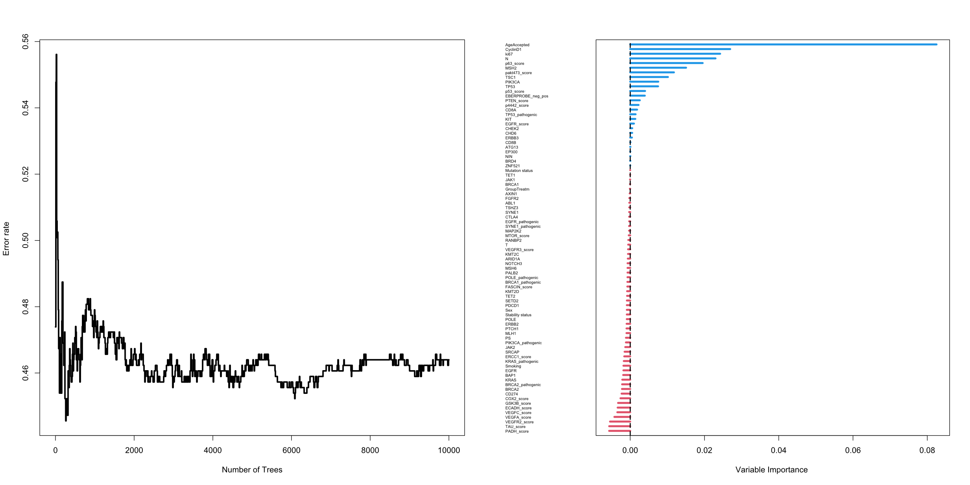

### Experiment #2

* Performance error: 0.43942993
* C-index: 0.21979704
* Most important variables (Importance > .01): *"AgeAccepted", "ki67", "p63_score", "EBERPROBE_neg_pos"*

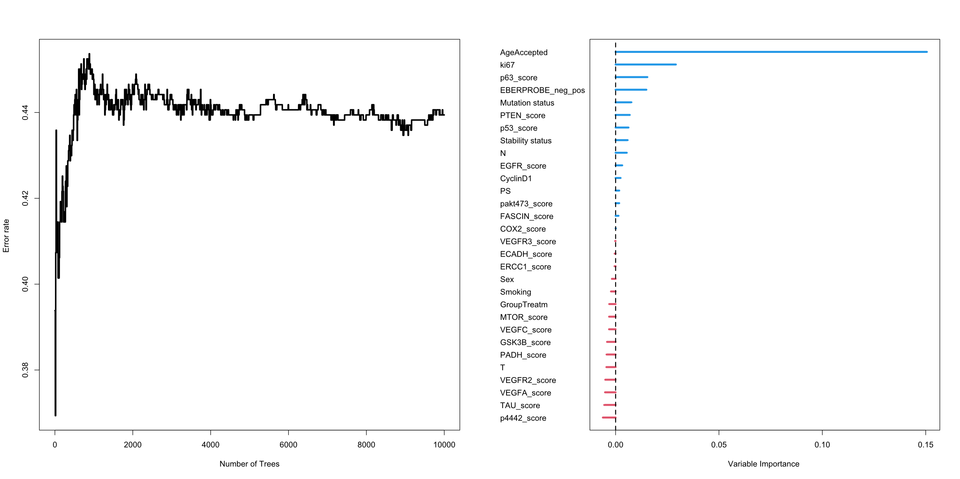

### Experiment #3

* Performance error: 0.56170531
* C-index: 0.24158321
* Most important variables (Importance > .01): *"BRCA1", "CD274", "MSH2", "TSC1", "PIK3CA" "KRAS", "KIT"*

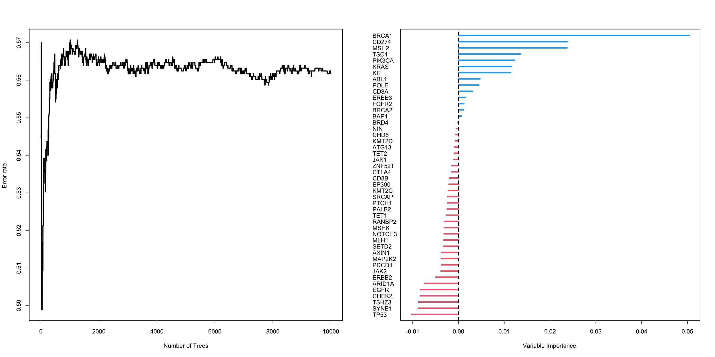

### Experiment #4

* Performance error: 0.62847966
* C-index: 0.2481601
* Most important variables (Importance > .01): *Does not return any important variables*

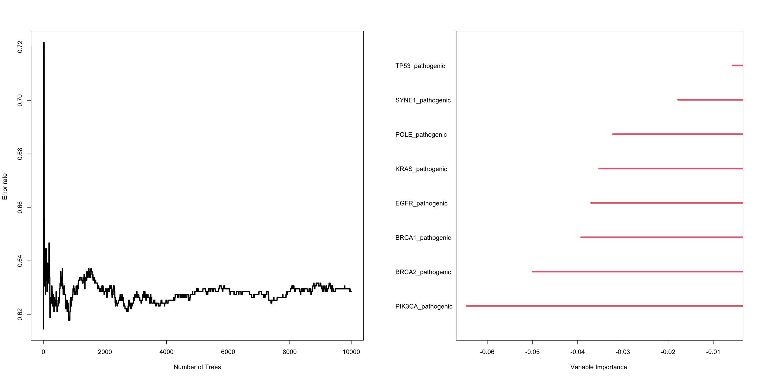

## Progression time prediction

Analysis was conducted in four experiments as above.

### Experiment #1

* Performance error: 0.50558659
* C-index: 0.251254
* Most important variables (Importance > .01): *"CyclinD1" "MSH2" "AgeAccepted" "pakt473_score" "p63_score" "ki67" "EGFR_score" "p53_score"*