2 Monitoring von Sockets)

1)

139 Sockets sind offen.

2)

UDP hat keinen State, TCP schon.
UDP verwendet nie einen Remote Port

3)

Established: represents an open connection, data received can be delivered to the user. The normal state for the data transfer phase of the connection.

Listening: represents waiting for a connection request from any remote TCP and port.

Close Wait: represents waiting for a connection termination request from the local user.

Time Wait: represents waiting for enough time to pass to be sure the remote TCP received the acknowledgment of its connection termination request.

4)

28 Listening States + 46 UDP

5)

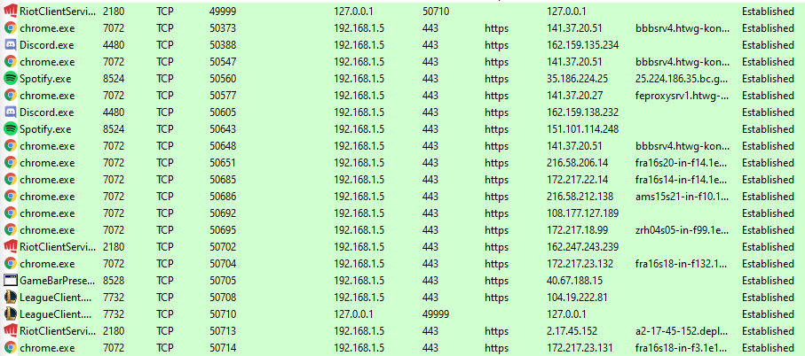
21 neue Establishes
6)

Um sich selbst zu pingen (lokale IP-Adresse)

Die meisten agieren über 80 und 443.
Spotify einmal über 4070 (tripe)
LeagueClient über 2099 (H.255.0 Annex G Signalling)
RiotClientService über 5223 (HP Virtual Management Group)
chrome einmal über 5228 (Reserved Netflow/IPFIX/sFlow)

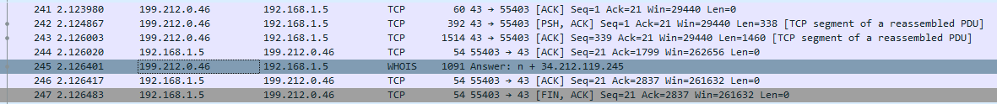
3 Details über die Kommunikationspartner ihres PCs)
WHOIS and TCP

2)

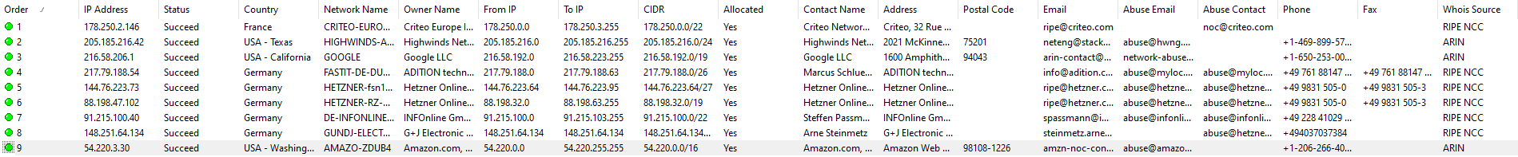

inetnum: 141.37.0.0 - 141.37.255.255
netname: FH-KN
country: DE
admin-c: HKTW1-RIPE
tech-c: HKTW1-RIPE
org: ORG-HKTW1-RIPE
status: LEGACY
remarks: **************************************************
remarks: * DEFAULT ABUSE CONTACT: abuse@htwg-konstanz.de *
remarks: **************************************************
mnt-by: BELWUE-MNT
mnt-by: RIPE-NCC-LEGACY-MNT
created: 2002-04-25T09:54:38Z
last-modified: 2016-04-14T08:23:18Z
source: RIPE
sponsoring-org: ORG-BA9-RIPE

organisation: ORG-HKTW1-RIPE
org-name: Hochschule Konstanz Technik, Wirtschaft und Gestaltung
org-type: OTHER
address: Brauneggerstr. 55
address: 78462 Konstanz, Germany
e-mail: netzwerk@htwg-konstanz.de
admin-c: HKTW1-RIPE
tech-c: HKTW1-RIPE
abuse-c: HKTW1-RIPE
mnt-ref: BELWUE-MNT
mnt-by: BELWUE-MNT
created: 2015-06-17T14:46:25Z
last-modified: 2015-06-18T11:34:36Z
source: RIPE

role: Hochschule Konstanz Technik, Wirtschaft und Gestaltung
address: Brauneggerstr. 55
address: 78462 Konstanz, Germany
e-mail: netzwerk@htwg-konstanz.de
admin-c: MS3208-RIPE
tech-c: MS3208-RIPE
nic-hdl: HKTW1-RIPE
abuse-mailbox: abuse@htwg-konstanz.de
mnt-by: BELWUE-MNT
created: 2015-06-17T14:46:25Z
last-modified: 2015-06-18T11:34:36Z
source: RIPE

% Information related to '141.37.0.0/16AS553'

route: 141.37.0.0/16
descr: FH-KONSTANZ
origin: AS553
mnt-by: BELWUE-MNT
created: 1970-01-01T00:00:00Z
last-modified: 2001-09-22T09:32:38Z
source: RIPE

% This query was served by the RIPE Database Query Service version 1.98 (HEREFORD)

4)

21 neue Sockets

5)

65535 TCP-Ports+ 65535 UDP-Ports

6)

443 (https)

7)

Julien Bailhache
Amazon Data Services Limited Ireland
Google LLC
Marcus Schlueter
Steffen Passmann
Hetzner Online GmbH
Akamai Technoloiges
viel Amazon

Bei Naver:
IP Manager von Naver
Akamai Technologies

