SRM INSTITUTE OF SCIENCE AND TECHNOLOGY
TIRUCHIRAPPALLI CAMPUS

CONTINUOUS LEARNING ASSESSMENT – 2
CODE TRACE CHALLENGE
THINK • TRACE • PREDICT • VERIFY

TASK – 2
Stack Operations Using an Array (C Programming)

DETAIL | INFORMATION
Submitted by | Nareshwar Perer S
Register Number | RA2510042050003
Programme / Department | B.Tech. – Computer Science and Business Systems (CSBS)
Course | 21CSC201J – Data Structures and Algorithms
Assessment | Continuous Learning Assessment – 2 (Task – 2)
Academic Year | 2026–2027

Department of Computer Science and Business System

DECLARATION OF ORIGINALITY
I, Nareshwar Perer S (Register Number: RA2510042050003), declare that this report presents my work for Continuous Learning Assessment – 2, Task 2, on stack operations using an array in C. The report records the supplied program’s logic, manual trace, predicted output, analysis and handwritten evidence. I will verify the program by compiling and executing it before final submission and will record the actual results accurately.

Student Name: Nareshwar Perer S
Register Number: RA2510042050003
Signature: __________________________________________
Date: _______________________________________________

CONTENTS
SECTION | TITLE
1 | Aim and objectives
2 | Task 1 – Code understanding
3 | Task 2 – Manual code tracing
4 | Task 3 – Value tracing and function return values
5 | Task 4 – Output prediction and final state
6 | Task 5 – What-if analysis
7 | Task 6 – Error analysis and limitations
8 | Task 7 – Verification after manual prediction
9 | Additional test cases
10 | Source code
11 | Handwritten-work evidence
12 | Conclusion
 | References

1. Aim and objectives
Aim: To understand and manually trace the implementation of a stack using an array in C, predict its output and final state, and verify the prediction by executing the program.
Objectives
- Identify the stack data structure, variables, initial values, functions, conditions and loop.
- Trace each push, pop and display operation and record top, stack contents and outputs.
- Predict overflow, underflow, function return values and the final stack state.
- Perform a modified-operation analysis and identify limitations or possible improvements.
- Verify the original program and additional test cases using a C compiler.

2. Task 1 – Code understanding

2.1 Data structure used
The program implements a stack using a one-dimensional integer array. A stack follows the LIFO principle (Last In, First Out): the last value inserted is the first value removed. The variable top stores the index of the current top element.

2.2 Variables and initial values
Variable | Type / declaration | Initial value | Purpose
stack | int stack[SIZE] | Zero-initialized global array | Stores up to five stack values.
SIZE | #define SIZE 5 | 5 | Defines the maximum capacity.
top | int | -1 | Index of top element; -1 means empty.
item (push) | int parameter | Passed by caller | Value to insert into the stack.
item (pop) | local int | Assigned stack[top] | Temporarily stores the removed value.
item (main) | local int | Uninitialized until assigned | Receives the return value of pop().
i | int in display() | Initialized by for-loop | Traverses stack elements.

2.3 Functions and purpose
Function | Purpose | Return / effect
push(int item) | Checks whether stack is full. If not, increments top and stores item. | void; prints pushed value or overflow message.
pop() | Checks whether stack is empty. If not, saves stack[top], decrements top and returns saved value. | Returns removed integer; returns -1 on underflow.
display() | Prints an empty message or traverses indices 0 through top. | void; does not modify the stack.
main() | Calls push, pop and display in the specified order. | Returns 0 when program ends normally.

2.4 Conditions and loop
- Overflow condition: top == SIZE - 1. With SIZE = 5, overflow occurs when top == 4.
- Underflow condition: top == -1. A pop on an empty stack prints Stack Underflow and returns -1.
- Display loop: for (i = 0; i <= top; i++). It prints from index 0 to the top element.
- The program has no user-input statement; all operations are hard-coded in main().

3. Task 2 – Manual code tracing
The stack contents below show only the logical stack, from bottom to top. Array cells beyond top may still contain old values, but those cells are not part of the active stack.
Step | Operation | Item | top | Logical stack | Output
0 | Initial state | — | -1 | Empty | —
1 | push(10) | 10 | 0 | 10 | Pushed: 10
2 | push(20) | 20 | 1 | 10, 20 | Pushed: 20
3 | push(30) | 30 | 2 | 10, 20, 30 | Pushed: 30
4 | display() | — | 2 | 10, 20, 30 | Stack: 10 20 30
5 | item = pop() | 30 | 1 | 10, 20 | Popped: 30
6 | push(40) | 40 | 2 | 10, 20, 40 | Pushed: 40
7 | push(50) | 50 | 3 | 10, 20, 40, 50 | Pushed: 50
8 | push(60) | 60 | 4 | 10, 20, 40, 50, 60 | Pushed: 60
9 | push(70) | 70 | 4 | 10, 20, 40, 50, 60 | Stack Overflow
10 | display() | — | 4 | 10, 20, 40, 50, 60 | Stack: 10 20 40 50 60
11 | pop() | 60 | 3 | 10, 20, 40, 50 | Popped: 60
12 | pop() | 50 | 2 | 10, 20, 40 | Popped: 50
13 | pop() | 40 | 1 | 10, 20 | Popped: 40
14 | pop() | 20 | 0 | 10 | Popped: 20
15 | pop() | 10 | -1 | Empty | Popped: 10
16 | display() | — | -1 | Empty | Stack is Empty
17 | pop() | -1 | -1 | Empty | Stack Underflow; Popped: -1

3.1 Display loop variable i
Display call | top at entry | Values of i | First i that stops loop | Result
1st display | 2 | 0, 1, 2 | 3 (3 <= 2 is false) | Prints 10 20 30
2nd display | 4 | 0, 1, 2, 3, 4 | 5 (5 <= 4 is false) | Prints 10 20 40 50 60
3rd display | -1 | Loop not entered | Not applicable | Prints Stack is Empty

In the empty case, the if condition is true, so display() prints Stack is Empty and skips the for-loop. The local variable i is not used in that branch.

4. Task 3 – Value tracing and function return values
Call from main() | Value / state and function action | Return to main() | Value in main item
push(10), push(20), push(30) | Each value is inserted; top becomes 0, 1 and then 2. | No return (void) | Not applicable
pop() #1 | Saves 30; top becomes 1. | 30 | 30
push(40), push(50), push(60) | Values inserted; top becomes 2, 3 and then 4. | No return (void) | Not applicable
push(70) | Full check succeeds; no insertion. | No return (void) | Not applicable
pop() #2–#6 | Removes 60, 50, 40, 20 and 10. | 60, 50, 40, 20, 10 | Updated each call
pop() #7 | Prints underflow; returns -1. | -1 | -1

The local variable item inside pop() is different from item in main(). The local variable stores the value being removed. The returned value is then assigned to main()’s item variable.

5. Task 4 – Output prediction and final state
Predicted complete output (before compiling):
Pushed: 10
Pushed: 20
Pushed: 30
Stack: 10 20 30
Popped: 30
Pushed: 40
Pushed: 50
Pushed: 60
Stack Overflow
Stack: 10 20 40 50 60
Popped: 60
Popped: 50
Popped: 40
Popped: 20
Popped: 10
Stack is Empty
Stack Underflow
Popped: -1

5.1 Predicted final state
Item | Predicted value
top | -1
Logical stack contents | Empty
Last value assigned to main()’s item | -1
Overflow occurrences | 1 (push(70))
Underflow occurrences | 1 (final pop())
Successful push operations | 6 (10, 20, 30, 40, 50, 60)
Successful pop operations | 6 (30, 60, 50, 40, 20, 10)

The array stores five elements. After the first three pushes and one pop, two elements remain. Three further pushes fill the array. The next push(70) is rejected because top is already 4. Five subsequent pops remove all active elements. The final pop is attempted when top is -1, causing underflow.

6. Task 5 – What-if analysis
Modification selected: Change push(60) in main() to push(65). All other statements remain unchanged.
Stage | Original program | Modified program
Input operation | push(60) | push(65)
After insertion | top=4; stack=10,20,40,50,60 | top=4; stack=10,20,40,50,65
Next operation | push(70) → Overflow | push(70) → Overflow
Second display | Stack: 10 20 40 50 60 | Stack: 10 20 40 50 65
Next pop | Returns 60 | Returns 65
Remaining pops | 50, 40, 20, 10 | 50, 40, 20, 10
Final state | top=-1; Empty | top=-1; Empty

Only the inserted value changes. The stack size and operation order remain the same, so overflow and underflow behavior do not change. The modified value 65 appears in the second display and is returned by the first pop after that display.

7. Task 6 – Error analysis and limitations
No incorrect stack-boundary condition is present in the supplied program. The overflow check top == SIZE - 1 and underflow check top == -1 are correct for this array implementation.
Observation | Explanation | Suggested improvement
Underflow sentinel ambiguity | pop() returns -1 on underflow, but -1 could also be a valid stored stack value. The caller cannot distinguish the two cases using the return value alone. | Return a status separately, use an output parameter, or use a sentinel disallowed by the input specification.
No user input | All values and operations are hard-coded in main(). | For an interactive version, read menu choices and values from the user.
Display direction | display() prints from index 0 to top (bottom to top). This is valid, but it does not show the top element first. | If top-to-bottom display is desired, loop from top down to 0.
No explicit array clearing | pop() decrements top but does not erase the old array cell. The old value remains physically stored but is outside the logical stack. | Clearing stack[top] before decrement is optional and not required for correctness in this integer example.

The program’s global array is zero-initialized by C, but the logical stack is empty because top starts at -1. Values physically left in stack[] after all pops do not mean the stack still contains elements.

8. Task 7 – Verification after manual prediction
Verification status: Completed. The program was compiled successfully with GCC and executed. The actual output matched the predicted output, including the final top value, empty logical stack, one overflow and one underflow.
Comparison item | Predicted result | Actual result – fill after running | Match / notes
Complete output | As listed in Section 5 | Matched the complete GCC output | Match
Final top | -1 | -1 | Match
Final logical stack | Empty | Empty | Match
Overflow | Once at push(70) | Once at push(70) | Match
Underflow | Once at final pop() | Once at final pop() | Match

9. Additional test cases
The following are separate operation sequences for testing the push/pop functions. Each test was executed independently, starting with top = -1 and an empty stack. The actual results are recorded in the final column and the corresponding execution screenshots are included in Section 10.1.
Test | Operations | Expected stack / result | Actual result
1 – Basic LIFO | push(10), push(20), pop() | pop returns 20; top=0; stack=[10] | Returned 20; stack=[10]; top=0.
2 – Overflow | push(1), push(2), push(3), push(4), push(5), push(6) | First five insert; sixth push reports Stack Overflow; top=4 | First five pushes succeeded; sixth caused Stack Overflow; stack=[1,2,3,4,5]; top=4.
3 – Underflow | pop() on an empty stack | Prints Stack Underflow; pop returns -1; top remains -1 | Stack Underflow printed; returned -1; top=-1.
4 – Fill and empty | push(4), push(8), push(12), pop(), pop(), pop() | Returns 12, 8, 4; final top=-1 | Popped 12, 8, 4; stack empty; top=-1.

The actual results matched the expected behavior for all four test cases.

10. Source code
#include <stdio.h>
#define SIZE 5
int stack[SIZE];
int top = -1;
void push(int item) {
if (top == SIZE - 1) {
printf("Stack Overflow\\n");
} else {
top++;
stack[top] = item;
printf("Pushed: %d\\n", item);
}
}
int pop() {
if (top == -1) {
printf("Stack Underflow\\n");
return -1;
} else {
int item = stack[top];
top--;
return item;
}
}
void display() {
int i;
if (top == -1) {
printf("Stack is Empty\\n");
} else {
printf("Stack: ");
for (i = 0; i <= top; i++) {
printf("%d ", stack[i]);
}
printf("\\n");
}
}
int main() {
int item;
push(10);
push(20);
push(30);
display();
item = pop();
printf("Popped: %d\\n", item);
push(40);
push(50);
push(60);
push(70);
display();
item = pop(); printf("Popped: %d\\n", item);
item = pop(); printf("Popped: %d\\n", item);
item = pop(); printf("Popped: %d\\n", item);
item = pop(); printf("Popped: %d\\n", item);
item = pop(); printf("Popped: %d\\n", item);
display();
item = pop();
printf("Popped: %d\\n", item);
return 0;
}

10.1 Actual program execution output
The following screenshots were generated from successful GCC compilations and executions of the supplied program and each independent test sequence.
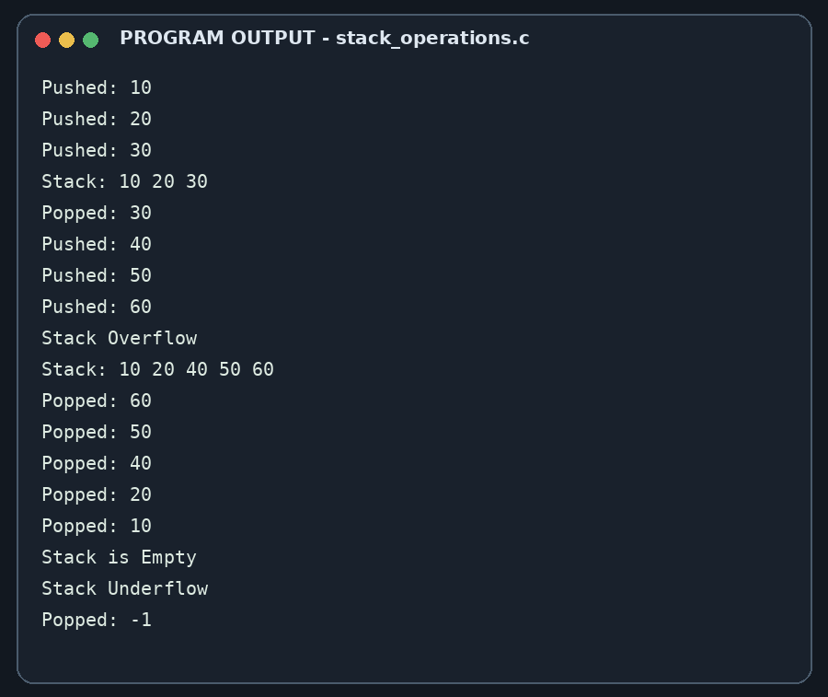
TEST CASE 1 – BASIC LIFO
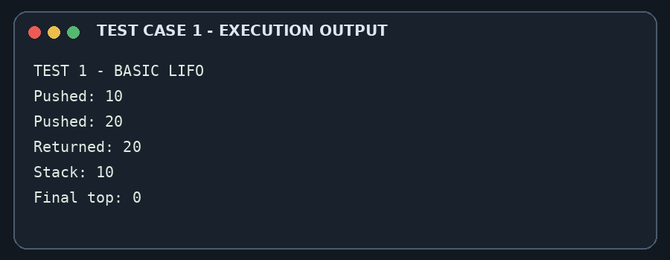
TEST CASE 2 – OVERFLOW
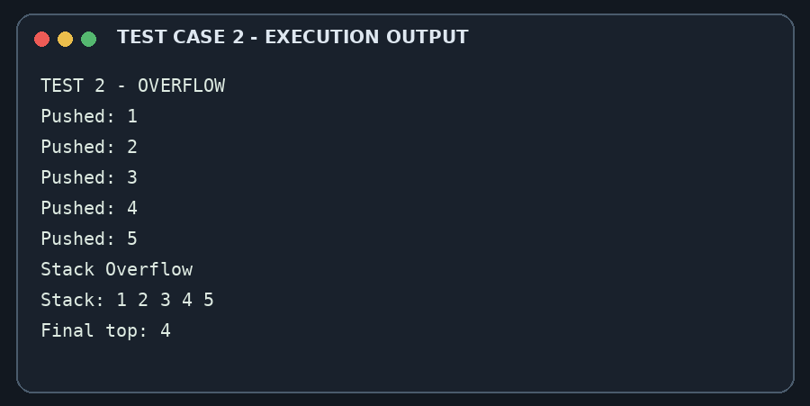
TEST CASE 3 – UNDERFLOW
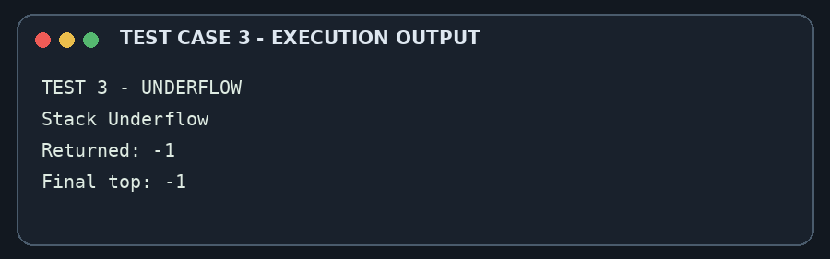
TEST CASE 4 – FILL AND EMPTY
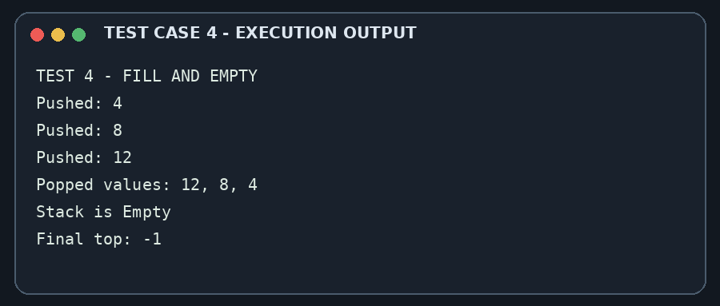

11. Handwritten-work evidence
The following pages are inserted from the separately supplied DSA_Task2.pdf. The handwritten pages are retained as supplied.
Handwritten evidence – Page 1
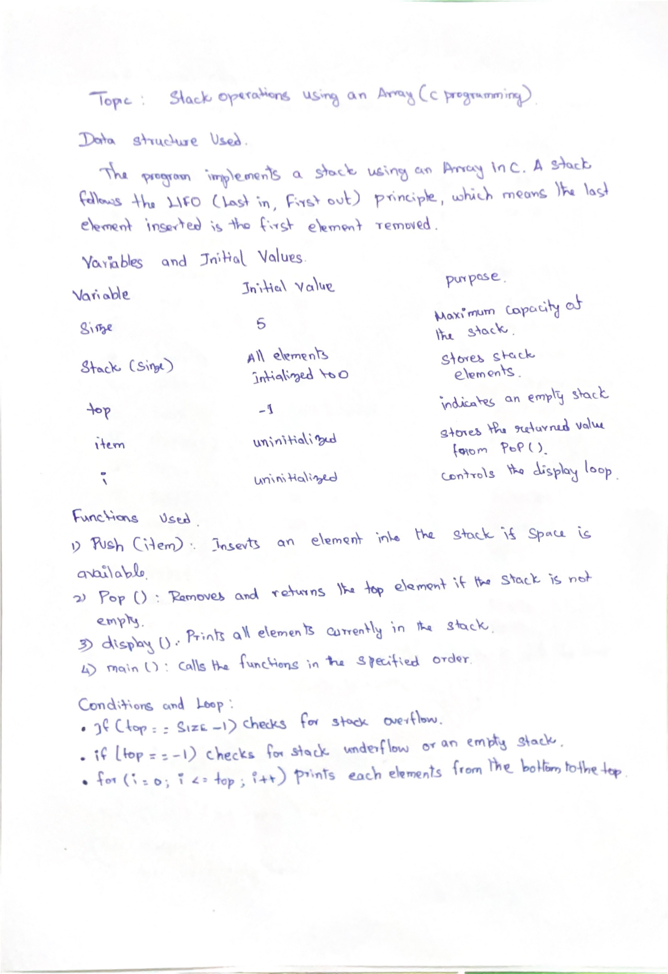

Handwritten evidence – Page 2
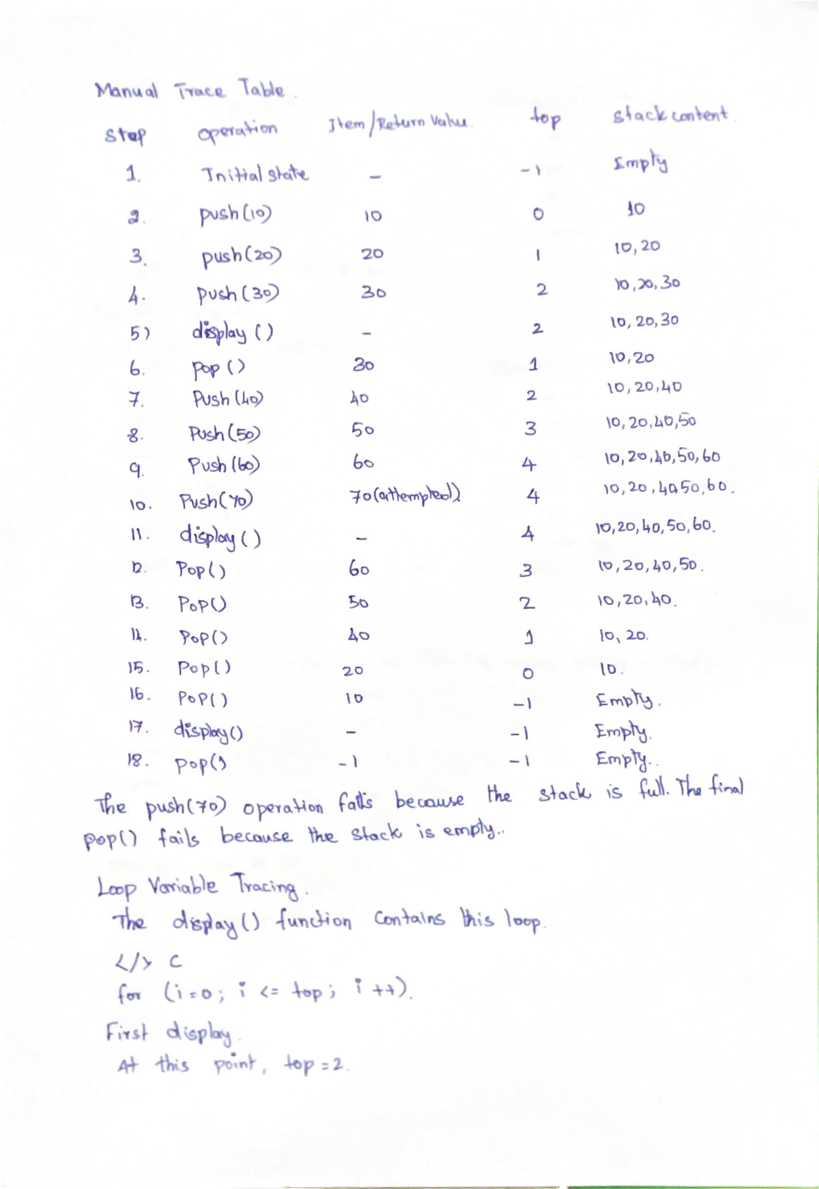

Handwritten evidence – Page 3
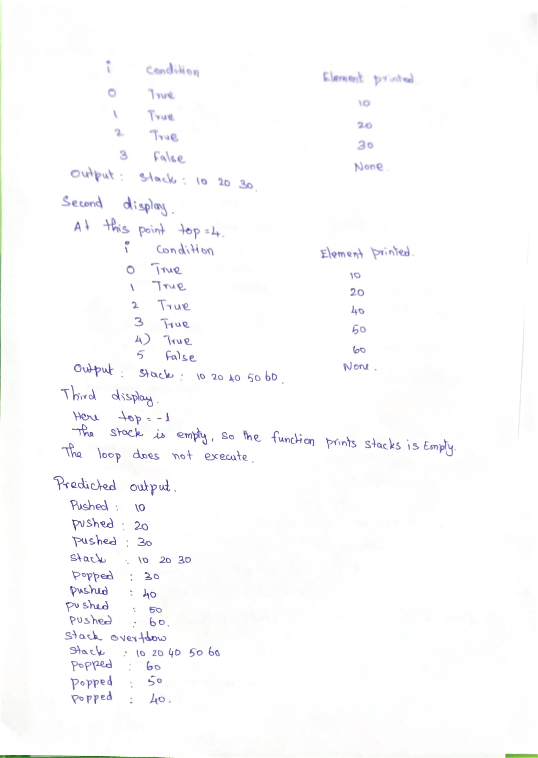

12. Conclusion
This assessment demonstrates the working of a stack implemented using an array and the LIFO principle. The top variable identifies the most recently inserted active element. The push operation inserts an item when capacity is available, while pop removes and returns the top item. The supplied program reaches overflow when push(70) is attempted on a full stack and reaches underflow when the final pop is attempted on an empty stack. The predicted final logical state is an empty stack with top = -1. The prediction must be confirmed by running the program and recording the actual output.

References
1. Supplied Task 2 stack-operations report used as the content reference.
2. DSA_Task2.pdf, three handwritten assessment pages supplied for evidence.

