I don't use the on screen emulator to run the application but use a real android mobile phone.

Step to execute:

* Click Start Button
* Click Snap Image Button and point to Image to be captured.
* Application will show the user current location and travel distance to Plaza Indonesia.
* Click Convert to Text to convert the text in the image and upload to Firebase.

Distance Calculator

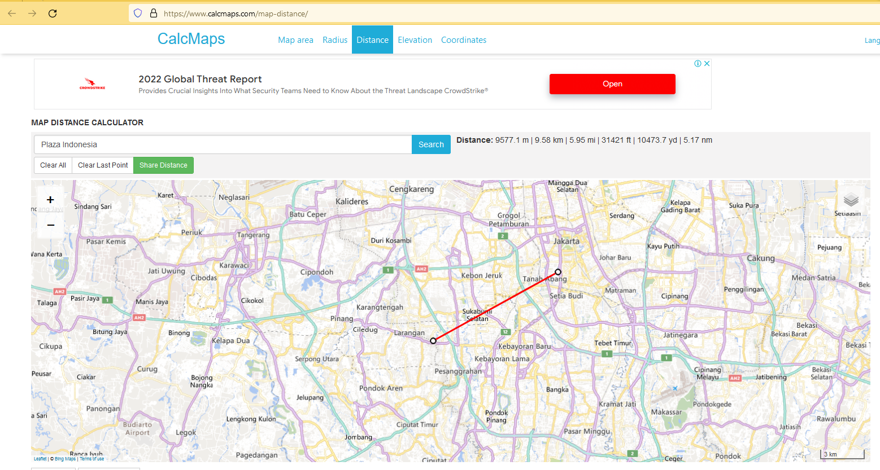

From my location to Plaza Indonesia is approximately 9577.1 m or 9.58 km

Firebase Data after click Convert Text button.

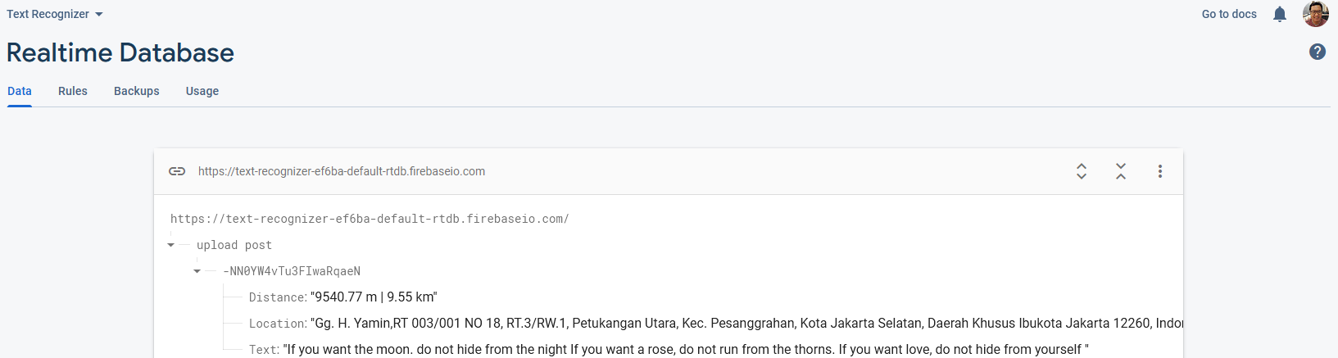

Note:

I can't display travel duration data from Plaza Indonesia to the location where the picture was taken because this feature must use Google's API (Paid)