*Arabidopsis thaliana* Distributions

**Current:**

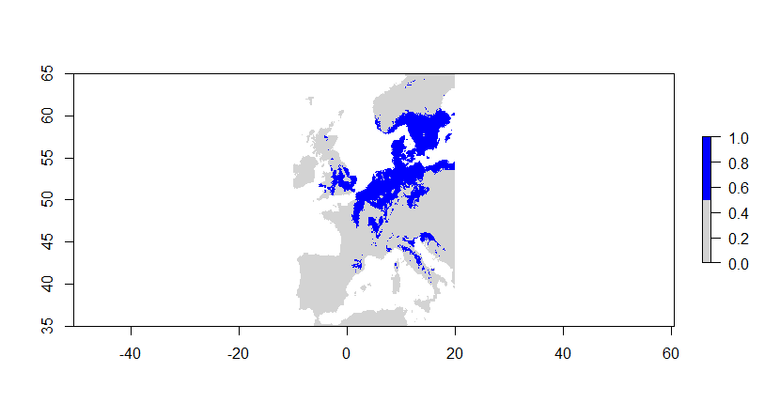

**Future:**

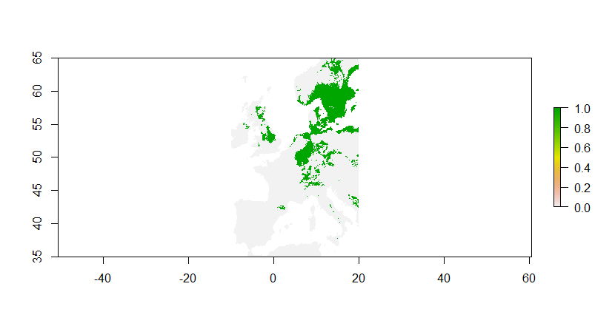

According to the current species distribution, *Arabidopsis thaliana* tends to be more spread throughout Europe. There seems to be more random patches throughout Europe, as well as large portions of land with lots of the plant present. According to the future distribution, however, some of the more random patches of *Arabidopsis thaliana* tend to occur less often. It also appears that the major portion of where the plant is distributed seems to be shifting north. While there are still some present in central Europe, *Arabidopsis thaliana* seems to be shifting toward Sweden and Norway. In the current distribution, there also seems to be some of these species present in Italy, while the future distribution predicts that there will not be many more present in Italy. There also seems to be less *Arabidopsis thaliana* present in the United Kingdom in the future distribution than the current distribution. There may be a few possible reasons for this shift north. One of the reasons may involve global warming. Due to this warmer weather, the plant may have an easier time living further up north. Plus, *Arabidopsis thaliana* tends to spread much easier than other plants. This is the reason that there were so many random patches throughout Europe in the current distribution. Some people may carry this to different parts of Europe without knowing it, and then it will begin to spread. The current distribution may also have some bias to it, as more people may be observing it at certain locations more than others. This would explain why there may be more of the species at one location rather than another. The future distribution may be adjusting for this bias by shifting the species more toward northern Europe. So, these species distributions show a general shift towards northern Europe instead of central.