Nikita Persikov
ASTE 404
HW13

Part 1:
Part f:
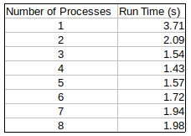

part i:
Here is a screenshot of the default output:
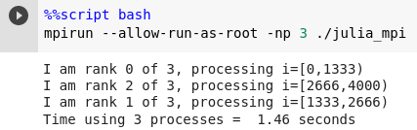

Here is a screenshot of the output with the additional code:
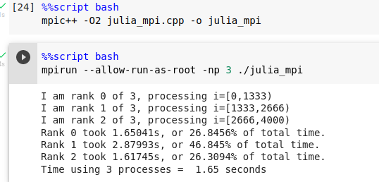

Sceenshot of the output from the code which use MPI communication:

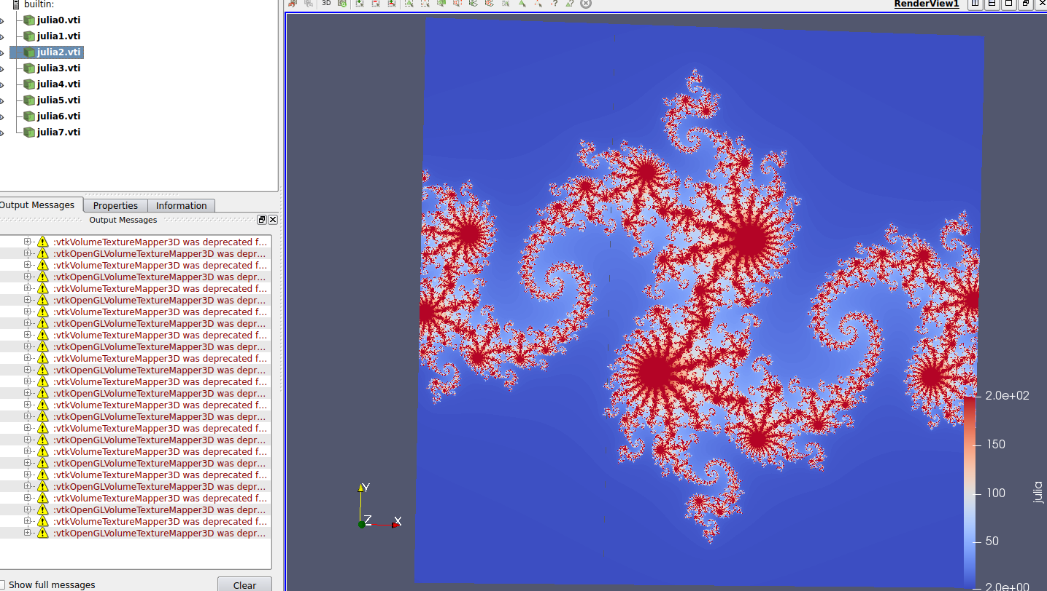

Part 2:
Part a:
Screenshot of GPU confirmation:
