ASTE 404
HW 4
Nikita Persikov
9/16/2021

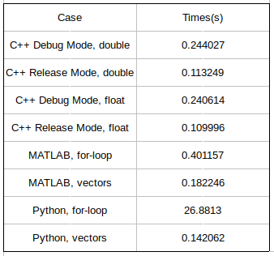
Part 1:

Part 2:
a) On line 4, r is being set to 2*x +y. On the line before, r is defined as a reference to x, which means line 4 is actually setting a value to variable x through its reference r. Therefore, the value of x is 2*1.2+4, which is equal to 6.4.

b) The function init() just takes the values of a and b and does things with them, but does not change the very variables themselves. Therefore, c will just be the sum of the default double values, which is 0+0=0. For c to equal 3, a and b can be declared in the same scope as the functions like this:

double a, b;
void init() {
a = 2; b = 1;
}

This way, when init() is run in main() (without arguments), a and b will actually be set and c will become 3.

c) In this case, the addresses of a and b are passed to init, which uses them as pointer variables. When a and b are set in init(), the variables at those memory locations are modified, so when c is calculated, it uses the same values since it pulls them from the same memory address. Therefore, c is equal to 3.

d) In this case, init() takes in the variables and treats them not as pointers, but as memory addresses, which the pointers in part c were set equal to. Since the values are applied to the variables at the input memory addresses, the variables updated in init() are in the same memory location as the ones in main(). Therefore, c will again be 3.

Part 3:

