ASTE 404
HW6
Nikita Persikov

Problem 1 (a-d):

Parts a, c, and d do not work. Part c results in a compile-time error. Part b works.

Problem 2:

a) The vector appears to double in size when it runs out of space.
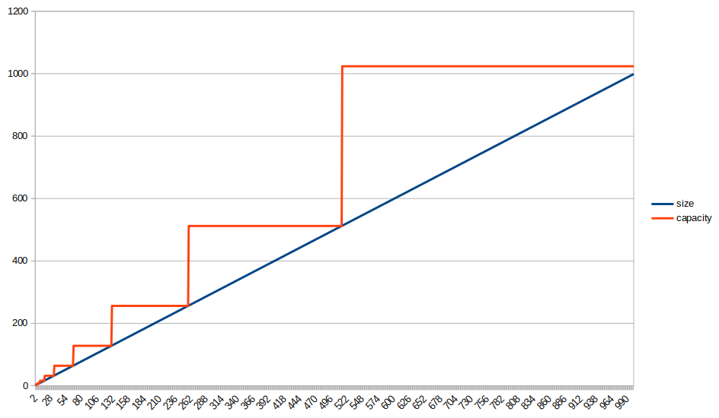
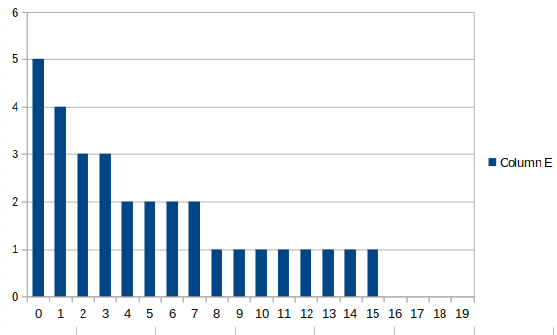
c)

Problem 3

a) My program is called a.out. This screenshot shows the really high memory use.

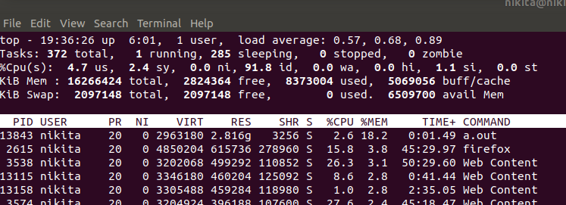
b) Using the destructor, this is now the peak memory usage of a.out. Clearly, the memory usage was greatly reduced.

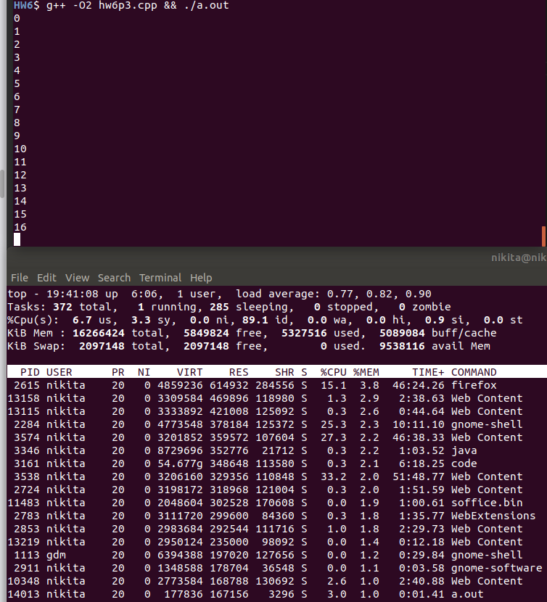

Problem 4:

a)

