ASTE 404
HW#10
Nikita Persikov

Problem 3:

Part a: For this, I used 0.04 for the inlet and 0.1-0.2 (open) for the outlet. The timesteps are 100, 400, 1000, 2000, 5000, 50000 (left to right, top down). The mesh size is 101 by 51.
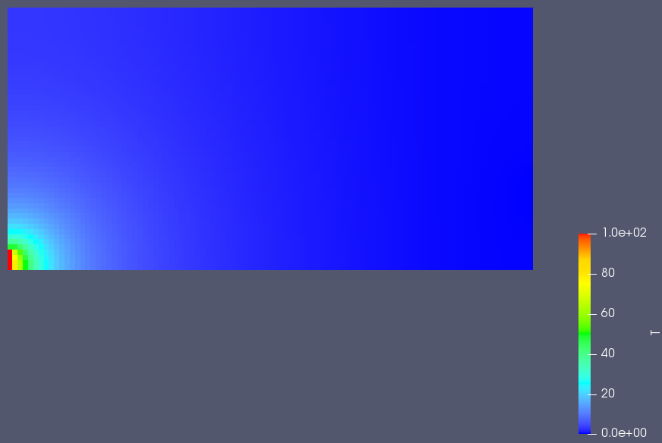
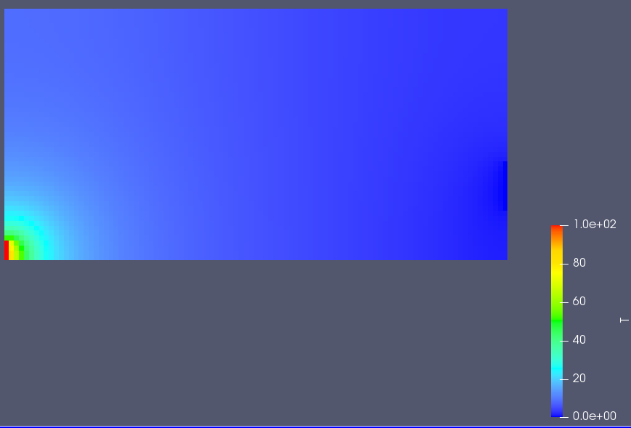
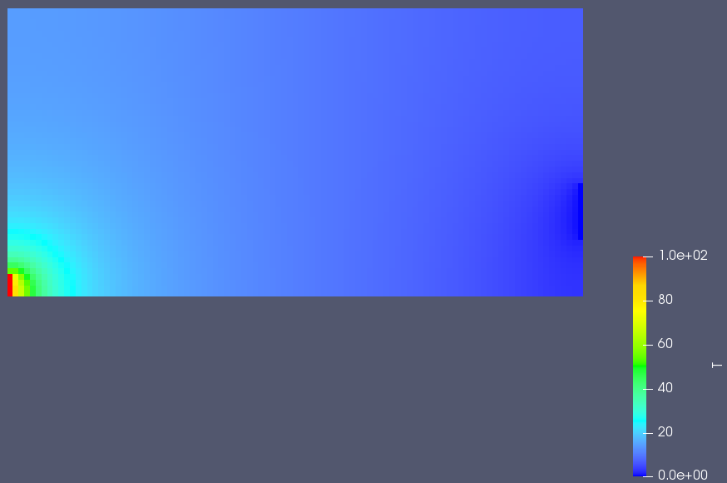
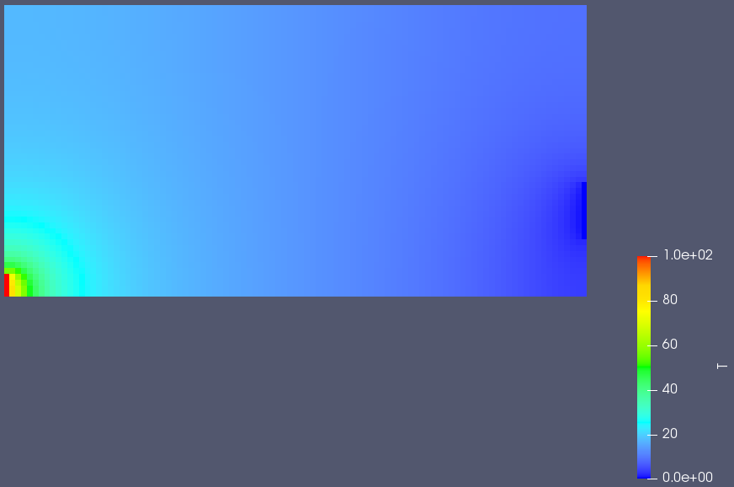
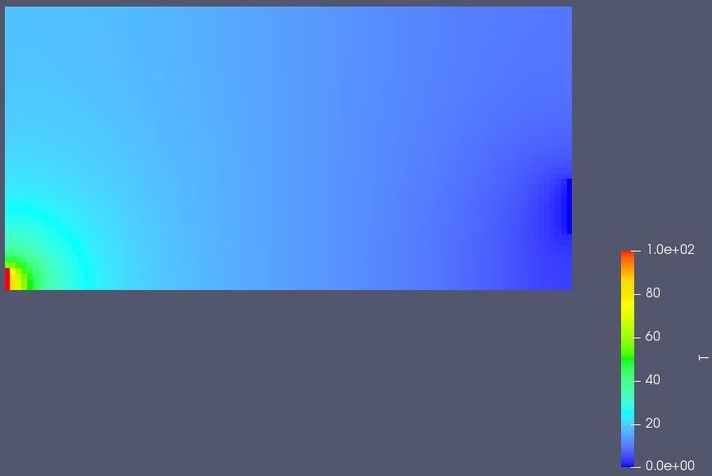
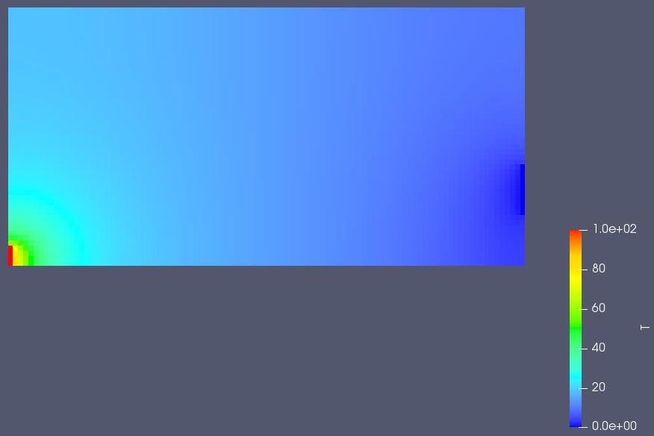

Part b: For this, I used 0.04 for the inlet and 0.1-0.1 (closed) for the outlet. Timesteps are: 1000, 4000, 10000, 20000, 37000. Mesh size is 101 by 51.

