PRO.MA.SI

Development

Table of Contents
1.Purpose 3
2.Overview 3
3.Other languages 3
4.Tools 3
5.Java API's 4
6.External Libraries 4

Purpose
The purpose of this document is to explain what tools,libraries etc are used in PRO.MA.SI so the new developers can study them before they begin contributing to the project.

Overview
PRO.MA.SI is developed with the Java programming language. Java is an open source, cross-platform, object oriented programming(OOP) language. The java language specification can be found Here

Other languages
Except from the Java programming language other languages are used in the PRO.MA.SI those languages are :
- Unified Modeling Language(UML) : The Unified Modeling Language offers a standard way to write a system's blueprints.
- Extensible Markup Language (XML) : XML is often used to describe structured data and to serialize objects.
- XML Path Language (XPath) : XPath is a language for selecting nodes from an XML document. In addition, XPath may be used to compute values (strings, numbers, or boolean values) from the content of an XML document.

Tools
In order to avoid confusion and incompatibility issues PRO.MA.SI uses a standard set of tools. All of those tools are cross-platform so the developers will not be forced to use a specific OS in order to start developing. The tools are open source, free or have a community license so that the developers are not forced to pay for a specific tool. The tools that are used in the PRO.MA.SI project are :
- Eclipse SDK : Eclipse is an open source IDE for developing java applications. It supports many other programming languages and has many plug-ins that help improve productivity. PRO.MA.SI is developed using Eclipse. Home page.
- OpenOffice.org : OpenOffice.org is an open source office suite. All the PRO.MA.SI documents are written in the ISO standard ODF format supported by the OpenOffice.org suite. Home page.
- MagicDraw : MagicDraw is a visual UML modeling tool. MagicDraw has a community license and its one of the best UML modeling tools that fully supports the UML 2.0 language. Home page.
- SVN : SVN is an open source version control system. Currently the PRO.MA.SI source code is managed with SVN. SVN Home page . Eclipse provides plug-ins for SVN it can be found here
- Planner : Planner is an open source program for creating gantt charts.Home page

Java API's
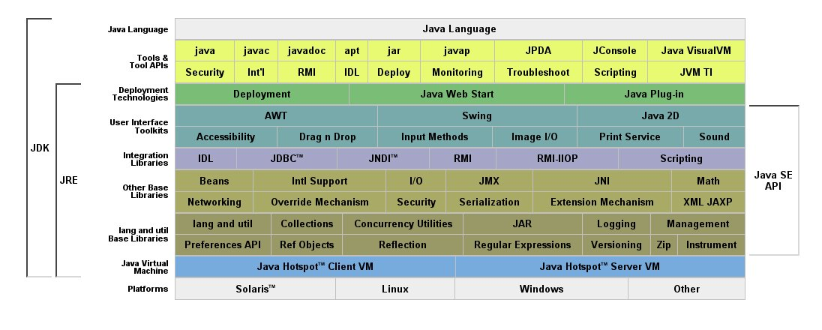
Java has many libraries for doing almost everything. A list of java libraries can be found here http://java.sun.com/javase/6/docs/ . PRO.MA.SI uses the following libraries.
- lang and util, Collections, I/O : Core language libraries.
- Swing, Drag & Drop, Java 2D, Image I/O : Those API's are used in order to create the user interface.
- Zip : Used for handling zip files.
- XML JAXP : Used for handling XML files.

External Libraries
Java has many external languages developed by groups of developers like the Apache Software Foundation or other companies. The libraries used in PRO.MA.SI are open source or free. PRO.MA.SI uses the following libraries :
- Log4j : Log4j is an open source logging library developed by the Apache Software Foundation. Home page
- JEP : JEP is a Java library for parsing and evaluating mathematical expressions. With this package you can allow your users to enter an arbitrary formula as a string, and instantly evaluate it. After version 2.4.1 JEP became a commercial project. PRO.MA.SI uses version 2.4.1 that has a GPL license. Home page
- Commons-Math : Commons Math is an open source library of lightweight, self-contained mathematics and statistics components addressing the most common problems not available in the Java programming language. Home page
- JFreeChart : JFreeChart is a free 100% Java chart library that makes it easy for developers to display professional quality charts in their applications. Home page
- Jasper Reports : Jasper reports is an open source reporting engine. Home page
- MigLayout : Open source layout manager for swing and SWT. Home page
- Joda-Time : Joda-Time provides a quality replacement for the Java date and time classes. Home page
- Commons-Digester : Many projects read XML configuration files to provide initialization of various Java objects within the system. There are several ways of doing this, and the Digester component was designed to provide a common implementation that can be used in many different projects. Home-page
- Commons-betwixt : The Betwixt library provides an XML introspection mechanism for mapping beans to XML in a flexible way. Home-page

