PRO.MA.SI

Introduction

Table of Contents
1 Purpose 3
2 Introduction 3
3 Project Management 3
4 Simulators 3
5 System Dynamics 4
6 PRO.MA.SI 4
6.1 Single player Scenario 4

Purpose
The purpose of this document is to give an idea about what is PRO.MA.SI.

Introduction
PRO.MA.SI stands for Project Management Simulator. The purpose of the Promasi is to train new project managers and prepare them for what they are going to face. Promasi uses a system dynamics like language, in order to achieve the simulation of a project.

Project Management
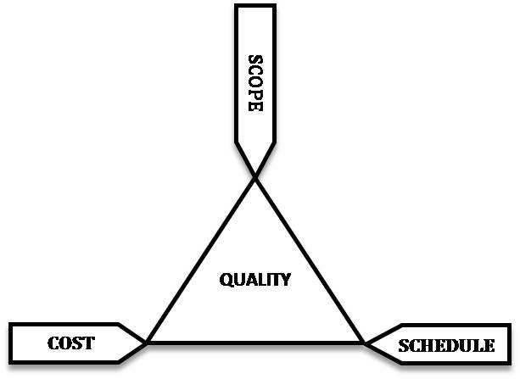
What is project management and why we need project managers? By definition project management is a set of well-defined methods and techniques for managing a team of people to accomplish a series of work tasks(project) within a well-defined schedule and budget. Project manager is responsible for the quality of the product. In order to achieve high quality, the project manager has to “play” with the cost,time and\or the features of a project. These are also referred to as the "Project Management Triangle," where each side represents a constraint. One side of the triangle cannot be changed without affecting the others. A further refinement of the constraints separates product "quality" or "performance" from scope, and turns quality into a fourth constraint.
The time constraint(schedule) refers to the amount of time available to complete a project. The cost constraint refers to the budgeted amount available for the project. The scope constraint refers to what must be done to produce the project's end result(features). These three constraints are often competing constraints: increased scope typically means increased time and increased cost, a tight time constraint could mean increased costs and reduced scope, and a tight budget could mean increased time and reduced scope.
The discipline of project management is about providing the tools and techniques that enable the project team (not just the project manager) to organize their work to meet these constraints. Another approach to project management is to consider the three constraints as finance, time and human resources. If you need to finish a job in a shorter time, you can throw more people at the problem, which in turn will raise the cost of the project. In that case the Brook's law must be taken into account : “adding manpower to a late software project makes it later”. Those 3 factors differ in every project, in order for the project manager to achieve the best possible result he must have experience with many different projects. There are techniques\methods that help the project manager but still experience is an important factor.

Simulators
Simulator is a software program that imitates a real thing. Many simulators exist such as flight simulators, military simulators etc. The purpose of a simulator is to train , for example a pilot, without risking any real damage, if the pilot crashes the plane in a simulation its ok because that pilot will learn from his mistake, this will give the pilot enough experience to be able to flight a real plane. The same goes for project management simulators they give experience to project managers so that they can handle real life projects without risking the company they work for.

System Dynamics
System dynamics is a powerful methodology and computer simulation modeling technique for framing, understanding, and discussing complex issues and problems. For more information about system dynamics see Wikipedia.

PRO.MA.SI

Single player Scenario
When the game starts the user takes the role of the project manager in a new company. The company receives it's first project, the details of the project(description,start\end date,budget) are given to the project manager. Since the company is new there are no available employees, so the project manager reads CV's of some people and decides, based on their salary and skills, who will be hired. The project manager has to schedule the tasks of this project, lets assume that the project has the following tasks :
- Take requirements
- Write Code
- Test Code
The project manager decides that for the first 3 days he will put 2 employees to take the requirements for this project. After that another 10 days will be spent to write the code and 3 days to test the code. The project starts, the employees are working on their assigned tasks and after 12 days the client wants more features for the project. The project manager stops all ongoing tasks and puts 2 people for 2 days to take the requirements and then all of the employees start writing code for 5 days and test the code for 3 days. The project manager sees that with this schedule the deadline is not sufficient, so he removes 2 days from writing code and 1 day from testing. The day for the delivery of the project has come, the project is evaluated and the company gets 6 out of 10 points, because the project manager did not spent many days for testing. The company receives another project and this goes on until all the levels are finished.

