OpenForum.be
2015-2016
A meeting and discussion place about the Open : open source, open society, open data, open education, open innovation ...

Every second Thursday of the months from October to June (except school holidays) from 18:30 to 21:30 at the University Foundation,
rue d'Egmont 11, 1000 Brussels. The first hour is a conference.

October 8 Open Source in Healthcare by Sébastien Jodogne
November 12 Open Education by Yves Deville & Olivier Bonaventure
December 10 Open population data for human and animal health
by Marius Gilbert & Catherine Linard
Éditeur responsable : Nicolas Pettiaux, avenue du Pérou 29, 1000 Bruxelles – Version du 28/11/2015
January 14 Open Innovation as seen in a bank by David Dab

March 10 Open Access, why is it significant for Society ?
by Bernard Rentier

April 14 Open Data & Copyright Reform by Peter Murray-Rust

May 12 Open Publications & Researchers Evaluation
by Pierre-Louis Lions (*)

June 9 Open Scientific Culture by Jean-Claude Guédon

Information & mandatory registration http://openforum.be

With the support of the University Foundation

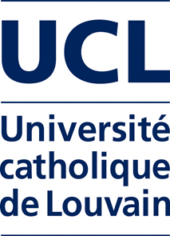
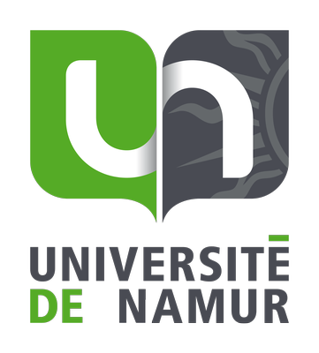

École supérieure d'informatique

Avec le soutien financier de la
Fédération Wallonie-Bruxelles

Organisation
Nicolas Pettiaux,
École supérieure d'informatique (ESI) & Université libre de Bruxelles (ULB)
Yves Poullet,
Université de Namur (UNamur)
Bernard Rentier, Université de Liège (ULG)

