Task -8: Java Introduction

1.Greatest of sum of two Integers

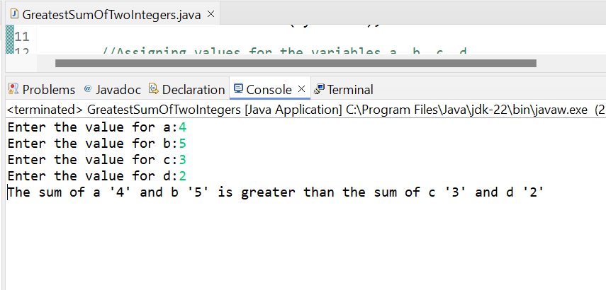

2.Even number

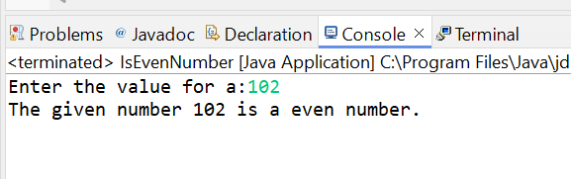

3.Print A to Z

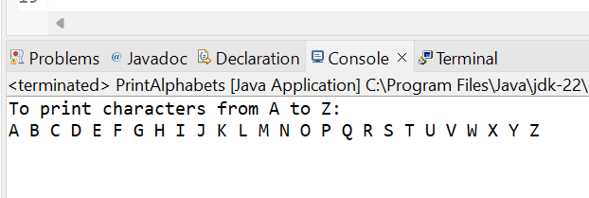

4.Swap 2 Numbers

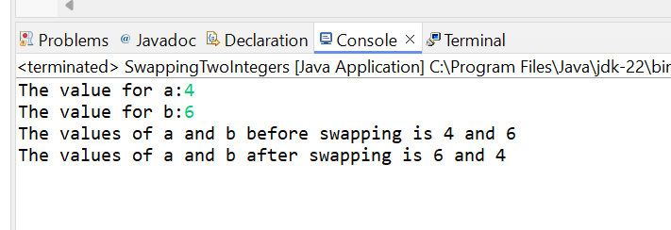

5.Prime Number

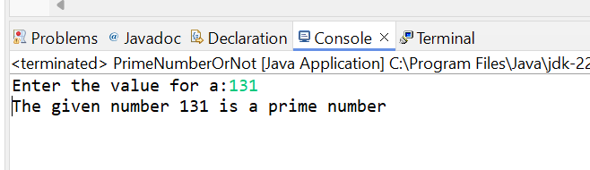

6. Factorial

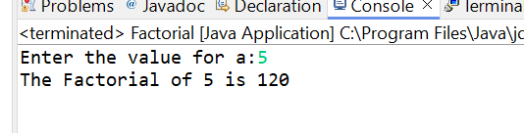

7. String Length

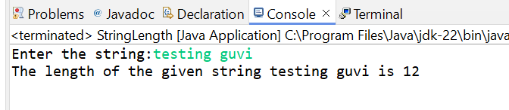

8. Print Welcome to GUVI

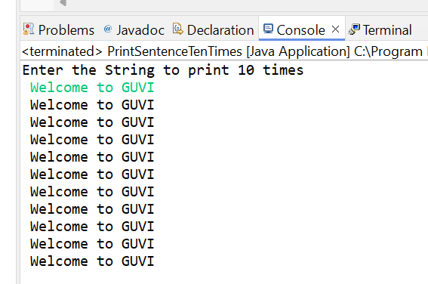

9. Senior Citizen

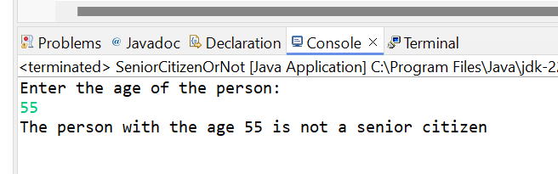

10.Count number of digits in the integer

