Task-9 Java

1.Palindrome

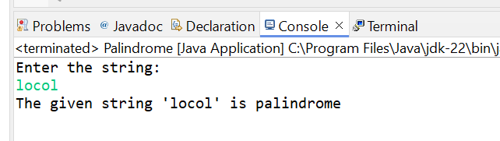

2. Reverse String

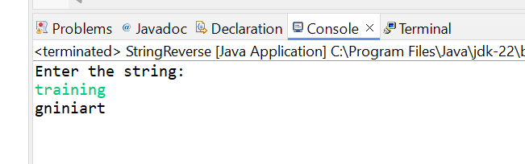

3.Number Pattern

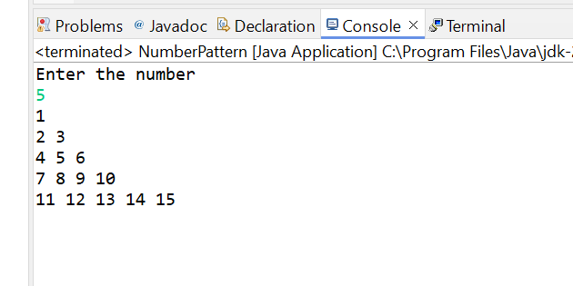

4. Star Pattern

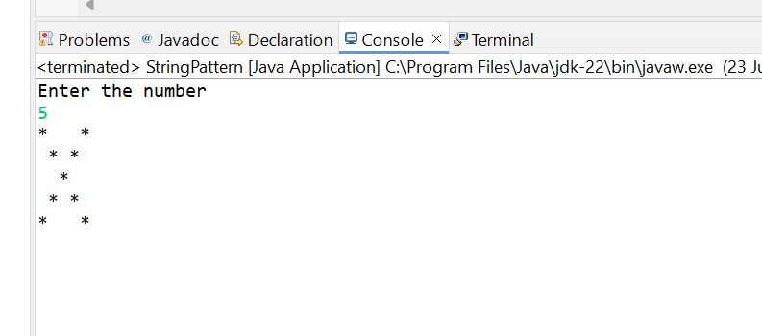

5. Grading System

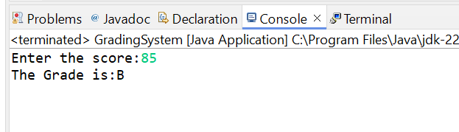

6. Hotel Tariff

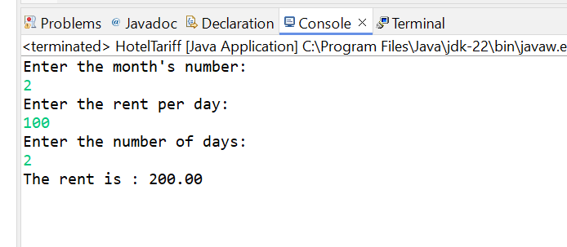

7. Largest of 3 numbers
