**Task-10 Java OOPS**

1. **Person Class, TaskOne Class**

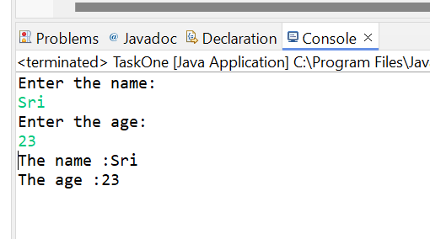

1. **Employee Class**

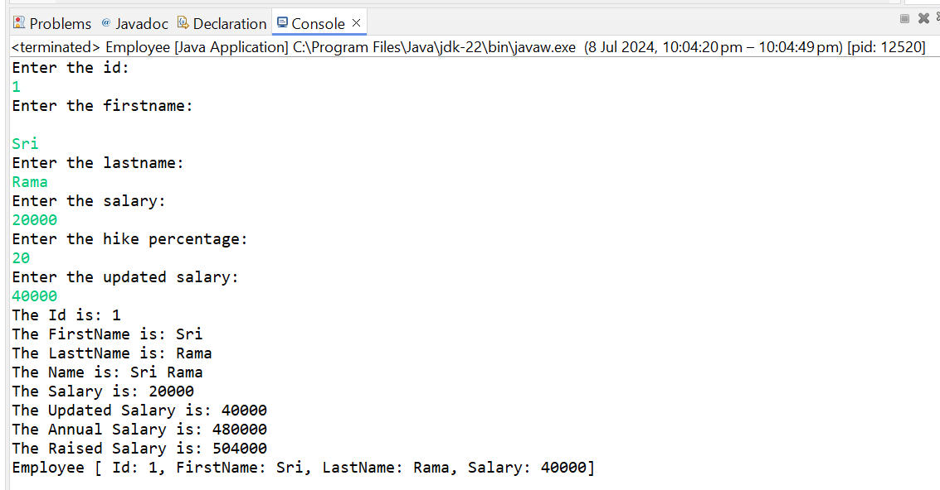

1. **Circle Class**

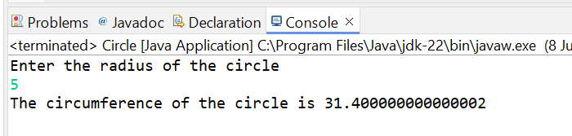

1. **Account class**

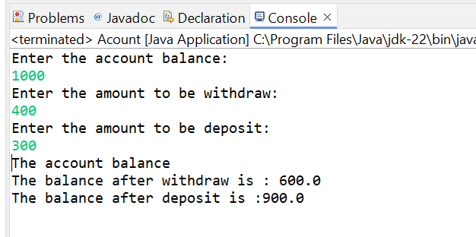

1. **Tea class**

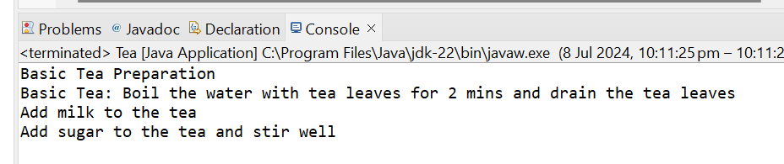

1. **Subclasses of Tea class: BlackTea class, HerbalTea class,GreenTea class**

**Black Tea**

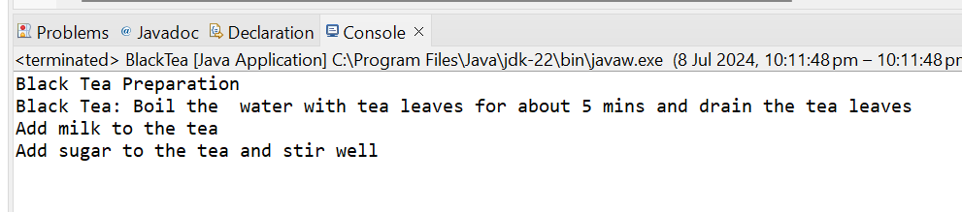

**Herbal Tea**

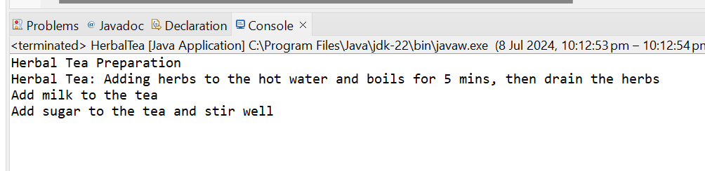

**Green Tea**

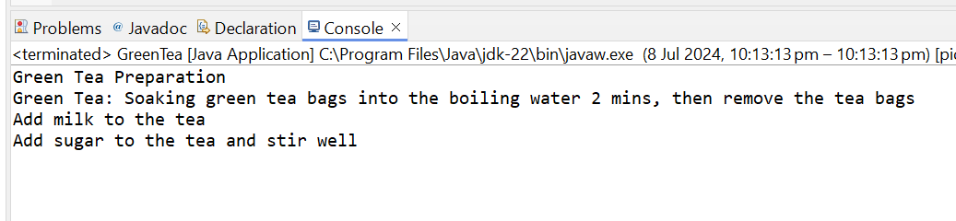

1. **Array of Objects - Tea Class, BlackTea class, HerbalTea class,GreenTea class**

