**Task -12 :Collection And Packages**

1. **Packages : com.example.hrtest ,com.example.hr**

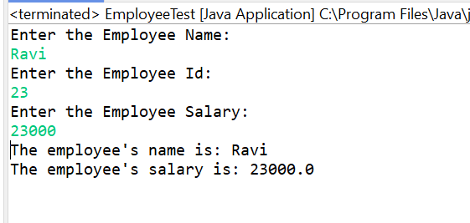

1. **ArrayList of String**

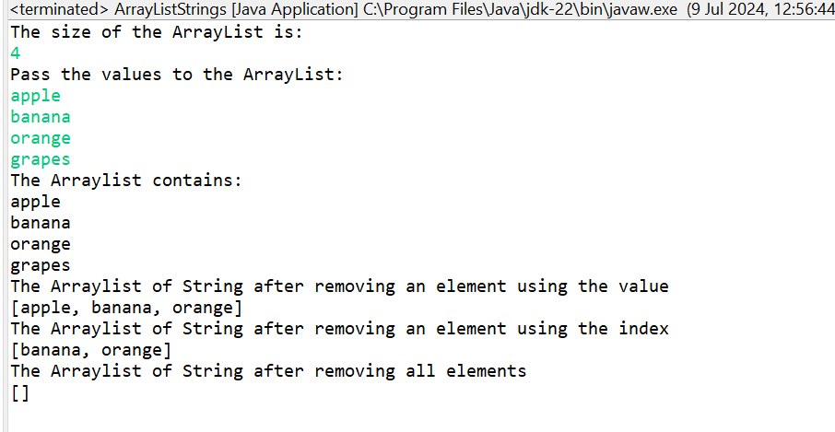

1. **Sort TreeMap**

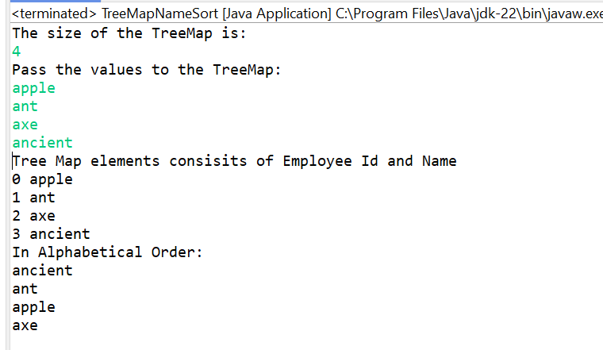

1. **Convert List to Array**

