**Task -8: Java Introduction**

**1.Greatest of sum of two Integers**

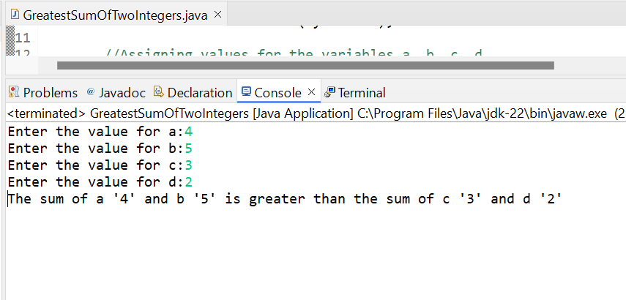

**2.Even number**

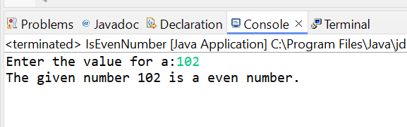

**3.Print A to Z**

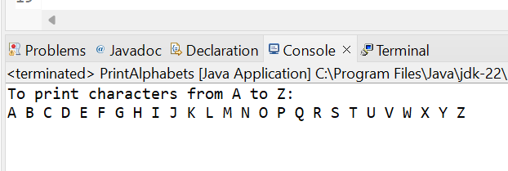

**4.Swap 2 Numbers**

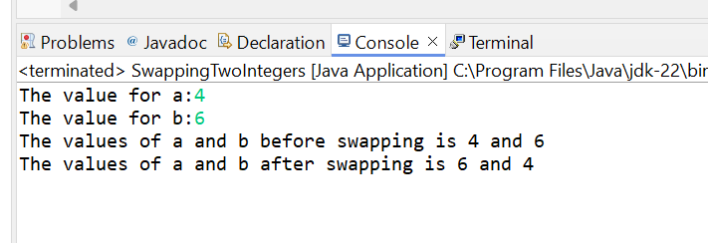

**5.Prime Number**

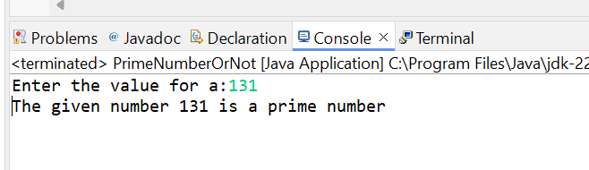

**6. Factorial**

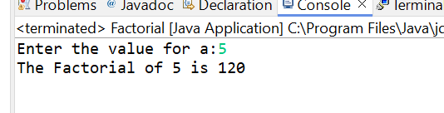

**7. String Length**

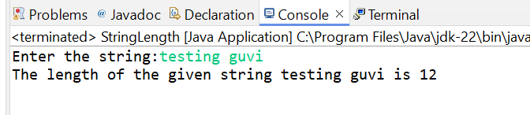

**8. Print Welcome to GUVI**

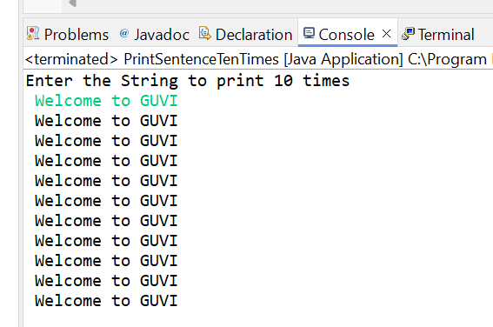

**9. Senior Citizen**

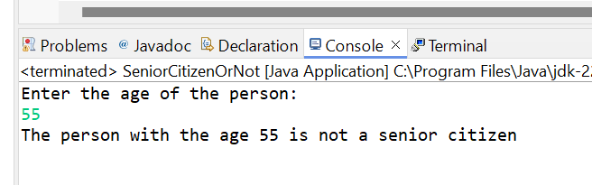

**10.Count number of digits in the integer**

