**Task-9 Java**

**1.Palindrome**

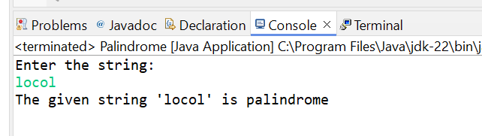

**2. Reverse String**

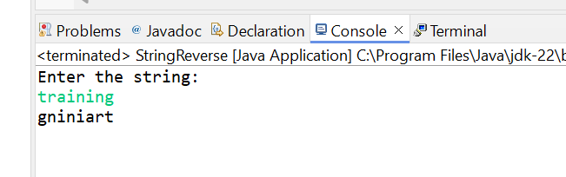

**3.Number Pattern**

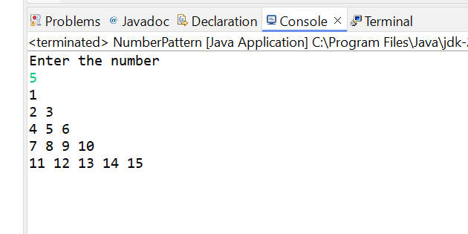

**4. Star Pattern**

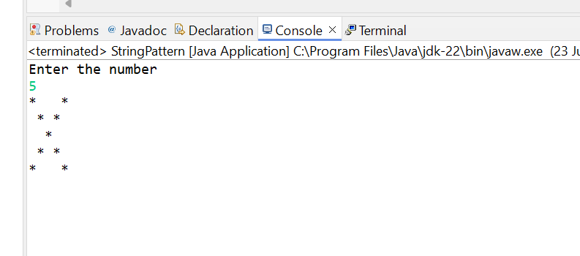

**5. Grading System**

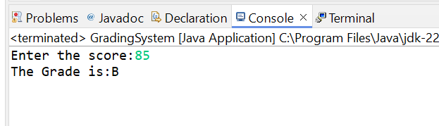

**6. Hotel Tariff**

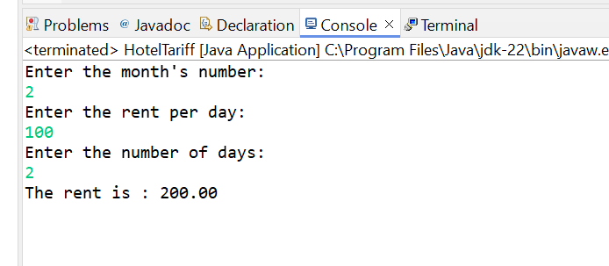

**7. Largest of 3 numbers**

