**Task -17 Selenium Web Components**

1. **Snap deal**

**Coding**

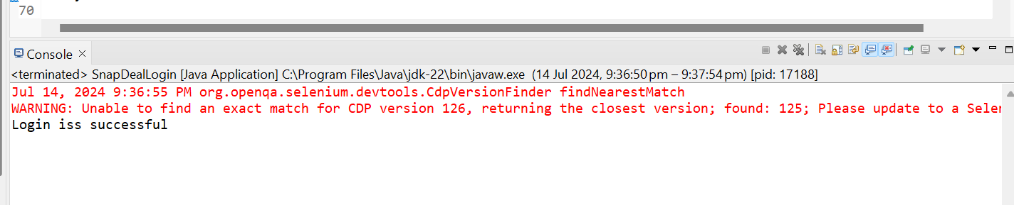

**Browser**

