**Task -16 Selenium Locators**

1. **Firefox Browser - Google URL**

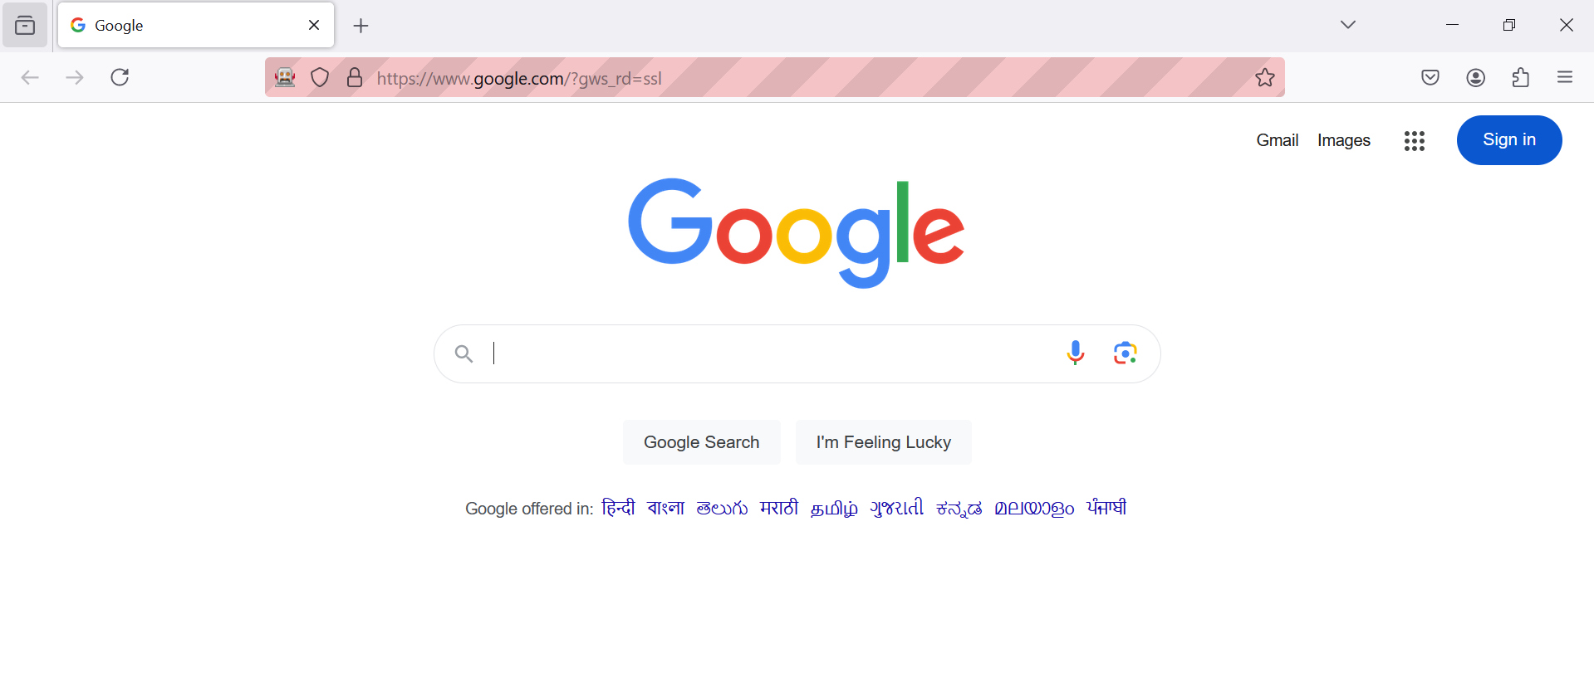

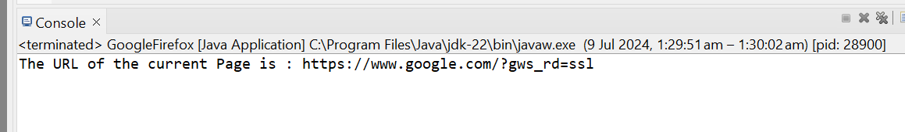

1. **Chrome Browser - Demo Blaze URL**

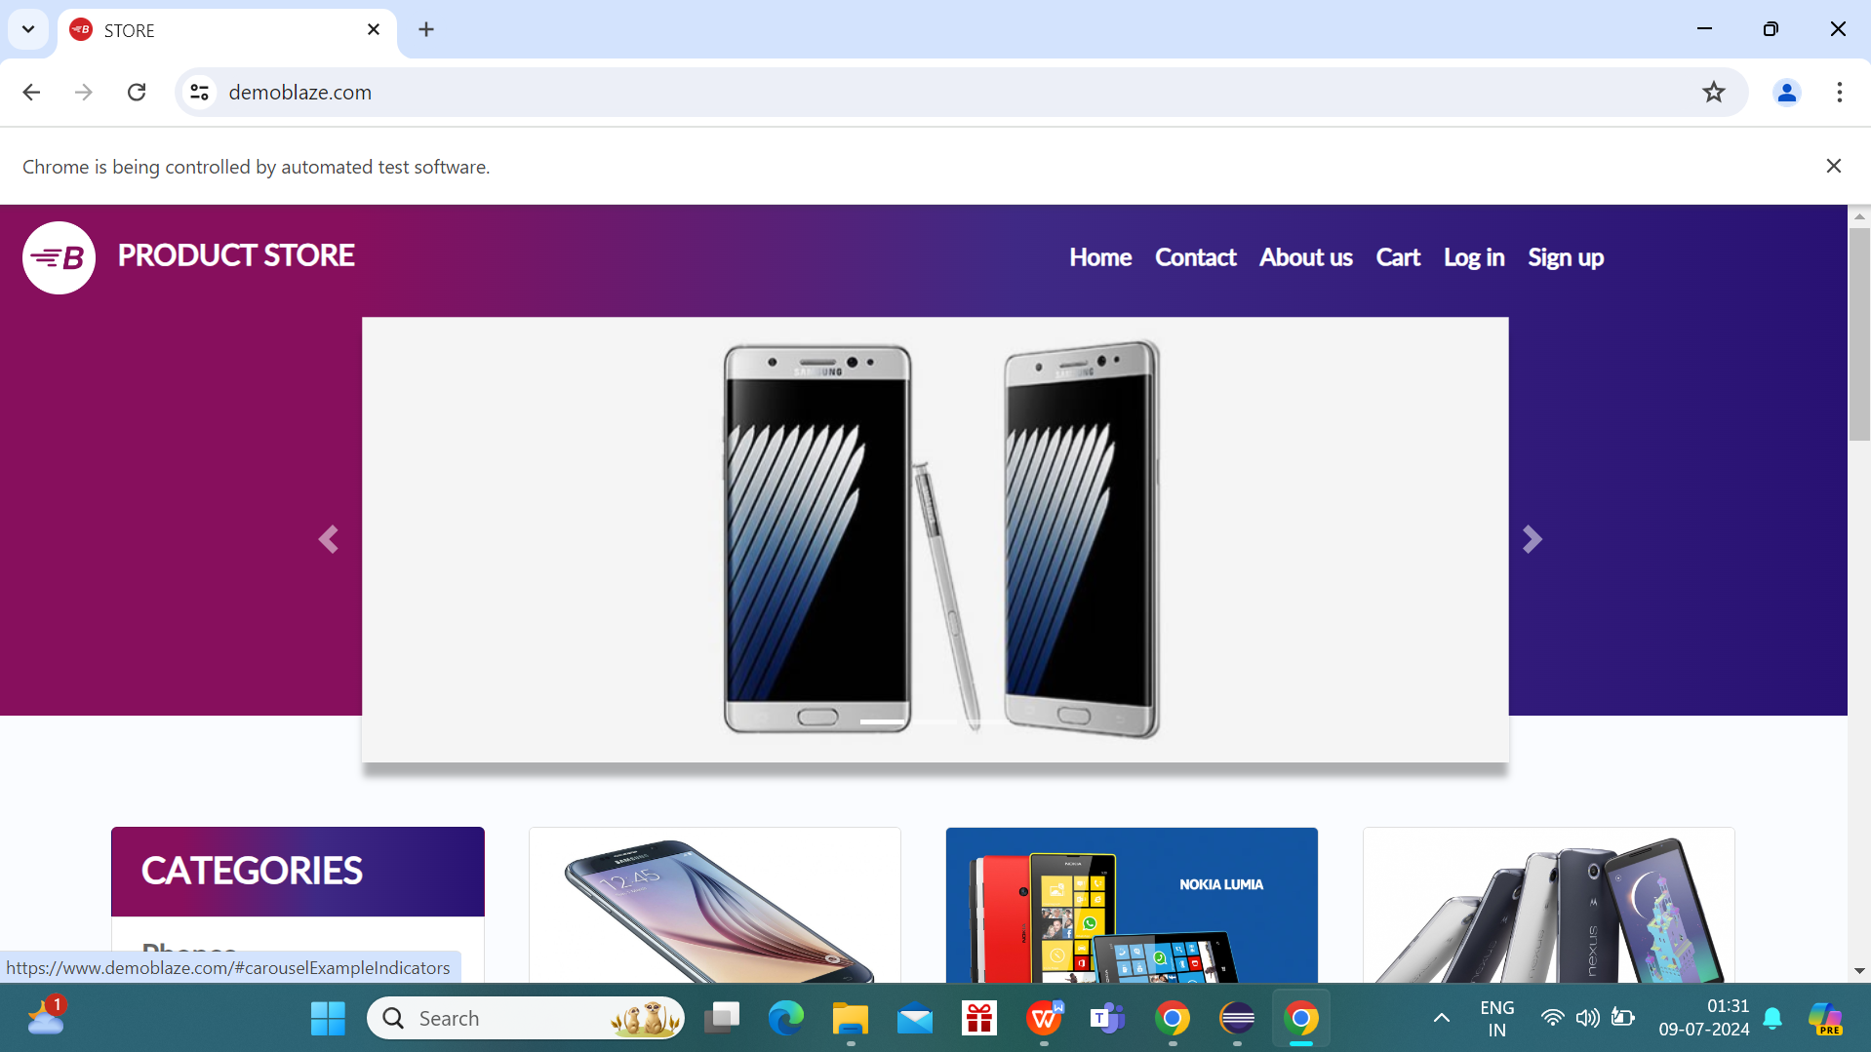

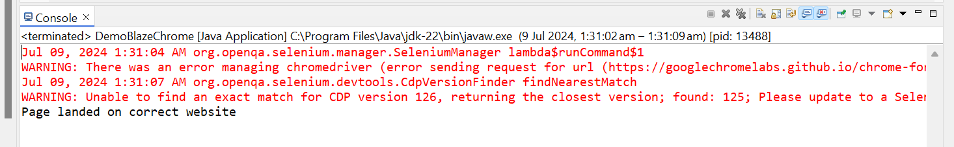

1. **Chrome Browser - Wikipedia**