**Task-23: MySQL**

1. **Empl table**

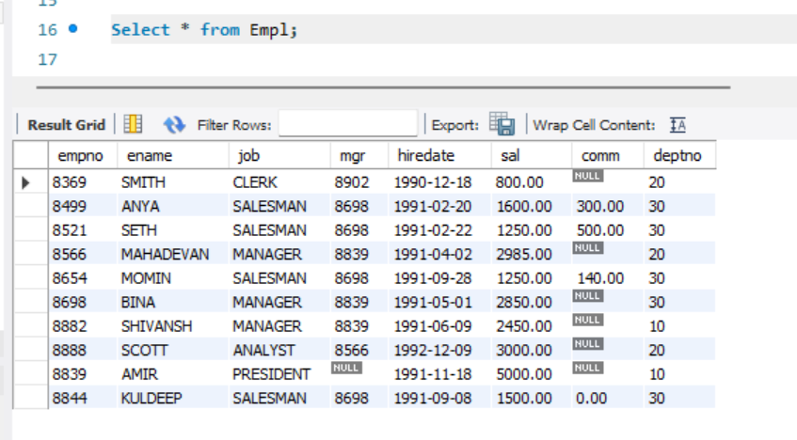

1. **Display Employee Name and Salary where Salary is greater than or equal to 2200**

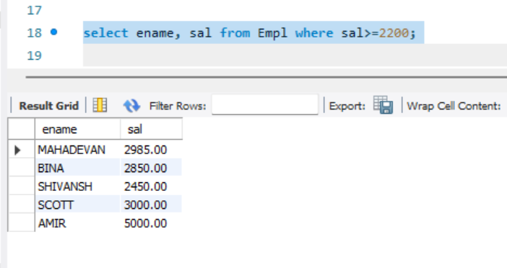

1. **Display Employee Details who are not getting commission**

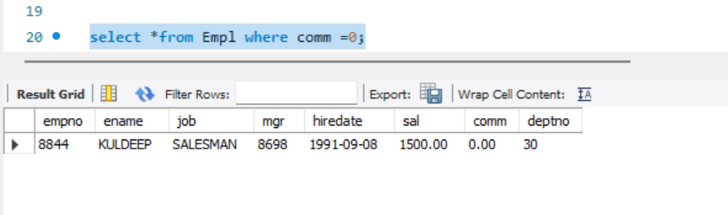

1. **Display Employee Name and Salary where the salary is not in the range of 2500 to 4000**

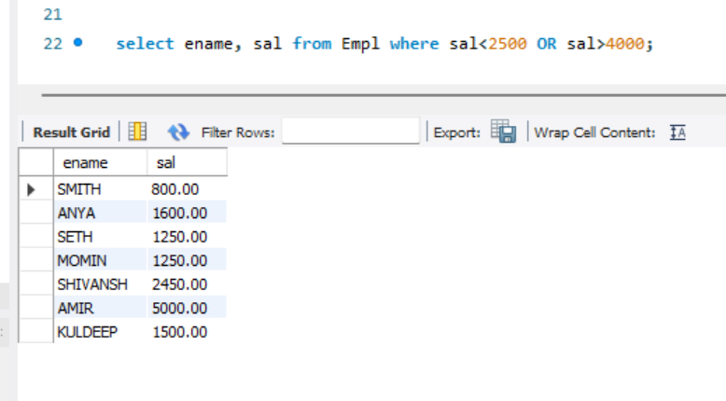

1. **Display Employee Name, Job Title and Salary who doesn’t have a manager**

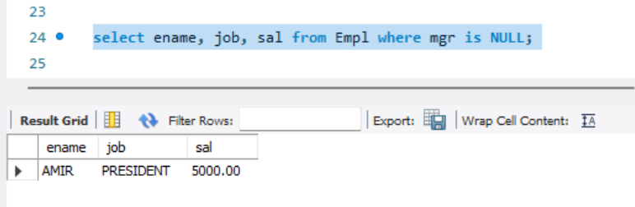

1. **Display Employee Name where Employee Name has Alphabet A in the third position**

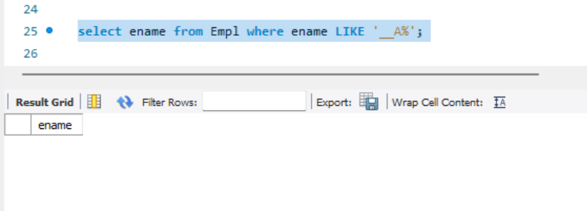

1. **Display Employee name whose name ends with T**

