**Task:21 - Selenium Windows and Frames(Class-26)**

1. **Window Handling**

**Link:** <https://the-internet.herokuapp.com/windows>

**Execution Screenshot**

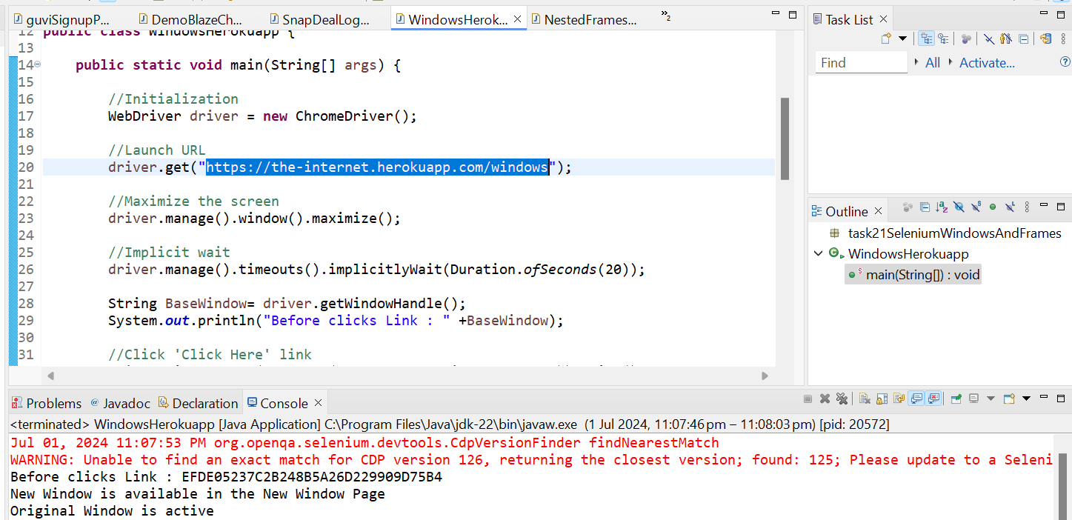

1. **Frames**

**Link:** http://the-internet.herokuapp.com/nested_frames

**Execution Screenshot**

