Variables:

Let *I*be the set of Days [0,1,...4]    (Days of the week {Mon, Tues, Wed, Thurs, Fri})

Let *Ji*be the set of Sessions in Day *i* [0,1,...16]    (2-hour sessions {08:00-10:00, 8:30-10:30, ... 16:00-18:00})

Let *K* be the set of Tracers [0,1,...3]    (Names of Tracers {PIB, AV1451, MK6240, UCB-J})



Hard Constraints:

Only one Tracer per Session of a Day



At least 1 Session per week for each Tracer (Could be increased or changed to increase # of individual tracers)



Unfortunately, my I am still lacking in the training to accurately model the other constraints in equations but have tried.  I have modeled these constraints in Python and here are their corresponding equations:

PIB (*k*=0) for Days (Tues-Fri; *I=*[1...4]) can have as many as 3 scans per day

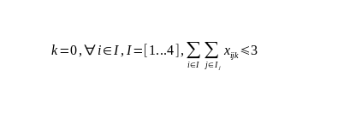

PIB (*k*=0) for Mon (*I=0)* can have as many as 1 scan per day

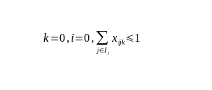

AV1451 (*k*=1) for all Days can have as many as 3 scans (per week)

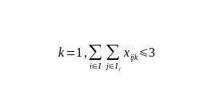

MK6240 (*k=2)*for all Days can have as many as 3 scans per day

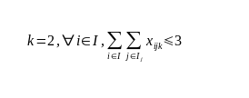

UCB-J (*k*=3) for all Days can have as many as 1 scan per day

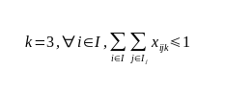

for all Sessions, for all Days, for all Tracers, time slots must not overlap so the sum of each Session and the next 3 must only be at most = 1

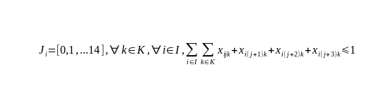

Unwritten Constraints but implemented in Python:

AV1451 (k=1) for all Days[0,1,...4], for all Sessions, must have a 24-hour gap between AV1451 sessions

AV1451 (k=1) for all Days, must not be scheduled before 12:00

PIB (k=0) for all Days, for all Sessions[0,1,...12], must have a 3-hour gap between PIB sessions

MK6240 (k=2) for all Days[1,2,...4], can only be scheduled for Sessions[10,11,...16]

MK6240 (k=2) for Mon (i=0), can only be scheduled for Sessions[8,9,...13]

UCB-J (k=3) for all Days[1,2,...4], can only be scheduled for Sessions{6,12}

UCB-J (k=3) for Mon (i=0), can only be scheduled for Sessions{14}

Let omega be the set of all solutions satisfying all hard constraints:

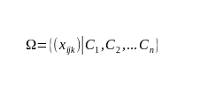

Objective Function: Sum of all binary integers

