**Pre-requisite:**

1. Install eclipse, Selenium Standalone Server, Apache poi jar files, chrome driver.

**Set up:**

1. Place the ‘WOW Bulk Upload’ folder in the C drive.
2. Place the chrome driver(.exe) in ‘WOW Bulk Upload’ folder.
3. Right click on the ‘Project Explorer’ window, select Import--> Import-->Browse ‘Wow Bulk Upload’ folder. Click ‘Ok’

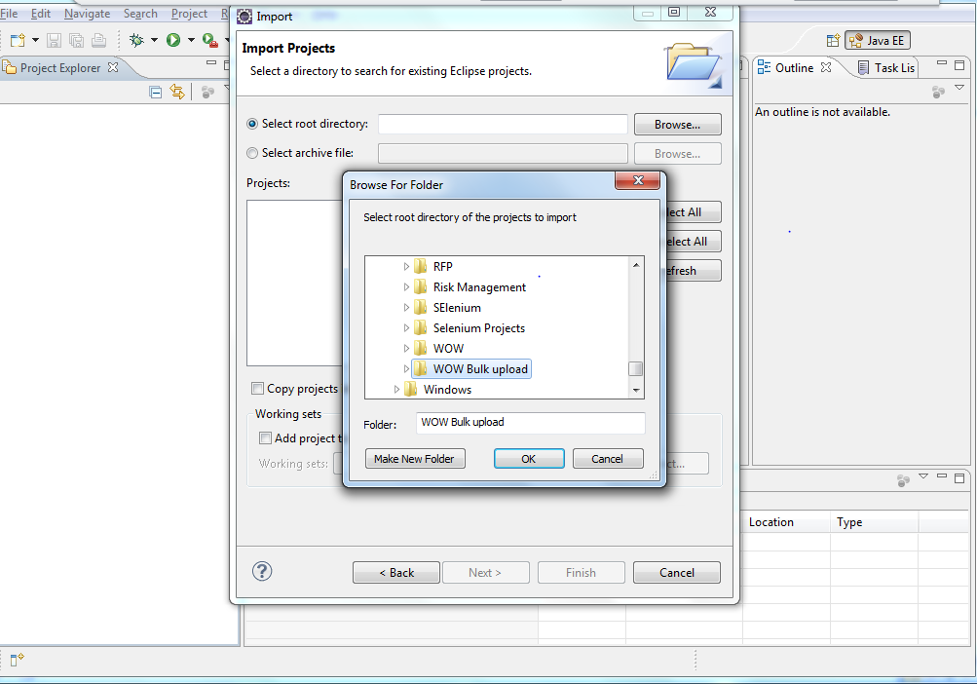

1. If error comes in the project folder,
   1. Right click on project folder and select properties-->Java build Path---> Libraries--> Remove all the jar files except **JRE System Libraries.**
   2. Click on ‘Add External Jars’ and open ‘Wow Bulk Upload’-->’Jars’ folder. Select all the jar files in each folder.

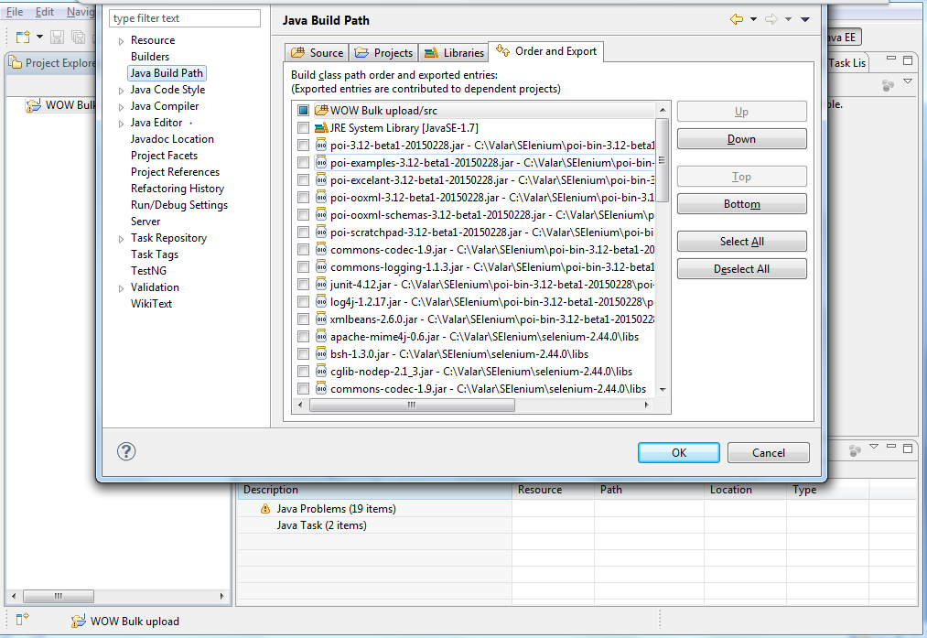

1. Ensure the downloaded Test data sheet from Share point should be placed in **WOW Bulk Upload\src\testData** and updated as below
2. For pillar of the Month rename the sheet as “WOW_Pillar_Awards” and format is “.xlsx”, rename the Sheet name as “WOW_Pillar_Nominations”.
3. Create the last column in the sheet as “status”.
4. Select all the data in the sheet and change the format as Text.
5. For pillar of the Month rename the sheet as “WOW_Pride_Awards” and format is “.xlsx”, rename the Sheet name as “WOW_Pride_Nominations”.
6. Create the last column in the sheet as “status”.
7. Select all the data in the sheet and change the format as Text.
8. Now the set up is done. Select the ‘Pillar_of_the_Month’ or ‘QEA_Pride’ java files under “wowautomation” and click on Run. Ensure the Test data excels are closed prior to run.

**Script Work Flow:**

1. Enter user id and password in the pop up screen once the user prompts to enter. The pop up waits for the user to provide the credentials.
2. Once run completes, verify the ‘status’ column in the test data excel sheet(WOW_Pillar_Awards or WOW_Pride_Awards)for the status.
   1. ‘Uploaded’ for valid ids within the BU and justifications with the correct character limit.
   2. ‘Not uploaded due to max length’ for the valid ids and with character length beyond the limit.
   3. ‘Not Uploaded because associate is outside SBU’ for those ids not in the current BU.
   4. ‘Not Uploaded due to insufficient criteria’ for those valid ids with less than 2 Criteria.
3. For the ‘Not uploaded’ ones, manual entry should be done.