Understanding & Using GitHub

Over 30,000 companies in the US use Github because it easily allows teams to collaborate and create a history of changes that occur over time in their code (Version Control). There is a good chance you will be applying to a company and working on a team that Push/Pulls code via Git or another Version control System.

Similar to LinkedIn, there is a positive risk-reward for those who strategically utilize Github for their job search. While mostly used for code collaboration and open source code development, as a Job Seeker we can leverage the 9+ million users and the many Github repositories to elevate our job search. LinkedIn is a global mosh-posh of the professional networking community--Github’s community is almost strictly developers and data scientists. Here are some tools to help you get started:

✔️[Step-by-step guide for getting started in GitHub](https://product.hubspot.com/blog/git-and-github-tutorial-for-beginners" \t "_blank)

✔️[The programmers cheat sheet](https://github.com/mtdvio/every-programmer-should-know" \t "_blank)

[✔️What employers look for on your GitHub profile](https://techbeacon.com/app-dev-testing/what-do-job-seeking-developers-need-their-github)

[✔️](https://techbeacon.com/app-dev-testing/what-do-job-seeking-developers-need-their-github)Be sure each GitHub repo that is connected to a project on your resume has a visual (GIF or screenshot) in the ReadMe section. Check out this [example](https://github.com/timwis/vizwit" \l "readme" \t "_blank)

[✔️](https://techbeacon.com/app-dev-testing/what-do-job-seeking-developers-need-their-github)Your goal should be to continuously commit to GitHub (first example below) and to not having large gaps in your contributions (second example below), this shows employers your dedication to continuously learning

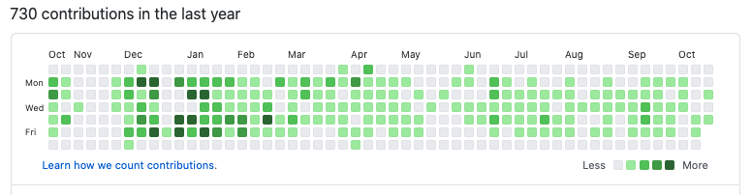

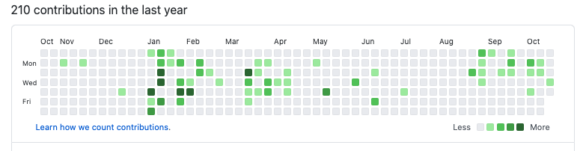

Understanding & Using GitHub

Over 30,000 companies in the US use Github because it easily allows teams to collaborate and create a history of changes that occur over time in their code (Version Control). There is a good chance you will be applying to a company and working on a team that Push/Pulls code via Git or another Version control System.

Similar to LinkedIn, there is a positive risk-reward for those who strategically utilize Github for their job search. While mostly used for code collaboration and open source code development, as a Job Seeker we can leverage the 9+ million users and the many Github repositories to elevate our job search. LinkedIn is a global mosh-posh of the professional networking community--Github’s community is almost strictly developers and data scientists. Here are some tools to help you get started:

✔️[Step-by-step guide for getting started in GitHub](https://product.hubspot.com/blog/git-and-github-tutorial-for-beginners" \t "_blank)

✔️[The programmers cheat sheet](https://github.com/mtdvio/every-programmer-should-know" \t "_blank)

[✔️What employers look for on your GitHub profile](https://techbeacon.com/app-dev-testing/what-do-job-seeking-developers-need-their-github)

[✔️](https://techbeacon.com/app-dev-testing/what-do-job-seeking-developers-need-their-github)Be sure each GitHub repo that is connected to a project on your resume has a visual (GIF or screenshot) in the ReadMe section. Check out this [example](https://github.com/timwis/vizwit" \l "readme" \t "_blank)

[✔️](https://techbeacon.com/app-dev-testing/what-do-job-seeking-developers-need-their-github)Your goal should be to continuously commit to GitHub (first example below) and to not having large gaps in your contributions (second example below), this shows employers your dedication to continuously learning





Youtube Videa: <https://www.youtube.com/watch?v=yaRwYYdiHxo>

# LinkedIn & GitHub Assignment

Now is your time to put together your LinkedIn & GitHub profiles to make sure they are ready for your job search. [You can find more information about the assignment here.](https://docs.google.com/document/d/1FDRWUJgInu7v7suurIiLXWAx6RebJ9kBFRd1d_doxKM/edit?usp=sharing) Be sure to reach out to your instructor with any questions and to seek feedback on your profiles.