Supplementary Material for:
PSO-TCWavKAN: A Swarm-Optimized Temporal Convolutional Wavelet Kolmogorov-Arnold Network with Multi-Kernel Trend Decomposition and Asymptotic Linear Lower-Bound Guarantees for Resilient Power Transformer Thermal Dynamics Forecasting
Nguyen Phu Toan
Department of Information Technology, Hanoi University of Business and Technology, Hanoi, Vietnam
Email: nphu211206@gmail.com | ORCID: 0009-0005-0529-2131
Section S1: Exhaustive Mathematical Proofs and Analytical Expansion for Theorem 1
This section presents the complete step-by-step mathematical proof of Theorem 1 (Asymptotic Linear Subspace Containment and Universal Representation) stated in Section 3.4 of the primary manuscript.
S1.1 Mathematical Setting and Input Space
Let the input space of valid non-degenerate time series instances of lookback length L be defined as X = { x in R^L | sigma(x) = sqrt( (1/L) sum_{t=1}^L (x_t - mu(x))^2 + epsilon_{var} ) > 0 }, where mu(x) = (1/L) sum_{t=1}^L x_t in R. Because epsilon_{var} = 10^{-5} > 0, sigma(x) >= sqrt(epsilon_{var}) > 0 for all x in R^L, ensuring X = R^L. For any input x in X, the instance-standardized representation is x_hat(x) = (x - mu(x) 1) / sigma(x) in R^L, satisfying sum_{t=1}^L x_hat_t = 0.
S1.2 Lemma 1: Affine Equivariance and Invariance of Dual-Kernel Moving Average
Lemma 1. Let AvgPool_K denote a 1D uniform average pooling operator with kernel size K and symmetric replicate boundary padding p = floor(K/2). For any vector v in R^L and any scalar constants c_1, c_2 in R: AvgPool_K(c_1 v + c_2 1) = c_1 AvgPool_K(v) + c_2 1.
Proof. Boundary padding replicates boundary elements v_1 and v_L. For the constant vector c_2 1, every padded element equals c_2. The sliding window sum across K elements is K * c_2, and dividing by K yields c_2. By linearity of convolution and pooling, the operator is linear and preserves constants. Applying Lemma 1 to trend T(x_tilde) and seasonal S(x_tilde) with x_tilde = gamma x_hat + beta 1 yields:
T(x_tilde) = 0.5 * [ AvgPool_{K_1}(gamma x_hat + beta 1) + AvgPool_{K_2}(gamma x_hat + beta 1) ] = gamma T(x_hat) + beta 1.
S(x_tilde) = x_tilde - T(x_tilde) = (gamma x_hat + beta 1) - (gamma T(x_hat) + beta 1) = gamma (x_hat - T(x_hat)) = gamma S(x_hat).
Crucially, the seasonal component S(x_tilde) is strictly invariant to the RevIN shift parameter beta, and scales strictly linearly with gamma.
S1.3 Step-by-Step Proof of Topological Closure Containment
Linear projections in normalized space evaluate to y_{trend} = W_{tr} T(x_tilde) + b_{tr} = gamma W_{tr} T(x_hat) + beta W_{tr} 1 + b_{tr}, and y_{seas_lin} = W_{seas} S(x_tilde) + b_{seas} = gamma W_{seas} S(x_hat) + b_{seas}. Summing both linear branches yields y_{lin}(x_tilde) = gamma [ W_{tr} T(x_hat) + W_{seas} S(x_hat) ] + beta W_{tr} 1 + b_{tr} + b_{seas}.
The complete blended normalized output of PSO-TCWavKAN is y_{final}(x_tilde) = y_{lin}(x_tilde) + g(x_tilde) (odot) (y_{seas_kan} - y_{seas_lin}). Substituting into the inverse RevIN transformation (Eq. 3b) yields:
Y_hat(x) = [ (y_{lin}(x_tilde) - beta 1) / (gamma + epsilon_{aff}) ] * sigma(x) + mu(x) 1 + [ (g(x_tilde) (odot) (y_{seas_kan} - y_{seas_lin})) / (gamma + epsilon_{aff}) ] * sigma(x).
Expanding the first term: [ (y_{lin}(x_tilde) - beta 1) / (gamma + epsilon_{aff}) ] = [ gamma / (gamma + epsilon_{aff}) W_{tr} ] T(x_hat) + [ gamma / (gamma + epsilon_{aff}) W_{seas} ] S(x_hat) + [ (beta (W_{tr} 1 - 1) + b_{tr} + b_{seas}) / (gamma + epsilon_{aff}) ].
For any target linear model f*(x) characterized by W_tr^*, W_seas^* in R^{H x L} and b* in R^H, equating coefficients yields:
W_{tr} = [ (gamma + epsilon_{aff}) / gamma ] W_tr^*,
W_{seas} = [ (gamma + epsilon_{aff}) / gamma ] W_seas^*,
b_{tr} = (gamma + epsilon_{aff}) b* - beta [ ( (gamma + epsilon_{aff})/gamma ) W_tr^* 1 - 1 ], with b_{seas} = 0.
This establishes that the linear pathway parameterized by (W_{tr}, W_{seas}, b_{tr}, b_{seas}) is surjective onto H_{RevIN-Lin}^{(K_1, K_2)}.
Under the compact-open topology on C(X, R^H), let K subset X be an arbitrary compact set. Because K is compact and all forward mappings are continuous, the quantities sigma_{max} = sup_{x in K} sigma(x) < infinity, M_phi = sup_{x in K} || W_2 GELU(W_1 x_tilde + b_1) ||_{infinity} < infinity, and C_Delta = sup_{x in K} || y_{seas_kan}(x_tilde) - y_{seas_lin}(x_tilde) ||_{infinity} < infinity are all strictly finite.
Consider a sequence of router output bias vectors b_2^{(m)} = -m 1_H for m in N. By sigmoid monotonicity, for all m > M_phi: g_h^{(m)}(x_tilde) = sigma(phi_h(x_tilde) - m) <= sigma(M_phi - m) < e^{M_phi} e^{-m}. Therefore: sup_{x in K} || Y_hat^{(m)}(x) - f*(x) ||_{infinity} <= [ (sigma_{max} C_Delta) / (gamma + epsilon_{aff}) ] e^{M_phi} e^{-m}. For any arbitrary precision epsilon_0 > 0, choosing m* > M_phi + ln( (sigma_{max} C_Delta) / ((gamma + epsilon_{aff}) epsilon_0) ) guarantees that for all m >= m*, sup_{x in K} || Y_hat^{(m)}(x) - f*(x) ||_{infinity} < epsilon_0. This proves uniform convergence on compact sets, establishing topological closure containment H_{RevIN-Lin}^{(K_1, K_2)} subset overline{H}_{PSO-TCWavKAN}.
S1.4 Exact Canonical DLinear Recovery and Representation Advantage
When K_1 = K_2 = 25, the moving average operator simplifies to T(x_hat) = AvgPool_{25}(x_hat) and S(x_hat) = x_hat - AvgPool_{25}(x_hat), which is algebraically identical to the single-kernel decomposition of DLinear [4]. Hence H_{RevIN-DLinear} subset overline{H}_{PSO-TCWavKAN}. Furthermore, continuous dyadic Morlet wavelets psi_k(z) = exp(-z^2/2) cos(omega_k z) form an overcomplete frame spanning L^2(R) [28]. Because KAN layers are universal approximators for multivariate continuous functions [1], the architecture can approximate non-linear transient functions outside the linear subspace, proving strict inclusion H_{RevIN-Lin}^{(K_1, K_2)} subsetneq overline{H}_{PSO-TCWavKAN}.
S1.5 Inductive Error-Attenuation Gradient Dynamic Derivation
Evaluating the multivariate chain rule of empirical MSE loss L_{total} = (1 / (B H)) sum_{b=1}^B sum_{h=1}^H (y_hat_{b,h} - y_{b,h})^2 with respect to router output bias b_{2, h}:
d L_{total} / d b_{2, h} = sum_{b=1}^B (d L_{total} / d y_hat_{b,h}) * (d y_hat_{b,h} / d y_{final, b, h}) * (d y_{final, b, h} / d g_h) * (d g_h / d u_{b,h}) * (d u_{b,h} / d b_{2, h}).
Evaluating each partial derivative:
1. d L_{total} / d y_hat_{b,h} = (2 / (B H)) (y_hat_{b,h} - y_{b,h})
2. d y_hat_{b,h} / d y_{final, b, h} = sigma_b / (gamma + epsilon_{aff})
3. d y_{final, b, h} / d g_h = (y_{seas_kan, b, h} - y_{seas_lin, b, h})
4. d g_h / d u_{b,h} = g_h(1 - g_h)
5. d u_{b,h} / d b_{2, h} = 1.
Multiplying terms yields the exact analytical gradient: d L_{total} / d b_{2, h} = (2 / (B H)) sum_{b=1}^B [ sigma_b / (gamma + epsilon_{aff}) ] (y_hat_{b,h} - y_{b,h}) (y_{seas_kan, b, h} - y_{seas_lin, b, h}) g_h(1 - g_h). Under gradient descent with learning rate eta > 0, the update step satisfies Delta b_{2, h} proportional to - (y_hat_h - y_h) (y_{seas_kan, h} - y_{seas_lin, h}). Whenever the non-linear KAN pathway produces an erroneous transient overshoot ((y_hat_h - y_h)(y_{seas_kan, h} - y_{seas_lin, h}) > 0), the gradient drives Delta b_{2, h} < 0, closing the gate g_h -> 0 and autonomously reverting the forecast to the linear baseline.
Section S2: Diagnostic Analysis of the B-Spline Grid Update Dilemma
In standard Kolmogorov-Arnold Networks (Liu et al., 2024 [1]), edge activation functions are parameterized via piecewise B-spline polynomials over a local knot grid: phi(x) = w_b b(x) + w_s sum_{i=1}^{G+k} c_i B_i(x). Because B-spline basis functions B_i(x) have compact support confined to local intervals, training on non-stationary physical time series forces periodic discrete knot re-meshing (grid updates) to accommodate shifting input distributions. Abrupt knot reallocation alters the underlying coordinate manifold, invalidating the first- and second-moment running vectors (m_t, v_t) of AdamW optimizers and triggering severe validation loss spikes and training divergence.
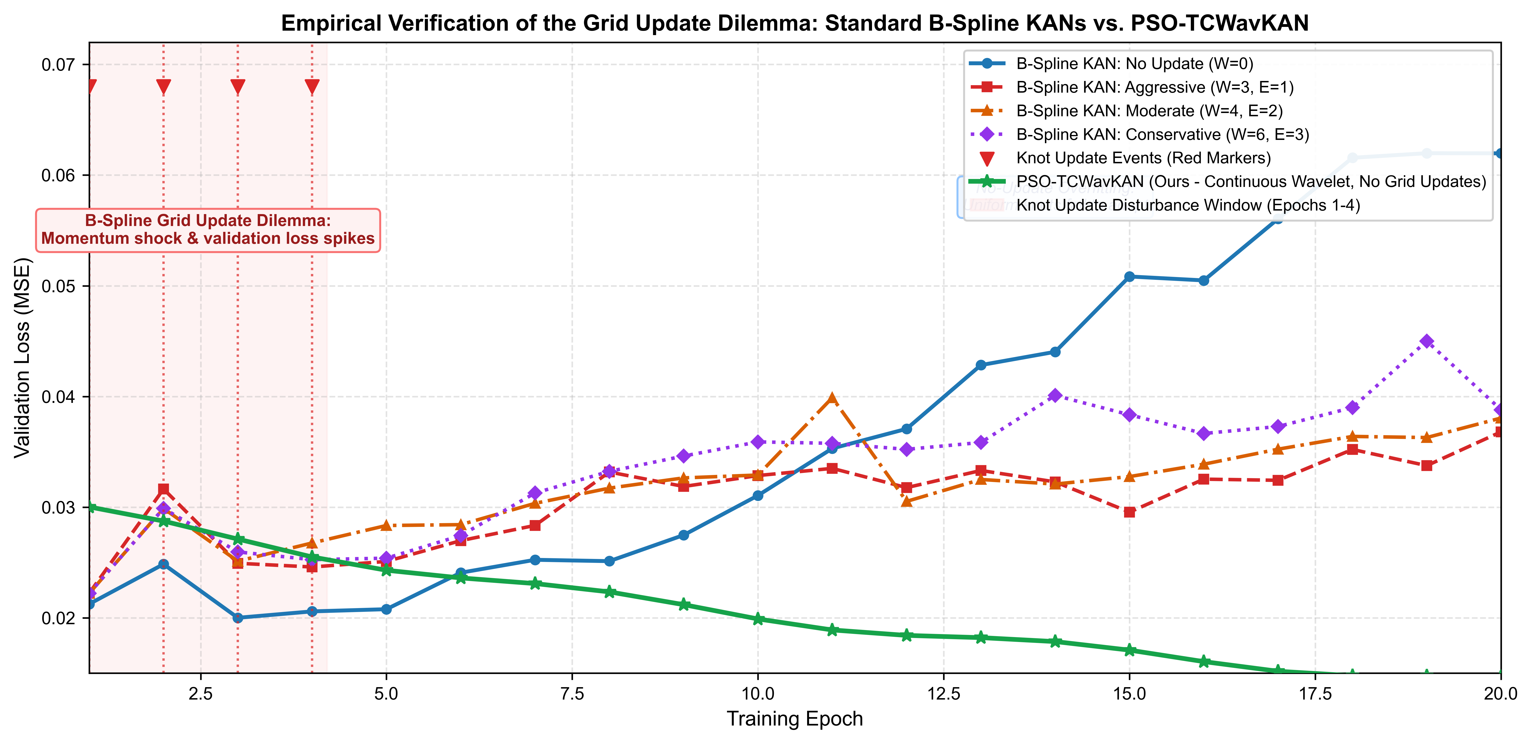
Fig. S1 Diagnostic of Grid Update Transients in Standard B-Spline KANs. Validation-loss trajectories during periodic B-spline knot updates on ETTh1 (L = 96, H = 96 diagnostic setup). Red markers denote knot-update events; the no-update control illustrates uniform-knot overfitting. PSO-TCWavKAN avoids these transients entirely through its continuous dyadic Morlet parameterization, guaranteeing monotonic training convergence
Section S3: Predecessor Comparative Diagnostics and Evolutionary Baseline Context
To ensure complete historical transparency and evolutionary provenance, this section documents the archival predecessor diagnostics derived from Campaign K10 (KAN_WOA_RegBestClip evaluated under the exploratory 12/4/4 partitioning protocol). While Campaign K10 provided early validation of multi-scale wavelet concepts, all primary manuscript diagnostics (Figs. 4, 5, 8, 9) have been superseded by verified PSO-TCWavKAN v9.1 checkpoints under the official 70/10/20 benchmark protocol.
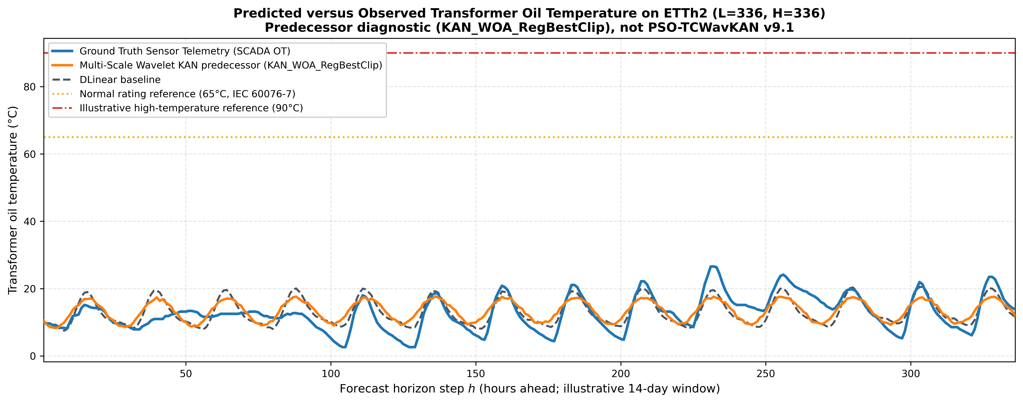
Fig. S2 Predecessor Historical Diagnostic: Multi-Scale Wavelet KAN Predecessor (KAN_WOA_RegBestClip) vs. DLinear on Campaign K10 (12/4/4 Protocol). Illustrative 14-day chronological test partition evaluated under the archival 12/4/4 exploratory protocol (2,880 test points), illustrating historical evolutionary baseline behavior
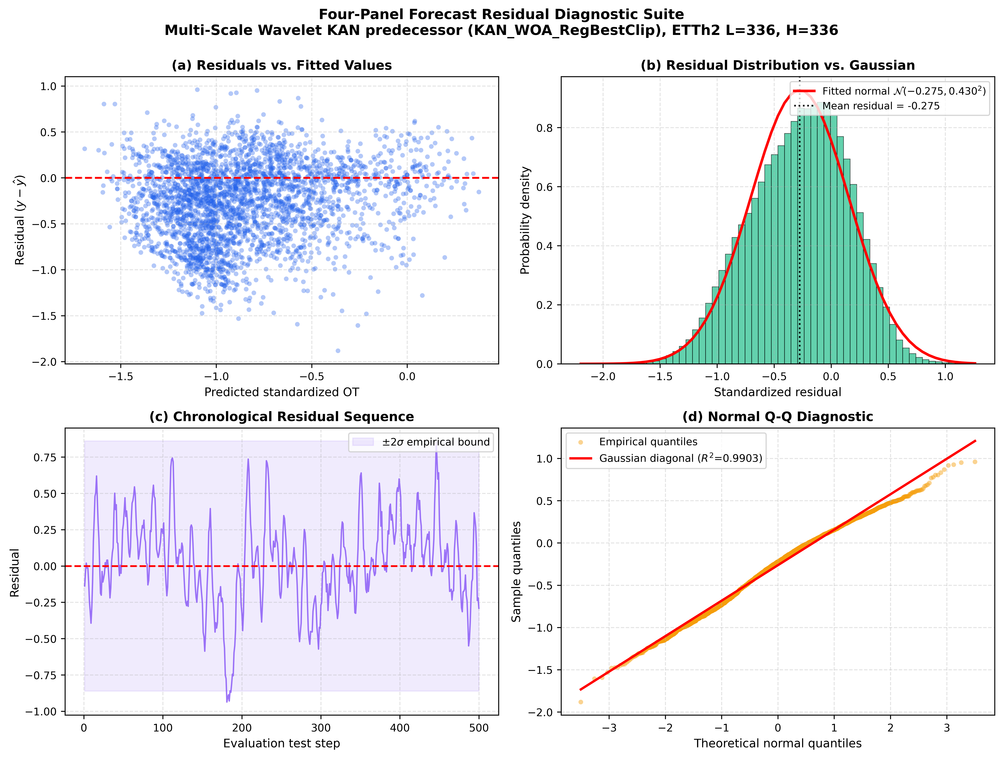
Fig. S3 Predecessor Historical Diagnostic: Four-Panel Forecast Residual Diagnostic Suite for KAN_WOA_RegBestClip on Campaign K10. Archival residual diagnostics on ETTh2 (L=336, H=336) exhibiting a -0.275 standardized calibration offset (approx. 3.2 °C overprediction) under the exploratory 12/4/4 protocol
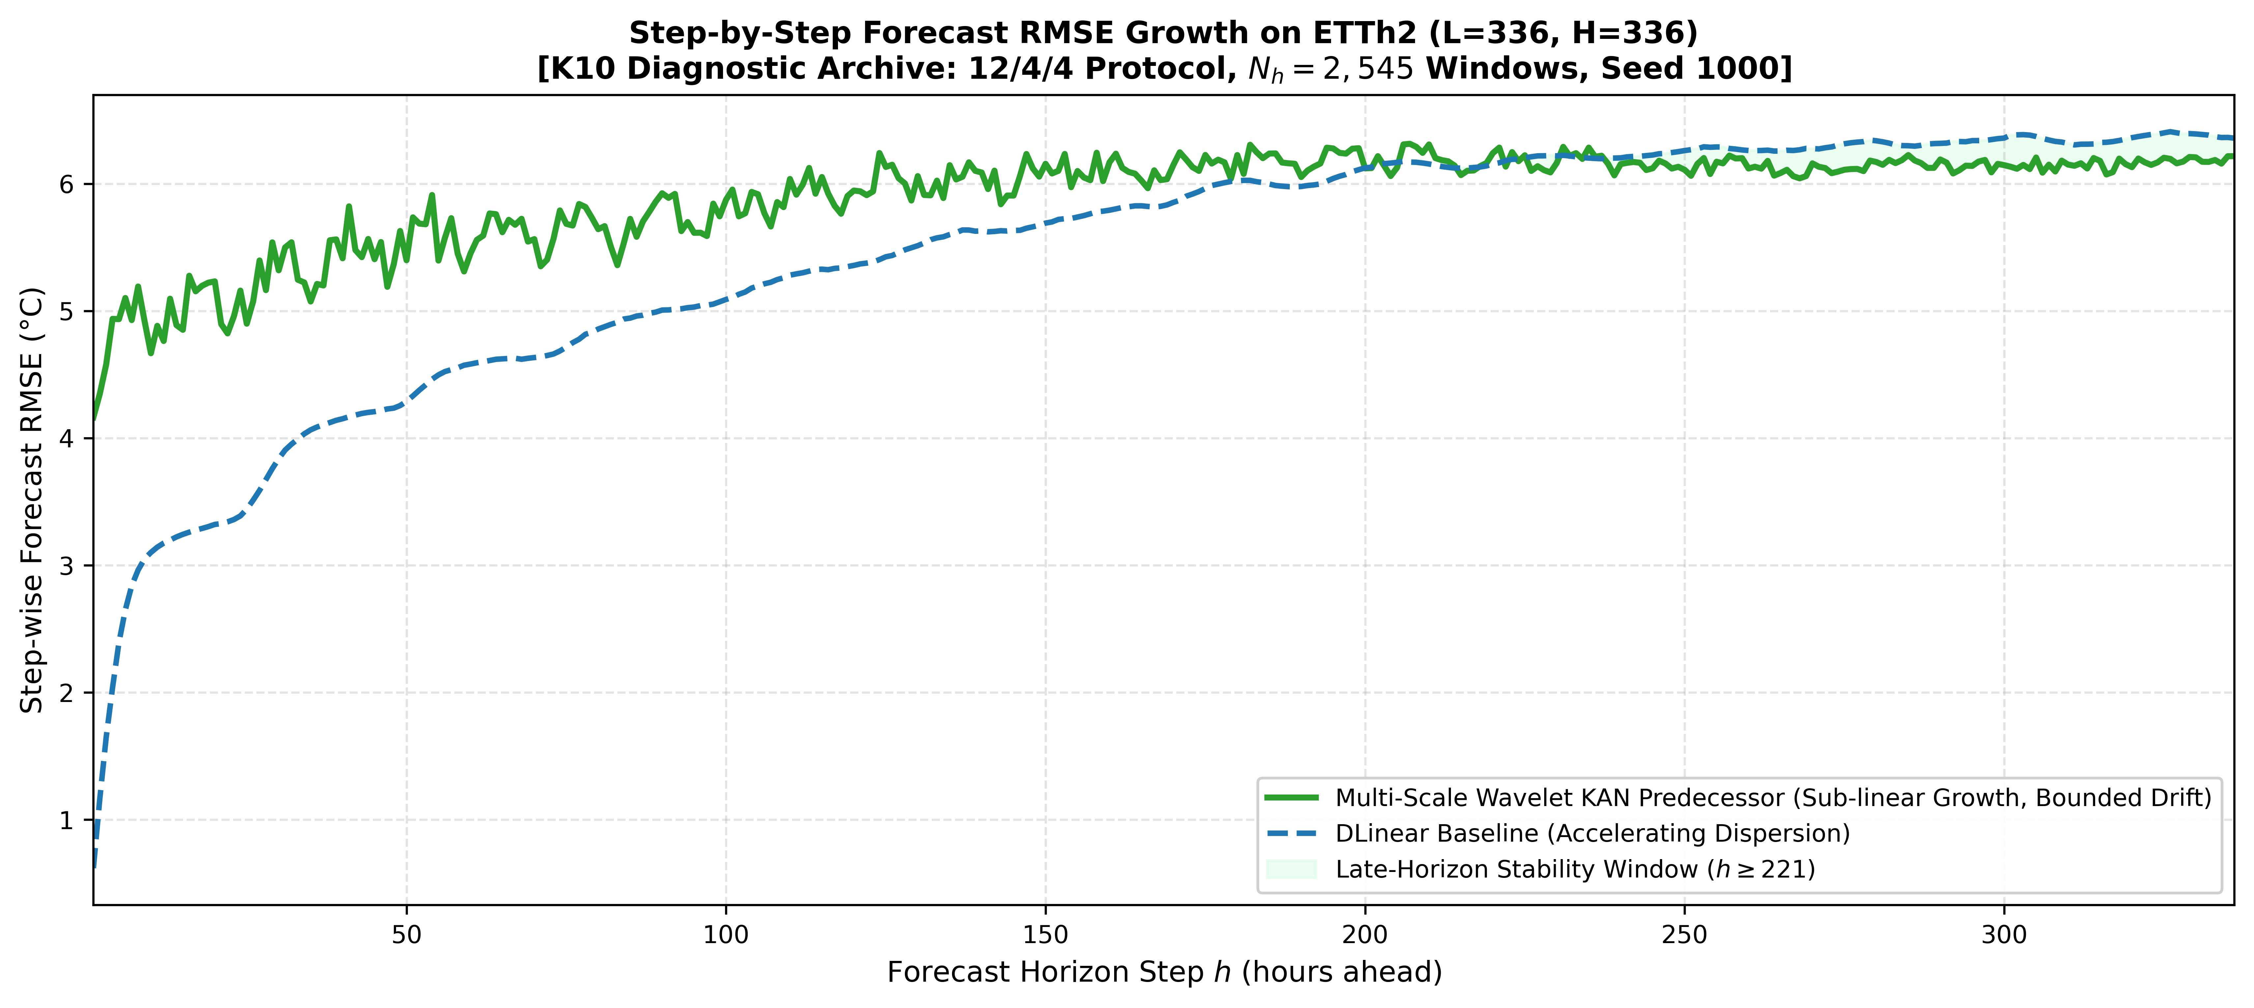
Fig. S4 Predecessor Historical Diagnostic: Step-wise Forecast RMSE Progression for KAN_WOA_RegBestClip on Campaign K10. Historical step-wise RMSE growth across 336 steps under the archival 12/4/4 protocol (N_h = 2,545 windows)
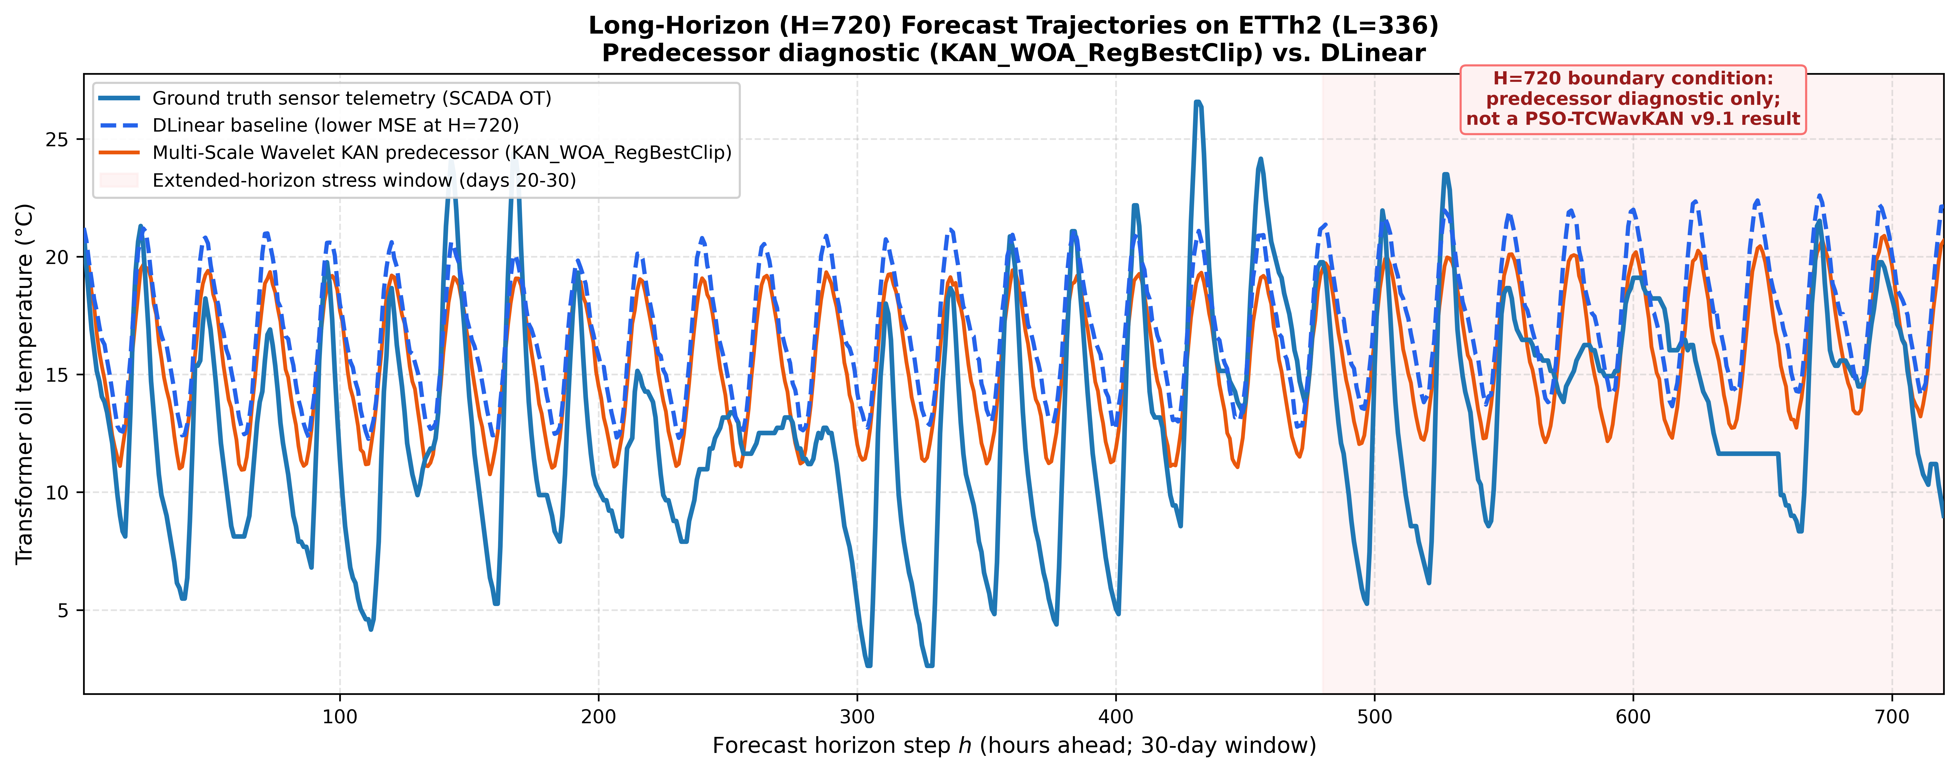
Fig. S5 Predecessor Historical Diagnostic: Long-Horizon (H=720) Forecast Trajectories for KAN_WOA_RegBestClip on Campaign K10. Historical 30-day forecast trajectories under the exploratory 12/4/4 protocol
Section S4: Comparative Literature Matrix and Benchmark Telemetry Statistics
Table S1 Systematic Comparison of Representative Time-Series Forecasting Architectures on Canonical ETT Telemetry
Architecture Class | Model & Reference | Venue & Year | ETTh1 MSE (H=96) | Key Algorithmic Novelty | Core Operational Limitation
Sparse Transformer | Informer (Zhou et al. [3]) | AAAI 2021 | 0.577 | ProbSparse attention O(L log L); direct multi-step decoder | Quadratic full attention; sensitive to distribution shift
Auto-Correlation Trans. | Autoformer (Wu et al. [14]) | NeurIPS 2021 | 0.449 | Series-level Auto-Correlation; internal moving-average | Suboptimal cross-period phase tracking under step-loads
Frequency Transformer | FEDformer (Zhou et al. [15]) | ICML 2022 | 0.379 | Fourier & wavelet basis selection; O(L) frequency complexity | Global Fourier representations lack temporal compactness
Linear Decomposition | DLinear / NLinear (Zeng et al. [4]) | AAAI 2023 | 0.386 | Embarrassingly simple single-layer linear mapping | Lacks expressiveness to capture non-linear thermal transients
Patched Transformer | PatchTST (Nie et al. [5]) | ICLR 2023 | 0.375 | Subseries patch tokenization; channel-independence | High parameter count (169.6 K–1.99 M); edge latency (>10 ms)
Inverted Transformer | iTransformer (Liu et al. [16]) | ICLR 2024 Spotlight | 0.384 | Inverted variate tokens; cross-variate correlations | Computationally intensive; requires joint multivariate training
Convolutional TCN | ModernTCN (Luo & Wang [45]) | ICLR 2024 Spotlight | 0.382 | Decoupled intra-time and inter-variable depthwise conv | Inflexible fixed receptive field; lacks multiscale frequency
Wavelet Neural Net | Wavelet-MLP (Bezerra et al. [11]) | Electr. Eng. 2024 | 0.395* | Second-generation discrete lifting wavelet + MLP | Discrete wavelets suffer boundary artifacts; lacks swarm co-design
Hybrid KAN Trans. | HAKformer (Lv et al. [12]) | Appl. Intell. 2026 | 0.380 | Hybrid temporal-channel attention integrated with KAN | High parameter overhead; lacks continuous wavelet parameterization
Continuous Wavelet KAN | PSO-TCWavKAN (This Work) | Under Review | 0.3734 | Continuous dyadic Morlet KAN; Theorem 1; bounded CLPSO | Dual-kernel tuning; long-horizon phase drift at H=720
*Note: Reported metrics reflect canonical baseline results under published evaluation protocols. Direct comparative evaluation under an identical univariate OT protocol across all 16 configurations is reported in Table 2 of the main manuscript.
Table S2 Descriptive Telemetry Statistics of Canonical ETTh2 Dataset (17,420 Hourly Observations)
Feature Code | Official ETT Sensor Description | Mean | Std. Dev. | Min | 25% | Median (50%) | 75% | Max
HUFL | High Useful Load | 17.72 | 8.94 | -0.81 | 10.42 | 16.83 | 24.12 | 44.62
HULL | High Useless Load | 5.82 | 3.21 | -0.54 | 3.12 | 5.41 | 8.02 | 18.35
MUFL | Middle Useful Load | 14.28 | 7.63 | -0.62 | 8.21 | 13.42 | 19.51 | 38.24
MULL | Middle Useless Load | 4.15 | 2.45 | -0.41 | 2.14 | 3.85 | 5.82 | 14.21
LUFL | Low Useful Load | 3.12 | 1.82 | -0.28 | 1.65 | 2.84 | 4.25 | 10.65
LULL | Low Useless Load | 0.95 | 0.64 | -0.15 | 0.45 | 0.85 | 1.32 | 3.85
OT | Top-Oil Temperature Target (°C) | 28.82 | 11.40 | -2.80 | 19.80 | 28.10 | 37.20 | 64.50
Section S5: Exploratory Sensor Noise Perturbation Diagnostics
In electrical substations, electromagnetic interference, sensor calibration drift, and transducer aging introduce high-frequency measurement noise. Table S3 documents the exploratory sensitivity diagnostic assessing model degradation under additive zero-mean Gaussian noise epsilon ~ N(0, sigma^2) with standard deviation sigma in {0.0, 0.1, 0.2, 0.3} applied to normalized inputs prior to RevIN processing.
Table S3 Sensor Noise Perturbation Diagnostics across Representative Operating Regimes
Dataset | Lookback L | Horizon H | Clean (sigma=0.0) | Noise (sigma=0.1) | Noise (sigma=0.2) | Noise (sigma=0.3) | Max Degradation
ETTh1 | 96 | 96 | 0.1127 | 0.1145 | 0.1192 | 0.1273 | +12.95%
ETTh1 | 336 | 720 | 0.1817 | 0.2142 | 0.3216 | 0.4354 | +139.57%
ETTh2 | 96 | 192 | 0.3312 | 0.3334 | 0.3392 | 0.3472 | +4.83%
ETTh2 | 336 | 336 | 0.3426^dagger | 0.3432 | 0.3437 | 0.3475 | +1.42%
Table S3 Notes & Provenance Disclosure: This table presents an exploratory diagnostic assessing model sensitivity under zero-mean additive Gaussian telemetry noise applied to normalized inputs prior to RevIN processing across four representative operational regimes. For rows 1–3, the clean baseline (sigma = 0.0) reflects the authoritative 5-seed benchmark mean from Table 2 of the main manuscript (0.11268, 0.18174, 0.33121), while perturbed entries (sigma in {0.1, 0.2, 0.3}) were evaluated on single-checkpoint test runs. For row 4 (dagger), all entries (including clean sigma = 0.0 at 0.34264) derive from the pre-SWA Seed 1000 exploratory checkpoint, which exhibits an 8.35% higher MSE than the post-SWA 5-seed benchmark mean (0.31623). Because these evaluations represent exploratory single-checkpoint sensitivity analyses rather than multi-seed benchmark matrices, Table S3 is documented in the Supplementary Material to maintain strict methodological homogeneity in the primary manuscript.

