Basketball-Free-Throws

Pinak Nayak

# Basketball Free Throw ----  
  
# Data ----  
  
#Seasons  
Seasons <- c("2005","2006","2007","2008","2009","2010","2011","2012","2013","2014")  
  
#Players  
Players <- c("KobeBryant","JoeJohnson","LeBronJames","CarmeloAnthony","DwightHoward","ChrisBosh","ChrisPaul","KevinDurant","DerrickRose","DwayneWade")  
  
  
#Games   
KobeBryant_G <- c(80,77,82,82,73,82,58,78,6,35)  
JoeJohnson_G <- c(82,57,82,79,76,72,60,72,79,80)  
LeBronJames_G <- c(79,78,75,81,76,79,62,76,77,69)  
CarmeloAnthony_G <- c(80,65,77,66,69,77,55,67,77,40)  
DwightHoward_G <- c(82,82,82,79,82,78,54,76,71,41)  
ChrisBosh_G <- c(70,69,67,77,70,77,57,74,79,44)  
ChrisPaul_G <- c(78,64,80,78,45,80,60,70,62,82)  
KevinDurant_G <- c(35,35,80,74,82,78,66,81,81,27)  
DerrickRose_G <- c(40,40,40,81,78,81,39,0,10,51)  
DwayneWade_G <- c(75,51,51,79,77,76,49,69,54,62)  
#Matrix  
Games <- rbind(KobeBryant_G, JoeJohnson_G, LeBronJames_G, CarmeloAnthony_G, DwightHoward_G, ChrisBosh_G, ChrisPaul_G, KevinDurant_G, DerrickRose_G, DwayneWade_G)  
rm(KobeBryant_G, JoeJohnson_G, CarmeloAnthony_G, DwightHoward_G, ChrisBosh_G, LeBronJames_G, ChrisPaul_G, DerrickRose_G, DwayneWade_G, KevinDurant_G)  
colnames(Games) <- Seasons  
rownames(Games) <- Players  
  
  
#Field Goals  
KobeBryant_FG <- c(978,813,775,800,716,740,574,738,31,266)  
JoeJohnson_FG <- c(632,536,647,620,635,514,423,445,462,446)  
LeBronJames_FG <- c(875,772,794,789,768,758,621,765,767,624)  
CarmeloAnthony_FG <- c(756,691,728,535,688,684,441,669,743,358)  
DwightHoward_FG <- c(468,526,583,560,510,619,416,470,473,251)  
ChrisBosh_FG <- c(549,543,507,615,600,524,393,485,492,343)  
ChrisPaul_FG <- c(407,381,630,631,314,430,425,412,406,568)  
KevinDurant_FG <- c(306,306,587,661,794,711,643,731,849,238)  
DerrickRose_FG <- c(208,208,208,574,672,711,302,0,58,338)  
DwayneWade_FG <- c(699,472,439,854,719,692,416,569,415,509)  
#Matrix  
FieldGoals <- rbind(KobeBryant_FG, JoeJohnson_FG, LeBronJames_FG, CarmeloAnthony_FG, DwightHoward_FG, ChrisBosh_FG, ChrisPaul_FG, KevinDurant_FG, DerrickRose_FG, DwayneWade_FG)  
rm(KobeBryant_FG, JoeJohnson_FG, LeBronJames_FG, CarmeloAnthony_FG, DwightHoward_FG, ChrisBosh_FG, ChrisPaul_FG, KevinDurant_FG, DerrickRose_FG, DwayneWade_FG)  
colnames(FieldGoals) <- Seasons  
rownames(FieldGoals) <- Players  
  
#Field Goal Attempts  
KobeBryant_FGA <- c(2173,1757,1690,1712,1569,1639,1336,1595,73,713)  
JoeJohnson_FGA <- c(1395,1139,1497,1420,1386,1161,931,1052,1018,1025)  
LeBronJames_FGA <- c(1823,1621,1642,1613,1528,1485,1169,1354,1353,1279)  
CarmeloAnthony_FGA <- c(1572,1453,1481,1207,1502,1503,1025,1489,1643,806)  
DwightHoward_FGA <- c(881,873,974,979,834,1044,726,813,800,423)  
ChrisBosh_FGA <- c(1087,1094,1027,1263,1158,1056,807,907,953,745)  
ChrisPaul_FGA <- c(947,871,1291,1255,637,928,890,856,870,1170)  
KevinDurant_FGA <- c(647,647,1366,1390,1668,1538,1297,1433,1688,467)  
DerrickRose_FGA <- c(436,436,436,1208,1373,1597,695,0,164,835)  
DwayneWade_FGA <- c(1413,962,937,1739,1511,1384,837,1093,761,1084)  
#Matrix  
FieldGoalAttempts <- rbind(KobeBryant_FGA, JoeJohnson_FGA, LeBronJames_FGA, CarmeloAnthony_FGA, DwightHoward_FGA, ChrisBosh_FGA, ChrisPaul_FGA, KevinDurant_FGA, DerrickRose_FGA, DwayneWade_FGA)  
rm(KobeBryant_FGA, JoeJohnson_FGA, LeBronJames_FGA, CarmeloAnthony_FGA, DwightHoward_FGA, ChrisBosh_FGA, ChrisPaul_FGA, KevinDurant_FGA, DerrickRose_FGA, DwayneWade_FGA)  
colnames(FieldGoalAttempts) <- Seasons  
rownames(FieldGoalAttempts) <- Players  
  
#Points  
KobeBryant_PTS <- c(2832,2430,2323,2201,1970,2078,1616,2133,83,782)  
JoeJohnson_PTS <- c(1653,1426,1779,1688,1619,1312,1129,1170,1245,1154)  
LeBronJames_PTS <- c(2478,2132,2250,2304,2258,2111,1683,2036,2089,1743)  
CarmeloAnthony_PTS <- c(2122,1881,1978,1504,1943,1970,1245,1920,2112,966)  
DwightHoward_PTS <- c(1292,1443,1695,1624,1503,1784,1113,1296,1297,646)  
ChrisBosh_PTS <- c(1572,1561,1496,1746,1678,1438,1025,1232,1281,928)  
ChrisPaul_PTS <- c(1258,1104,1684,1781,841,1268,1189,1186,1185,1564)  
KevinDurant_PTS <- c(903,903,1624,1871,2472,2161,1850,2280,2593,686)  
DerrickRose_PTS <- c(597,597,597,1361,1619,2026,852,0,159,904)  
DwayneWade_PTS <- c(2040,1397,1254,2386,2045,1941,1082,1463,1028,1331)  
#Matrix  
Points <- rbind(KobeBryant_PTS, JoeJohnson_PTS, LeBronJames_PTS, CarmeloAnthony_PTS, DwightHoward_PTS, ChrisBosh_PTS, ChrisPaul_PTS, KevinDurant_PTS, DerrickRose_PTS, DwayneWade_PTS)  
rm(KobeBryant_PTS, JoeJohnson_PTS, LeBronJames_PTS, CarmeloAnthony_PTS, DwightHoward_PTS, ChrisBosh_PTS, ChrisPaul_PTS, KevinDurant_PTS, DerrickRose_PTS, DwayneWade_PTS)  
colnames(Points) <- Seasons  
rownames(Points) <- Players  
  
  
#Free Throws  
KobeBryant_FT <- c(696,667,623,483,439,483,381,525,18,196)  
JoeJohnson_FT <- c(261,235,316,299,220,195,158,132,159,141)  
LeBronJames_FT <- c(601,489,549,594,593,503,387,403,439,375)  
CarmeloAnthony_FT <- c(573,459,464,371,508,507,295,425,459,189)  
DwightHoward_FT <- c(356,390,529,504,483,546,281,355,349,143)  
ChrisBosh_FT <- c(474,463,472,504,470,384,229,241,223,179)  
ChrisPaul_FT <- c(394,292,332,455,161,337,260,286,295,289)  
KevinDurant_FT <- c(209,209,391,452,756,594,431,679,703,146)  
DerrickRose_FT <- c(146,146,146,197,259,476,194,0,27,152)  
DwayneWade_FT <- c(629,432,354,590,534,494,235,308,189,284)  
#Matrix  
FreeThrows <- rbind(KobeBryant_FT, JoeJohnson_FT, LeBronJames_FT, CarmeloAnthony_FT, DwightHoward_FT,   
 ChrisBosh_FT, ChrisPaul_FT, KevinDurant_FT, DerrickRose_FT, DwayneWade_FT)  
colnames(FreeThrows) <- Seasons  
rownames(FreeThrows) <- Players  
  
print(FreeThrows)

## 2005 2006 2007 2008 2009 2010 2011 2012 2013 2014  
## KobeBryant 696 667 623 483 439 483 381 525 18 196  
## JoeJohnson 261 235 316 299 220 195 158 132 159 141  
## LeBronJames 601 489 549 594 593 503 387 403 439 375  
## CarmeloAnthony 573 459 464 371 508 507 295 425 459 189  
## DwightHoward 356 390 529 504 483 546 281 355 349 143  
## ChrisBosh 474 463 472 504 470 384 229 241 223 179  
## ChrisPaul 394 292 332 455 161 337 260 286 295 289  
## KevinDurant 209 209 391 452 756 594 431 679 703 146  
## DerrickRose 146 146 146 197 259 476 194 0 27 152  
## DwayneWade 629 432 354 590 534 494 235 308 189 284

#Free Throw Attempts  
KobeBryant_FTA <- c(819,768,742,564,541,583,451,626,21,241)  
JoeJohnson_FTA <- c(330,314,379,362,269,243,186,161,195,176)  
LeBronJames_FTA <- c(814,701,771,762,773,663,502,535,585,528)  
CarmeloAnthony_FTA <- c(709,568,590,468,612,605,367,512,541,237)  
DwightHoward_FTA <- c(598,666,897,849,816,916,572,721,638,271)  
ChrisBosh_FTA <- c(581,590,559,617,590,471,279,302,272,232)  
ChrisPaul_FTA <- c(465,357,390,524,190,384,302,323,345,321)  
KevinDurant_FTA <- c(256,256,448,524,840,675,501,750,805,171)  
DerrickRose_FTA <- c(205,205,205,250,338,555,239,0,32,187)  
DwayneWade_FTA <- c(803,535,467,771,702,652,297,425,258,370)  
#Matrix  
FreeThrowAttempts <- rbind(KobeBryant_FTA, JoeJohnson_FTA, LeBronJames_FTA, CarmeloAnthony_FTA, DwightHoward_FTA,   
 ChrisBosh_FTA, ChrisPaul_FTA, KevinDurant_FTA, DerrickRose_FTA, DwayneWade_FTA)  
colnames(FreeThrowAttempts) <- Seasons  
rownames(FreeThrowAttempts) <- Players  
  
  
### Assignment ----  
  
#You need to create three plots that potray the following insights:  
# 1) Free throw attempts per game  
# 2) Accuracy of Free Throws  
# 3) Player playing style (2 vs 3 point preference) excluding free throws  
  
  
# Create a function to plot quickly ----  
myplot <- function(data, rows = 1:10){  
 Data <- data[rows,,drop=F]  
 matplot(t(Data), type="b", pch=15:18, col=c(1:4,6))  
 #legend("bottomleft", inset=0.01, cex = 0.55, legend=Players[rows],col=c(1:4,6),pch=15:18, horiz=F)  
 legend("bottomleft", inset = c(0,0) , cex = 0.55, col = c(1:4,6),   
 lty = 10, lwd = 2, ncol = 5, legend = Players)  
}

# 1) Free throw attempts per game ----  
  
myplot(FreeThrowAttempts/Games)

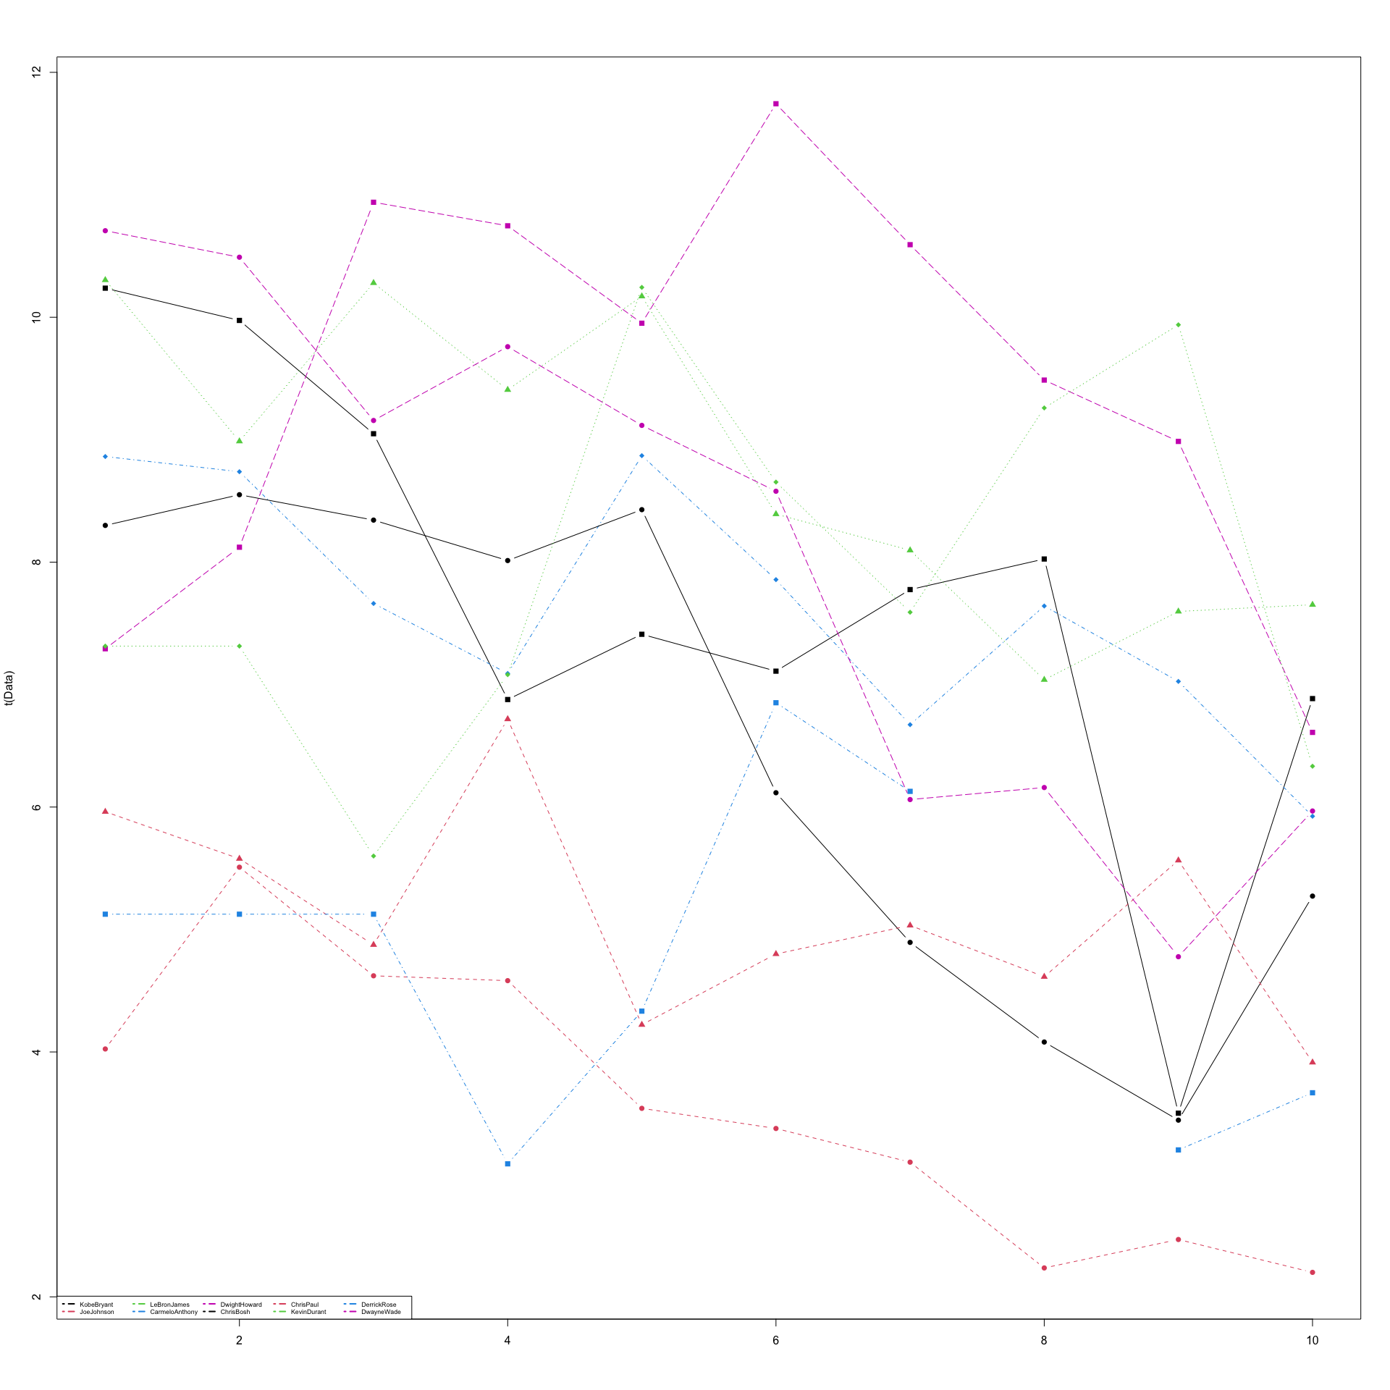

# 2) Accuracy of Free Throws ----  
  
myplot(FreeThrows/FreeThrowAttempts)

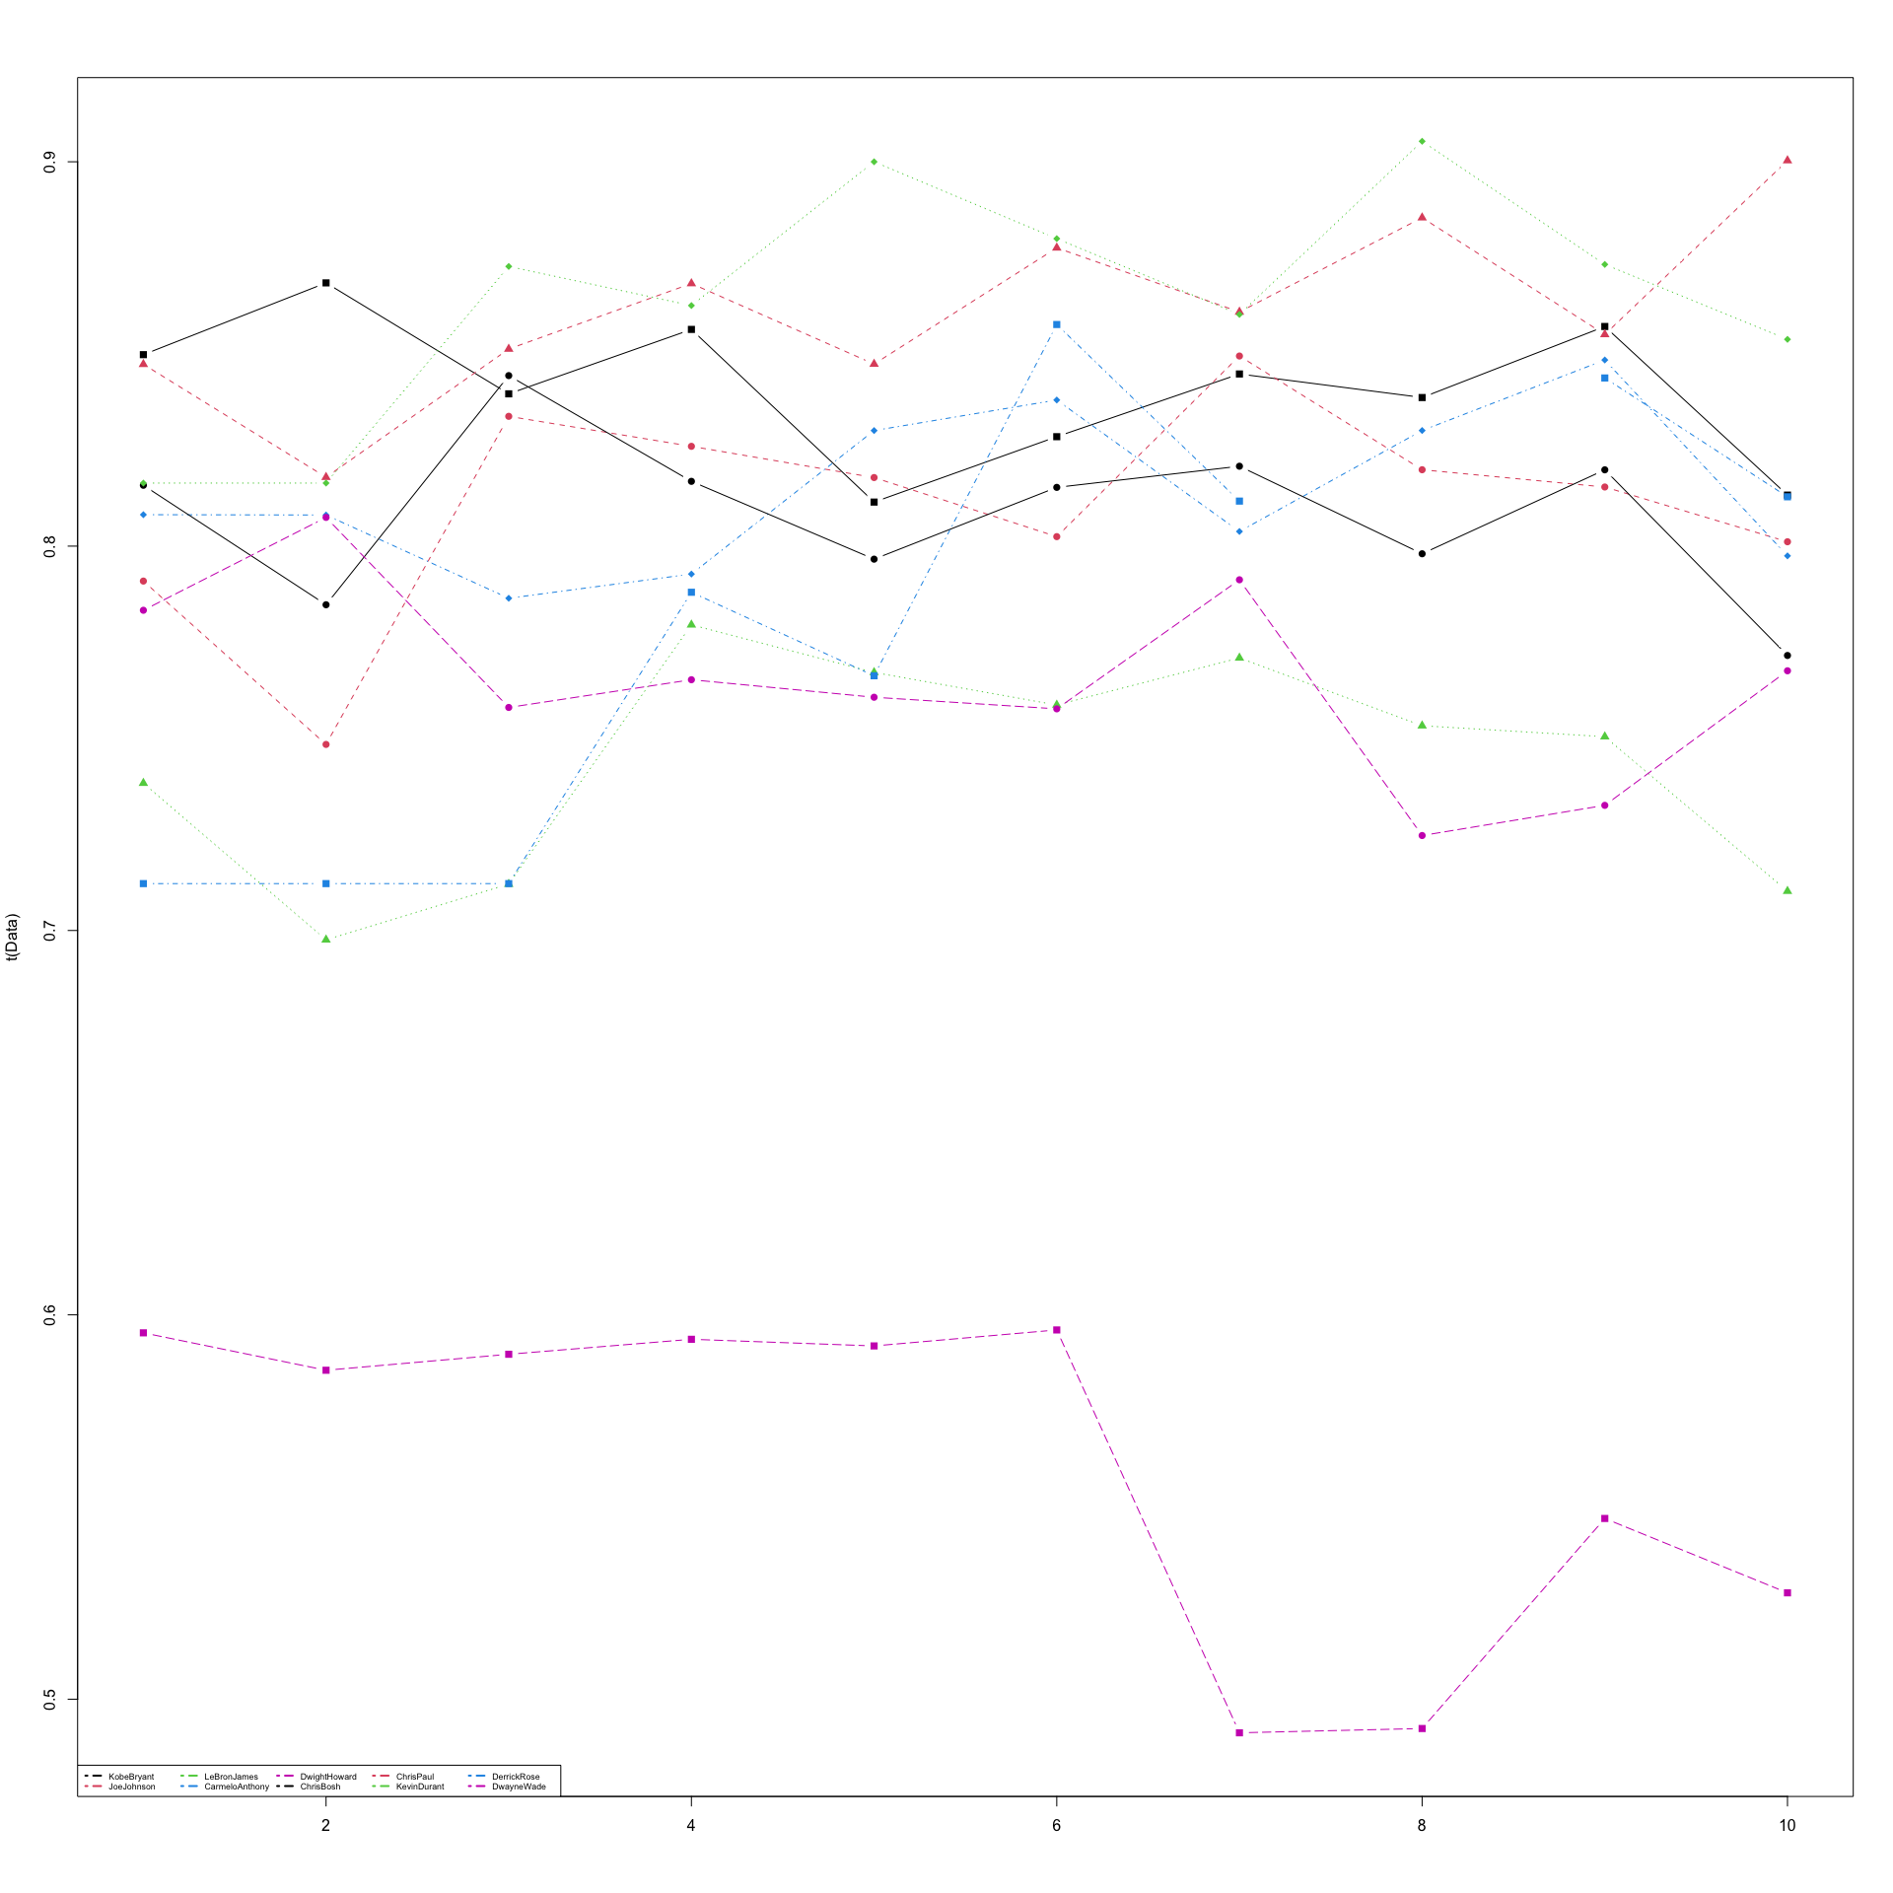

# 3) Player playing style (2 vs 3 point preference) excluding free throws ----  
  
# calculate ratio of points:fieldgoals. Have to subtract free throws first  
  
Points.No.FreeThrows <- Points - FreeThrows   
  
  
myplot(Points.No.FreeThrows/FieldGoals)

