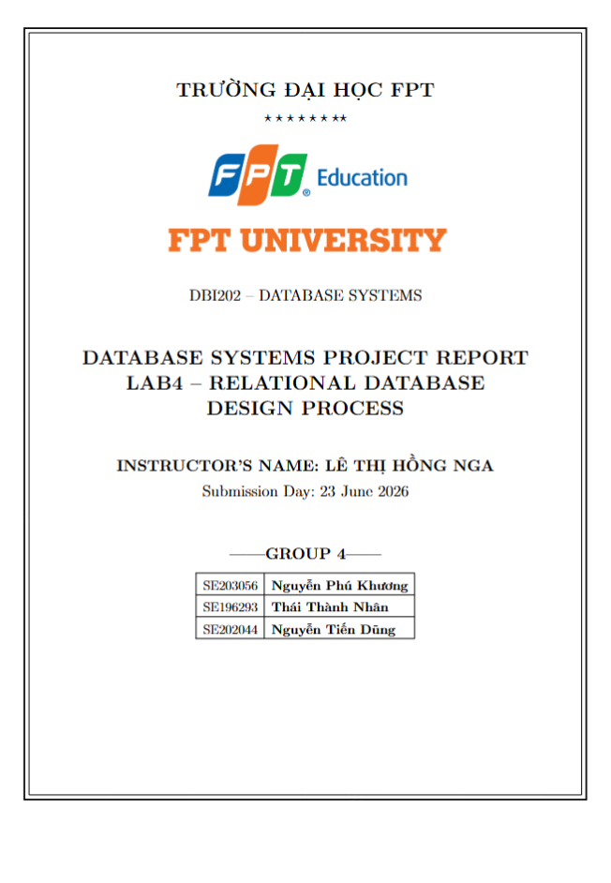

Contents
1
1. Objective 3
2. Conceptual Model (ERD) 4
2.1. Entities and Attributes 4
2.2. Relationships and Cardinalities 5
3. Logical Model 7
3.1. Relational Schema 7
3.2. Primary Keys and Foreign Keys 8
3.3. M:N Relationship Resolution 9
4. Physical Model 10
4.1. Table Definitions with Data Types 10
5. Constraints 15
5.1. Column-Level Constraints 15
5.2. Table-Level Constraints 17
6. Conclusion and Reflection 19

1. Objective
The purpose of Lab 4 is to guide students through the structured process of relational database design — translating business requirements into a conceptual model (Entity-Relationship Diagram), refining it into a logical relational model, implementing it as a physical database schema for Microsoft SQL Server, and specifying comprehensive constraints to ensure data integrity. This lab integrates the work from previous labs (requirements analysis, ERD design, and normalization) into a complete, deployable database design for the Household Cleaning Robot Sales & Maintenance Management System.
- Develop an Entity-Relationship Diagram (ERD) for the Household Cleaning Robot Sales & Maintenance Management System
- Convert the ERD into a logical relational schema with primary keys (PK) and foreign keys (FK)
- Map the logical schema to a physical model with SQL Server data types
- Specify comprehensive constraints (NOT NULL, UNIQUE, PK, FK, CHECK, DEFAULT) to enforce data integrity
- Document the complete design process and reflect on data integrity considerations

2. Conceptual Model (ERD)
This section presents the Entity-Relationship Diagram for the Household Cleaning Robot Sales & Maintenance Management System. The ERD was developed based on the project requirements and business rules identified in previous labs, identifying all entities, their attributes, and the relationships between them with appropriate cardinalities.

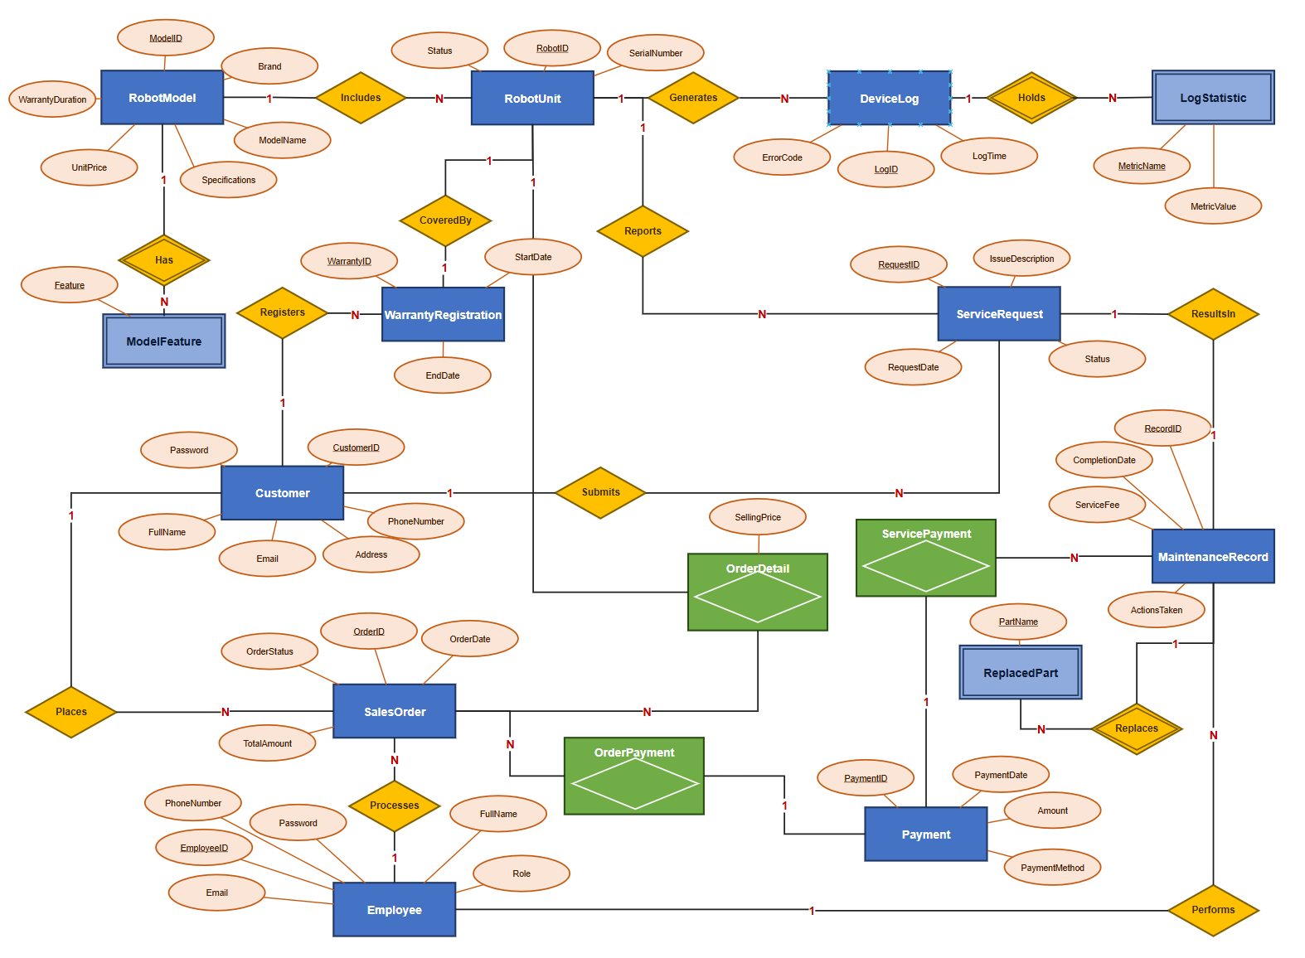
ER Diagram

2.1. Entities and Attributes
The following table summarizes all 16 entities identified for the system, organized by functional domain. Each entity is listed with its attributes and a brief description of its purpose within the system.
Entity | Attributes | Description
Customer | CustomerID (PK), FullName, PhoneNumber, Email, Address, Password | Stores customer personal information and account credentials
Employee | EmployeeID (PK), FullName, Role, PhoneNumber, Email, Password | Manages staff information including sales staff, technicians, and administrators
RobotModel | ModelID (PK), Brand, ModelName, Specifications, UnitPrice, WarrantyDuration | Defines robot product models with pricing and warranty info
ModelFeature | ModelID (PK, FK), Feature (PK) | Stores individual features for each robot model (multi-valued attribute decomposition)
RobotUnit | RobotID (PK), ModelID (FK), SerialNumber, Status | Tracks individual robot units in inventory
SalesOrder | OrderID (PK), CustomerID (FK), EmployeeID (FK), OrderDate, TotalAmount, OrderStatus | Records sales transactions
OrderDetail | RobotID (PK, FK), OrderID (FK), SellingPrice | Links specific robot units to sales orders
Payment | PaymentID (PK), Amount, PaymentDate, PaymentMethod | Records payment transactions (base entity)
OrderPayment | PaymentID (PK, FK), OrderID (FK) | Links payments to sales orders
ServicePayment | PaymentID (PK, FK), ServiceRecordID (FK) | Links payments to maintenance services
WarrantyRegistration | WarrantyID (PK), RobotID (FK), CustomerID (FK), StartDate, EndDate | Manages warranty coverage for purchased robots
ServiceRequest | RequestID (PK), RobotID (FK), CustomerID (FK), IssueDescription, RequestDate, Status | Tracks customer service/repair requests
MaintenanceRecord | RecordID (PK), RequestID (FK), TechnicianID (FK), ActionsTaken, ServiceFee, CompletionDate | Documents maintenance/repair work performed
ReplacedPart | RecordID (PK, FK), PartName (PK) | Tracks individual parts replaced during maintenance
DeviceLog | LogID (PK), RobotID (FK), LogTime, ErrorCode | Stores IoT data from connected robots
LogStatistic | LogID (PK, FK), MetricName (PK), MetricValue | Stores individual usage metrics from device logs

2.2. Relationships and Cardinalities
The following table documents all relationships between entities in the system, including the cardinality type and a description of each relationship.
Relationship | Type | Description
Customer → SalesOrder | 1:N | A customer can place multiple sales orders
Employee → SalesOrder | 1:N | An employee can process multiple sales orders
SalesOrder → OrderDetail | 1:N | A sales order contains multiple order detail lines
RobotUnit → OrderDetail | 1:1 | Each robot unit can only be sold once
RobotModel → RobotUnit | 1:N | A robot model can have multiple individual units
RobotModel → ModelFeature | 1:N | A robot model can have multiple features
Payment → OrderPayment | 1:1 | Each order payment links to exactly one payment
Payment → ServicePayment | 1:1 | Each service payment links to exactly one payment
SalesOrder → OrderPayment | 1:N | A sales order can have multiple payments
MaintenanceRecord → ServicePayment | 1:N | A maintenance record can have multiple payments
Customer → WarrantyRegistration | 1:N | A customer can have multiple warranty registrations
RobotUnit → WarrantyRegistration | 1:1 | Each robot unit has exactly one warranty
Customer → ServiceRequest | 1:N | A customer can submit multiple service requests
RobotUnit → ServiceRequest | 1:N | A robot unit can have multiple service requests
ServiceRequest → MaintenanceRecord | 1:1 | Each service request has one maintenance record
Employee → MaintenanceRecord | 1:N | A technician can handle multiple maintenance records
RobotUnit → DeviceLog | 1:N | A robot unit generates multiple device logs
DeviceLog → LogStatistic | 1:N | A device log contains multiple usage statistics
MaintenanceRecord → ReplacedPart | 1:N | A maintenance record can involve multiple replaced parts

3. Logical Model
This section converts the conceptual ERD into a relational schema. The logical model defines the structure of each relation, identifies primary keys and foreign keys, and resolves any M:N relationships. All relations are normalized to BCNF as established in Lab 3.

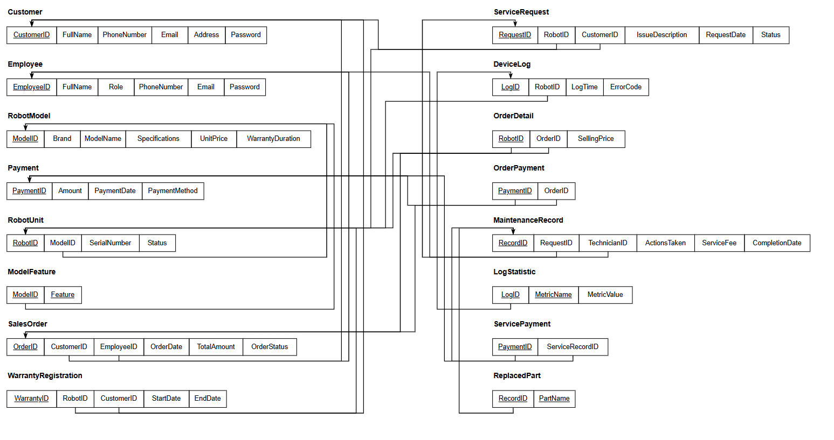
Relational Model Diagram

3.1. Relational Schema
The following presents the complete relational schema for the system, organized by functional domain. The schema consists of 16 relations, all normalized to BCNF (as established in Lab 3).
User Management
Customer(CustomerID, FullName, PhoneNumber, Email, Address, Password)
PK: CustomerID | Unique: Email, PhoneNumber
Employee(EmployeeID, FullName, Role, PhoneNumber, Email, Password)
PK: EmployeeID | Unique: Email
Product & Inventory
RobotModel(ModelID, Brand, ModelName, Specifications, UnitPrice, WarrantyDuration)
PK: ModelID | Unique: ModelName
ModelFeature(ModelID, Feature)
PK: {ModelID, Feature} | FK: ModelID → RobotModel
RobotUnit(RobotID, ModelID, SerialNumber, Status)
PK: RobotID | Unique: SerialNumber | FK: ModelID → RobotModel
Sales & Transactions
SalesOrder(OrderID, CustomerID, EmployeeID, OrderDate, TotalAmount, OrderStatus)
PK: OrderID | FK: CustomerID → Customer, EmployeeID → Employee
OrderDetail(RobotID, OrderID, SellingPrice)
PK: RobotID | FK: RobotID → RobotUnit, OrderID → SalesOrder
Payment(PaymentID, Amount, PaymentDate, PaymentMethod)
PK: PaymentID
OrderPayment(PaymentID, OrderID)
PK: PaymentID | FK: PaymentID → Payment, OrderID → SalesOrder
ServicePayment(PaymentID, ServiceRecordID)
PK: PaymentID | FK: PaymentID → Payment, ServiceRecordID → MaintenanceRecord
WarrantyRegistration(WarrantyID, RobotID, CustomerID, StartDate, EndDate)
PK: WarrantyID | Unique: RobotID | FK: RobotID → RobotUnit, CustomerID → Customer
Maintenance & IoT
ServiceRequest(RequestID, RobotID, CustomerID, IssueDescription, RequestDate, Status)
PK: RequestID | FK: RobotID → RobotUnit, CustomerID → Customer
MaintenanceRecord(RecordID, RequestID, TechnicianID, ActionsTaken, ServiceFee, CompletionDate)
PK: RecordID | Unique: RequestID | FK: RequestID → ServiceRequest, TechnicianID → Employee
ReplacedPart(RecordID, PartName)
PK: {RecordID, PartName} | FK: RecordID → MaintenanceRecord
DeviceLog(LogID, RobotID, LogTime, ErrorCode)
PK: LogID | Unique: {RobotID, LogTime} | FK: RobotID → RobotUnit
LogStatistic(LogID, MetricName, MetricValue)
PK: {LogID, MetricName} | FK: LogID → DeviceLog

3.2. Primary Keys and Foreign Keys
The following table provides a comprehensive summary of all primary keys, foreign keys, and unique keys across all 16 relations in the system.
Relation | Primary Key | Foreign Key(s) | Unique Key(s)
Customer | CustomerID | — | Email, PhoneNumber
Employee | EmployeeID | — | Email
RobotModel | ModelID | — | ModelName
ModelFeature | {ModelID, Feature} | ModelID → RobotModel | —
RobotUnit | RobotID | ModelID → RobotModel | SerialNumber
SalesOrder | OrderID | CustomerID → Customer, EmployeeID → Employee | —
OrderDetail | RobotID | RobotID → RobotUnit, OrderID → SalesOrder | —
Payment | PaymentID | — | —
OrderPayment | PaymentID | PaymentID → Payment, OrderID → SalesOrder | —
ServicePayment | PaymentID | PaymentID → Payment, ServiceRecordID → MaintenanceRecord | —
WarrantyRegistration | WarrantyID | RobotID → RobotUnit, CustomerID → Customer | RobotID
ServiceRequest | RequestID | RobotID → RobotUnit, CustomerID → Customer | —
MaintenanceRecord | RecordID | RequestID → ServiceRequest, TechnicianID → Employee | RequestID
ReplacedPart | {RecordID, PartName} | RecordID → MaintenanceRecord | —
DeviceLog | LogID | RobotID → RobotUnit | {RobotID, LogTime}
LogStatistic | {LogID, MetricName} | LogID → DeviceLog | —

3.3. M:N Relationship Resolution
In the original Lab 2 design, there were no explicit many-to-many (M:N) relationships. However, the conceptual model contained implicit multi-valued attributes which were resolved through decomposition during the normalization process in Lab 3. The following decompositions were performed:
- RobotModel.Features → ModelFeature (junction table): The multi-valued Features attribute was decomposed into a separate relation with a composite primary key {ModelID, Feature}.
- MaintenanceRecord.PartsReplaced → ReplacedPart (junction table): The multi-valued PartsReplaced attribute was decomposed into a separate relation with a composite primary key {RecordID, PartName}.
- DeviceLog.UsageStatistics → LogStatistic (junction table): The multi-valued UsageStatistics attribute was decomposed into a separate relation with a composite primary key {LogID, MetricName}.
Additionally, the Payment entity was decomposed into three relations — Payment, OrderPayment, and ServicePayment — using a supertype/subtype pattern. This eliminates nullable foreign keys (OrderID and ServiceRecordID) that would have existed in a single Payment table, as each payment is either for an order or for a service, but not both.

4. Physical Model
This section maps the logical schema to a physical database design for Microsoft SQL Server. It includes detailed table definitions with specific data types, identity columns, default values, and storage considerations appropriate for a production environment.

4.1. Table Definitions with Data Types
The following tables define the complete physical schema for all 16 relations. Each table specifies column names, SQL Server data types, nullability, keys, default values, and descriptions.
Table 1: Customer
Column | Data Type | Nullable | Key | Default | Description
CustomerID | INT | NO | PK (IDENTITY) | Auto-increment | Unique customer identifier
FullName | NVARCHAR(100) | NO |  |  | Customer full name
PhoneNumber | VARCHAR(15) | NO | UNIQUE |  | Contact phone number
Email | NVARCHAR(100) | NO | UNIQUE |  | Email address
Address | NVARCHAR(255) | YES |  | NULL | Residential address
Password | NVARCHAR(255) | NO |  |  | Hashed account password
Table 2: Employee
Column | Data Type | Nullable | Key | Default | Description
EmployeeID | INT | NO | PK (IDENTITY) | Auto-increment | Unique employee identifier
FullName | NVARCHAR(100) | NO |  |  | Employee full name
Role | NVARCHAR(50) | NO |  |  | Job role (Sales Staff/Technician/Administrator)
PhoneNumber | VARCHAR(15) | NO |  |  | Contact phone number
Email | NVARCHAR(100) | NO | UNIQUE |  | Email address
Password | NVARCHAR(255) | NO |  |  | Hashed account password
Table 3: RobotModel
Column | Data Type | Nullable | Key | Default | Description
ModelID | INT | NO | PK (IDENTITY) | Auto-increment | Unique model identifier
Brand | NVARCHAR(100) | NO |  |  | Manufacturer brand name
ModelName | NVARCHAR(100) | NO | UNIQUE |  | Model designation
Specifications | NVARCHAR(MAX) | YES |  | NULL | Technical specifications
UnitPrice | DECIMAL(18,2) | NO |  |  | Retail price per unit
WarrantyDuration | INT | NO |  |  | Warranty period in months
Table 4: ModelFeature
Column | Data Type | Nullable | Key | Default | Description
ModelID | INT | NO | PK, FK → RobotModel |  | Reference to robot model
Feature | NVARCHAR(100) | NO | PK |  | Individual feature name
Table 5: RobotUnit
Column | Data Type | Nullable | Key | Default | Description
RobotID | INT | NO | PK (IDENTITY) | Auto-increment | Unique robot unit identifier
ModelID | INT | NO | FK → RobotModel |  | Reference to robot model
SerialNumber | VARCHAR(50) | NO | UNIQUE |  | Manufacturer serial number
Status | NVARCHAR(30) | NO |  | 'Available' | Current unit status
Table 6: SalesOrder
Column | Data Type | Nullable | Key | Default | Description
OrderID | INT | NO | PK (IDENTITY) | Auto-increment | Unique order identifier
CustomerID | INT | NO | FK → Customer |  | Purchasing customer
EmployeeID | INT | NO | FK → Employee |  | Processing staff member
OrderDate | DATETIME | NO |  | GETDATE() | Date/time order was placed
TotalAmount | DECIMAL(18,2) | NO |  |  | Total order value
OrderStatus | NVARCHAR(30) | NO |  | 'Pending' | Current order status
Table 7: OrderDetail
Column | Data Type | Nullable | Key | Default | Description
RobotID | INT | NO | PK, FK → RobotUnit |  | Sold robot unit
OrderID | INT | NO | FK → SalesOrder |  | Associated sales order
SellingPrice | DECIMAL(18,2) | NO |  |  | Actual selling price
Table 8: Payment
Column | Data Type | Nullable | Key | Default | Description
PaymentID | INT | NO | PK (IDENTITY) | Auto-increment | Unique payment identifier
Amount | DECIMAL(18,2) | NO |  |  | Payment amount
PaymentDate | DATETIME | NO |  | GETDATE() | Date/time of payment
PaymentMethod | NVARCHAR(30) | NO |  |  | Method of payment
Table 9: OrderPayment
Column | Data Type | Nullable | Key | Default | Description
PaymentID | INT | NO | PK, FK → Payment |  | Reference to payment
OrderID | INT | NO | FK → SalesOrder |  | Reference to sales order
Table 10: ServicePayment
Column | Data Type | Nullable | Key | Default | Description
PaymentID | INT | NO | PK, FK → Payment |  | Reference to payment
ServiceRecordID | INT | NO | FK → MaintenanceRecord |  | Reference to maintenance record
Table 11: WarrantyRegistration
Column | Data Type | Nullable | Key | Default | Description
WarrantyID | INT | NO | PK (IDENTITY) | Auto-increment | Unique warranty identifier
RobotID | INT | NO | FK → RobotUnit, UNIQUE |  | Registered robot unit
CustomerID | INT | NO | FK → Customer |  | Warranty holder
StartDate | DATE | NO |  |  | Warranty start date
EndDate | DATE | NO |  |  | Warranty expiration date
Table 12: ServiceRequest
Column | Data Type | Nullable | Key | Default | Description
RequestID | INT | NO | PK (IDENTITY) | Auto-increment | Unique request identifier
RobotID | INT | NO | FK → RobotUnit |  | Robot requiring service
CustomerID | INT | NO | FK → Customer |  | Requesting customer
IssueDescription | NVARCHAR(MAX) | NO |  |  | Description of the issue
RequestDate | DATETIME | NO |  | GETDATE() | Date/time request was submitted
Status | NVARCHAR(30) | NO |  | 'Pending' | Current request status
Table 13: MaintenanceRecord
Column | Data Type | Nullable | Key | Default | Description
RecordID | INT | NO | PK (IDENTITY) | Auto-increment | Unique record identifier
RequestID | INT | NO | FK → ServiceRequest, UNIQUE |  | Associated service request
TechnicianID | INT | NO | FK → Employee |  | Assigned technician
ActionsTaken | NVARCHAR(MAX) | YES |  | NULL | Description of repair actions
ServiceFee | DECIMAL(18,2) | NO |  | 0 | Service charge amount
CompletionDate | DATETIME | YES |  | NULL | Date/time of completion
Table 14: ReplacedPart
Column | Data Type | Nullable | Key | Default | Description
RecordID | INT | NO | PK, FK → MaintenanceRecord |  | Reference to maintenance record
PartName | NVARCHAR(100) | NO | PK |  | Name of replaced part
Table 15: DeviceLog
Column | Data Type | Nullable | Key | Default | Description
LogID | INT | NO | PK (IDENTITY) | Auto-increment | Unique log identifier
RobotID | INT | NO | FK → RobotUnit |  | Source robot unit
LogTime | DATETIME | NO |  | GETDATE() | Timestamp of log entry
ErrorCode | VARCHAR(20) | YES |  | NULL | Error code (if any)
Table 16: LogStatistic
Column | Data Type | Nullable | Key | Default | Description
LogID | INT | NO | PK, FK → DeviceLog |  | Reference to device log
MetricName | NVARCHAR(100) | NO | PK |  | Name of usage metric
MetricValue | NVARCHAR(255) | YES |  | NULL | Value of the metric

5. Constraints
This section provides a comprehensive description of all constraints applied to the database schema. Constraints ensure data integrity, consistency, and reliability by enforcing business rules at the database level. The constraints are organized into column-level and table-level categories.

5.1. Column-Level Constraints
NOT NULL Constraints
NOT NULL constraints are applied to all mandatory columns to prevent incomplete records. The following table highlights key NOT NULL columns across the schema. All primary key columns and most business-critical columns are defined as NOT NULL.
Table | NOT NULL Columns | Purpose
Customer | FullName, PhoneNumber, Email, Password | Essential customer information
Employee | FullName, Role, PhoneNumber, Email, Password | Essential employee information
RobotModel | Brand, ModelName, UnitPrice, WarrantyDuration | Core product information
RobotUnit | ModelID, SerialNumber, Status | Inventory tracking fields
SalesOrder | CustomerID, EmployeeID, OrderDate, TotalAmount, OrderStatus | Transaction details
OrderDetail | OrderID, SellingPrice | Order line item details
Payment | Amount, PaymentDate, PaymentMethod | Payment transaction details
ServiceRequest | RobotID, CustomerID, IssueDescription, RequestDate, Status | Service request details
MaintenanceRecord | RequestID, TechnicianID, ServiceFee | Maintenance record details
WarrantyRegistration | RobotID, CustomerID, StartDate, EndDate | Warranty coverage details
UNIQUE Constraints
UNIQUE constraints prevent duplicate values in columns that must contain distinct data. These are applied in addition to the uniqueness guaranteed by primary keys.
Table | Column(s) | Purpose
Customer | Email | Prevent duplicate email addresses
Customer | PhoneNumber | Prevent duplicate phone numbers
Employee | Email | Prevent duplicate employee emails
RobotModel | ModelName | Ensure unique model names
RobotUnit | SerialNumber | Ensure unique serial numbers
WarrantyRegistration | RobotID | Each robot has at most one active warranty
MaintenanceRecord | RequestID | Each service request has at most one maintenance record
DEFAULT Values
DEFAULT constraints provide automatic values for columns when no explicit value is supplied during insertion. These improve usability and reduce the risk of insertion errors.
Table | Column | Default Value | Purpose
RobotUnit | Status | 'Available' | New units default to available
SalesOrder | OrderDate | GETDATE() | Auto-set order timestamp
SalesOrder | OrderStatus | 'Pending' | New orders start as pending
Payment | PaymentDate | GETDATE() | Auto-set payment timestamp
ServiceRequest | RequestDate | GETDATE() | Auto-set request timestamp
ServiceRequest | Status | 'Pending' | New requests start as pending
MaintenanceRecord | ServiceFee | 0 | Default no charge (warranty coverage)
CHECK Constraints
CHECK constraints enforce domain-specific validation rules at the database level, ensuring that column values fall within acceptable ranges or match predefined lists.
Table | Column | CHECK Expression | Purpose
Employee | Role | IN ('Sales Staff', 'Technician', 'Administrator') | Restrict valid roles
RobotModel | UnitPrice | > 0 | Price must be positive
RobotModel | WarrantyDuration | > 0 | Duration must be positive
RobotUnit | Status | IN ('Available', 'Sold', 'Under Maintenance', 'Retired') | Valid statuses only
SalesOrder | TotalAmount | >= 0 | Non-negative order total
SalesOrder | OrderStatus | IN ('Pending', 'Confirmed', 'Shipped', 'Delivered', 'Cancelled') | Valid statuses
OrderDetail | SellingPrice | > 0 | Price must be positive
Payment | Amount | > 0 | Payment must be positive
Payment | PaymentMethod | IN ('Cash', 'Credit Card', 'Bank Transfer', 'E-Wallet') | Valid methods
WarrantyRegistration | EndDate | EndDate > StartDate | End must be after start
ServiceRequest | Status | IN ('Pending', 'Assigned', 'In Progress', 'Completed', 'Cancelled') | Valid statuses
MaintenanceRecord | ServiceFee | >= 0 | Non-negative fee

5.2. Table-Level Constraints
PRIMARY KEY Constraints
Every table has a primary key constraint that uniquely identifies each row. The following table lists all primary key definitions, including whether they use IDENTITY auto-increment or are composite keys.
Table | Primary Key Column(s) | Type
Customer | CustomerID | IDENTITY (1,1)
Employee | EmployeeID | IDENTITY (1,1)
RobotModel | ModelID | IDENTITY (1,1)
ModelFeature | {ModelID, Feature} | Composite
RobotUnit | RobotID | IDENTITY (1,1)
SalesOrder | OrderID | IDENTITY (1,1)
OrderDetail | RobotID | Single column (no IDENTITY)
Payment | PaymentID | IDENTITY (1,1)
OrderPayment | PaymentID | Single column (no IDENTITY)
ServicePayment | PaymentID | Single column (no IDENTITY)
WarrantyRegistration | WarrantyID | IDENTITY (1,1)
ServiceRequest | RequestID | IDENTITY (1,1)
MaintenanceRecord | RecordID | IDENTITY (1,1)
ReplacedPart | {RecordID, PartName} | Composite
DeviceLog | LogID | IDENTITY (1,1)
LogStatistic | {LogID, MetricName} | Composite
FOREIGN KEY Constraints
Foreign key constraints maintain referential integrity between related tables. The following table lists all foreign key relationships with their referential actions (ON DELETE and ON UPDATE).
Table | FK Column | References | ON DELETE | ON UPDATE
ModelFeature | ModelID | RobotModel.ModelID | CASCADE | CASCADE
RobotUnit | ModelID | RobotModel.ModelID | NO ACTION | CASCADE
SalesOrder | CustomerID | Customer.CustomerID | NO ACTION | CASCADE
SalesOrder | EmployeeID | Employee.EmployeeID | NO ACTION | CASCADE
OrderDetail | RobotID | RobotUnit.RobotID | NO ACTION | NO ACTION
OrderDetail | OrderID | SalesOrder.OrderID | CASCADE | CASCADE
OrderPayment | PaymentID | Payment.PaymentID | CASCADE | CASCADE
OrderPayment | OrderID | SalesOrder.OrderID | NO ACTION | NO ACTION
ServicePayment | PaymentID | Payment.PaymentID | CASCADE | CASCADE
ServicePayment | ServiceRecordID | MaintenanceRecord.RecordID | NO ACTION | NO ACTION
WarrantyRegistration | RobotID | RobotUnit.RobotID | NO ACTION | CASCADE
WarrantyRegistration | CustomerID | Customer.CustomerID | NO ACTION | CASCADE
ServiceRequest | RobotID | RobotUnit.RobotID | NO ACTION | CASCADE
ServiceRequest | CustomerID | Customer.CustomerID | NO ACTION | CASCADE
MaintenanceRecord | RequestID | ServiceRequest.RequestID | NO ACTION | CASCADE
MaintenanceRecord | TechnicianID | Employee.EmployeeID | NO ACTION | CASCADE
ReplacedPart | RecordID | MaintenanceRecord.RecordID | CASCADE | CASCADE
DeviceLog | RobotID | RobotUnit.RobotID | NO ACTION | CASCADE
LogStatistic | LogID | DeviceLog.LogID | CASCADE | CASCADE
Composite Unique Constraints
Composite unique constraints ensure that combinations of column values are unique, preventing logical duplicate records.
Table | Columns | Purpose
DeviceLog | {RobotID, LogTime} | Prevent duplicate logs for same robot at same time

6. Conclusion and Reflection
This lab successfully designed a complete relational database for the Household Cleaning Robot Sales & Maintenance Management System through three structured design phases: conceptual modeling (Entity-Relationship Diagram), logical design (relational schema with primary and foreign keys), and physical implementation (SQL Server table definitions with specific data types and constraints). The design builds upon the requirements analysis from Lab 1, the ERD from Lab 2, and the normalization work from Lab 3.
Key Accomplishments:
- Identified 16 entities capturing all aspects of the business domain — from customer management and product inventory to sales transactions, warranty tracking, maintenance services, and IoT device monitoring
- Established 19 relationships with proper cardinalities (1:1, 1:N) ensuring accurate representation of business rules
- Defined comprehensive data types optimized for Microsoft SQL Server, including appropriate use of NVARCHAR for Unicode support, DECIMAL for financial precision, and IDENTITY for auto-increment primary keys
- Specified 40+ constraints ensuring data integrity at multiple levels — including NOT NULL, UNIQUE, CHECK, DEFAULT, PRIMARY KEY, and FOREIGN KEY constraints
Reflection on Constraints:
The constraints defined in this lab serve as the primary mechanism for enforcing data integrity at the database level. Each type of constraint addresses a specific aspect of data quality:
- NOT NULL constraints prevent incomplete records by requiring values for all essential fields, ensuring that critical business data is always captured
- UNIQUE constraints eliminate duplicate data in columns such as Email, PhoneNumber, SerialNumber, and ModelName, maintaining data distinctness
- CHECK constraints enforce business rules directly at the database level — for example, ensuring prices are positive, dates are logically ordered, and status values conform to predefined enumerations
- FOREIGN KEY constraints maintain referential integrity between related tables, with appropriate ON DELETE and ON UPDATE actions (CASCADE for dependent child records, NO ACTION for important references that should not be implicitly removed)
- DEFAULT values improve usability by automatically populating timestamps (GETDATE()), initial statuses ('Pending', 'Available'), and zero-value fees, reducing the burden on application code and minimizing insertion errors
The combination of these constraints creates a robust, self-documenting database that enforces business rules independently of the application layer, providing a defense-in-depth approach to data integrity.
Finally, the normalization work completed in Lab 3 (achieving BCNF for all relations) ensures minimal redundancy and eliminates update anomalies. The constraints defined in Lab 4 add an additional layer of protection by enforcing domain rules, referential integrity, and business logic directly within the database schema. Together, normalization and constraints create a database design that is both structurally sound and operationally reliable for the Household Cleaning Robot Sales & Maintenance Management System.

