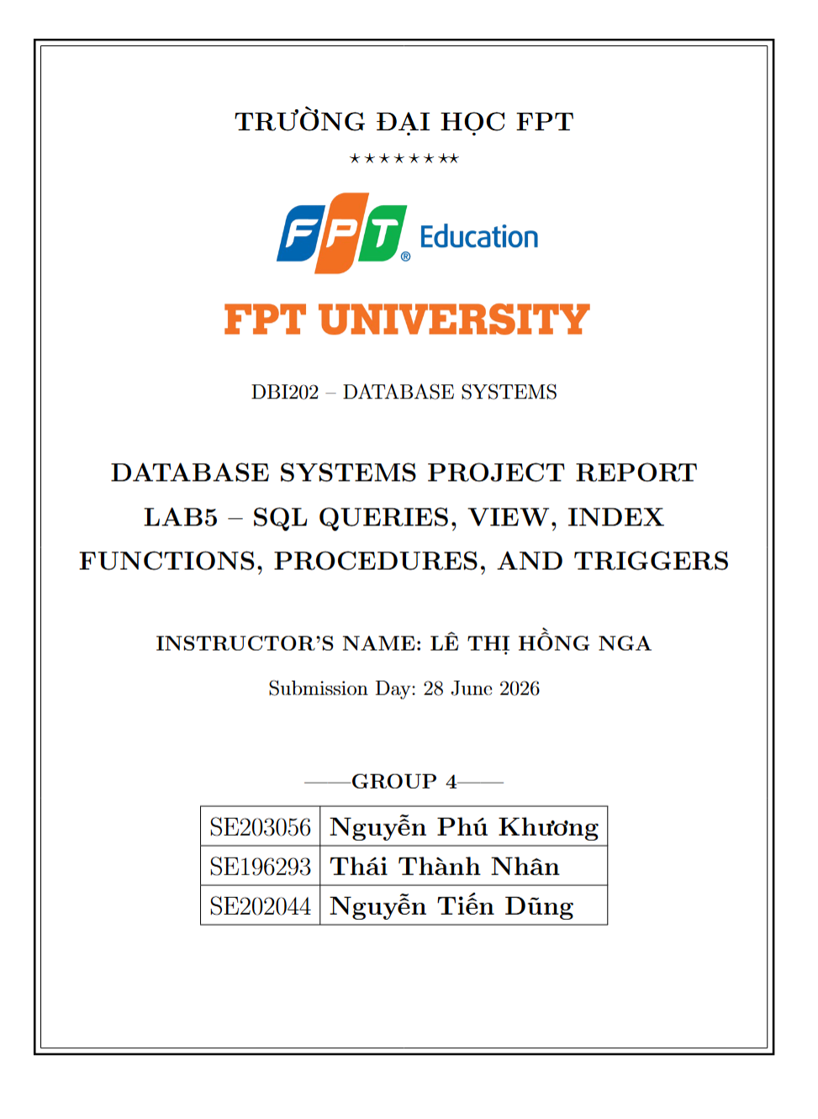

Contents
1
1. Objective 2
2. Database Design (from Lab 4) 3
3. SQL Queries 5
3.1. Basic Queries 5
SELECT queries over entire tables 5
Filtering data with WHERE 5
Sorting with ORDER BY 7
Aggregate functions (COUNT, SUM, AVG, MAX, MIN) 9
3.2. Intermediate Queries 11
Joining multiple tables (INNER JOIN / LEFT JOIN) 11
Grouping with GROUP BY and HAVING 13
Subqueries in WHERE / FROM 15
3.3. Advanced Queries 17
Nested subqueries 17
Using EXISTS, IN, ANY/ALL 18
Set operations (UNION / INTERSECT / EXCEPT) 19
4. Functions 21
5. Stored Procedures 23
6. Triggers 26
7. Views and Indexes 29
Views - simplifying complex queries 29
Indexes - speeding up queries 30
8. Conclusion and Reflection 31

1. Objective
Lab 5 focuses on practicing SQL programming on the database designed in Lab 4 for the Household Cleaning Robot Sales & Maintenance Management System (HCRS&MMS). Students write queries ranging from basic to advanced, and build Functions, Stored Procedures, and Triggers to enforce business rules and automate tasks, together with Views and Indexes.
Specific objectives:
- Write SELECT, WHERE, ORDER BY queries and aggregate functions (COUNT/SUM/AVG/MAX/MIN).
- Write intermediate queries: multi-table JOINs, GROUP BY/HAVING and subqueries.
- Write advanced queries: nested subqueries, EXISTS/IN/ANY/ALL, and set operations UNION/INTERSECT/EXCEPT.
- Build at least 4 Functions, 4 Stored Procedures and 4 Triggers.
- Create Views to simplify queries and Indexes to improve performance.

2. Database Design (from Lab 4)
The HCRS_DB database consists of 16 relations (normalized to BCNF in Lab 4) covering the main business areas: user management, product & inventory, sales & payment, warranty, maintenance, and IoT data. The table below summarizes the main entities; the full DDL (data types, PK/FK/UNIQUE/CHECK/DEFAULT).
Relation | Key Attributes | Meaning
Customer | CustomerID (PK), FullName, PhoneNumber, Email, Address, Password | Customers
Employee | EmployeeID (PK), FullName, Role, PhoneNumber, Email, Password | Employees (sales / technical / admin)
RobotModel | ModelID (PK), Brand, ModelName, Specifications, UnitPrice, WarrantyDuration | Robot models (catalog)
ModelFeature | ModelID (PK,FK), Feature (PK) | Features of each robot model
RobotUnit | RobotID (PK), ModelID (FK), SerialNumber, Status | Individual robot units in stock
SalesOrder | OrderID (PK), CustomerID (FK), EmployeeID (FK), OrderDate, TotalAmount, OrderStatus | Sales orders
OrderDetail | RobotID (PK,FK), OrderID (FK), SellingPrice | Order line items
Payment | PaymentID (PK), Amount, PaymentDate, PaymentMethod | Payments (super-type)
OrderPayment | PaymentID (PK,FK), OrderID (FK) | Payments for sales orders
ServicePayment | PaymentID (PK,FK), ServiceRecordID (FK) | Payments for maintenance services
WarrantyRegistration | WarrantyID (PK), RobotID (FK,UQ), CustomerID (FK), StartDate, EndDate | Warranty registrations
ServiceRequest | RequestID (PK), RobotID (FK), CustomerID (FK), IssueDescription, RequestDate, Status | Service / repair requests
MaintenanceRecord | RecordID (PK), RequestID (FK,UQ), TechnicianID (FK), ActionsTaken, ServiceFee, CompletionDate | Maintenance results
ReplacedPart | RecordID (PK,FK), PartName (PK) | Replaced parts
DeviceLog | LogID (PK), RobotID (FK), LogTime, ErrorCode | IoT data from robots
LogStatistic | LogID (PK,FK), MetricName (PK), MetricValue | Metrics derived from logs
In addition to the 16 tables above, Lab 5 adds a supporting table RobotStatusAudit to record the history of robot status changes (written automatically by a trigger).
Sample data: 8 customers, 8 employees, 6 robot models, 15 robots, 8 sales orders, 8 payments, 8 warranty registrations, 7 service requests, 6 maintenance records and 10 IoT log records - enough for every query to return meaningful results.

3. SQL Queries
This section presents SQL queries at three increasing levels: basic, intermediate and advanced. Each query includes an explanation and a placeholder for the execution result screenshot.

3.1. Basic Queries

SELECT queries over entire tables
1. Get all customers
Retrieve all records from the Customer table.
SELECT * FROM Customer;
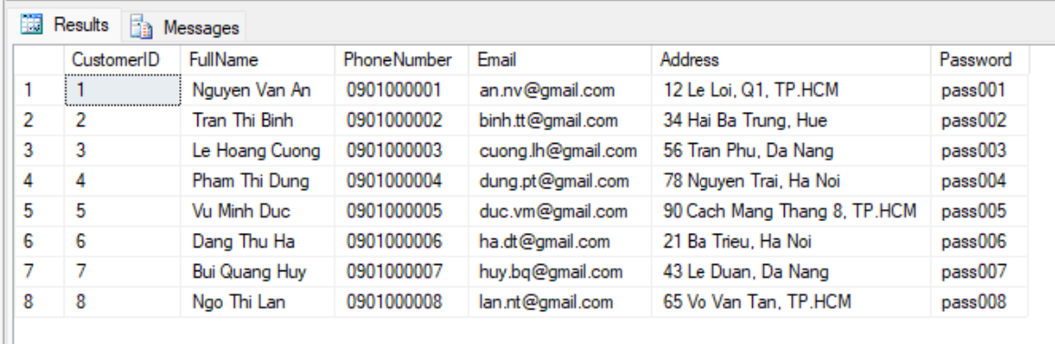2. Get all employees
Retrieve all employees (sales, technical, admin).
SELECT * FROM Employee;
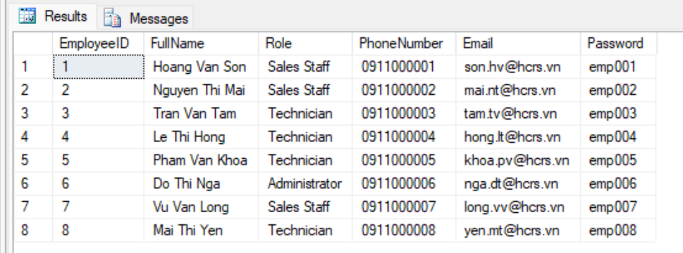3. Get all robot models in the catalog
Retrieve all robot models with selling price and warranty duration.
SELECT * FROM RobotModel;
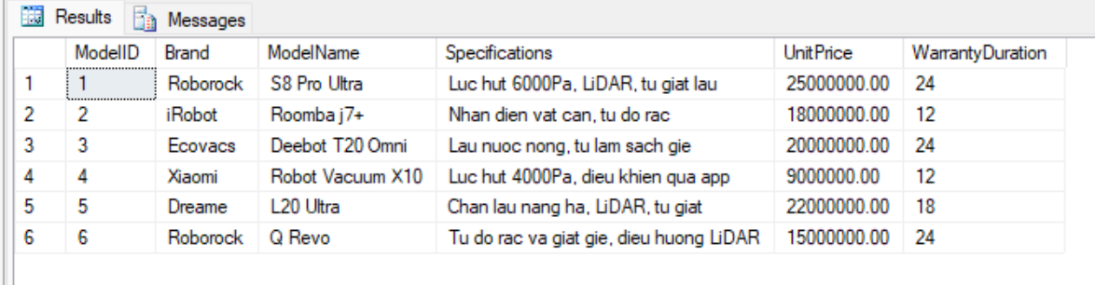4. Get all robots in stock
Retrieve every robot unit and its current status.
SELECT * FROM RobotUnit;
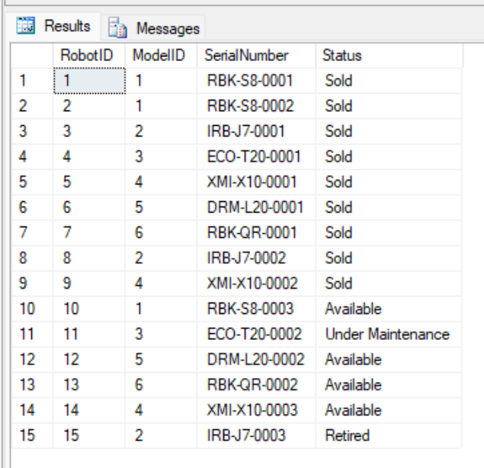
5. Get all sales orders
Retrieve all sales orders.
SELECT * FROM SalesOrder;
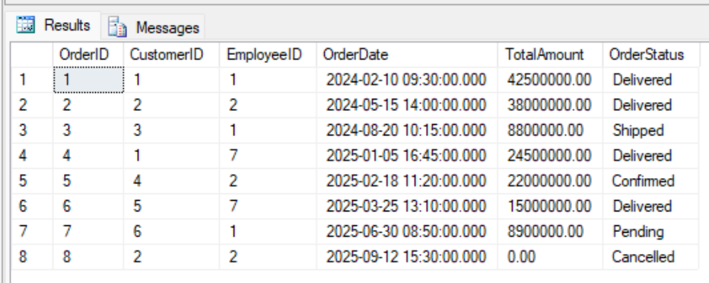
6. Get data from transaction and maintenance tables
Quick look at the remaining tables: payments, service requests, maintenance, IoT logs.
SELECT * FROM Payment;
SELECT * FROM ServiceRequest;
SELECT * FROM MaintenanceRecord;
SELECT * FROM DeviceLog;
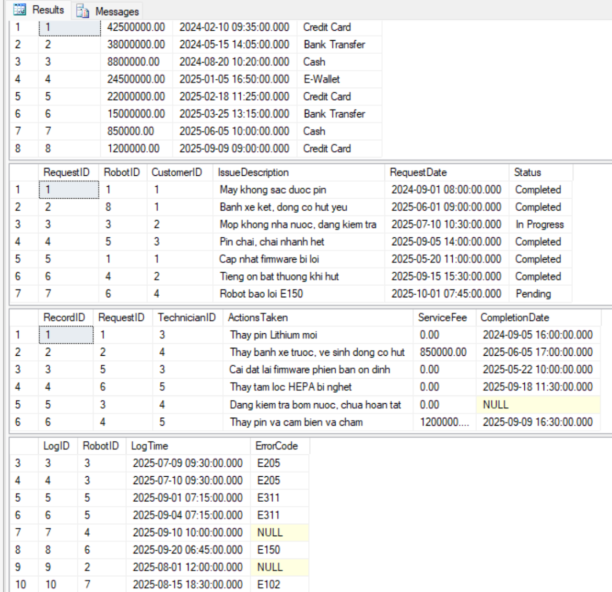

Filtering data with WHERE
1. Customers in Ho Chi Minh City
Filter customers whose address contains "TP.HCM" using the LIKE operator.
SELECT CustomerID, FullName, Address
FROM Customer
WHERE Address LIKE N'%TP.HCM%';
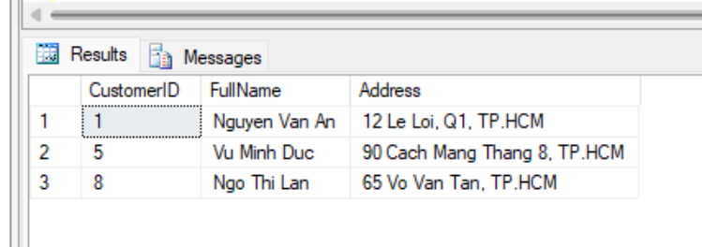
2. Employees who are technicians
Filter employees whose Role is Technician.
SELECT EmployeeID, FullName, Role
FROM Employee
WHERE Role = N'Technician';
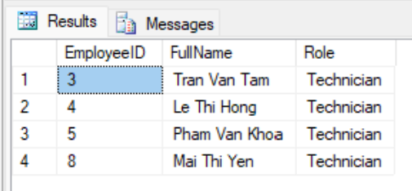
3. Robot models priced above 20 million
Filter premium robot models with UnitPrice > 20,000,000 VND.
SELECT ModelID, Brand, ModelName, UnitPrice
FROM RobotModel
WHERE UnitPrice > 20000000;
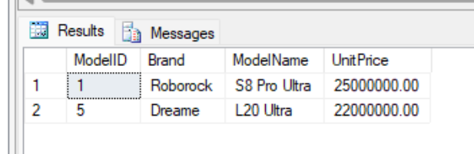
4. Robot models of the Roborock brand
Filter robot models belonging to the Roborock brand.
SELECT ModelID, ModelName, UnitPrice
FROM RobotModel
WHERE Brand = N'Roborock';
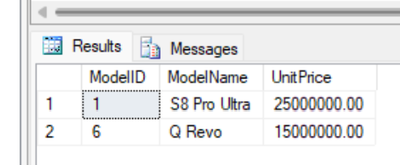
5. Robots still available in stock
Filter robots with status Available (ready to sell).
SELECT RobotID, ModelID, SerialNumber
FROM RobotUnit
WHERE Status = N'Available';
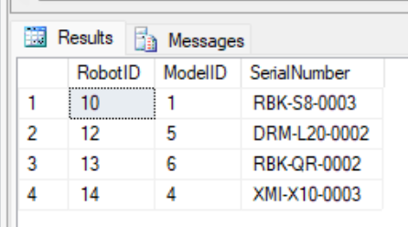
6. Successfully delivered orders
Filter orders with status Delivered.
SELECT OrderID, CustomerID, OrderDate, TotalAmount
FROM SalesOrder
WHERE OrderStatus = N'Delivered';
[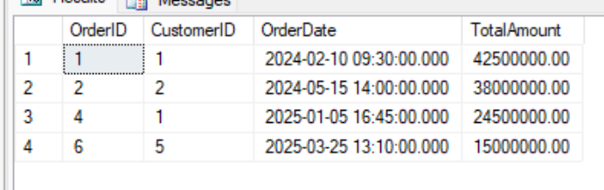
7. Orders in 2025
Filter orders created in 2025 using a date-range condition.
SELECT OrderID, OrderDate, TotalAmount, OrderStatus
FROM SalesOrder
WHERE OrderDate >= '2025-01-01' AND OrderDate < '2026-01-01';
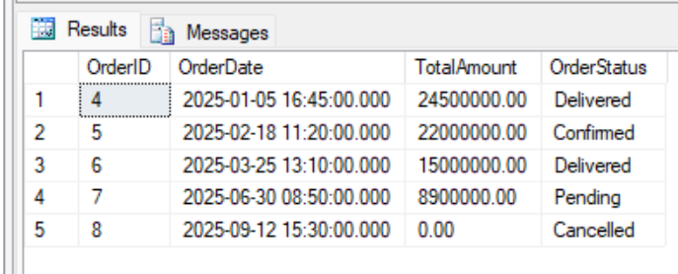
8. Orders with total amount from 10 to 40 million
Filter orders by value range using BETWEEN.
SELECT OrderID, TotalAmount, OrderStatus
FROM SalesOrder
WHERE TotalAmount BETWEEN 10000000 AND 40000000;
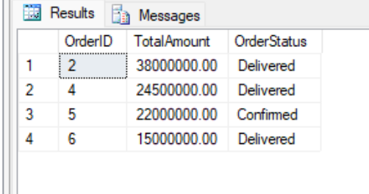
9. Payments by credit card
Filter payment transactions made by Credit Card.
SELECT PaymentID, Amount, PaymentDate
FROM Payment
WHERE PaymentMethod = N'Credit Card';
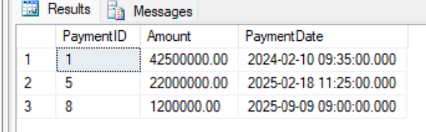
10. Service requests not yet completed
Filter service requests not in Completed status (using IN for multiple statuses).
SELECT RequestID, RobotID, Status, RequestDate
FROM ServiceRequest
WHERE Status IN (N'Pending', N'Assigned', N'In Progress');
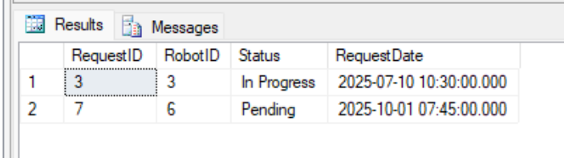
11. Warranties still valid
Filter warranty registrations whose end date has not passed the current date.
SELECT WarrantyID, RobotID, StartDate, EndDate
FROM WarrantyRegistration
WHERE EndDate >= CAST(GETDATE() AS DATE);
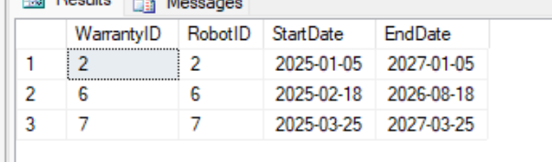
12. Device logs with an error code
Filter IoT logs that actually recorded an error code (ErrorCode IS NOT NULL).
SELECT LogID, RobotID, LogTime, ErrorCode
FROM DeviceLog
WHERE ErrorCode IS NOT NULL;
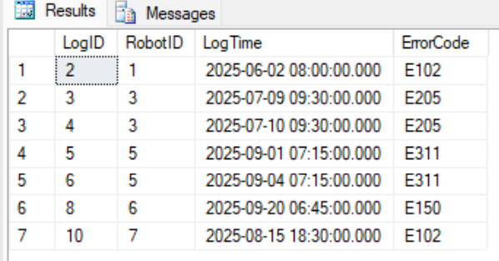
13. Maintenance with a service fee
Filter maintenance records that actually incurred a service fee (> 0).
SELECT RecordID, RequestID, ServiceFee, CompletionDate
FROM MaintenanceRecord
WHERE ServiceFee > 0;
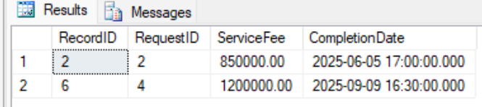

Sorting with ORDER BY
1. Robot models by descending price
Sort the catalog from most to least expensive.
SELECT ModelID, ModelName, UnitPrice
FROM RobotModel
ORDER BY UnitPrice DESC;
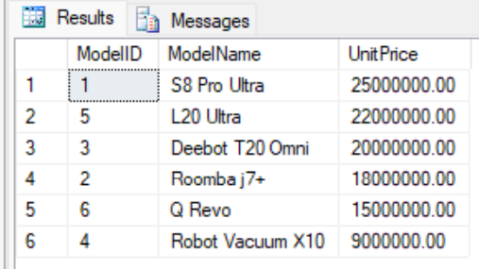
2. Customers by name A-Z
Sort the customer list by full name ascending.
SELECT CustomerID, FullName
FROM Customer
ORDER BY FullName ASC;
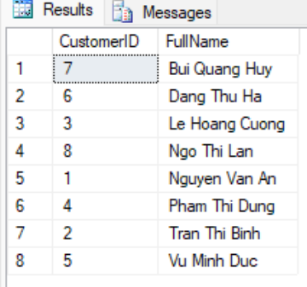
3. Q1/2025 orders by descending date
List orders in Q1 2025, sorted by order date descending.
SELECT OrderID, OrderDate, TotalAmount
FROM SalesOrder
WHERE OrderDate >= '2025-01-01' AND OrderDate < '2025-04-01'
ORDER BY OrderDate DESC;
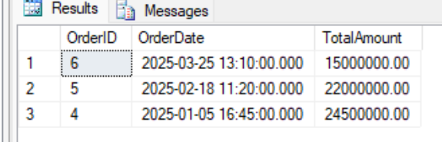
4. Employees by role then by name
Sort employees by Role, and by name within the same role.
SELECT FullName, Role
FROM Employee
ORDER BY Role ASC, FullName ASC;
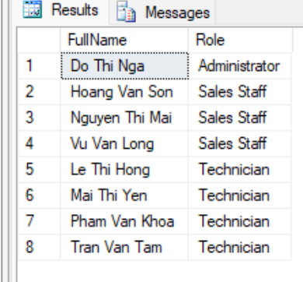
5. Robots by status then by model
Sort robots by Status, and by ModelID within the same status.
SELECT RobotID, ModelID, Status
FROM RobotUnit
ORDER BY Status ASC, ModelID ASC;
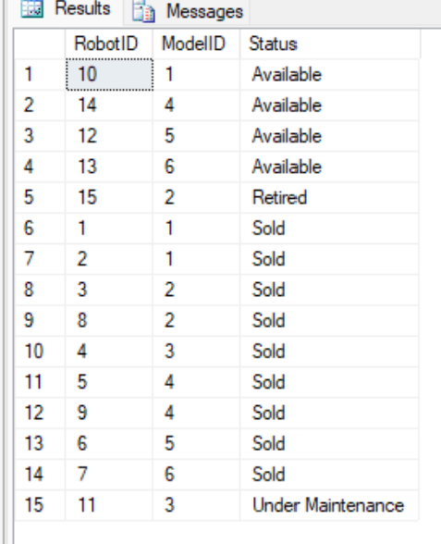
6. Payments by descending amount
Sort transactions by amount from high to low.
SELECT PaymentID, Amount, PaymentMethod
FROM Payment
ORDER BY Amount DESC;
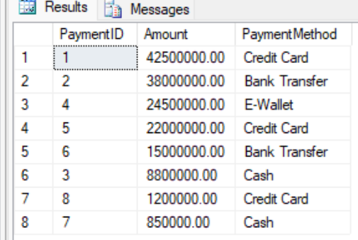
7. Service requests by ascending date
Sort service requests by submission date ascending.
SELECT RequestID, RobotID, RequestDate, Status
FROM ServiceRequest
ORDER BY RequestDate ASC;
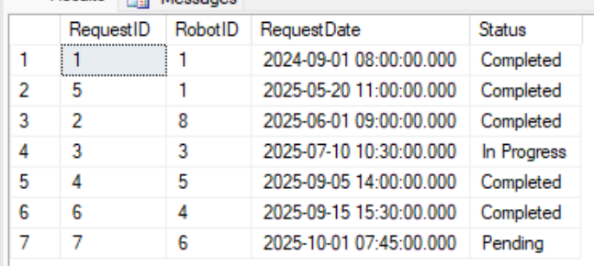
8. Maintenance by descending fee
Sort maintenance records by service fee descending.
SELECT RecordID, RequestID, ServiceFee
FROM MaintenanceRecord
ORDER BY ServiceFee DESC;
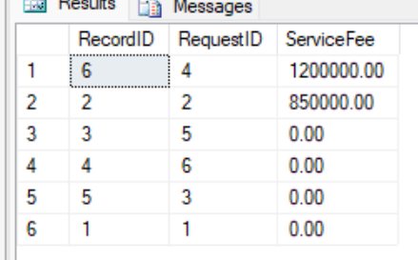
9. Warranties by expiry date
Sort warranty registrations by end date ascending.
SELECT WarrantyID, RobotID, EndDate
FROM WarrantyRegistration
ORDER BY EndDate ASC;
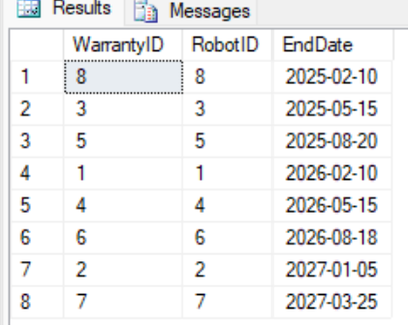
10. Latest device logs first
Sort IoT logs by time descending (latest first).
SELECT LogID, RobotID, LogTime, ErrorCode
FROM DeviceLog
ORDER BY LogTime DESC;
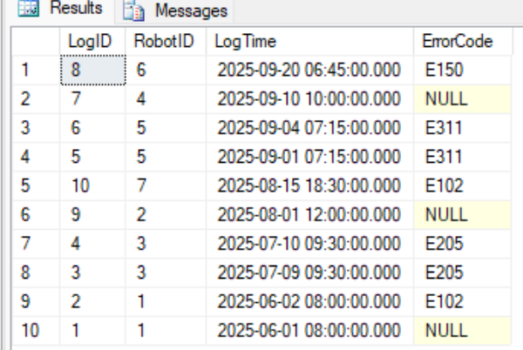

Aggregate functions (COUNT, SUM, AVG, MAX, MIN)
1. Total number of customers
Count the total number of customers in the system.
SELECT COUNT(*) AS TotalCustomers FROM Customer;
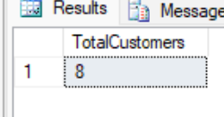
2. Total number of robots in stock
Count the total number of robot units managed.
SELECT COUNT(*) AS TotalRobots FROM RobotUnit;
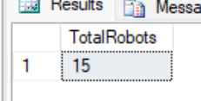
3. Average robot model price
Compute the average selling price of robot models.
SELECT AVG(UnitPrice) AS AvgPrice FROM RobotModel;
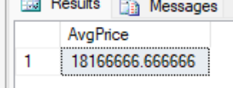
4. Highest and lowest price
Find the highest and lowest selling price in the catalog.
SELECT MAX(UnitPrice) AS MaxPrice, MIN(UnitPrice) AS MinPrice FROM RobotModel;
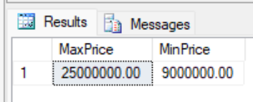
5. Total revenue by orders
Compute the total value of all orders (by the TotalAmount column).
SELECT SUM(TotalAmount) AS TotalRevenue FROM SalesOrder;
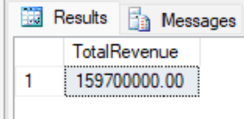
6. Number of robots ready to sell
Count robots currently in Available status.
SELECT COUNT(*) AS AvailableRobots
FROM RobotUnit
WHERE Status = N'Available';
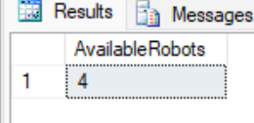
7. Total amount actually collected from payments
Compute the total amount collected across all payment transactions.
SELECT SUM(Amount) AS TotalCollected FROM Payment;
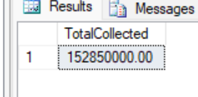
8. Average service fee
Compute the average maintenance fee across records.
SELECT AVG(ServiceFee) AS AvgServiceFee FROM MaintenanceRecord;
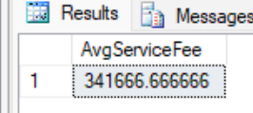
9. Highest service fee
Find the highest maintenance fee ever incurred.
SELECT MAX(ServiceFee) AS MaxServiceFee FROM MaintenanceRecord;
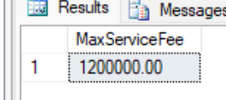
10. Total number of service requests
Count the total number of maintenance/repair requests.
SELECT COUNT(*) AS TotalRequests FROM ServiceRequest;
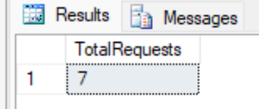
11. Number of logs recording an error
Count IoT logs that have an error code (ignoring NULL logs).
SELECT COUNT(ErrorCode) AS ErrorLogCount FROM DeviceLog;
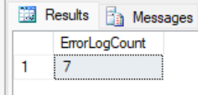

3.2. Intermediate Queries

Joining multiple tables (INNER JOIN / LEFT JOIN)
1. Orders with customer and salesperson names
INNER JOIN the three tables SalesOrder, Customer, Employee to display the customer and the handling employee.
SELECT so.OrderID, c.FullName AS Customer, e.FullName AS SalesStaff,
so.OrderDate, so.TotalAmount, so.OrderStatus
FROM SalesOrder so
JOIN Customer c ON so.CustomerID = c.CustomerID
JOIN Employee e ON so.EmployeeID = e.EmployeeID;
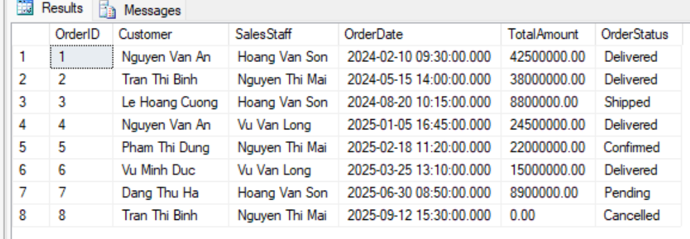
2. Sold robots with model and selling price
JOIN OrderDetail -> RobotUnit -> RobotModel to know which model each sold robot belongs to.
SELECT od.OrderID, od.RobotID, rm.Brand, rm.ModelName, od.SellingPrice
FROM OrderDetail od
JOIN RobotUnit ru ON od.RobotID = ru.RobotID
JOIN RobotModel rm ON ru.ModelID = rm.ModelID
ORDER BY od.OrderID;
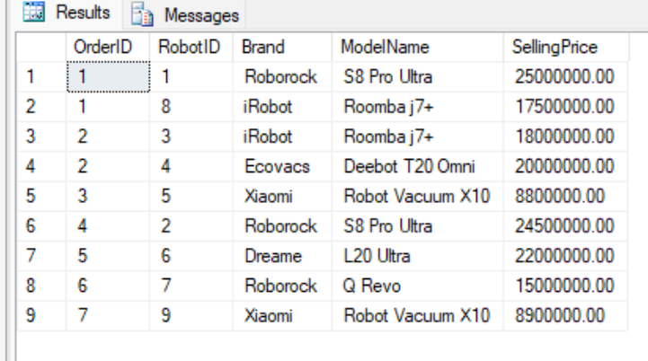
3. Robots in stock with model information
JOIN RobotUnit with RobotModel to display brand, model name, and status.
SELECT ru.RobotID, ru.SerialNumber, rm.Brand, rm.ModelName, ru.Status
FROM RobotUnit ru
JOIN RobotModel rm ON ru.ModelID = rm.ModelID;
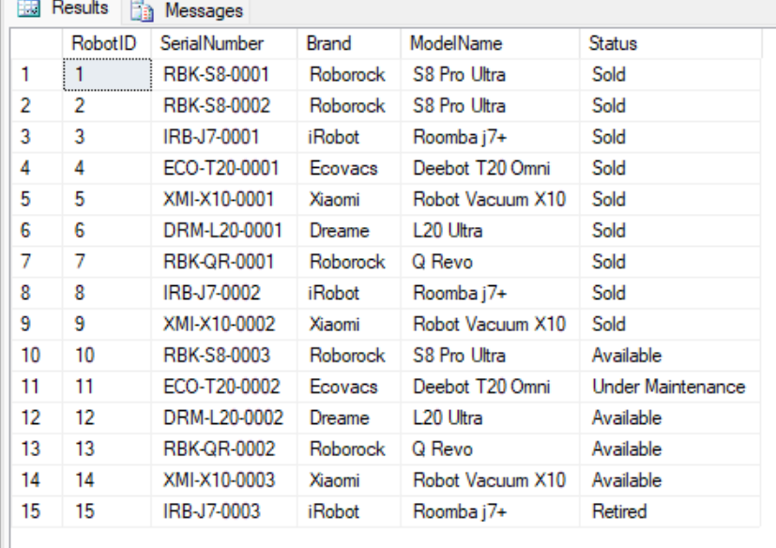
4. Service requests with customer name and robot serial
JOIN ServiceRequest with Customer and RobotUnit to see who submitted a request for which robot.
SELECT sr.RequestID, c.FullName AS Customer, ru.SerialNumber,
sr.IssueDescription, sr.Status
FROM ServiceRequest sr
JOIN Customer c ON sr.CustomerID = c.CustomerID
JOIN RobotUnit ru ON sr.RobotID = ru.RobotID;
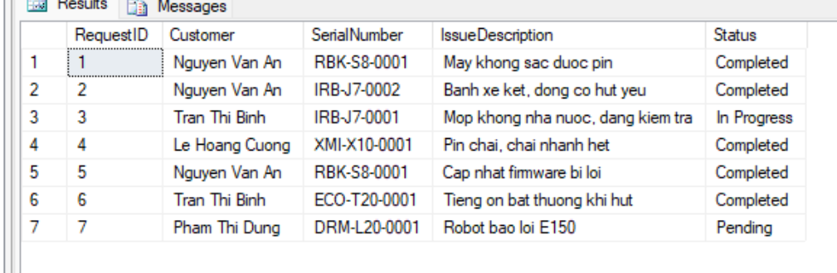
5. Maintenance history with the assigned technician
JOIN MaintenanceRecord -> ServiceRequest -> Employee to link each maintenance with its issue and technician.
SELECT mr.RecordID, sr.IssueDescription, e.FullName AS Technician,
mr.ServiceFee, mr.CompletionDate
FROM MaintenanceRecord mr
JOIN ServiceRequest sr ON mr.RequestID = sr.RequestID
JOIN Employee e ON mr.TechnicianID = e.EmployeeID;
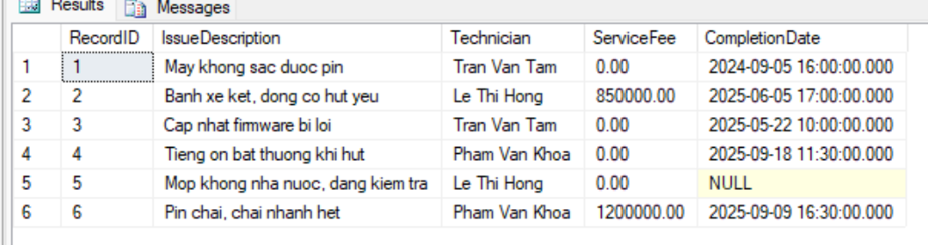
6. Full warranty information
JOIN WarrantyRegistration with RobotUnit, RobotModel and Customer.
SELECT w.WarrantyID, c.FullName AS Owner, rm.ModelName,
ru.SerialNumber, w.StartDate, w.EndDate
FROM WarrantyRegistration w
JOIN RobotUnit ru ON w.RobotID = ru.RobotID
JOIN RobotModel rm ON ru.ModelID = rm.ModelID
JOIN Customer c ON w.CustomerID = c.CustomerID;
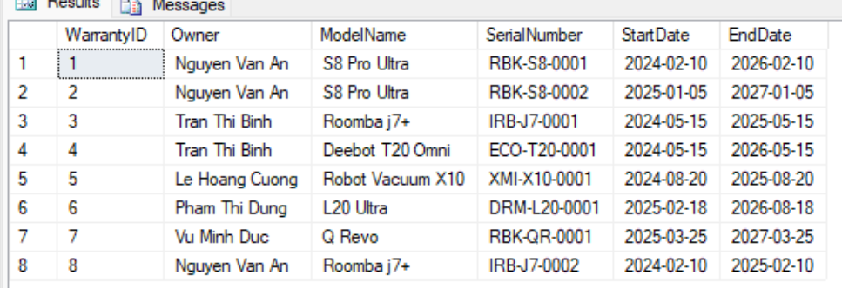
7. Payments for sales orders
JOIN Payment -> OrderPayment -> SalesOrder to know which order each payment corresponds to.
SELECT p.PaymentID, p.Amount, p.PaymentMethod, op.OrderID, so.OrderStatus
FROM Payment p
JOIN OrderPayment op ON p.PaymentID = op.PaymentID
JOIN SalesOrder so ON op.OrderID = so.OrderID;
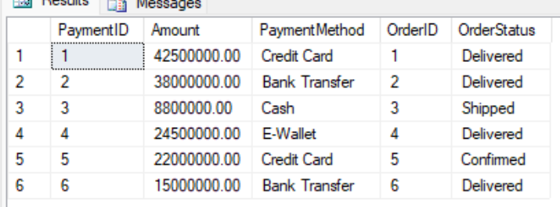
8. Payments for maintenance services
JOIN Payment -> ServicePayment -> MaintenanceRecord to see which maintenance a payment is for.
SELECT p.PaymentID, p.Amount, p.PaymentMethod, sp.ServiceRecordID, mr.ActionsTaken
FROM Payment p
JOIN ServicePayment sp ON p.PaymentID = sp.PaymentID
JOIN MaintenanceRecord mr ON sp.ServiceRecordID = mr.RecordID;
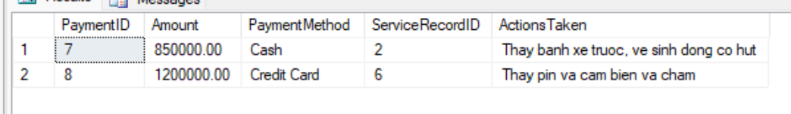
9. IoT logs with robot model
JOIN DeviceLog -> RobotUnit -> RobotModel to associate each log with its robot model.
SELECT dl.LogID, rm.ModelName, dl.LogTime, dl.ErrorCode
FROM DeviceLog dl
JOIN RobotUnit ru ON dl.RobotID = ru.RobotID
JOIN RobotModel rm ON ru.ModelID = rm.ModelID;
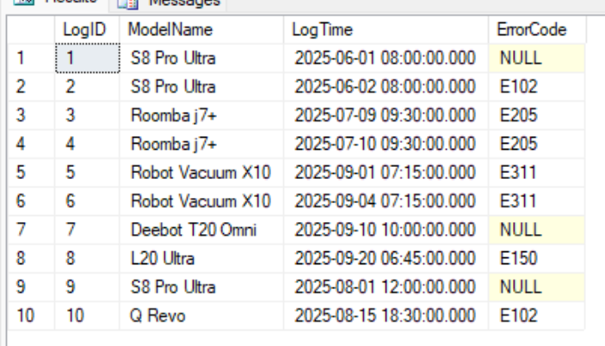
10. All orders including those without line items (LEFT JOIN)
LEFT JOIN SalesOrder with OrderDetail: cancelled orders (without line items) still appear with NULL values.
SELECT so.OrderID, so.OrderStatus, od.RobotID, od.SellingPrice
FROM SalesOrder so
LEFT JOIN OrderDetail od ON so.OrderID = od.OrderID
ORDER BY so.OrderID;
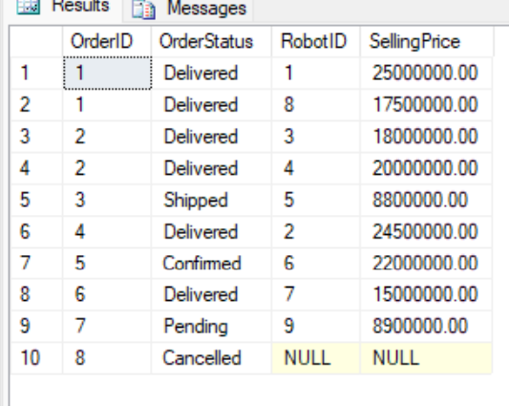
11. All customers including those who never bought (LEFT JOIN)
LEFT JOIN Customer with SalesOrder to also find customers who have not placed any order.
SELECT c.CustomerID, c.FullName, so.OrderID
FROM Customer c
LEFT JOIN SalesOrder so ON c.CustomerID = so.CustomerID
ORDER BY c.CustomerID;
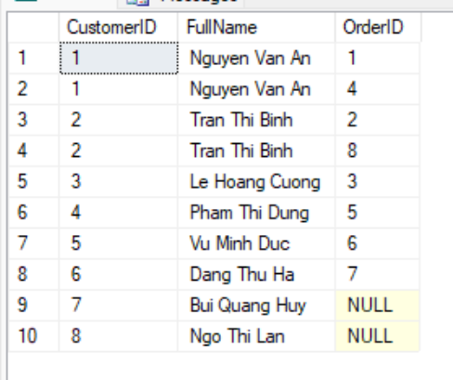
12. Features of each robot model
JOIN RobotModel with ModelFeature to list features per model.
SELECT rm.ModelName, mf.Feature
FROM RobotModel rm
JOIN ModelFeature mf ON rm.ModelID = mf.ModelID
ORDER BY rm.ModelName;
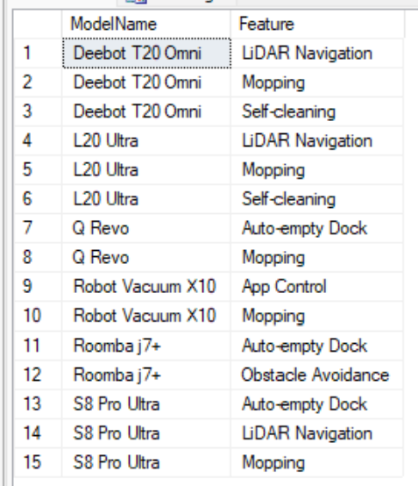

Grouping with GROUP BY and HAVING
1. Number of robots per model
GROUP BY ModelID, counting the robot units in stock for each model.
SELECT rm.ModelName, COUNT(ru.RobotID) AS Quantity
FROM RobotModel rm
JOIN RobotUnit ru ON rm.ModelID = ru.ModelID
GROUP BY rm.ModelName;
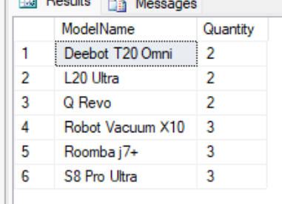
2. Number of robots per status
GROUP BY Status to summarize inventory (Available/Sold/Under Maintenance/Retired).
SELECT Status, COUNT(*) AS Quantity
FROM RobotUnit
GROUP BY Status;
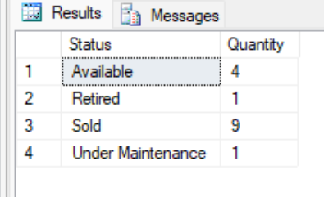
3. Total spending per customer
GROUP BY customer, computing the total order value.
SELECT c.FullName, SUM(so.TotalAmount) AS TotalSpending
FROM Customer c
JOIN SalesOrder so ON c.CustomerID = so.CustomerID
GROUP BY c.FullName
ORDER BY TotalSpending DESC;
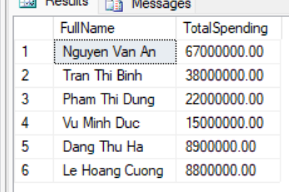
4. Number of orders handled by each salesperson
GROUP BY employee to count the orders handled.
SELECT e.FullName, COUNT(so.OrderID) AS OrderCount
FROM Employee e
JOIN SalesOrder so ON e.EmployeeID = so.EmployeeID
GROUP BY e.FullName;
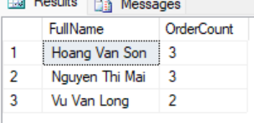
5. Total sales per order (from line items)
GROUP BY OrderID on OrderDetail to compute the actual total selling price of each order.
SELECT OrderID, COUNT(RobotID) AS RobotCount, SUM(SellingPrice) AS TotalAmount
FROM OrderDetail
GROUP BY OrderID;
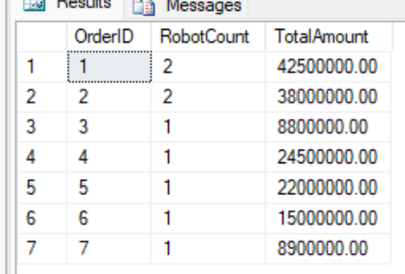
6. Number of robots sold per model
JOIN and GROUP BY to count the robots sold for each model.
SELECT rm.ModelName, COUNT(od.RobotID) AS SoldCount
FROM RobotModel rm
JOIN RobotUnit ru ON rm.ModelID = ru.ModelID
JOIN OrderDetail od ON ru.RobotID = od.RobotID
GROUP BY rm.ModelName;
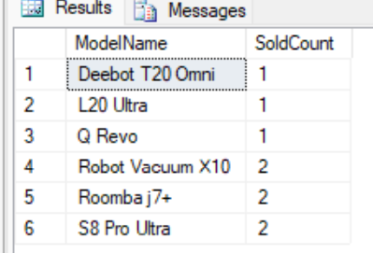
7. Number of service requests per status
GROUP BY Status on ServiceRequest.
SELECT Status, COUNT(*) AS RequestCount
FROM ServiceRequest
GROUP BY Status;
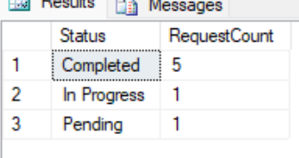
8. Robots sent for maintenance 2 or more times (HAVING)
GROUP BY RobotID and filter HAVING COUNT >= 2 to find robots that frequently fail.
SELECT RobotID, COUNT(*) AS RequestCount
FROM ServiceRequest
GROUP BY RobotID
HAVING COUNT(*) >= 2;
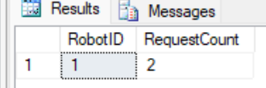
9. Total service fee per technician
GROUP BY technician to compute the total fee earned from maintenance work.
SELECT e.FullName, COUNT(mr.RecordID) AS MaintenanceCount, SUM(mr.ServiceFee) AS TotalFee
FROM Employee e
JOIN MaintenanceRecord mr ON e.EmployeeID = mr.TechnicianID
GROUP BY e.FullName;
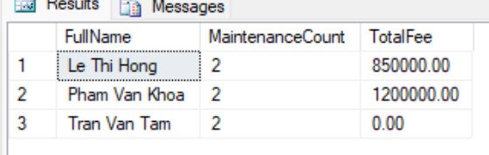
10. Number of features per robot model
GROUP BY model to count features.
SELECT rm.ModelName, COUNT(mf.Feature) AS FeatureCount
FROM RobotModel rm
JOIN ModelFeature mf ON rm.ModelID = mf.ModelID
GROUP BY rm.ModelName;
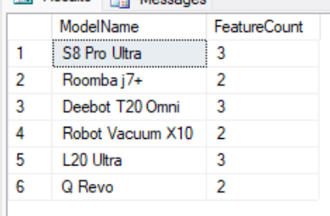
11. Robot models with more than 2 units in stock (HAVING)
GROUP BY model and filter HAVING COUNT > 2.
SELECT rm.ModelName, COUNT(ru.RobotID) AS Quantity
FROM RobotModel rm
JOIN RobotUnit ru ON rm.ModelID = ru.ModelID
GROUP BY rm.ModelName
HAVING COUNT(ru.RobotID) > 2;
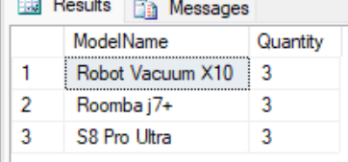
12. Customers spending more than 30 million (HAVING)
GROUP BY customer and use HAVING to filter big spenders.
SELECT c.FullName, SUM(so.TotalAmount) AS TotalSpending
FROM Customer c
JOIN SalesOrder so ON c.CustomerID = so.CustomerID
GROUP BY c.FullName
HAVING SUM(so.TotalAmount) > 30000000;
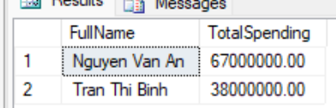

Subqueries in WHERE / FROM
1. Customers who have placed an order
Subquery in IN: get customers whose CustomerID appears in SalesOrder.
SELECT CustomerID, FullName
FROM Customer
WHERE CustomerID IN (SELECT CustomerID FROM SalesOrder);
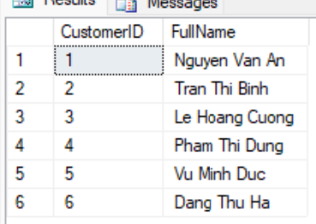
2. Robots never sold
Subquery NOT IN: robots not present in the OrderDetail table.
SELECT RobotID, SerialNumber, Status
FROM RobotUnit
WHERE RobotID NOT IN (SELECT RobotID FROM OrderDetail);
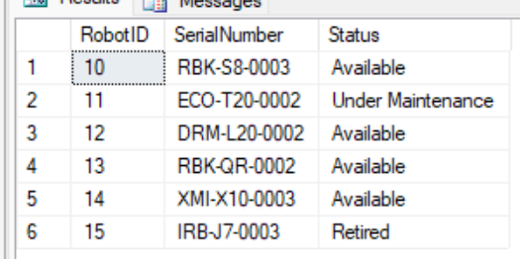
3. Robot models more expensive than average
Scalar subquery: compare UnitPrice with the catalog-wide average price.
SELECT ModelName, UnitPrice
FROM RobotModel
WHERE UnitPrice > (SELECT AVG(UnitPrice) FROM RobotModel);
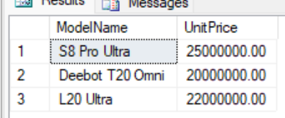
4. Orders larger than the average value
Scalar subquery computing AVG(TotalAmount) then filtering.
SELECT OrderID, TotalAmount
FROM SalesOrder
WHERE TotalAmount > (SELECT AVG(TotalAmount) FROM SalesOrder);
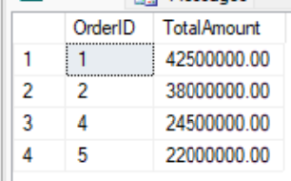
5. Customers who never requested service
Subquery NOT IN on ServiceRequest.
SELECT CustomerID, FullName
FROM Customer
WHERE CustomerID NOT IN (SELECT CustomerID FROM ServiceRequest);
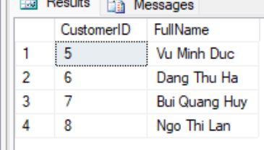
6. Employees who have performed maintenance
Subquery IN on MaintenanceRecord to get technicians who have work.
SELECT EmployeeID, FullName, Role
FROM Employee
WHERE EmployeeID IN (SELECT TechnicianID FROM MaintenanceRecord);
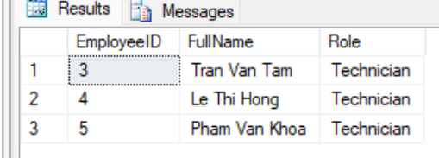
7. Revenue per customer (subquery in FROM)
Use a derived table to compute total spending then filter spenders > 20 million.
SELECT t.CustomerID, c.FullName, t.TotalSpending
FROM (SELECT CustomerID, SUM(TotalAmount) AS TotalSpending
FROM SalesOrder GROUP BY CustomerID) t
JOIN Customer c ON t.CustomerID = c.CustomerID
WHERE t.TotalSpending > 20000000;
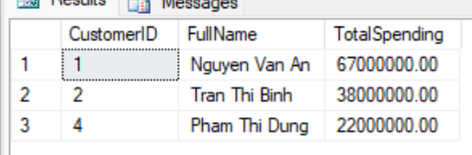
8. Robots currently under warranty
Subquery IN on WarrantyRegistration.
SELECT RobotID, SerialNumber
FROM RobotUnit
WHERE RobotID IN (SELECT RobotID FROM WarrantyRegistration);
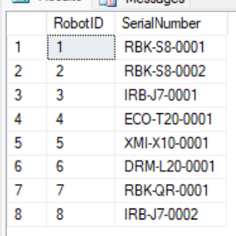
9. The most recent order
Scalar subquery using MAX(OrderDate) in WHERE.
SELECT OrderID, OrderDate, TotalAmount
FROM SalesOrder
WHERE OrderDate = (SELECT MAX(OrderDate) FROM SalesOrder);
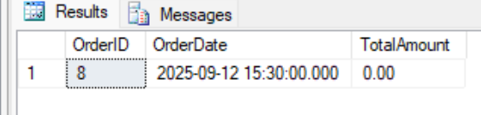
10. Robot models with no "Available" unit left
Subquery NOT IN: models not appearing in the set of models that have Available robots.
SELECT ModelID, ModelName
FROM RobotModel
WHERE ModelID NOT IN (
SELECT ModelID FROM RobotUnit WHERE Status = N'Available'
);
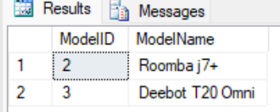
3.3. Advanced Queries

Nested subqueries
1. Customers who bought a Roborock-brand robot
4-level nesting: RobotModel(Brand) -> RobotUnit -> OrderDetail -> SalesOrder to trace back to the customer.
SELECT CustomerID, FullName
FROM Customer
WHERE CustomerID IN (
SELECT CustomerID FROM SalesOrder
WHERE OrderID IN (
SELECT OrderID FROM OrderDetail
WHERE RobotID IN (
SELECT RobotID FROM RobotUnit
WHERE ModelID IN (
SELECT ModelID FROM RobotModel WHERE Brand = N'Roborock'
)
)
)
);
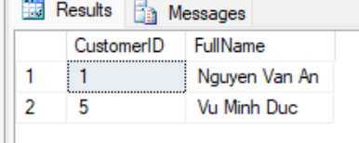
2. Robots that incurred a paid maintenance cost
2-level nesting: MaintenanceRecord(fee>0) -> ServiceRequest to get the RobotID.
SELECT RobotID, SerialNumber
FROM RobotUnit
WHERE RobotID IN (
SELECT RobotID FROM ServiceRequest
WHERE RequestID IN (
SELECT RequestID FROM MaintenanceRecord WHERE ServiceFee > 0
)
);
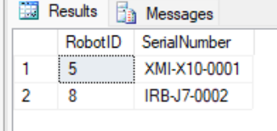
3. Technicians who repaired an iRobot-brand robot
Multi-level nesting through MaintenanceRecord -> ServiceRequest -> RobotUnit -> RobotModel(Brand).
SELECT EmployeeID, FullName
FROM Employee
WHERE EmployeeID IN (
SELECT TechnicianID FROM MaintenanceRecord
WHERE RequestID IN (
SELECT RequestID FROM ServiceRequest
WHERE RobotID IN (
SELECT RobotID FROM RobotUnit
WHERE ModelID IN (
SELECT ModelID FROM RobotModel WHERE Brand = N'iRobot'
)
)
)
);
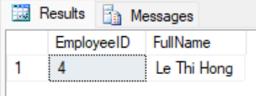
4. Robot models that currently have a unit under maintenance
Nested subquery: get the ModelID of robots with Status = Under Maintenance.
SELECT ModelID, ModelName
FROM RobotModel
WHERE ModelID IN (
SELECT ModelID FROM RobotUnit WHERE Status = N'Under Maintenance'
);
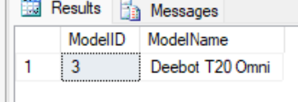
5. Customers with a robot still under valid warranty
Nested subquery combining the expiry-date condition with the list of sold robots.
SELECT CustomerID, FullName
FROM Customer
WHERE CustomerID IN (
SELECT CustomerID FROM WarrantyRegistration
WHERE EndDate >= CAST(GETDATE() AS DATE)
);
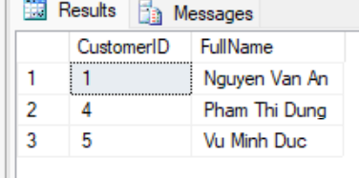
6. Customers spending above the average per customer
Nested subquery: compare a customer's total spending with the average of all customers' total spending.
SELECT c.FullName, SUM(so.TotalAmount) AS TotalSpending
FROM Customer c
JOIN SalesOrder so ON c.CustomerID = so.CustomerID
GROUP BY c.FullName
HAVING SUM(so.TotalAmount) > (
SELECT AVG(t.Total)
FROM (SELECT SUM(TotalAmount) AS Total FROM SalesOrder GROUP BY CustomerID) t
);
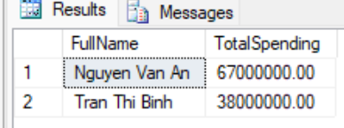

Using EXISTS, IN, ANY/ALL
1. Customers who have placed an order (EXISTS)
Correlated EXISTS: at least one order exists for the customer under consideration.
SELECT c.CustomerID, c.FullName
FROM Customer c
WHERE EXISTS (SELECT 1 FROM SalesOrder so WHERE so.CustomerID = c.CustomerID);
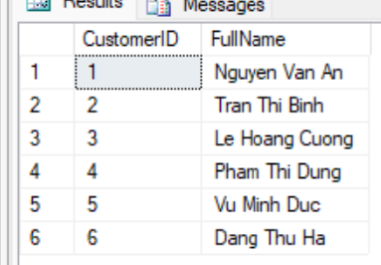
2. Robots that have never sent any IoT log (NOT EXISTS)
NOT EXISTS: no log row exists in DeviceLog for the robot under consideration.
SELECT ru.RobotID, ru.SerialNumber
FROM RobotUnit ru
WHERE NOT EXISTS (SELECT 1 FROM DeviceLog dl WHERE dl.RobotID = ru.RobotID);
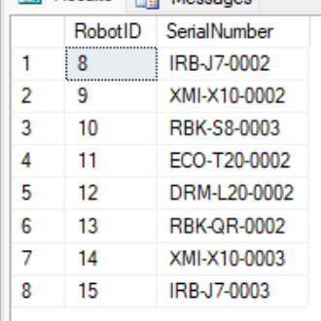
3. Robot models with at least 1 available unit (correlated EXISTS)
Correlated EXISTS with RobotUnit Status = Available.
SELECT rm.ModelID, rm.ModelName
FROM RobotModel rm
WHERE EXISTS (
SELECT 1 FROM RobotUnit ru
WHERE ru.ModelID = rm.ModelID AND ru.Status = N'Available'
);
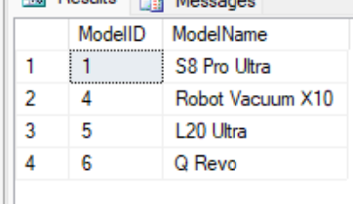
4. Robots sold in delivered orders (IN)
IN with a subquery filtering OrderIDs that have Delivered status.
SELECT RobotID, OrderID, SellingPrice
FROM OrderDetail
WHERE OrderID IN (SELECT OrderID FROM SalesOrder WHERE OrderStatus = N'Delivered');
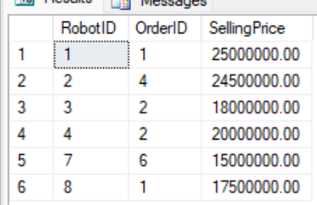
5. Robot models more expensive than at least 1 Roborock model (ANY)
> ANY: price greater than the lowest price among Roborock models.
SELECT ModelName, UnitPrice
FROM RobotModel
WHERE UnitPrice > ANY (SELECT UnitPrice FROM RobotModel WHERE Brand = N'Roborock');
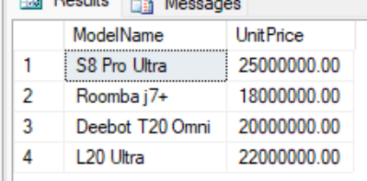
6. The most expensive robot model (>= ALL)
>= ALL: price greater than or equal to all others, i.e. the most expensive model.
SELECT ModelName, UnitPrice
FROM RobotModel
WHERE UnitPrice >= ALL (SELECT UnitPrice FROM RobotModel);
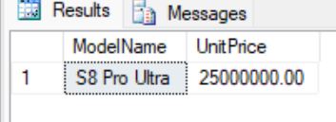

Set operations (UNION / INTERSECT / EXCEPT)
1. Combined contact directory (UNION)
UNION merges names + emails of customers and employees into a single directory (duplicates removed).
SELECT FullName, Email, N'Customer' AS ContactType FROM Customer
UNION
SELECT FullName, Email, N'Employee' FROM Employee;
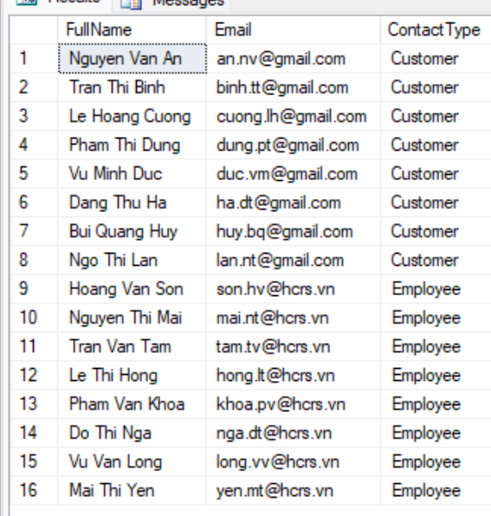
2. Customer IDs with any transaction (UNION)
UNION of CustomerIDs from orders and from service requests (union of the two sets).
SELECT CustomerID FROM SalesOrder
UNION
SELECT CustomerID FROM ServiceRequest;
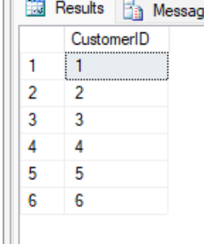
3. Customers who both bought and requested service (INTERSECT)
INTERSECT: the intersection of customers with orders and customers with service requests.
SELECT CustomerID FROM SalesOrder
INTERSECT
SELECT CustomerID FROM ServiceRequest;
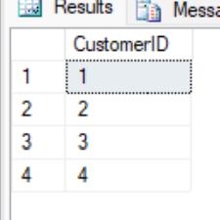
4. Customers who bought but never requested service (EXCEPT)
EXCEPT: customers with orders minus customers with service requests.
SELECT CustomerID FROM SalesOrder
EXCEPT
SELECT CustomerID FROM ServiceRequest;
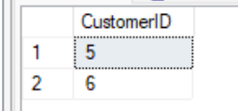
5. Robots never sold (EXCEPT)
EXCEPT: all robots minus robots that appear in OrderDetail.
SELECT RobotID FROM RobotUnit
EXCEPT
SELECT RobotID FROM OrderDetail;
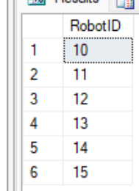
6. Robots with both IoT logs and service requests (INTERSECT)
INTERSECT: the intersection of robots with logs and robots with service requests.
SELECT RobotID FROM DeviceLog
INTERSECT
SELECT RobotID FROM ServiceRequest;
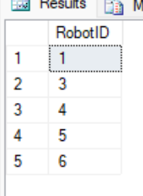

4. Functions
1. fn_GetWarrantyStatus - check the warranty status of a robot
A scalar function that takes a RobotID and returns "Under Warranty", "Warranty Expired" or "No Warranty" by comparing EndDate with the current date.
GO
CREATE FUNCTION dbo.fn_GetWarrantyStatus (@RobotID INT)
RETURNS NVARCHAR(30)
AS
BEGIN
DECLARE @End DATE;
SELECT @End = EndDate FROM WarrantyRegistration WHERE RobotID = @RobotID;
IF @End IS NULL
RETURN N'No Warranty';
IF @End >= CAST(GETDATE() AS DATE)
RETURN N'Under Warranty';
RETURN N'Warranty Expired';
END;
GO
-- Demo: apply the function to each sold robot
SELECT RobotID, SerialNumber, dbo.fn_GetWarrantyStatus(RobotID) AS WarrantyStatus
FROM RobotUnit
WHERE Status <> N'Available';
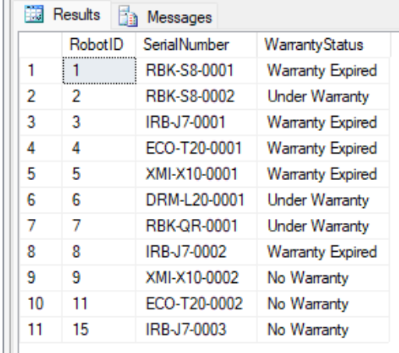
2. fn_GetCustomerTotalSpending - total spending of a customer
A scalar function computing the total amount a customer has paid for orders (via Payment + OrderPayment). Uses ISNULL to return 0 if the customer has not paid.
GO
CREATE FUNCTION dbo.fn_GetCustomerTotalSpending (@CustomerID INT)
RETURNS DECIMAL(18,2)
AS
BEGIN
DECLARE @Total DECIMAL(18,2);
SELECT @Total = SUM(p.Amount)
FROM Payment p
JOIN OrderPayment op ON p.PaymentID = op.PaymentID
JOIN SalesOrder so ON op.OrderID = so.OrderID
WHERE so.CustomerID = @CustomerID;
RETURN ISNULL(@Total, 0);
END;
GO
-- Demo: list the total spending of each customer
SELECT CustomerID, FullName, dbo.fn_GetCustomerTotalSpending(CustomerID) AS TotalSpending
FROM Customer
ORDER BY TotalSpending DESC;
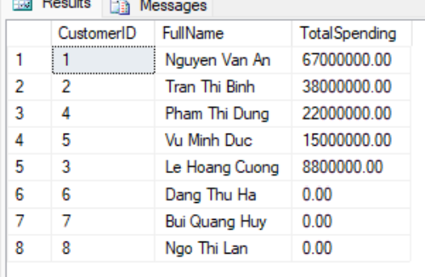
3. fn_GetModelAvailableUnits - number of available units of a model
A scalar function returning the number of robots in Available status for a model, helping salespeople check stock quickly.
GO
CREATE FUNCTION dbo.fn_GetModelAvailableUnits (@ModelID INT)
RETURNS INT
AS
BEGIN
DECLARE @Cnt INT;
SELECT @Cnt = COUNT(*)
FROM RobotUnit
WHERE ModelID = @ModelID AND Status = N'Available';
RETURN @Cnt;
END;
GO
-- Demo: available stock per model
SELECT ModelID, ModelName, dbo.fn_GetModelAvailableUnits(ModelID) AS AvailableUnits
FROM RobotModel;
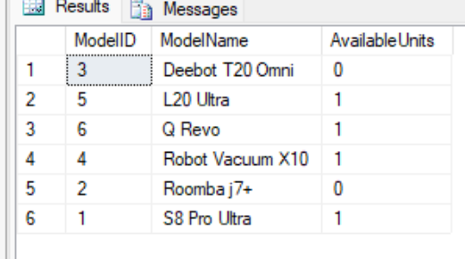
4. fn_GetMaintenanceHistoryByRobot - maintenance history of a robot (table-valued)
An inline table-valued function listing the entire maintenance history of a robot, including the issue, technician, and service fee.
GO
CREATE FUNCTION dbo.fn_GetMaintenanceHistoryByRobot (@RobotID INT)
RETURNS TABLE
AS
RETURN
(
SELECT mr.RecordID, sr.RequestID, sr.IssueDescription,
e.FullName AS Technician, mr.ServiceFee, mr.CompletionDate
FROM MaintenanceRecord mr
JOIN ServiceRequest sr ON mr.RequestID = sr.RequestID
JOIN Employee e ON mr.TechnicianID = e.EmployeeID
WHERE sr.RobotID = @RobotID
);
GO
-- Demo: maintenance history of robot RobotID = 1
SELECT * FROM dbo.fn_GetMaintenanceHistoryByRobot(1);
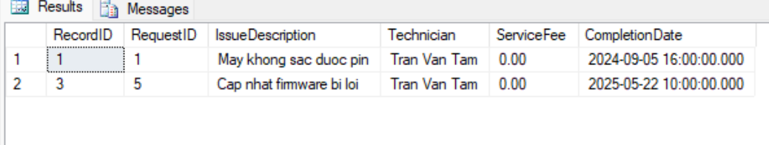

5. Stored Procedures
1. sp_CreateSalesOrder - create a complete sales order
A multi-step procedure within a transaction: check that the robot is available, create the SalesOrder, add OrderDetail, create Payment and OrderPayment, and update inventory (robot -> Sold). Uses TRY/CATCH to roll back on error.
GO
CREATE PROCEDURE sp_CreateSalesOrder
@CustomerID INT,
@EmployeeID INT,
@RobotID INT,
@SellingPrice DECIMAL(18,2),
@PaymentMethod NVARCHAR(30)
AS
BEGIN
SET NOCOUNT ON;
BEGIN TRY
BEGIN TRANSACTION;

IF NOT EXISTS (SELECT 1 FROM RobotUnit WHERE RobotID = @RobotID AND Status = N'Available')
BEGIN
-- RAISERROR requires (Message, Severity, State)
RAISERROR (N'Robot does not exist or is no longer available for sale.', 16, 1);
ROLLBACK TRANSACTION; -- Must rollback manually if we don't jump to CATCH
RETURN;
END

DECLARE @OrderID INT, @PaymentID INT;

INSERT INTO SalesOrder (CustomerID, EmployeeID, TotalAmount, OrderStatus)
VALUES (@CustomerID, @EmployeeID, @SellingPrice, N'Confirmed');
SET @OrderID = SCOPE_IDENTITY();

INSERT INTO OrderDetail (RobotID, OrderID, SellingPrice)
VALUES (@RobotID, @OrderID, @SellingPrice);

UPDATE RobotUnit SET Status = N'Sold' WHERE RobotID = @RobotID;

INSERT INTO Payment (Amount, PaymentMethod) VALUES (@SellingPrice, @PaymentMethod);
SET @PaymentID = SCOPE_IDENTITY();
INSERT INTO OrderPayment (PaymentID, OrderID) VALUES (@PaymentID, @OrderID);

COMMIT TRANSACTION;
SELECT @OrderID AS NewOrderID, @PaymentID AS NewPaymentID;
END TRY
BEGIN CATCH
IF @@TRANCOUNT > 0 ROLLBACK TRANSACTION;
-- Re-throw the original error info
DECLARE @ErrMsg NVARCHAR(4000) = ERROR_MESSAGE();
DECLARE @ErrSev INT = ERROR_SEVERITY();
DECLARE @ErrState INT = ERROR_STATE();
RAISERROR(@ErrMsg, @ErrSev, @ErrState);
END CATCH
END;
GO
-- Demo: sell robot RobotID = 10 (Available) to customer 7
EXEC sp_CreateSalesOrder @CustomerID = 7, @EmployeeID = 1, @RobotID = 10,
@SellingPrice = 24000000, @PaymentMethod = N'Credit Card';
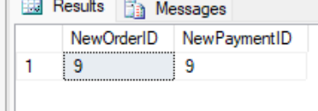
2. sp_RegisterWarranty - register a warranty for a sold robot
A procedure that automatically computes the warranty end date from the model's duration (months). Prevents duplicate registration and checks that the robot exists.
GO
CREATE PROCEDURE sp_RegisterWarranty
@RobotID INT,
@CustomerID INT,
@StartDate DATE = NULL
AS
BEGIN
SET NOCOUNT ON;
IF @StartDate IS NULL SET @StartDate = CAST(GETDATE() AS DATE);
IF EXISTS (SELECT 1 FROM WarrantyRegistration WHERE RobotID = @RobotID)
BEGIN
RAISERROR (N'This robot already has a warranty registration.', 16, 1);
RETURN;
END
DECLARE @Months INT;
SELECT @Months = rm.WarrantyDuration
FROM RobotUnit ru
JOIN RobotModel rm ON ru.ModelID = rm.ModelID
WHERE ru.RobotID = @RobotID;
IF @Months IS NULL
BEGIN
RAISERROR (N'Robot does not exist in the system.', 16, 1);
RETURN;
END
DECLARE @End DATE = DATEADD(MONTH, @Months, @StartDate);
INSERT INTO WarrantyRegistration (RobotID, CustomerID, StartDate, EndDate)
VALUES (@RobotID, @CustomerID, @StartDate, @End);
SELECT @RobotID AS RobotID, @StartDate AS StartDate, @End AS EndDate;
END;
GO
-- Demo: register a warranty for robot 10 just sold to customer 7
EXEC sp_RegisterWarranty @RobotID = 10, @CustomerID = 7;
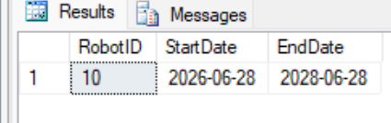
3. sp_CompleteMaintenance - record completion of maintenance
A multi-step procedure: check the service request, waive the fee if the robot is under warranty, create a MaintenanceRecord, update the request status to Completed, and create a service payment if a fee applies. Reuses the fn_GetWarrantyStatus function.
GO
CREATE PROCEDURE sp_CompleteMaintenance
@RequestID INT,
@TechnicianID INT,
@ActionsTaken NVARCHAR(MAX),
@BaseFee DECIMAL(18,2),
@PaymentMethod NVARCHAR(30) = N'Cash'
AS
BEGIN
SET NOCOUNT ON;
BEGIN TRY
BEGIN TRANSACTION;

-- Check if request exists
IF NOT EXISTS (SELECT 1 FROM ServiceRequest WHERE RequestID = @RequestID)
BEGIN
RAISERROR (N'Service request does not exist.', 16, 1);
ROLLBACK TRANSACTION;
RETURN;
END

-- Check if record already exists
IF EXISTS (SELECT 1 FROM MaintenanceRecord WHERE RequestID = @RequestID)
BEGIN
RAISERROR (N'This request already has a maintenance record.', 16, 1);
ROLLBACK TRANSACTION;
RETURN;
END

DECLARE @RobotID INT;
SELECT @RobotID = RobotID FROM ServiceRequest WHERE RequestID = @RequestID;

-- Calculate Fee based on warranty
DECLARE @Fee DECIMAL(18,2) = @BaseFee;
IF dbo.fn_GetWarrantyStatus(@RobotID) = N'Under Warranty'
SET @Fee = 0;

DECLARE @RecordID INT;
INSERT INTO MaintenanceRecord (RequestID, TechnicianID, ActionsTaken, ServiceFee, CompletionDate)
VALUES (@RequestID, @TechnicianID, @ActionsTaken, @Fee, GETDATE());
SET @RecordID = SCOPE_IDENTITY();

UPDATE ServiceRequest SET Status = N'Completed' WHERE RequestID = @RequestID;

-- Process payment if fee is applicable
IF @Fee > 0
BEGIN
DECLARE @PaymentID INT;
INSERT INTO Payment (Amount, PaymentMethod) VALUES (@Fee, @PaymentMethod);
SET @PaymentID = SCOPE_IDENTITY();
INSERT INTO ServicePayment (PaymentID, ServiceRecordID) VALUES (@PaymentID, @RecordID);
END

COMMIT TRANSACTION;
SELECT @RecordID AS NewRecordID, @Fee AS AppliedFee;
END TRY
BEGIN CATCH
IF @@TRANCOUNT > 0 ROLLBACK TRANSACTION;

-- Re-raise error using parameters retrieved from system functions
DECLARE @ErrMsg NVARCHAR(4000) = ERROR_MESSAGE();
DECLARE @ErrSev INT = ERROR_SEVERITY();
DECLARE @ErrState INT = ERROR_STATE();
RAISERROR(@ErrMsg, @ErrSev, @ErrState);
END CATCH
END;
GO
-- Demo: complete service request RequestID = 7 (robot 6 under warranty -> free)
EXEC sp_CompleteMaintenance @RequestID = 7, @TechnicianID = 5,
@ActionsTaken = N'Inspect and reset error E150', @BaseFee = 500000;
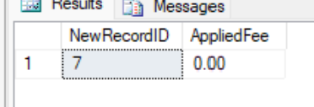
4. sp_GenerateSalesReport - revenue report by model & date range
A procedure that takes a date range and returns a summary report: units sold and revenue for each robot model within that range, sorted by revenue descending.
GO
CREATE PROCEDURE sp_GenerateSalesReport
@FromDate DATE,
@ToDate DATE
AS
BEGIN
SET NOCOUNT ON;
SELECT rm.Brand, rm.ModelName,
COUNT(od.RobotID) AS UnitsSold,
SUM(od.SellingPrice) AS Revenue
FROM OrderDetail od
JOIN SalesOrder so ON od.OrderID = so.OrderID
JOIN RobotUnit ru ON od.RobotID = ru.RobotID
JOIN RobotModel rm ON ru.ModelID = rm.ModelID
WHERE so.OrderDate >= @FromDate
AND so.OrderDate < DATEADD(DAY, 1, @ToDate)
GROUP BY rm.Brand, rm.ModelName
ORDER BY Revenue DESC;
END;
GO
-- Demo: revenue report from 01/2024 to 12/2025
EXEC sp_GenerateSalesReport @FromDate = '2024-01-01', @ToDate = '2025-12-31';
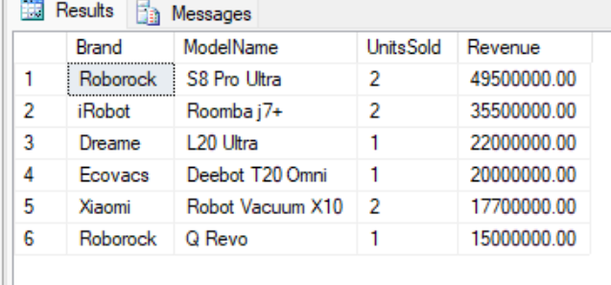

6. Triggers
1. trg_RobotUnit_AuditStatus - automatically log robot status changes
An AFTER UPDATE trigger on RobotUnit: whenever the Status column changes, it automatically writes a row into the RobotStatusAudit table (old status -> new status, timestamp). It logs only when the values actually differ.
GO
CREATE TRIGGER trg_RobotUnit_AuditStatus ON RobotUnit
AFTER UPDATE
AS
BEGIN
SET NOCOUNT ON;
INSERT INTO RobotStatusAudit (RobotID, OldStatus, NewStatus)
SELECT i.RobotID, d.Status, i.Status
FROM inserted i
JOIN deleted d ON i.RobotID = d.RobotID
WHERE i.Status <> d.Status;
END;
GO
-- Demo: change robot 14 status (Available -> Retired) and view the audit log
UPDATE RobotUnit SET Status = N'Retired' WHERE RobotID = 14;
SELECT * FROM RobotStatusAudit WHERE RobotID = 14;
[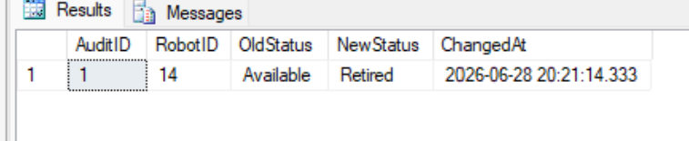]
2. trg_OrderDetail_AfterInsert - automatically update inventory after a sale
An AFTER INSERT trigger on OrderDetail: when a robot is added to an order line, it automatically changes that robot status to "Sold". This illustrates "updating inventory after a sales transaction".
GO
CREATE TRIGGER trg_OrderDetail_AfterInsert ON OrderDetail
AFTER INSERT
AS
BEGIN
SET NOCOUNT ON;
UPDATE ru
SET ru.Status = N'Sold'
FROM RobotUnit ru
JOIN inserted i ON ru.RobotID = i.RobotID
WHERE ru.Status <> N'Sold';
END;
GO
-- Demo: sell robot 12 (Available) by inserting OrderDetail directly
SELECT RobotID, Status AS BeforeSale FROM RobotUnit WHERE RobotID = 12;
DECLARE @demoOrder INT;
INSERT INTO SalesOrder (CustomerID, EmployeeID, TotalAmount, OrderStatus)
VALUES (2, 2, 22000000, N'Confirmed');
SET @demoOrder = SCOPE_IDENTITY();
INSERT INTO OrderDetail (RobotID, OrderID, SellingPrice) VALUES (12, @demoOrder, 22000000);
SELECT RobotID, Status AS AfterSale FROM RobotUnit WHERE RobotID = 12; -- -> Sold
SELECT * FROM RobotStatusAudit WHERE RobotID = 12; -- audit captured
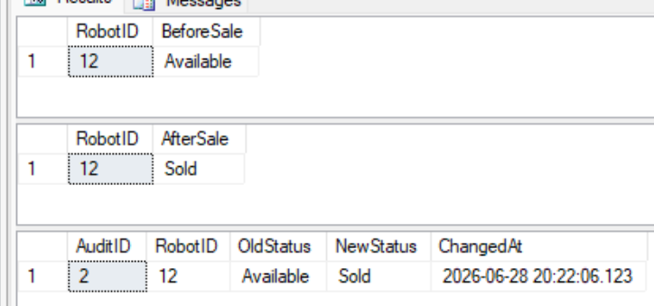
3. trg_PreventDeleteCustomerWithOrders - block deletion of referenced customers
An INSTEAD OF DELETE trigger on Customer: it disallows deleting a customer who still has orders or service requests (protecting parent records). It performs the delete only when valid.
GO
CREATE TRIGGER trg_PreventDeleteCustomerWithOrders ON Customer
INSTEAD OF DELETE
AS
BEGIN
SET NOCOUNT ON;
IF EXISTS (SELECT 1 FROM SalesOrder so JOIN deleted d ON so.CustomerID = d.CustomerID)
OR EXISTS (SELECT 1 FROM ServiceRequest sr JOIN deleted d ON sr.CustomerID = d.CustomerID)
BEGIN
RAISERROR(N'Cannot delete a customer who has orders or service requests.', 16, 1);
RETURN;
END
DELETE FROM Customer WHERE CustomerID IN (SELECT CustomerID FROM deleted);
END;
GO
-- Demo: (a) delete an unreferenced customer -> success; (b) delete a customer with orders -> blocked
INSERT INTO Customer (FullName, PhoneNumber, Email, Password)
VALUES (N'Temp Demo Customer', '0900000099', N'tam.demo@gmail.com', N'temp');
DELETE FROM Customer WHERE Email = N'tam.demo@gmail.com'; -- success
BEGIN TRY
DELETE FROM Customer WHERE CustomerID = 1; -- blocked by trigger
END TRY
BEGIN CATCH
PRINT ERROR_MESSAGE();
END CATCH
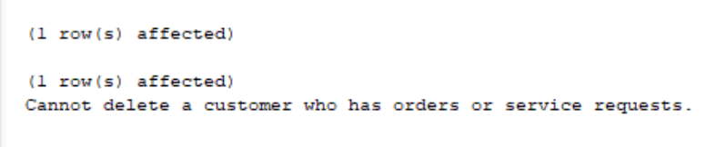
4. trg_Maintenance_AfterInsert - apply the warranty rule & sync status
An AFTER INSERT trigger on MaintenanceRecord: (1) if the robot is under warranty at the time of maintenance, it automatically sets ServiceFee = 0 (free under warranty); (2) when a completion date is present, it automatically updates the related service request to Completed status.
GO
CREATE TRIGGER trg_Maintenance_AfterInsert ON MaintenanceRecord
AFTER INSERT
AS
BEGIN
SET NOCOUNT ON;
UPDATE mr
SET mr.ServiceFee = 0
FROM MaintenanceRecord mr
JOIN inserted i ON mr.RecordID = i.RecordID
JOIN ServiceRequest sr ON i.RequestID = sr.RequestID
JOIN WarrantyRegistration w ON sr.RobotID = w.RobotID
WHERE i.ServiceFee > 0
AND CAST(GETDATE() AS DATE) BETWEEN w.StartDate AND w.EndDate;
UPDATE sr
SET sr.Status = N'Completed'
FROM ServiceRequest sr
JOIN inserted i ON sr.RequestID = i.RequestID
WHERE i.CompletionDate IS NOT NULL;
END;
GO
-- Demo: create a new request for robot 6 (under warranty) then insert a maintenance record with fee 600000
DECLARE @demoReq INT;
INSERT INTO ServiceRequest (RobotID, CustomerID, IssueDescription, Status)
VALUES (6, 4, N'Periodic maintenance within warranty', N'Assigned');
SET @demoReq = SCOPE_IDENTITY();
INSERT INTO MaintenanceRecord (RequestID, TechnicianID, ActionsTaken, ServiceFee, CompletionDate)
VALUES (@demoReq, 5, N'Periodic maintenance', 600000, GETDATE());
-- Result: ServiceFee set to 0 by the trigger (under warranty) and the request -> Completed
SELECT mr.RecordID, mr.ServiceFee, sr.Status
FROM MaintenanceRecord mr JOIN ServiceRequest sr ON mr.RequestID = sr.RequestID
WHERE mr.RequestID = @demoReq;
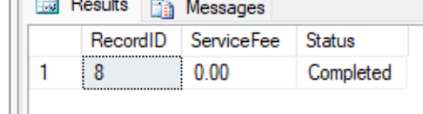

7. Views and Indexes

Views - simplifying complex queries
1. vw_RobotInventory - robot inventory with warranty status
A view aggregating each robot with brand, model name, price, status and warranty status (calling fn_GetWarrantyStatus). Helps staff look up inventory quickly.
GO
CREATE VIEW vw_RobotInventory AS
SELECT ru.RobotID, ru.SerialNumber, rm.Brand, rm.ModelName, rm.UnitPrice,
ru.Status, dbo.fn_GetWarrantyStatus(ru.RobotID) AS WarrantyStatus
FROM RobotUnit ru
JOIN RobotModel rm ON ru.ModelID = rm.ModelID;
GO
-- Demo: view the entire inventory through the view
SELECT * FROM vw_RobotInventory ORDER BY RobotID;
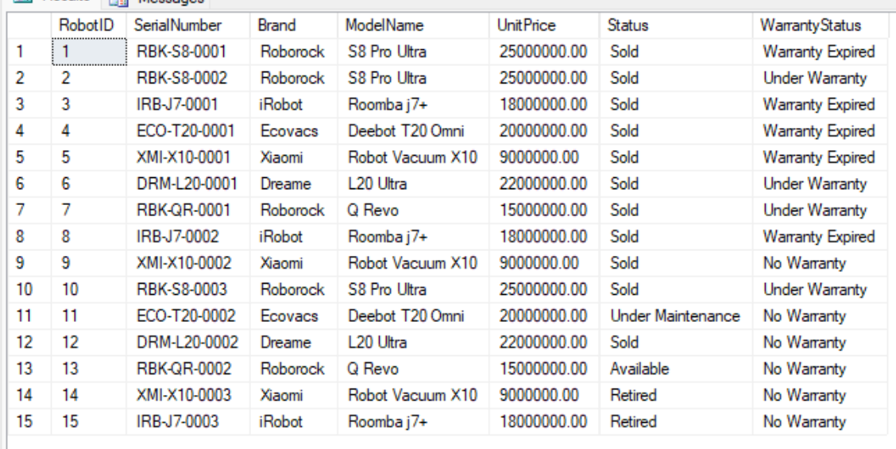
2. vw_SalesOrderSummary - order summary with amount paid
A view joining orders with customer name, salesperson and total amount paid (subquery), enabling sales reporting without rewriting complex JOINs.
GO
CREATE VIEW vw_SalesOrderSummary AS
SELECT so.OrderID, c.FullName AS CustomerName, e.FullName AS SalesStaff,
so.OrderDate, so.TotalAmount, so.OrderStatus,
ISNULL((SELECT SUM(p.Amount)
FROM OrderPayment op JOIN Payment p ON op.PaymentID = p.PaymentID
WHERE op.OrderID = so.OrderID), 0) AS PaidAmount
FROM SalesOrder so
JOIN Customer c ON so.CustomerID = c.CustomerID
JOIN Employee e ON so.EmployeeID = e.EmployeeID;
GO
-- Demo: view the summary of all orders
SELECT * FROM vw_SalesOrderSummary ORDER BY OrderID;
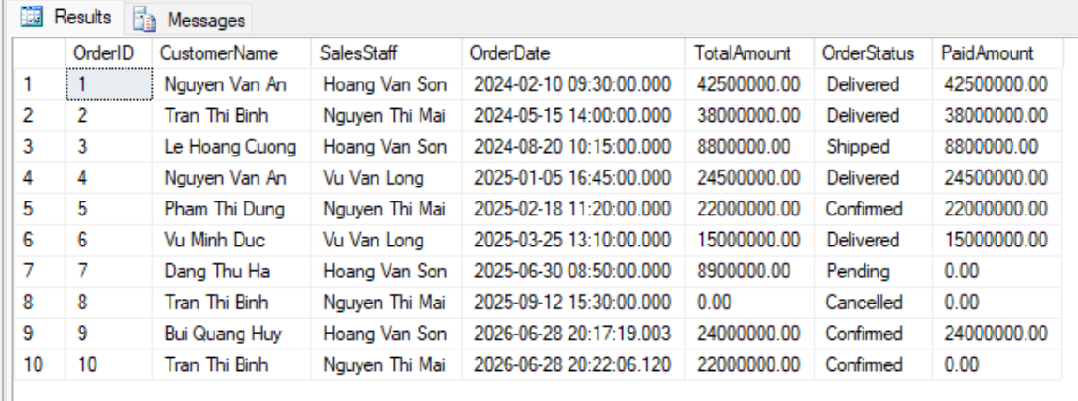
3. vw_MaintenanceDetails - full maintenance details
A view joining maintenance records with robot, customer, technician and issue description, helping managers track maintenance history by querying a single object.
GO
CREATE VIEW vw_MaintenanceDetails AS
SELECT mr.RecordID, ru.SerialNumber, rm.ModelName, c.FullName AS Customer,
tech.FullName AS Technician, sr.IssueDescription, mr.ServiceFee, mr.CompletionDate
FROM MaintenanceRecord mr
JOIN ServiceRequest sr ON mr.RequestID = sr.RequestID
JOIN RobotUnit ru ON sr.RobotID = ru.RobotID
JOIN RobotModel rm ON ru.ModelID = rm.ModelID
JOIN Customer c ON sr.CustomerID = c.CustomerID
JOIN Employee tech ON mr.TechnicianID = tech.EmployeeID;
GO
-- Demo: view maintenance details through the view
SELECT * FROM vw_MaintenanceDetails ORDER BY RecordID;
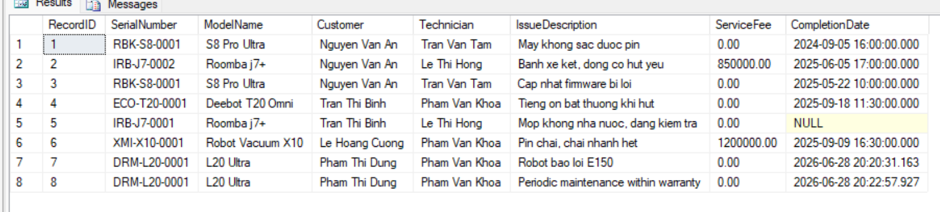

Indexes - speeding up queries
1. IX_RobotUnit_Status - single-column index
A non-clustered index on the single column RobotUnit(Status), speeding up queries that filter/aggregate by inventory status (e.g. counting Available robots).
GO
CREATE NONCLUSTERED INDEX IX_RobotUnit_Status ON RobotUnit(Status);
GO
-- Demo: a query that benefits from this index (see the Actual Execution Plan in SSMS)
SELECT RobotID, ModelID, SerialNumber FROM RobotUnit WHERE Status = N'Available';
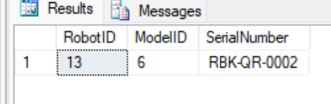
2. IX_SalesOrder_Customer_Date - composite index
A composite index on SalesOrder(CustomerID, OrderDate) optimizing queries that look up a customer orders within a date range (e.g. purchase history).
GO
CREATE NONCLUSTERED INDEX IX_SalesOrder_Customer_Date ON SalesOrder(CustomerID, OrderDate);
GO
-- Demo: a query filtering by customer and time
SELECT OrderID, OrderDate, TotalAmount
FROM SalesOrder
WHERE CustomerID = 1 AND OrderDate >= '2024-01-01'
ORDER BY OrderDate;
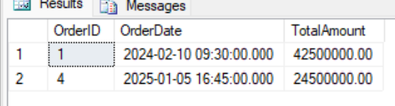
3. IX_ServiceRequest_Status - single-column index (additional)
An index on ServiceRequest(Status) helps speed up listing service requests awaiting handling (Pending/Assigned/In Progress).
GO
CREATE NONCLUSTERED INDEX IX_ServiceRequest_Status ON ServiceRequest(Status);
GO
-- Demo
SELECT RequestID, RobotID, RequestDate FROM ServiceRequest WHERE Status = N'Pending';
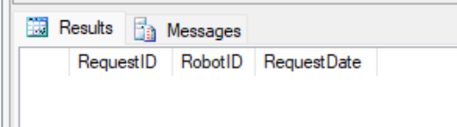

8. Conclusion and Reflection
Through Lab 5, the team has fully practiced SQL programming techniques on a realistic database for the household cleaning robot sales & maintenance system. From basic queries (SELECT, WHERE, ORDER BY, aggregate functions), to intermediate queries (JOIN, GROUP BY/HAVING, subqueries) and advanced queries (nested subqueries, EXISTS/IN/ANY/ALL, UNION/INTERSECT/EXCEPT), the team has explored the data from many business perspectives.
Key takeaways:
- Functions enable logic reuse (e.g., checking warranty status, computing a customer total spending) and can be reused inside Views and Procedures.
- Stored Procedures encapsulate multi-step operations (creating a sales order, registering a warranty, completing maintenance) within transactions, ensuring data integrity when errors occur.
- Triggers enforce business rules at the database level: automatically updating inventory after a sale, logging status changes, preventing deletion of referenced parent records, and waiving service fees while under warranty.
- Views simplify complex queries, while Indexes (single-column and composite) improve the performance of filtering/sorting queries.
Combining constraints (Lab 4) with Functions/Procedures/Triggers (Lab 5) produces a database that is both structurally robust and capable of automating business logic, reducing dependence on the application layer and limiting data errors.

