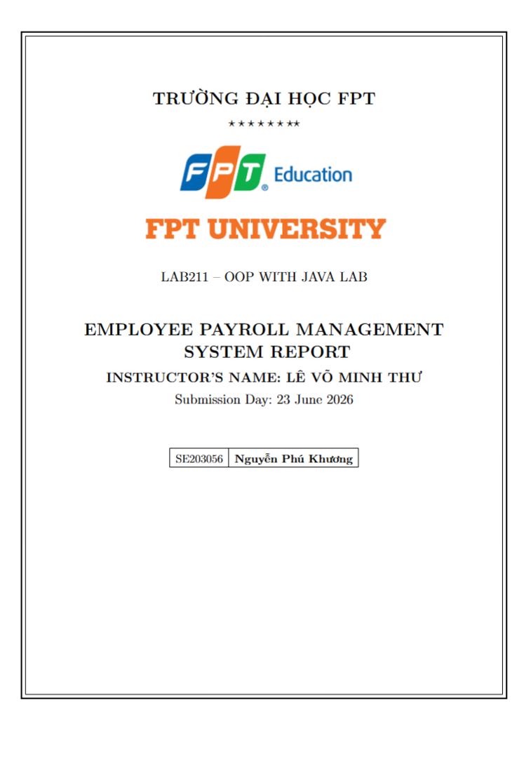
Contents
1. Project Overview 4
Main Features: 4
Access Control (Authorization): 4
Data Constraints: 5
Meal Allowance Constraints (Phu cap an): 5
2. Class Diagram & UML 6
2.1. Class Diagram 6
Class Relationships: 6
2.2. Use Case Diagram 7
4. Class Descriptions 8
4.1. Model Layer 8
4.2. Factory Layer 10
4.3. Tools Layer 10
4.4. Business Layer 11
4.5. Presentation Layer 11
5. How to Run the Program 12
5.1. System Requirements 12
5.2. Running with IDE (IntelliJ IDEA) 12
5.4. Default Accounts 12
5.5. Startup / Login Screen 12
6. Feature Usage Guide 13
6.0. Login & Authorization 13
13
6.1. Feature 1: Load employee data from file 13
14
6.2. Feature 2: Add a new employee (Admin only) 14
14
6.3. Feature 3: Update employee information (Admin only) 14
6.4. Feature 4: Remove an employee by ID (Admin only) 15
6.5. Feature 5: Search employees by attribute 15
6.6. Feature 6: Calculate monthly payroll 15
6.7. Feature 7: Display employee list 16
6.8. Feature 8: Save data to file (Admin only) 16
6.9. Feature 9: Meal allowance management (Phu cap an) 17
6.10. Feature 10: Quit program 17
7. OOP Concepts Applied 18
8. Conclusion 18
8.1. Achievements 18
8.2. Challenges & Solutions 18

1. Project Overview
The "Employee Payroll Management System" project (J1.L.P0037) is a console-based application developed in Java following the Object-Oriented Programming (OOP) approach. It manages employee information and calculates the monthly payroll. The system also includes a role-based authorization layer: users must log in, and each role (Admin or Staff) is granted access to a specific set of functions. Employee records are stored in a text file (employees.txt), and the system supports loading, adding, updating, removing, searching, payroll calculation, displaying and saving data safely.
In addition to payroll, the system provides a Meal Allowance (Phu cap an) sub-module (Feature 9): a separate CRUD menu that manages per-employee monthly meal allowances, stored in its own data file (meal_allowances.txt). The main menu therefore now offers 10 features (Quit is Feature 10).

Main Features:
# | Feature | Target | Access
- | Login (role-based authentication) | Security | All users
1 | Load employee data from file | System / File | Admin, Staff
2 | Add a new employee | Employee | Admin
3 | Update employee information | Employee | Admin
4 | Remove an employee by ID | Employee | Admin
5 | Search employees by attribute | Employee | Admin, Staff
6 | Calculate monthly payroll (active only) | Payroll | Admin, Staff
7 | Display employee list | Employee | Admin, Staff
8 | Save data to file | System / File | Admin
9 | Meal allowance management (Phu cap an) | Payroll / Allowance | Admin, Staff
10 | Quit program (confirm saving) | System | Admin, Staff

Access Control (Authorization):
Each role is mapped to a set of allowed features. The check is polymorphic: the menu asks the account object whether it can access a feature, without any if-else on the role.
Role | Allowed Features | Description
Admin | 1, 2, 3, 4, 5, 6, 7, 8, 9, 10 | Full access (all functions, incl. meal allowance)
Staff | 1, 5, 6, 7, 9, 10 | Read-only on payroll + full meal allowance (load, search, payroll, display, meal allowance, quit)

Data Constraints:
Attribute | Constraint | Valid example
id | Format ^E\d{3}$ (E001..E999), non-empty, unique | E001
name | Non-empty | David Miller
role | One of: Developer / Tester / Manager / HR | Developer
baseSalary | Positive double ( > 0 ) | 1300
workingDays | Integer in range 0 - 26 | 21
bonus | Double >= 0 | 250
status | active or inactive | active

Salary formula (not given by the assignment - self-defined and justified):
salary = baseSalary / 26 * workingDays (salary by working days)
+ bonus
+ roleAllowance() (role-based allowance - polymorphic)
roleAllowance: Developer 10%*base | Tester 5%*base
Manager 20%*base + 200 | HR 8%*base
Note: 26 is the standard maximum working days defined in the assignment. The monthly payroll (Feature 6) only sums salaries of employees whose status is active.

Meal Allowance Constraints (Phu cap an):
The Meal Allowance module manages per-employee monthly meal allowances. Each record links to an existing employee and a specific month.
Attribute | Constraint | Valid example
id | Format ^ML-\d{4}$ (ML-0001..ML-9999), unique | ML-0001
employeeId | Match ^E\d{3}$ AND must exist in the employee list | E001
month | Format MM/yyyy (month 01-12) | 06/2026
days | Integer in range 0 - 26 | 22
(employeeId, month) | Composite key - unique (one record per employee per month) | E001 + 06/2026
Meal allowance formula (self-defined):
amount = days * UNIT_PRICE, where UNIT_PRICE = 30,000 / day (constant defined in MealAllowance).

2. Class Diagram & UML

2.1. Class Diagram
The Class Diagram below illustrates the relationships between all classes in the system (employee model + authorization model).
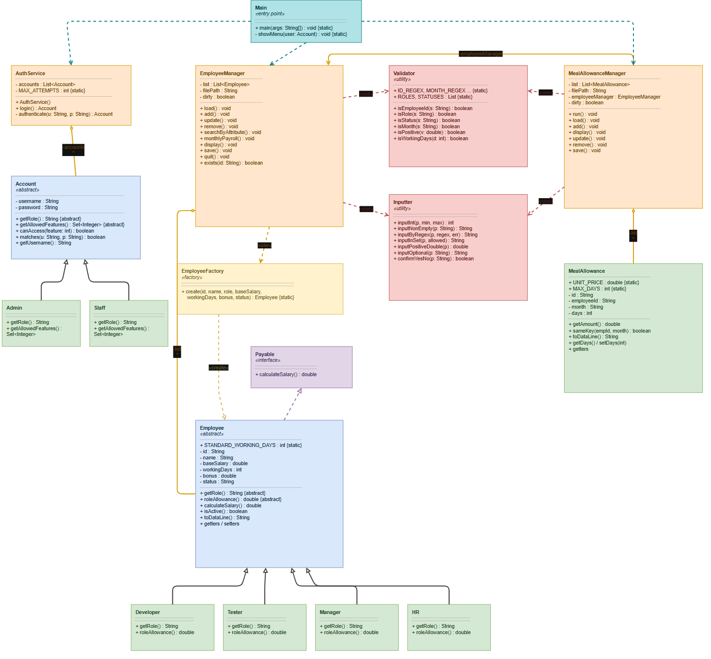

Class Relationships:
Relationship | From | To | Type
Implementation | Employee | Payable | implements
Inheritance | Developer / Tester / Manager / HR | Employee | extends
Inheritance | Admin / Staff | Account | extends
Association | EmployeeManager | List<Employee> | has-a
Association | AuthService | List<Account> | has-a
Dependency | EmployeeManager | EmployeeFactory | uses
Dependency | Main | EmployeeManager / AuthService | uses

2.2. Use Case Diagram
The Use Case Diagram shows all system functions from the user's perspective, including login and role-based access.
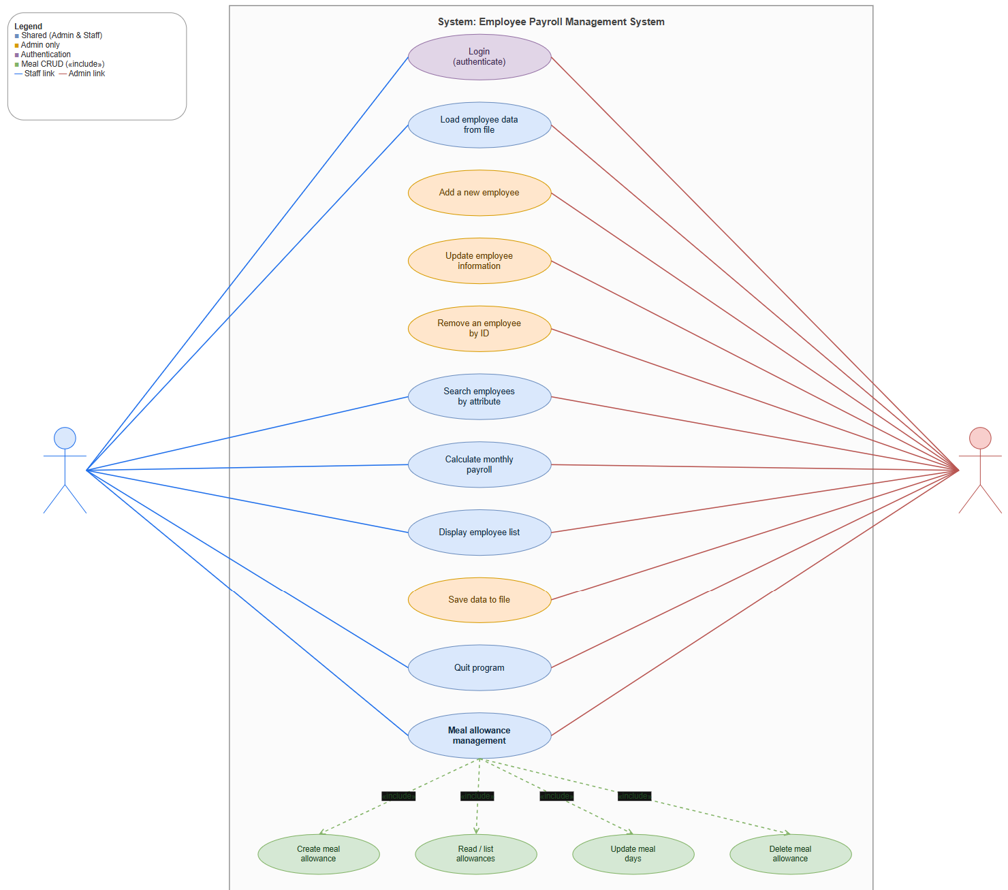
Use case diagrams

2.2. Sequence Diagram
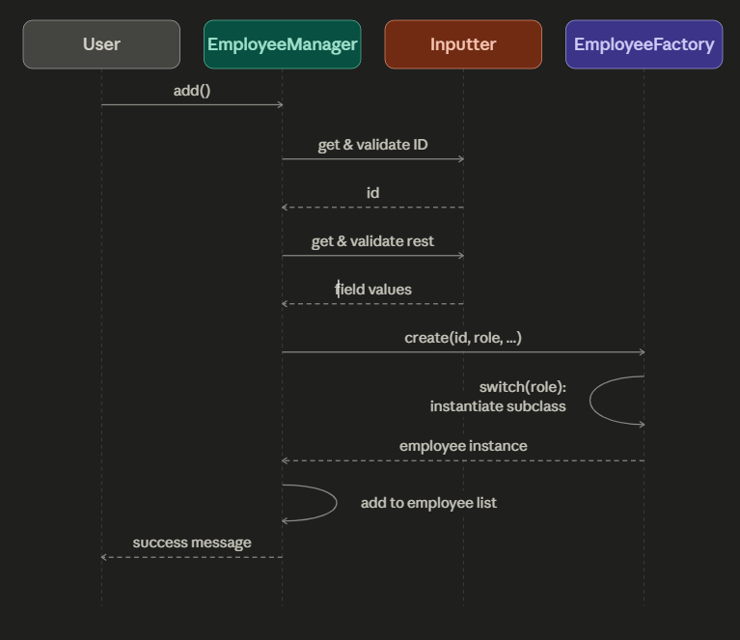
Sequence diagrams

4. Class Descriptions

4.1. Model Layer
Payable.java (Interface)
Declares the calculateSalary() contract, demonstrating polymorphism: clients depend on Payable, not concrete classes.
Employee.java (Abstract Class)
Abstract base class holding the common state and defining the abstract methods getRole() and roleAllowance() for subclass-specific behaviour (Abstraction).
Member | Type | Description
-id | String (private) | Unique identifier (E\d{3})
-name / -status | String | Name; active/inactive
-baseSalary / -bonus | double | Base salary ( > 0 ); bonus ( >= 0 )
-workingDays | int | Working days (0-26)
+getRole() | abstract String | Role name - Polymorphism
+roleAllowance() | abstract double | Role allowance - Polymorphism
+calculateSalary() | double | Template salary formula (uses roleAllowance)
+isActive() | boolean | True if status is active
+toDataLine() / toString() | String | File format / table display
+equals() / hashCode() | boolean / int | Compare by employee ID
Developer / Tester / Manager / HR (extends Employee)
Four subclasses that inherit Employee and override roleAllowance() and getRole() (Inheritance + Polymorphism).
Subclass | roleAllowance()
Developer | 0.10 * baseSalary
Tester | 0.05 * baseSalary
Manager | 0.20 * baseSalary + 200
HR | 0.08 * baseSalary
Account.java (Abstract Class) - Authorization
Abstract base class representing a user account. Holds username/password and defines the abstract methods getRole() and getAllowedFeatures(). The canAccess(feature) method is polymorphic, so the menu never needs an if-else on the role.
Member | Type | Description
-username / -password | String (private) | Login credentials (Encapsulation)
+getRole() | abstract String | Role name - Polymorphism
+getAllowedFeatures() | abstract Set<Integer> | Allowed feature numbers - Polymorphism
+canAccess(feature) | boolean | True if the feature is allowed for this role
+matches(user, pass) | boolean | Credential check for login
Admin / Staff (extends Account)
Subclass | getAllowedFeatures()
Admin | {1,2,3,4,5,6,7,8,9,10} - full access
Staff | {1,5,6,7,9,10} - read-only payroll + meal allowance
MealAllowance.java (Entity) - Meal Allowance module
Represents a monthly meal allowance for one employee. Encapsulates id, employeeId, month and days, and computes amount = days * UNIT_PRICE. Uniqueness is defined by the composite key (employeeId, month) via overridden equals()/hashCode() (Encapsulation).
Member | Type | Description
UNIT_PRICE / MAX_DAYS | static final | 30,000 per day; maximum 26 days
-id | String (private) | Unique meal allowance id (ML-\d{4})
-employeeId / -month | String (private) | Linked employee id; month (MM/yyyy)
-days | int (private) | Number of meal days (0-26)
+getAmount() | double | days * UNIT_PRICE
+setDays(days) | void | Update days within [0,26] (recalculates amount)
+sameKey(empId, month) | boolean | Composite-key match
+toDataLine() / toString() | String | File format / table display
+equals() / hashCode() | boolean / int | Compare by (employeeId, month)

4.2. Factory Layer
EmployeeFactory.java
Centralizes object creation: maps a role string to the correct Employee subclass. Adding a new role only requires one new subclass and one factory branch (Open/Closed Principle).

4.3. Tools Layer
Validator.java
Centralizes all validation rules in one place (Pattern Recognition): ID_REGEX (E\d{3}), ROLES, STATUSES, and range checks. It also validates the Meal Allowance module: MEAL_ALLOWANCE_ID_REGEX (ML-\d{4}), MONTH_REGEX (MM/yyyy), and the meal-day range (0-26).
Inputter.java
Utility class for keyboard input with built-in validation loops:
Method | Description
inputInt(prompt, min, max) | Input integer within [min, max]
inputByRegex(prompt, regex, err) | Input string matching a regex
inputInSet(prompt, allowed) | Input a value within an allowed set
inputNonEmpty / inputPositiveDouble / inputNonNegativeDouble | Constrained inputs
inputOptional(prompt) | Optional input (Enter to keep current value)
confirmYesNo(prompt) | Y/N confirmation

4.4. Business Layer
EmployeeManager.java
Manages the List<Employee> and the employee features (1-8) plus quit. Uses a dirty flag to track unsaved changes.
Method | Function
load() | Read employees.txt; skip & count invalid lines safely
add() / update() / remove() | CRUD with validation; confirm before remove
searchByAttribute() | Search by ID / Name / Role / Status (substring)
monthlyPayroll() | Sum salary of active employees (polymorphic)
display() / save() | Table display / write back to file
quit() | Confirm saving before exit (dirty flag)
AuthService.java
Manages the List<Account> and the login process (max 3 attempts).
Method | Function
login() | Prompt credentials, authenticate, return the Account or null
authenticate(user, pass) | Find a matching account in the list
MealAllowanceManager.java
Manages the List<MealAllowance> and the meal allowance sub-menu (its own CRUD loop with 6 options). Holds a reference to EmployeeManager to verify that an employee exists before creating an allowance (association). Uses its own dirty flag and a separate data file (meal_allowances.txt).
Method | Function
run() | Load data, then loop the 6-option meal allowance sub-menu
load() | Read meal_allowances.txt; skip & count invalid lines safely
add() | Create a record; validate id/employeeId/month/days; reject duplicates
display() / update() / remove() | Print table / update days (recompute amount) / delete by id (confirm)
save() | Write all records back to meal_allowances.txt

4.5. Presentation Layer
Main.java
Main entry point. Requires login first; then runs the 10-feature menu loop (including the meal allowance sub-menu) and checks currentUser.canAccess(choice) before executing each feature. Sets Locale.US for consistent number formatting.

5. How to Run the Program

5.1. System Requirements
- JDK 1.8 or higher (installed and JAVA_HOME configured)
- IDE: IntelliJ IDEA / Eclipse / NetBeans (IntelliJ recommended)
- OS: Windows / macOS / Linux

5.2. Running with IDE (IntelliJ IDEA)
- Open Netbean -> File -> Open -> select the EmployeePayrollManagementSystem folder
- Wait for the IDE to finish indexing all Java files
- Open file src/main/Main.java
- Right-click on Main.java -> select "Run 'Main.main()'"
- The program will run in the IDE's Console window5.3. Running with Command Line
Step 1: Open Terminal and navigate to the project directory.
Step 2: Compile all Java files:
javac -encoding UTF-8 -d out -sourcepath src src/main/Main.java
Step 3: Run the program:
java -cp out main.Main

5.4. Default Accounts
Username | Password | Role
admin | admin123 | Admin (full access)
staff | staff123 | Staff (read-only)

5.5. Startup / Login Screen
On startup the system asks the user to log in, then displays the menu. Functions outside the current role are marked [locked].
===== LOGIN =====
Username: admin
Password: admin123
Login successful. Welcome admin (Admin).
===== EMPLOYEE PAYROLL MANAGEMENT SYSTEM =====
Logged in as: admin (Admin)
----------------------------------------------
==============================================
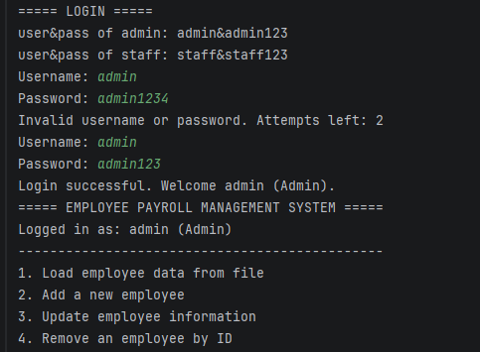

6. Feature Usage Guide

6.0. Login & Authorization
On startup, enter a username and password. After 3 failed attempts the program exits. Once logged in, the menu shows all 10 features but marks the ones outside your role as [locked]; selecting a locked feature shows "Access denied".

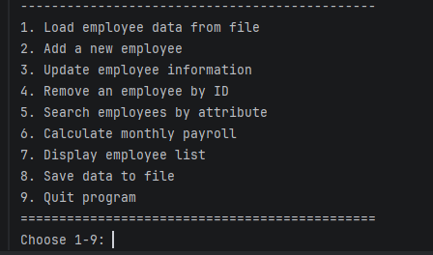

6.1. Feature 1: Load employee data from file
Enter 1 -> Reads employees.txt line by line. Invalid lines (wrong field count, bad number, failed validation, or duplicate ID) are skipped safely and counted. Example: "Loaded 11 record(s), skipped 3 invalid line(s)."

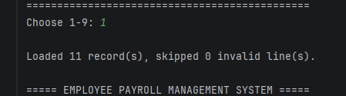

6.2. Feature 2: Add a new employee (Admin only)
Enter 2 -> Input the following fields (each validated; invalid input is re-prompted):
- Employee ID (Exxx) - format validated, duplicates rejected
- Name - non-empty
- Role - Developer/Tester/Manager/HR
- Base salary - must be positive
- Working days - 0 to 26
- Bonus - >= 0
- Status - active/inactive
If all fields are valid -> "Employee added successfully."

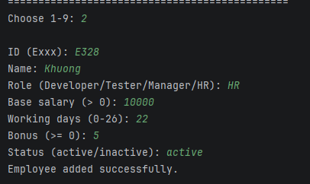

6.3. Feature 3: Update employee information (Admin only)
Enter 3 -> Input Employee ID -> Update role, salary, working days, bonus, status. Press Enter to keep the current value. Changing the role re-creates the object as the correct subclass via the factory.

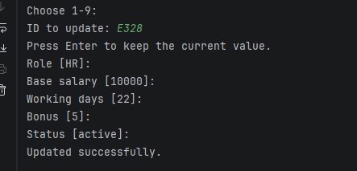6.4. Feature 4: Remove an employee by ID (Admin only)
Enter 4 -> Input Employee ID -> Confirm (Y/N). Employee removed, or "This employee does not exist!" / "Cancelled.".

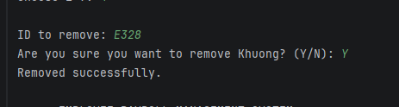6.5. Feature 5: Search employees by attribute
Enter 5 -> Choose attribute (1.ID 2.Name 3.Role 4.Status) -> Input keyword -> Displays all matching employees (case-insensitive substring match).
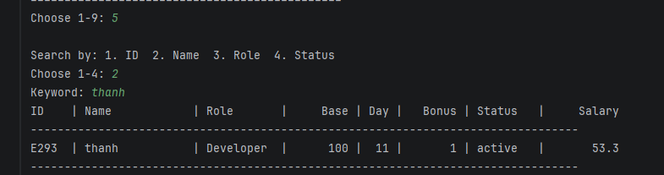

6.6. Feature 6: Calculate monthly payroll
Enter 6 -> Displays each active employee with their computed salary (polymorphic calculateSalary()), then the TOTAL payroll. Inactive employees are skipped.
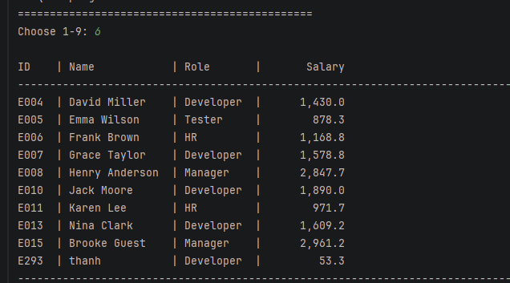

6.7. Feature 7: Display employee list
Enter 7 -> Displays all employees in a formatted table (ID | Name | Role | Base | Day | Bonus | Status | Salary).
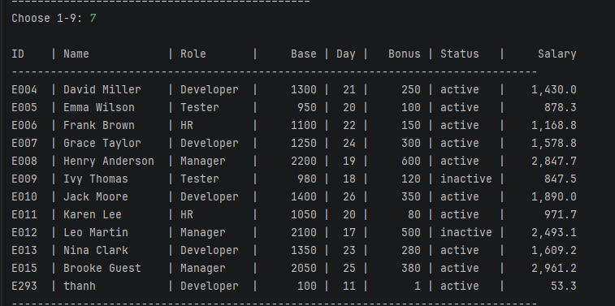

6.8. Feature 8: Save data to file (Admin only)
Enter 8 -> Writes all employees back to employees.txt in the 7-field format. Example: "Data saved to 'employees.txt' (N record(s))."
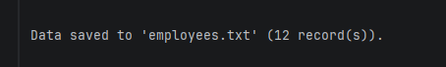

6.9. Feature 9: Meal allowance management (Phu cap an)
Enter 9 -> Opens the Meal Allowance sub-menu. The module first loads meal_allowances.txt, shows the unit price (30,000 / day), then loops its own 6-option menu:
- Create meal allowance - input id (ML-xxxx), employee id (must exist), month (MM/yyyy) and days (0-26); duplicates are rejected and the computed amount is shown.
- Read - print all records in a table (ID | EmpID | Month | Day | Amount).
- Update days - input id, then new days; the amount is recalculated automatically.
- Delete by id - input id, then confirm (Y/N).
- Save to file - write all records to meal_allowances.txt.
- Back to main menu - prompts to save if there are unsaved changes.
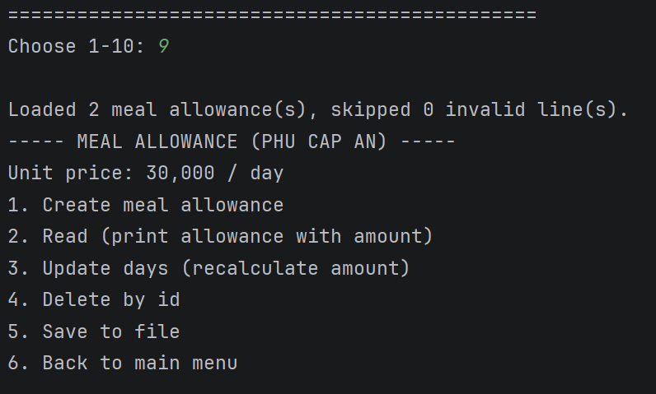

6.10. Feature 10: Quit program
Enter 10 -> If unsaved changes are detected (dirty flag), prompts "Save before exit? (Y/N)". Then exits with "Goodbye!".
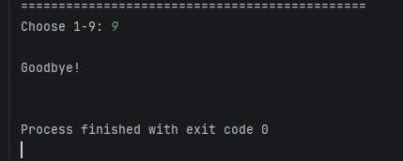

7. OOP Concepts Applied
OOP Concept | Application | Specific Example
Abstraction | Abstract base classes define common interfaces | Employee.roleAllowance(); Account.getAllowedFeatures(); interface Payable
Inheritance | Subclasses reuse base state and behaviour | Developer extends Employee; Admin extends Account
Polymorphism | Overridden methods drive behaviour without if-else | calculateSalary() uses roleAllowance(); menu uses canAccess()
Encapsulation | Private fields with controlled access | Employee.setWorkingDays() (0-26); Account hides password
Open/Closed | Extend without modifying existing logic | Add a new role/account = one new subclass only
Association / Dependency | One manager uses another to validate references | MealAllowanceManager -> EmployeeManager.exists() before creating a record

8. Conclusion

8.1. Achievements
- Implemented all core features for employee management and payroll (Features 1-8, 10).
- Added a role-based authorization layer (login + Admin/Staff permissions).
- Applied OOP principles to both the employee model and the authorization model.
- Strict validation: regex (ID), value ranges, role/status sets, unique ID.
- Polymorphic salary calculation and polymorphic access control (no if-else on role).
- Monthly payroll counts active employees only.
- Safe file loading: malformed lines are skipped and reported, never crashing.
- Added a Meal Allowance (Phu cap an) module: its own CRUD sub-menu, ML-id and MM/yyyy validation, composite-key uniqueness (employee + month), amount = days x 30,000, and a check that the linked employee exists.

8.2. Challenges & Solutions
Challenge | Solution
Different allowance per role without if-else | Abstract Employee + roleAllowance() overridden in each subclass
Role-based access without if-else on role | Abstract Account + getAllowedFeatures() overridden; menu calls canAccess()
Salary formula not provided by the assignment | Self-defined a transparent formula and justified it
Reading a file that may contain erroneous data | try-catch + field-count + per-field validation; skip & count invalid lines
Inconsistent number formatting across locales | Locale.setDefault(Locale.US)
Linking a meal allowance to an existing employee | MealAllowanceManager keeps a reference to EmployeeManager and checks exists(employeeId) before creating
Preventing duplicate meal allowance per month | Composite key (employeeId, month) via equals()/hashCode() + existsKey() check

