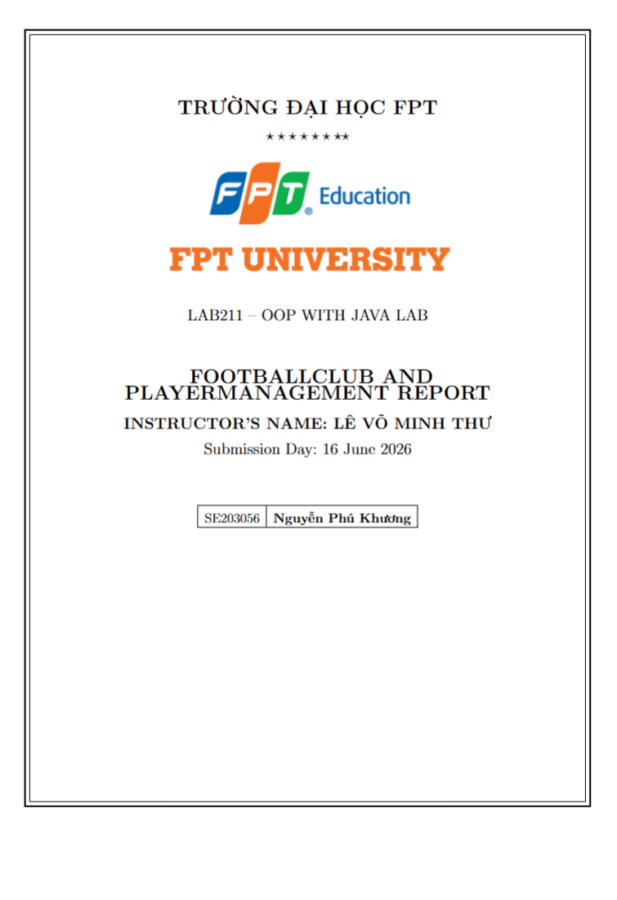

Contents
1. Project Overview 4
Main Features: 4
Data Constraints: 4
2. Class Diagram & UML 6
2.1. Class Diagram 6
Class Relationships: 7
2.2. Use Case Diagram 7
3. Project Structure 7
4. Class Descriptions 9
4.1. Model Layer 9
Person.java (Abstract Class) 9
Player.java (extends Person) 9
Club.java 9
Validatable.java (Interface) 10
4.2. Business Layer 10
ClubsManager.java 10
PlayersManager.java 11
4.3. Dispatcher Layer 11
Menu.java 11
4.4. Tools Layer 11
Inputter.java 11
5. How to Run the Program 12
5.1. System Requirements 12
5.2. Running with IDE (IntelliJ IDEA) 12
5.3. Running with Command Line 12
5.4. Startup Screen 12
6. Feature Usage Guide 14
6.1. Club Management (Features 1-5) 14
Feature 1: List all clubs 14
Feature 2: Add a new club 14
Feature 3: Search club by ID 15
Feature 4: Update a club by ID 15
Feature 5: List clubs with budget <= input 16
6.2. Player Management (Features 6-11) 17
Feature 6: List players sorted by club name, shirt number 17
Feature 7: Search players by partial name 17
Feature 8: Add a new player 18
Feature 9: Remove a player by ID 19
Feature 10: Update a player by ID 19
Feature 11: List players by position 19
6.3. System — Save / Load / Quit (Features 12-14) 21
Feature 12: Save data to files 21
Feature 13: Load data from files 21
Feature 14: Quit 21
7. OOP Concepts Applied 22
8. Conclusion 22
8.1. Achievements 22
9.2. Challenges & Solutions 22
APPENDIX: Extension — Topic 32: YouthPlayer 23
A1. Extension Overview 23
Test Cases from Topic: 23
A2. System Changes 23
New Files: 23
Modified Files: 24
Extended Menu (19 Features): 24

1. Project Overview
The "Football Club & Player Management" project (J1.L.P0036) is a console-based system developed in Java using a 3-layer architecture. It provides full CRUD functionality for Clubs and Players, along with search, filter, sort, and file-based data persistence.

Main Features:
# | Feature | Target
1 | List all clubs | Club
2 | Add a new club | Club
3 | Search for a club by ID | Club
4 | Update a club by ID | Club
5 | List clubs with budget <= input value | Club
6 | List players sorted by club name, shirt number | Player
7 | Search players by partial name | Player
8 | Add a new player | Player
9 | Remove a player by ID | Player
10 | Update a player by ID | Player
11 | List players by position | Player
12 | Save data to files | System
13 | Load data from files | System
14 | Quit | System

Data Constraints:
Entity | Attribute | Constraint
Club | clubID | Format: ^CL-\d{4}$ (CL-0001..CL-9999), unique
Club | name | Non-empty
Club | sponsor | Non-empty
Club | budget | Positive double (million EUR)
Player | id | Format: ^P\d{4}$ (P0001..P9999), unique
Player | clubID | Must exist in Club list (foreign key)
Player | name | Non-empty
Player | position | Goalkeeper / Defender / Midfielder / Forward / Winger
Player | shirtNumber | 1-99, unique within the same Club

2. Class Diagram & UML

2.1. Class Diagram
The Class Diagram below illustrates the relationships between all classes in the core system (excluding the YouthPlayer extension):
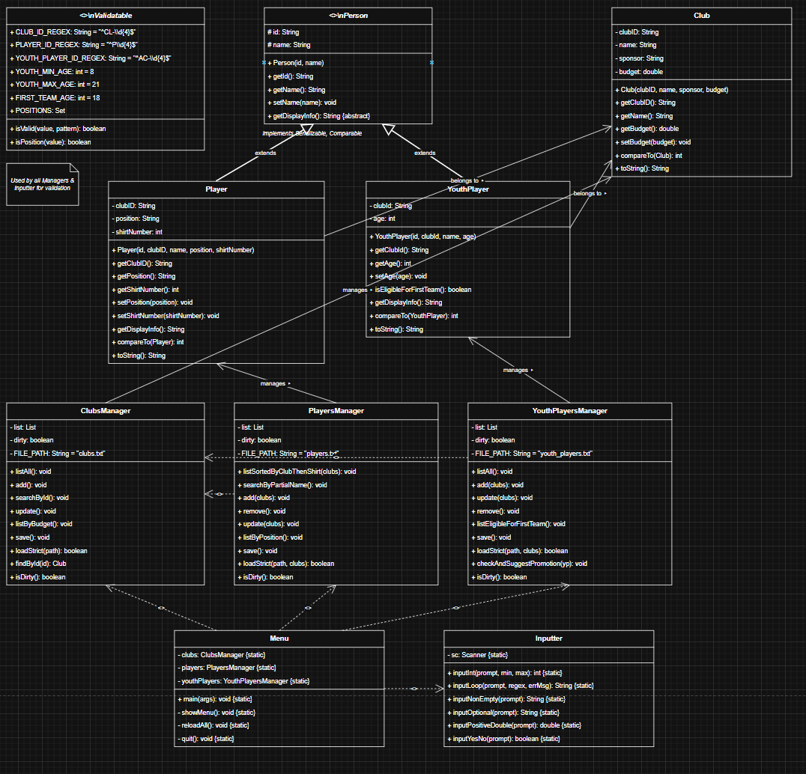
Description: Insert the Class Diagram here. Classes: Person (abstract, #id, #name, +getDisplayInfo()), Player (extends Person: -clubID, -position, -shirtNumber), Club (-clubID, -name, -sponsor, -budget), Validatable (interface: constants + isValid(), isPosition()), ClubsManager (List<Club>: CRUD + save/load), PlayersManager (List<Player>: CRUD + save/load), Menu (main: static clubs, players), Inputter (static utility methods). Relationships: Person <|-- Player (extends), Player <>-- Club (association via clubID), Menu --> ClubsManager (dependency), Menu --> PlayersManager (dependency).

Class Relationships:
Relationship | From | To | Type
Inheritance | Player | Person | extends
Implementation | Player | Comparable<Player> | implements
Implementation | Club | Comparable<Club> | implements
Implementation | Person | Serializable | implements
Association | PlayersManager | List<Player> | has-a
Association | ClubsManager | List<Club> | has-a
Dependency | Menu | ClubsManager | uses
Dependency | Menu | PlayersManager | uses
Dependency | Menu | Inputter | uses

2.2. Use Case Diagram
The Use Case Diagram shows all system functions from the user's perspective:
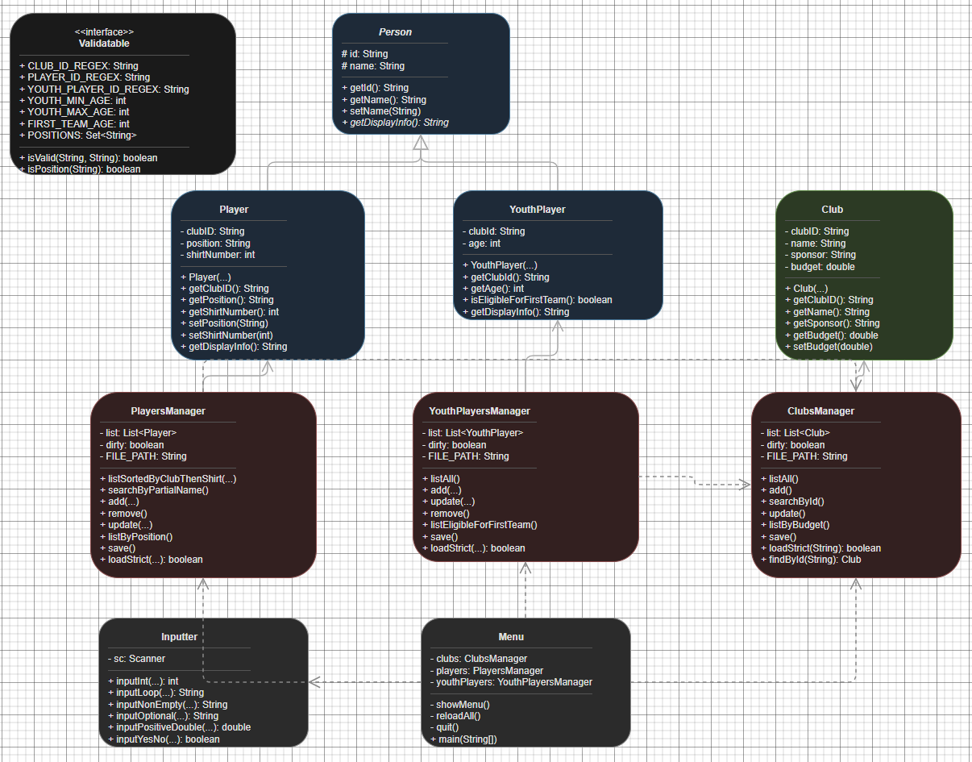
Description: Insert Use Case Diagram. Actor: User (Manager). Use Cases grouped by: Club (List all, Add, Search by ID, Update, Filter by budget), Player (List sorted, Search by name, Add, Remove, Update, List by position), System (Save, Load, Quit).

2.3. Sequence Diagram
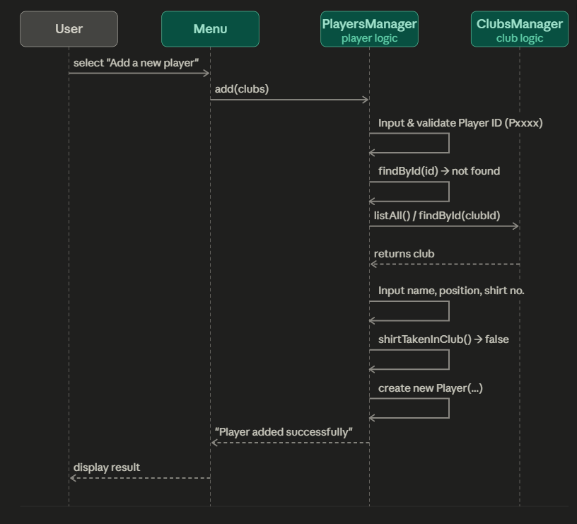
Sequence Diagram

3. Project Structure
The project follows a 3-layer architecture:
FootballClub_n_PlayerManagement/
|-- src/
| |-- model/ <-- Data Layer
| | |-- Person.java (Abstract base class)
| | |-- Player.java (extends Person)
| | |-- Club.java (Serializable, Comparable)
| | +-- Validatable.java (Interface - validation constants)
| |-- business/ <-- Business Layer
| | |-- ClubsManager.java (Club CRUD + save/load)
| | +-- PlayersManager.java (Player CRUD + save/load)
| |-- dispatcher/ <-- Presentation Layer
| | +-- Menu.java (Main entry point - 14 features)
| +-- tools/ <-- Utility
| +-- Inputter.java (Input validation helper)
|-- clubs.txt (Club data file)
+-- players.txt (Player data file)

The 3-layer architecture ensures clear separation of concerns: Model (data) — Business (logic) — Dispatcher (presentation). The Tools package contains shared utility classes.

4. Class Descriptions

4.1. Model Layer

Person.java (Abstract Class)
Abstract base class representing a person. Contains common attributes (id, name) and defines the abstract method getDisplayInfo() for subclass-specific display (Polymorphism).
Member | Type | Description
#id | String (protected) | Unique identifier
#name | String (protected) | Person name
+Person(id, name) | Constructor | Initialize with id and name
+getId() | String | Getter
+getName() / setName() | String | Getter / Setter
+getDisplayInfo() | abstract String | Display info — Polymorphism

Player.java (extends Person)
Represents a football player. Inherits from Person (Inheritance). Adds clubID, position, and shirtNumber. Implements Comparable for natural ordering by shirt number.
Member | Type | Description
-clubID | String | FK -> Club (CL-xxxx)
-position | String | Goalkeeper / Defender / Midfielder / Forward / Winger
-shirtNumber | int | Shirt number (1-99), unique within Club
+getDisplayInfo() | String | Override from Person
+compareTo(Player) | int | Sort by shirt number (Comparable)
+toString() | String | Table-format display
+equals() / hashCode() |  | Compare by player ID

Club.java
Represents a football club. Implements Serializable and Comparable (sorted by name, case-insensitive).
Member | Type | Description
-clubID | String | Club ID (CL-xxxx)
-name | String | Club name
-sponsor | String | Sponsor brand
-budget | double | Budget (million EUR, > 0)
+compareTo(Club) | int | Sort by name (case-insensitive)
+setBudget(double) | void | Only accepts positive values (Encapsulation)

Validatable.java (Interface)
Interface centralizing all validation rules in one place (Pattern Recognition).
Constant / Method | Value | Description
CLUB_ID_REGEX | ^CL-\d{4}$ | Club ID format
PLAYER_ID_REGEX | ^P\d{4}$ | Player ID format
POSITIONS | Set<String> | goalkeeper, defender, midfielder, forward, winger
isValid(value, pattern) | boolean | Check if string matches regex
isPosition(value) | boolean | Check if position is valid (case-insensitive)

4.2. Business Layer

ClubsManager.java
Manages CRUD operations for Club. Uses a dirty flag to track unsaved changes.
Method | Function
listAll() | Display all clubs sorted by name (Comparable)
add() | Add new club — validate ID, reject duplicates
searchById() | Search club by ID
update() | Update club — press Enter to keep current value
listByBudget() | Filter clubs with budget <= input value
save() | Write to clubs.txt
loadStrict(path) | Load from file with strict per-line validation
findById(id) | Helper — find club by ID (case-insensitive)

PlayersManager.java
Manages CRUD operations for Player. Uses Comparator chaining for sorting.
Method | Function
listSortedByClubThenShirt(clubs) | Sort by club name then shirt number (Comparator chaining)
searchByPartialName() | Search by name (partial match, case-insensitive)
add(clubs) | Add player — validate ID, clubId, position, unique shirt number
remove() | Remove player by ID
update(clubs) | Update player — press Enter to keep current value
listByPosition() | Filter players by position
save() | Write to players.txt
loadStrict(path, clubs) | Load from file with strict per-line validation

4.3. Dispatcher Layer

Menu.java
Main entry point containing the main() method. Controls the 14-feature menu loop. Auto-loads data on startup and auto-saves on exit when changes are detected (dirty flag).

4.4. Tools Layer

Inputter.java
Utility class for keyboard input with built-in validation:
Method | Description
inputInt(prompt, min, max) | Input integer within [min, max] range
inputLoop(prompt, regex, errMsg) | Input string matching regex pattern
inputNonEmpty(prompt) | Input non-empty string
inputOptional(prompt) | Optional input (Enter to skip)
inputPositiveDouble(prompt) | Input positive double

5. How to Run the Program

5.1. System Requirements
- JDK 1.8 or higher (installed and JAVA_HOME configured)
- IDE: IntelliJ IDEA / Eclipse / NetBeans (IntelliJ recommended)
- OS: Windows / macOS / Linux

5.2. Running with IDE (IntelliJ IDEA)
- Open IntelliJ IDEA -> File -> Open -> select the FootballClub_n_PlayerManagement folder
- Wait for the IDE to finish indexing all Java files
- Open file src/dispatcher/Menu.java
- Right-click on Menu.java -> select "Run 'Menu.main()'"
- The program will run in the IDE's Console/Terminal window
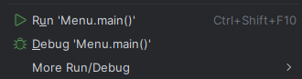
Description: Screenshot of IntelliJ IDEA right-clicking Menu.java and selecting Run. Show the context menu.

5.3. Running with Command Line
Step 1: Open Terminal and navigate to the project directory.
Step 2: Compile all Java files:
javac -encoding UTF-8 -d out -sourcepath src src/dispatcher/Menu.java
Step 3: Run the program:
java -cp out dispatcher.Menu

5.4. Startup Screen
On startup, the system automatically loads data from clubs.txt and players.txt, then displays the main menu with 14 features:
=== European Elite League (EEL) Management System ===
Loading data...
Load data successfully!
+========================================================+
| FOOTBALL CLUB & PLAYER MANAGEMENT (EEL) |
+=========================================================+
| 1. List all clubs |
| 2. Add a new club |
| 3. Search for a club by ID |
| 4. Update a club by ID |
| 5. List clubs with budget <= input value |
| 6. List players sorted by club name, shirt number |
| 7. Search players by partial name |
| 8. Add a new player |
| 9. Remove a player by ID |
| 10. Update a player by ID |
| 11. List players by position |
| 12. Save data to files |
| 13. Load data from files |
| 14. Quit |
+=========================================================+
Choose 1-14:

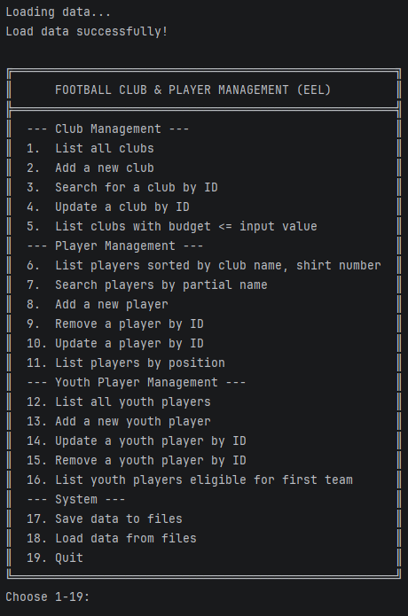
Description: Screenshot of the console displaying "Load data successfully!" and the full 14-feature menu.

6. Feature Usage Guide

6.1. Club Management (Features 1-5)

Feature 1: List all clubs
Enter 1 -> Displays all clubs in table format (Club ID | Club Name | Sponsor | Budget), sorted by club name (Comparable).
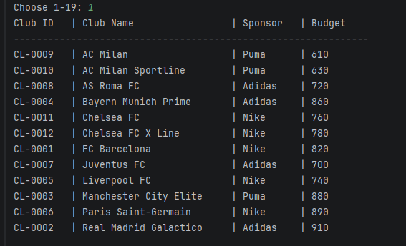
Description: Screenshot of the console displaying the club table with header and data rows.

Feature 2: Add a new club
Enter 2 -> Input the following fields:
- Club ID (CL-xxxx) — format validated, duplicates rejected
- Club name — non-empty
- Sponsor brand — non-empty
- Budget (million EUR) — must be positive
If all fields are valid -> "Club added successfully."
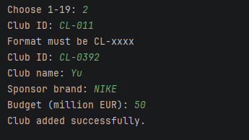
Description: Screenshot of the console adding a new club: all input steps and success message.

Feature 3: Search club by ID
Enter 3 -> Input Club ID -> Displays club info or "This club does not exist!".
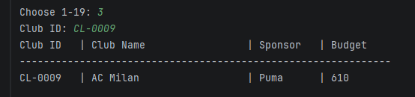
Description: Screenshot: (a) club found — info displayed, (b) club not found — error message.

Feature 4: Update a club by ID
Enter 4 -> Input Club ID -> Update name, sponsor, budget. Press Enter to skip a field and keep the current value.
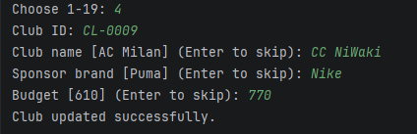
Description: Screenshot of updating a club: current values shown, new values entered, success message.

Feature 5: List clubs with budget <= input
Enter 5 -> Input maximum budget -> Displays all clubs with budget <= that value.
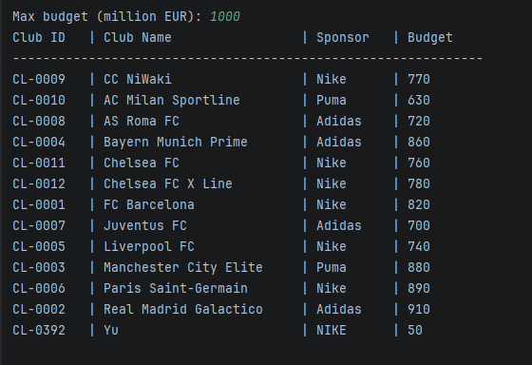
Description: Screenshot: input max budget value, filtered club list displayed.

6.2. Player Management (Features 6-11)

Feature 6: List players sorted by club name, shirt number
Enter 6 -> Displays all players sorted by club name (ascending), then by shirt number within the same club (Comparator chaining).
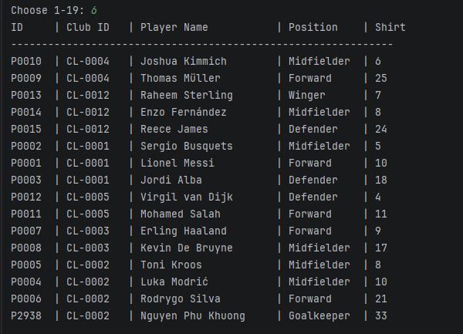
Description: Screenshot of the player table sorted by club name then shirt number.

Feature 7: Search players by partial name
Enter 7 -> Input a keyword -> Displays all players whose name contains the keyword (case-insensitive).
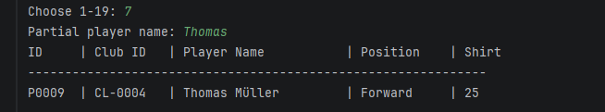
Description: Screenshot: input search keyword, matching players displayed.

Feature 8: Add a new player
Enter 8 -> Add a new player with the following steps:
- Input Player ID (Pxxxx) — format validated, duplicates rejected
- System displays available clubs for reference
- Input Club ID (CL-xxxx) — must exist in the club list
- Input player name — non-empty
- Input position (Goalkeeper/Defender/Midfielder/Forward/Winger) — validated
- Input shirt number (1-99) — must be unique within the same club
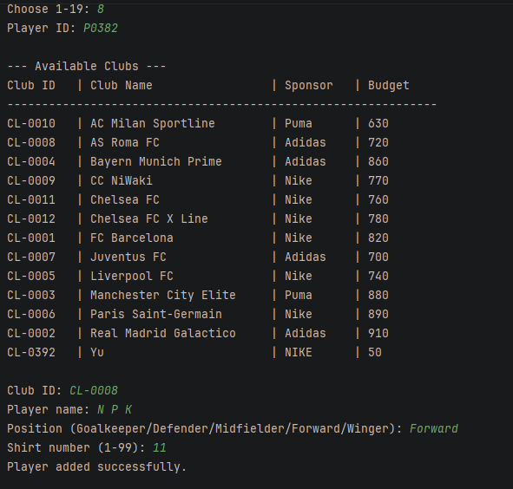
Description: Screenshot of adding a new player: all input steps and success message.

Feature 9: Remove a player by ID
Enter 9 -> Input Player ID -> Player removed or "This player does not exist!".
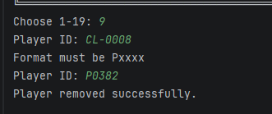
Description: Screenshot: input player ID, success/error message displayed.

Feature 10: Update a player by ID
Enter 10 -> Input Player ID -> Update name, position, shirt number. Press Enter to skip. Position and shirt number are validated when entered.
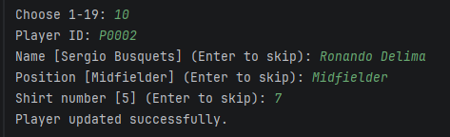
Description: Screenshot: current values shown, new values entered, success message.

Feature 11: List players by position
Enter 11 -> Input a position -> Displays all players in that position.
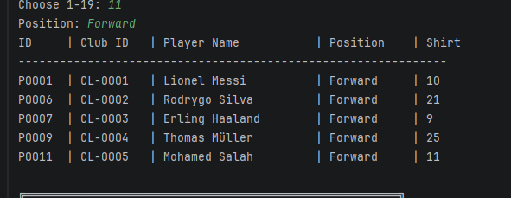
Description: Screenshot: input position name, filtered player list displayed.

6.3. System — Save / Load / Quit (Features 12-14)

Feature 12: Save data to files
Enter 12 -> Saves all Club and Player data to clubs.txt and players.txt respectively.
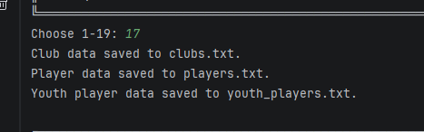
Description: Screenshot: "Club data saved to clubs.txt." and "Player data saved to players.txt."

Feature 13: Load data from files
Enter 13 -> Reloads all data from files with strict per-line validation. If any line is invalid -> "Load data failed!".
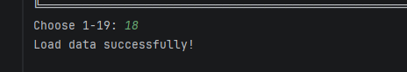
Description: Screenshot: (a) successful load, (b) failed load when file is corrupted.

Feature 14: Quit
Enter 14 -> Exits the program. If unsaved changes are detected (dirty flag) -> auto-saves before exiting.
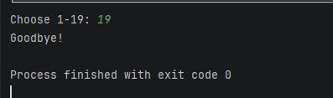
Description: Screenshot: "Changes detected. Saving data before exit..." followed by "Goodbye!"

7. OOP Concepts Applied
OOP Concept | Application | Specific Example
Abstraction | Person is an abstract class defining a common interface | abstract getDisplayInfo() — each subclass defines its own display
Inheritance | Player inherits from Person, reusing id and name | class Player extends Person
Polymorphism | Player overrides getDisplayInfo() and compareTo() | Player.getDisplayInfo() differs from Person's
Encapsulation | Private fields accessed through getter/setter with validation | Club.setBudget() only accepts positive values
Comparable | Club and Player implement Comparable for natural sorting | Club: sort by name; Player: sort by shirt number

8. Conclusion

8.1. Achievements
- Successfully implemented all 14 CRUD features for Club and Player.
- Followed OOP principles: Abstraction, Inheritance, Polymorphism, Encapsulation.
- Strict validation: regex, range, unique constraint, foreign key.
- Flexible sorting: Comparable, Comparator chaining.
- File-based data persistence with strict validation on load.
- Auto-save on exit when changes are detected (dirty flag).
- All 18 test cases PASSED.

9.2. Challenges & Solutions
Challenge | Solution
Sorting players by multiple criteria (club name + shirt) | Used Comparator chaining: byClubName.thenComparingInt()
Validating unique shirt number within the same club | shirtTakenInClub() method iterates list to check duplicates
Strict per-line validation when loading from file | loadStrict() checks field count, format, existence, and duplicates
Unicode encoding on Windows (JDK 1.8) | Used -encoding UTF-8 flag during compilation

APPENDIX A :Extension — Topic 32: YouthPlayer
This section describes the YouthPlayer extension feature added to the system as required by Topic 32.

A1. Extension Overview
Topic 32 requires adding a Youth Player management feature. A Youth Player has an ID (AC-xxxx), belongs to a club, has a name and age (8-21). If age >= 18, the system suggests promotion to the first team.
Requirement | Details
Entity | YouthPlayer { id: ^AC-\d{4}$, clubId, name, age: 8..21 }
Create | Add a youth player to a club
Read | List all youth players & those eligible for first team
Update | Update age; infer first team promotion suggestion
Delete | Delete by ID with confirmation prompt
Validation | age in [8, 21]; age >= 18 -> suggest promotion; clubId must exist
OOP | Inherits from Person

Test Cases from Topic:
Input Age | Expected Result | Explanation
19 | Valid + Suggest first team promotion | age >= 18
7 | Rejected | age < 8 (out of range [8, 21])
22 | Rejected | age > 21 (out of range [8, 21])

A2. System Changes

New Files:
File | Description
model/YouthPlayer.java | Model extending Person; fields: clubId, age; method: isEligibleForFirstTeam()
business/YouthPlayersManager.java | Full CRUD + promotion suggestion + save/load
youth_players.txt | Sample youth player data file

Modified Files:
File | Change
model/Validatable.java | +YOUTH_PLAYER_ID_REGEX, +YOUTH_MIN_AGE (8), +YOUTH_MAX_AGE (21), +FIRST_TEAM_AGE (18)
tools/Inputter.java | +inputYesNo(prompt) — Y/N confirmation method
dispatcher/Menu.java | Menu expanded from 14 to 19 features; added YouthPlayersManager

Extended Menu (19 Features):
+=========================================================+
| FOOTBALL CLUB & PLAYER MANAGEMENT (EEL) |
+=========================================================+
| --- Club Management --- |
| 1-5 (unchanged) |
| --- Player Management --- |
| 6-11 (unchanged) |
| --- Youth Player Management --- * NEW |
| 12. List all youth players |
| 13. Add a new youth player |
| 14. Update a youth player by ID |
| 15. Remove a youth player by ID |
| 16. List youth players eligible for first team |
| --- System --- |
| 17. Save data to files |
| 18. Load data from files |
| 19. Quit |
+=========================================================+

APPENDIX B: Authorization & Access Control (RBAC)

B1. Overview
This extension adds an authorization layer using the Role-Based Access Control (RBAC) model. Each user logs in with a username and password and is assigned a Role. A Role owns a set of Permissions, and every menu feature declares the Permission it requires. The menu then displays only the features the logged-in user is allowed to perform, so unauthorized actions are never even shown.
The design favours OOP principles: permissions are an enum (type-safe), a role aggregates permissions through composition, and the menu is data-driven via MenuItem objects rather than a hard-coded switch. Adding a feature or a role does not require touching the dispatch logic.

B2. Roles & Permissions Matrix
Three roles are provided with the following permissions:
Permission | ADMIN | MANAGER | VIEWER
CLUB_VIEW | Yes | Yes | Yes
CLUB_MANAGE | Yes | No | No
PLAYER_VIEW | Yes | Yes | Yes
PLAYER_MANAGE | Yes | Yes | No
YOUTH_VIEW | Yes | Yes | Yes
YOUTH_MANAGE | Yes | Yes | No
DATA_PERSIST | Yes | Yes | No

Default demo accounts:
Username | Password | Role | Access
admin | admin123 | ADMIN | All 18 features
manager | manager123 | MANAGER | View clubs; manage players & youth; save/load
viewer | viewer123 | VIEWER | Read-only: list/search only

B3. New & Modified Files
File | Type | Description
model/Permission.java | NEW | enum of atomic permissions
model/Role.java | NEW | enum mapping each role to an EnumSet<Permission>; can()
model/User.java | NEW | account holding username/password/role; can(), matches()
business/AuthManager.java | NEW | user store + login() with up to 3 attempts
dispatcher/MenuItem.java | NEW | label + required Permission + Runnable action
dispatcher/Menu.java | MODIFIED | login first, dynamic menu filtered by permission

B4. Key Design Points
- Permission is an enum, giving type-safe, self-documenting capability names.
- Role stores permissions in an EnumSet and exposes can(Permission) - the single source of truth for access checks.
- User delegates can() to its Role, so callers never inspect role internals.
- MenuItem couples each feature with the permission it needs, enabling a uniform filter.
- Menu computes the allowed items once per session and renders a compact, renumbered menu.
- Because unauthorized items are hidden, there is no scattered "Access denied" handling.

B5. Sample Menus per Role
VIEWER sees read-only features only:
===== FOOTBALL CLUB & PLAYER MANAGEMENT (EEL) =====
Logged in as: viewer [VIEWER]
---------------------------------------------------
1. List all clubs
2. Search for a club by ID
3. List clubs with budget <= input value
4. List players sorted by club name, shirt number
5. Search players by partial name
6. List players by position
7. List all youth players
8. List youth players eligible for first team
9. Quit

ADMIN sees the full menu (all 18 features + Quit).

