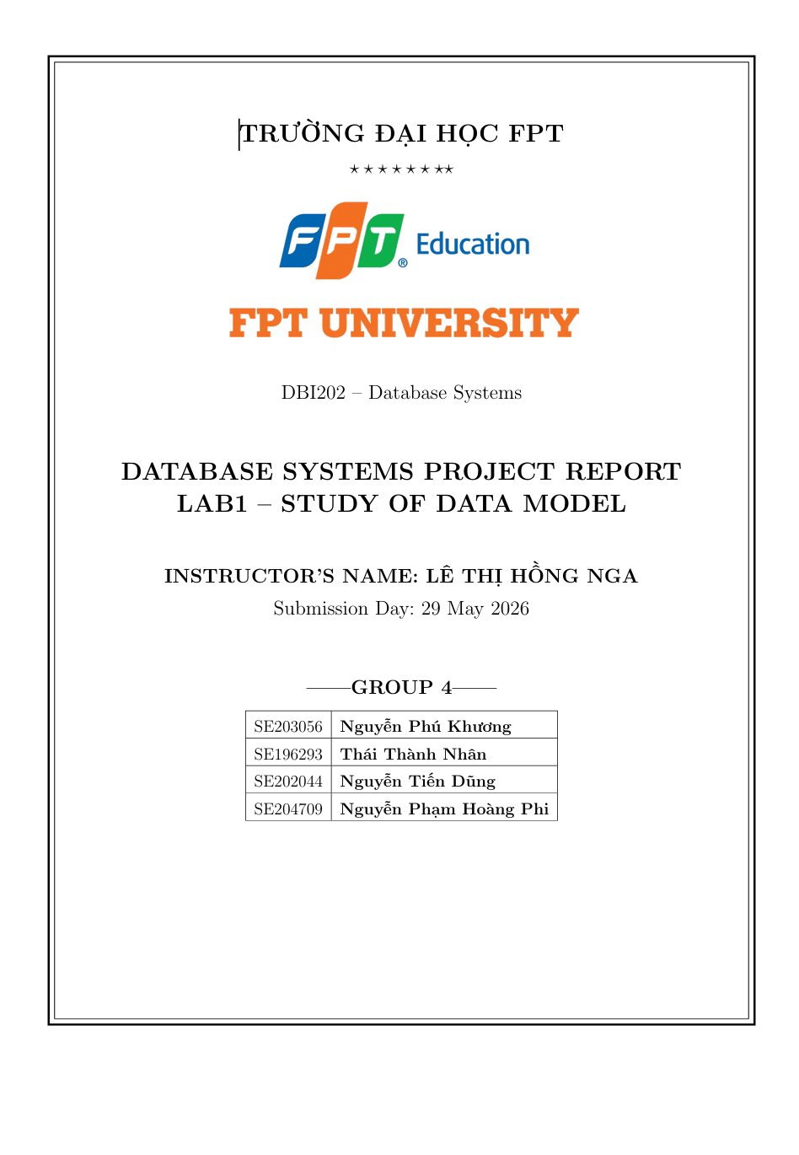

1. Objective
The purpose of this lab is to explore and analyze existing data models in database systems. Through this report, my group will gain a solid understanding of basic structures, constraints, data manipulation methods associated with each model, as well as their practical applications in solving softwarerelated problems.

2. Study of Data Models

2.1. Relational Data Model
- Storage structure: Data is organized into tables (Relations) consisting of rows (Tuples) and columns (Attributes).
- Constraints: Domain constraints; Key constraints (Primary Key); Entity integrity and Referential integrity (Foreign Key).
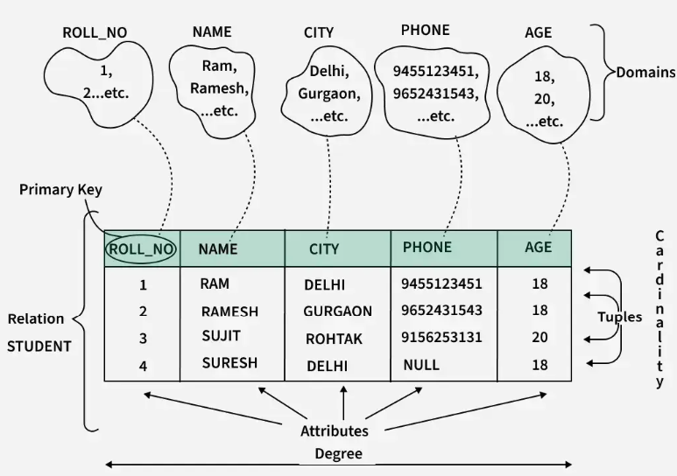
Example Relational Data Model in DBMS

- Data manipulation operators: Uses Relational Algebra or SQL language (SELECT, INSERT, UPDATE, DELETE) based on set theory.
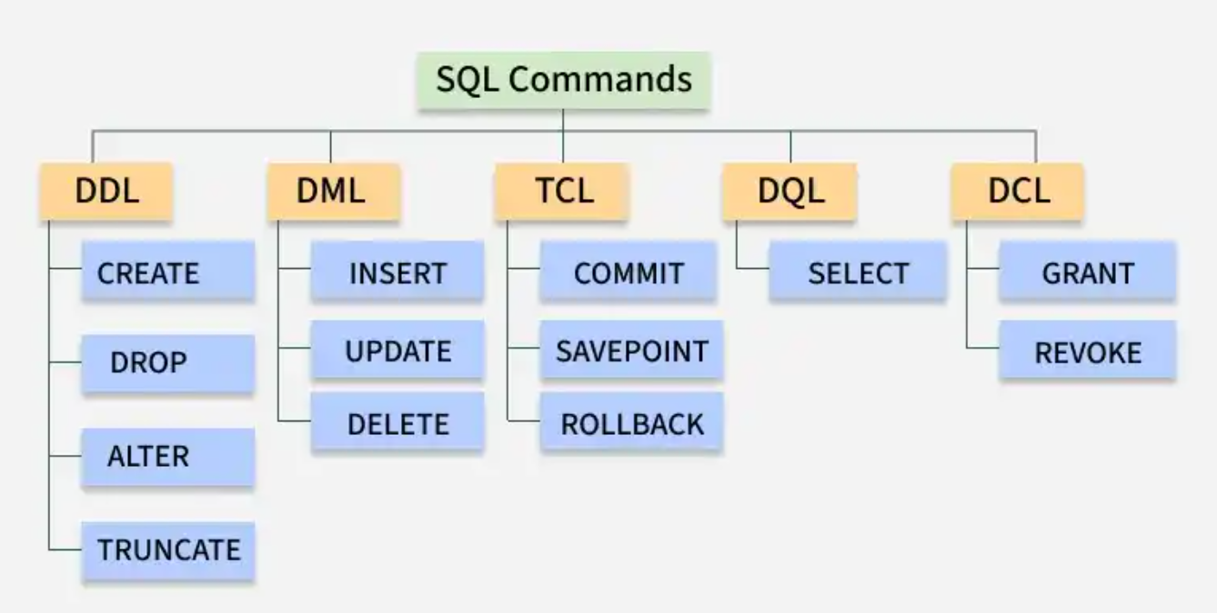
Example SQL language

- Advantages: High consistency, strict compliance with ACID principles, good data independence, and powerful standard query language (SQL).
- Limitations: Difficult horizontal scaling and reduced performance when executing complex JOIN queries on massive datasets.
- Suitable applications: Financial management systems (Banking, Securities), ERP, HR management, and traditional sales management systems.

2.2. Semi-structured Data Model (XML/JSON)
- Storage structure: Data does not follow a fixed table schema but is organized hierarchically, as trees or graphs through tags or nested key-value pairs (JSON, XML).
- Constraints: Very flexible. The schema may be self-describing within the data or loosely defined through XML Schema/JSON Schema.

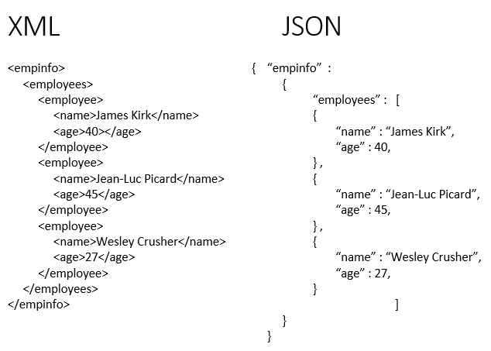
Example Json & XML

- Data manipulation: Uses languages such as XPath, XQuery for XML or JSONPath for JSON.
- Advantages: Highly flexible for storing heterogeneous data, easy to change structure, suitable for web data exchange.
- Limitations: Consumes more storage due to repeated metadata (tags, keys), and queries are more complex and less optimized than SQL on large datasets.
- Suitable applications: System configuration, data exchange between web APIs, and integration of data from multiple sources.
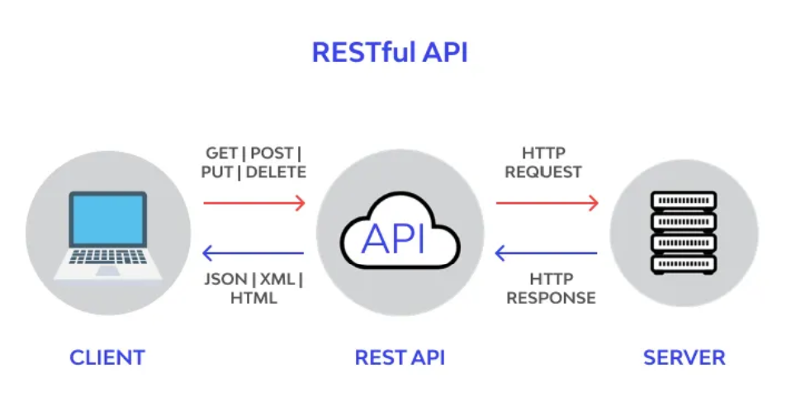

Examples of applications of Semi-structured Data Models

2.3. NoSQL Models
NoSQL Model | Structure & Constraints | Data Manipulation | Advantages / Limitations & Applications
Document-oriented | Stores data as Documents (JSON/BSON). Flexible schema. | CRUD via API with support for nested-field queries. | Flexible schema, good horizontal scaling.  Limited JOIN support and ACID compliance. Applications: CMS, Product Catalogs.
Key-Value Store | Stores data as Key-Value pairs. Keys must be unique. | GET(key), PUT(key, value), DELETE(key). Cannot query by value. | Extremely fast retrieval speed and easy scaling. Limited query capability. Applications: Redis caching, Session management.
Graph Database | Node (entity) and Edge (relationship). Constraints define relationship validity. | Graph traversal using Cypher (Neo4j) or Gremlin. | Excellent for multi-level relationships. Not suitable for large aggregate calculations. Applications: Social networks, Recommendation systems.
Column-family Store | Stores data in rows with dynamic columns. Organized into column families. Keyspace defines the schema. | Query by row key, column family, or column modifier using CQL (Cassandra Query Language) or API. | Advantages: High write throughput, mass scaling, compression efficiency.  Limitations: Complex data modeling, poor support for ad-hoc queries.  Applications: Time-series data, Analytics, IoT logging (e.g., Apache Cassandra, HBase).

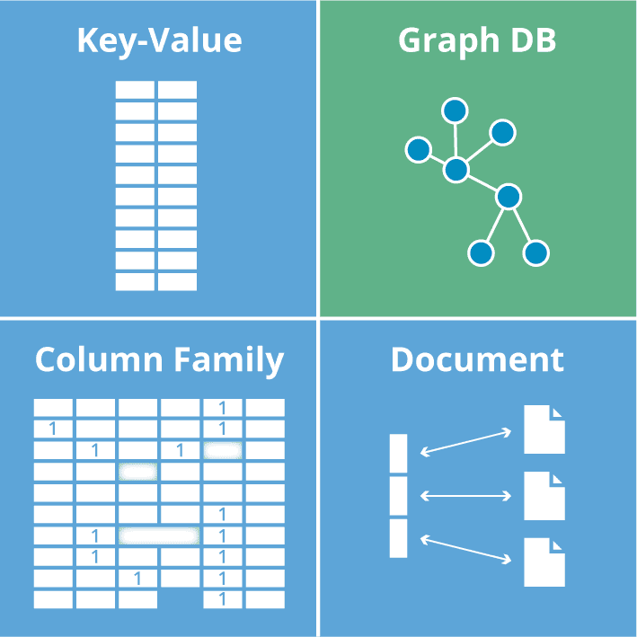
Example of NoSQL Model

3. Model Selection for Group Project (Household Cleaning Robot System)
- Project: Household Cleaning Robot Sales & Maintenance Management System. The team decided to use only the Relational Data Model for the entire system based on three core reasons:
- Ensuring business transaction integrity: Sales, warranty, and repair assignment processes require strict data constraints. The Foreign Key mechanism and ACID properties of relational databases ensure that order, payment, and inventory data are always absolutely accurate, without discrepancies or fragmentation.
- Optimizing multi-dimensional report generation: The system requires the generation of complex linked reports (sales, maintenance history, technician performance). SQL provides powerful query operators (JOIN, GROUP BY, aggregation functions) to quickly aggregate and analyze this data.
-Integrated system architecture (including IoT/AI): Instead of using additional NoSQL databases, robot error log data is standardized and stored directly in the DeviceLogs table (including LogID, RobotID, Time, and Data). This design allows the use of JOIN commands to directly connect device logs to customer records, supporting predictive maintenance scheduling analysis on a single, unified database platform, optimizing operational effort.

4. Conclusion & Reflection
Comprehensive research into data models provided the team with deep insights into the characteristics and application boundaries of each technology. For the intelligent cleaning robot management and maintenance system, the consistent application of the Relational Database Model was a strategic and practical decision. This choice perfectly met the core requirements of reliability and data integrity. The relational model is fully capable of effectively managing the flow of device monitoring data (IoT), creating a solid and secure foundation for the long-term development of the system.

