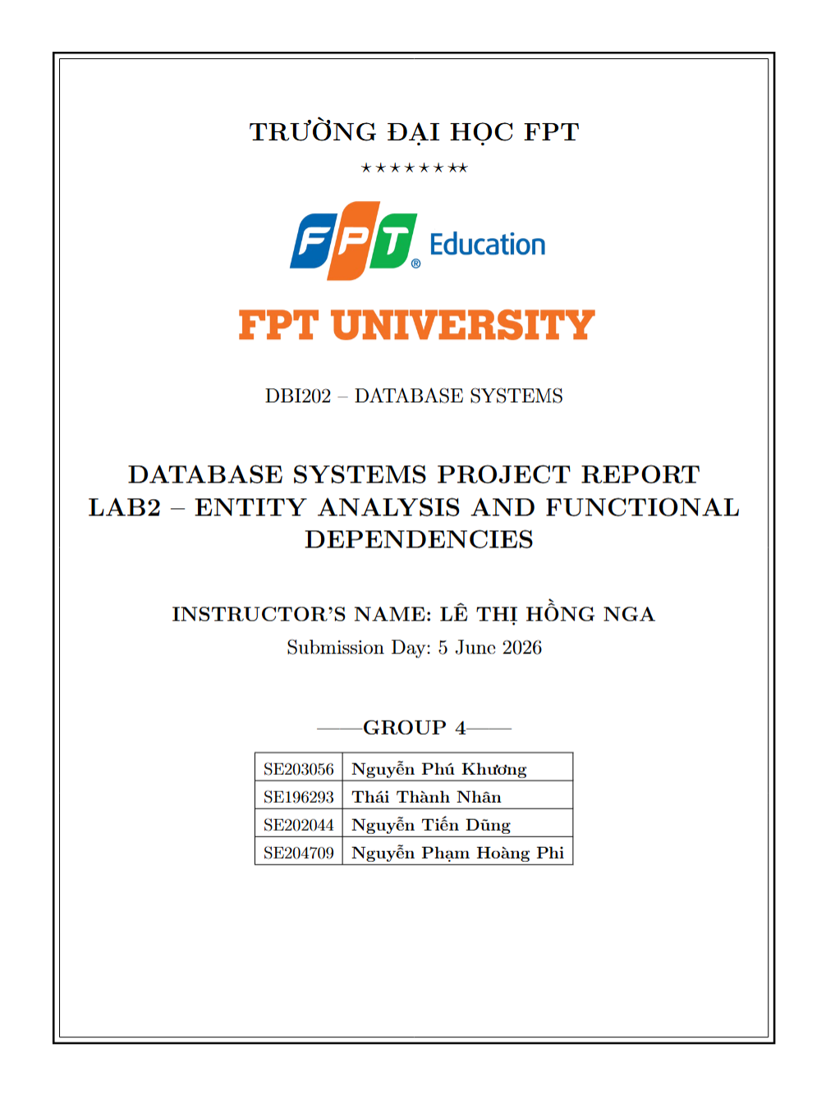

1. Objective
The objective of this practical lab is to develop an in depth understanding of entities, attributes, functional dependencies , and keys within a database context. Through this report, the group will practice analyzing the data structure for the "Household Cleaning Robot Sales & Maintenance Management System" project, identifying relationships to ensure data integrity.
2. Entity Analysis, Attributes, FDs and Keys
The "Household Cleaning Robot Sales & Maintenance Management System" is structured around four core functional modules: User Management, which handles customer and employee data; Product & Inventory Management, which tracks robot models and individual units, Sales & Transactions Management, which covers orders, payments, and warranty registrations, and Maintenance, Repair & IoT Extension, which manages service requests, maintenance records, and device logs. The following section provides a detailed analysis of the entities, attributes, functional dependencies, and keys within each module.
2.1. User Management Entity Group
Entity: Customer
- Description: This entity manages all external client identities within the system. Data is gathered from the online customer registration form and account profile settings. It maintains essential personal profiles, communication details, and encrypted login credentials, serving as the foundational anchor for product sales, warranty registrations, and after-sales service requests.
- Attributes: CustomerID, FullName, PhoneNumber, Email, Address, Password.
- Functional Dependencies :
+ CustomerID → FullName, PhoneNumber, Email, Address, Password
+ Email → CustomerID
+ PhoneNumber → CustomerID
- Candidate Keys: CustomerID, Email, PhoneNumber
- Primary Key: CustomerID
Entity: Employee (including Admin, Sales, Technician)
- Description: This entity represents the internal workforce roster, encompassing all system user roles including Administrators, Sales Staff, and Maintenance Technicians. Collected from internal HR assignment logs, it centralizes staff profiles and authentication details, enabling secure role based access control (RBAC) to ensure employees can only execute features mapped to their specific operational duties.
- Attributes: EmployeeID, FullName, Role, PhoneNumber, Email, Password.
- Functional Dependencies :
+ EmployeeID → FullName, Role, PhoneNumber, Email, Password
+ Email → EmployeeID
- Candidate Keys: EmployeeID, Email
- Primary Key: EmployeeID
2.2. Product & Inventory Management Entity Group
Entity: RobotModel (Robot Category/Model)
- Description: This entity acts as the centralized master product catalog for all household cleaning appliances handled by the business. Sourced from official manufacturer product specification sheets and e-commerce browsing pages, it archives static design data—such as structural features, engineering specifications, baseline unit pricing, and standard warranty durations—shared across all physical units of a specific line.
- Attributes: ModelID, Brand, ModelName, Features, Specifications, UnitPrice, WarrantyDuration.
- Functional Dependencies :
+ ModelID → Brand, ModelName, Features, Specifications, UnitPrice, WarrantyDuration
+ ModelName → ModelID
- Candidate Keys: ModelID, ModelName
- Primary Key: ModelID
Entity: RobotUnit (Device/Inventory Unit)
- Description: This entity tracks individual, physical serialized hardware assets currently resting in inventory or deployed in customer households. Sourced from physical product serial-number stickers and warehouse stock inventory logs, it bridges the gap between a conceptual product model and a unique piece of operational hardware, actively monitoring its real-time lifecycle status (Available, Sold, or Under Maintenance).
- Attributes: RobotID, ModelID, SerialNumber, Status (Available/Sold/Maintenance).
- Functional Dependencies :
+ RobotID → ModelID, SerialNumber, Status
SerialNumber → RobotID, ModelID, Status
- Candidate Keys: RobotID, SerialNumber
- Primary Key: RobotID
2.3. Sales & Transactions Management Entity Group
Entity: SalesOrder
- Description: This entity captures the high-level transactional metadata of a commercial retail agreement between a customer and the business. Sourced from checkout invoices and sales receipt layouts, it logs the purchasing event, binds the customer and the handling sales staff member to the transaction, and tracks critical payment milestones through order status indicators.
- Attributes: OrderID, CustomerID, EmployeeID, OrderDate, TotalAmount, OrderStatus.
- Functional Dependencies :
+ OrderID → CustomerID, EmployeeID, OrderDate, TotalAmount, OrderStatus
- Candidate Keys: OrderID
- Primary Key: OrderID
Entity: OrderDetail
- Description: This entity functions as an itemized line-item ledger that breaks down the specific individual physical components contained within a larger sales order. Modeled from itemized retail invoice receipts, it pairs specific physical robot units to their respective sales transactions and locks in the final customized historical selling price, accommodating seasonal discounts or bundle adjustments.
- Attributes: OrderID, RobotID, SellingPrice.
- Functional Dependencies :
+ OrderID, RobotID → SellingPrice
+ RobotID → OrderID
- Candidate Keys: RobotID, {OrderID, RobotID}
- Primary Key: {OrderID, RobotID}
Entity: Payment
- Description: This entity handles the financial ledger entries tracking all incoming monetary revenue generated by the system. Modeled after commercial banking confirmation sheets and online checkout point-of-sale (POS) receipts, it records the exact amount, date, and processing method of a transaction, featuring flexible foreign key bindings to handle clear closures for both retail sales orders and technical service records.
- Attributes: PaymentID, OrderID, ServiceRecordID, Amount, PaymentDate, PaymentMethod.
- Functional Dependencies :
+ PaymentID → OrderID, ServiceRecordID, Amount, PaymentDate, PaymentMethod
- Candidate Keys: PaymentID
- Primary Key: PaymentID
Entity: WarrantyRegistration
- Description: This entity manages the legal operational timelines governing product protection periods for sold merchandise. Sourced from after-sales customer warranty certificates, it links a specific physical device to its owner, explicitly calculating activation and expiration dates to programmatically determine whether subsequent repair actions qualify for service fee waivers.
- Attributes: WarrantyID, RobotID, CustomerID, StartDate, EndDate.
- Functional Dependencies :
+ WarrantyID → RobotID, CustomerID, StartDate, EndDate
+ RobotID → WarrantyID
- Candidate Keys: WarrantyID, RobotID
- Primary Key: WarrantyID
2.4. Maintenance, Repair & IoT Extension Entity Group
Entity: ServiceRequest
- Description: This entity represents an open support ticket initiated when a machine experiences technical errors or requires routine checkups. Sourced from online customer helpdesk forms and customer service intake logs, it documents raw customer complaints, identifies the troubled device, registers the date of entry, and monitors the life cycle of the repair tracking loop.
- Attributes: RequestID, RobotID, CustomerID, IssueDescription, RequestDate, Status.
- Functional Dependencies :
+ RequestID → RobotID, CustomerID, IssueDescription, RequestDate, Status
- Candidate Keys: RequestID
- Primary Key: RequestID
Entity: MaintenanceRecord
- Description: This entity archives the technical resolution, engineering workflows, and specialized maintenance actions executed to close an active service request. Generated from internal technician work orders and maintenance shop repair logs, it lists specific mechanical diagnostics, parts replaced, labor costs applied, and accountability records identifying the assigned technician.
- Attributes: RecordID, RequestID, TechnicianID, ActionsTaken, PartsReplaced, ServiceFee, CompletionDate.
- Functional Dependencies :
+ RecordID → RequestID, TechnicianID, ActionsTaken, PartsReplaced, ServiceFee, CompletionDate
+ RequestID → RecordID
- Candidate Keys: RecordID, RequestID
- Primary Key: RecordID
Entity: DeviceLog (IoT History)
- Description: This entity serves as a structured historical time-series database tracking raw automated telemetry transmissions coming directly from smart home devices. Sourced from streaming IoT data feeds and machine error log files, it continuously logs diagnostic timestamps, background statistics, and specific anomaly error codes to feed downstream predictive maintenance scheduling models.
- Attributes: LogID, RobotID, LogTime, ErrorCode, UsageStatistics.
- Functional Dependencies :
+ LogID → RobotID, LogTime, ErrorCode, UsageStatistics
+ RobotID, LogTime → LogID, ErrorCode, UsageStatistics
- Candidate Keys: LogID, {RobotID, LogTime}
- Primary Key: LogID
3. Conclusion and Reflection
Through Lab 2, the group has successfully completed an in depth analysis of the data structure by explicitly defining entities, attributes, and particularly the functional dependencies .
- The Importance of Functional Dependencies: The group recognized that FDs act as a powerful mathematical tool to demonstrate data dependency. By correctly identifying FDs, the team was able to precisely determine the Candidate Keys and select the most optimal Primary Key based on logic, rather than relying on intuition.
- Meeting Project Requirements: The thorough analysis of transactional entities such as ServiceRequest, MaintenanceRecord, and WarrantyRegistration confirms that the Relational Database model selected in Lab 1 is exceptionally suited to uphold the business integrity required for warranty and maintenance operations (ACID properties).

